
By Luciana Romanski

Southern Cross Community Healthcare Pty Ltd v Blacktown City Council [2023] NSWSC 1347

I FACTS
The worker was leaving residential premises which fronted a footpath after working an overnight shift as a Carer. The worker slopped on a seed pod on the concrete footpath, which had fallen from a tree planted on the nature strip, as owned by Blacktown City Council (‘the Council’), being the Defendant. The Plaintiff in this matter is Southern Cross Community Healthcare Pty Ltd.
At least two years prior to the workers’ incident, the Council had been put on notice of the risk of slipping due to the seed pods regarding pedestrians who would lawfully pass along the footpath. An assessment was made by the Council that the tree was “inappropriate” for the location and work was issued, however, this work never occurred until after the workers’ incident. The Plaintiff sought the opinion of an expert arborist regarding the specie of tree involved in the matter.
The worker allegedly suffered serious injuries involving a complete tear of her hamstring, resulting in surgery to reattach the hamstring to the insertional tendon. This surgery was not successful, and the worker has had ongoing difficulties such as a large defect in her thigh. The multiple attempts by plastic surgeons to repair her thigh were not successful. In May 2023, a medical assessment was conducted as per the Workers Compensation Act, which assessed the worker as suffering a 59% whole person impairment. This relates to an ongoing disability suffered by the worker since May 2018.
The Council applied for an adjournment.
II LEGAL ISSUES
Whether the Council has insufficient particulars as to notional damages and workers compensation payments.
III THE SUPREME COURT OF NEW SOUTH WALES
The ultimate decision of Justice Campbell was an adjournment His Honour ruled that the information provided to the Council by the Plaintiff was insufficient to inform the Council about the nature of the case regarding to meet and be liable to establish liability conditions under section 151Z(1)(d) of the ‘WCA’. This section of the ‘WCA’ includes:
- If the injury for which compensation is payable under this Act was caused under circumstances creating a liability in some person other than the worker’s employer to pay damages in respect of the injury, the following provisions have effect –
…
- if the worker has recovered compensation under this Act, the person by whom the compensation was paid is entitled to be indemnified by the person so liable to pay those damages (being an indemnity limited to the amount of those damages)
…
The aforementioned section was determined by Justice Campbell as an essential part of the Court’s task to determine the employer’s claim regarding making a notional assessment of the damages that would have been payable to the injured worker.
Justice Campbell noted that the cost of ongoing nursing care, medical treatment and pharmaceuticals for the worker accrued at approximately $10,500 per month, leasing to significant notional damages.
His Honour examined a full list of payments from the Defendant and described it was “opaque”. However, he highlighted that this item included the amounts paid, date of payment and identity of the payees. It did not describe in any chronological way regarding the nature of the service provided for each payment. Consequently, Justice Campbell concluded that it was very difficult in this document to understand what had been paid involving each service and whether there is any apparent duplicate or overservicing, which will determine the reasonability and necessity high rate of continuous medical treatment for the worker’s injuries and disabilities.
Furthermore, His Honour highlighted that the assessment of 59% whole person impairment, the workers’ young age of 47 years old and the analysis of the workers’ extent of her ongoing injury, would ultimately result in a significant and continuous payment under the ‘WCA’. The costs for the worker over a period of five and a half years accumulated to $911,000, which was justified and would continue for the foreseeable future.
Justice Campbell acknowledged the Council’s concerns, where qualified plastic surgeons quoted that “The costs of any future treatment will depend upon what the treatment was and cannot be predicted”. The Council argued that no individual had recently seen the injured worker. However, His Honour noted that more action could have been undertaken by the Council to better inform themselves regarding the likely full extent of their liability if the Plaintiff was successful in establishing these conditions under the ‘WCA’.
IV IMPLICATIONS OF THE COURT’S DECISION
Notional Damages: Justice Campbell noted that notional damages are not directly payment by the Council. Rather, the notional damages guide the maximum that the Plaintiff can recover under the statutory indemnity if they establish that the Council holds liability. Notional damages are also referred to as nominal damages. These are a symbolic sum of money such is awarded to the Plaintiff when the Court finds that their legal rights were infringed, however, no actual, measurable loss or damage could be proven. It is also awarded where a tort is actional per se. Notional damages serve to vindicate the Plaintiff and acknowledge that a wrong occurred. It is contrasted with compensatory damages, which is aimed to cover financial or physical losses.
Adjournment: Justice Campbell made significant notes regarding the importance of adjournments for cases such as this matter. He was very reluctant to grant an adjournment on the hearing date of this matter. An adjournment is seen as a necessary preparation for an additional decision date. This order is seen as essential to ensuring that legal proceedings are fair, just and efficient, rather than quickening the pace of the Court’s decision. The adjournment provides a necessary and ordered pause from the Judge for parties to gather evidence, obtain legal representation or manage unexpected circumstances such as illness. This notion upholds procedural fairness in the common law system. Justice Campbell noted that both the Plaintiff and the Council would benefit from a “further opportunity to reassess and remarshal their case”. His Honour highlighted that the Court seeks to deal with cases equally and stated that the injured workers’ rights would not be impacted by the adjournment.

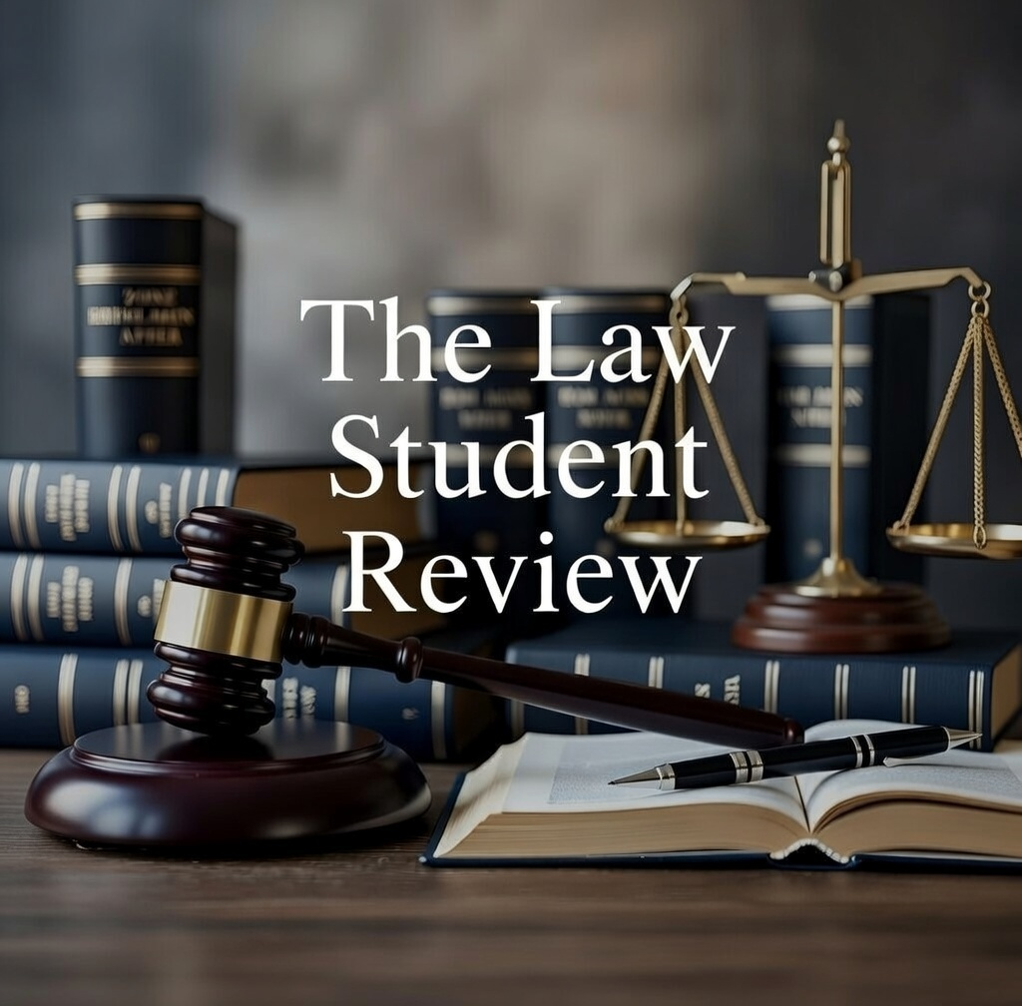

Southern Cross Community Healthcare Pty Ltd v Blacktown City Council [2023] NSWSC 1347 [2] (Campbell J) (‘SCCH v BCC’).
Workers Compensation Act (No 70) 1987 (NSW) (‘WCA’).
WCA (n 2) s 151Z(d).
SCCH v BCC (n 1) [5] (Campbell J).
Ibid [9] (Campbell J).
Ibid [6] (Campbell J).
Ibid.
Ibid [10] (Campbell J).
Ibid [14] (Campbell J).

