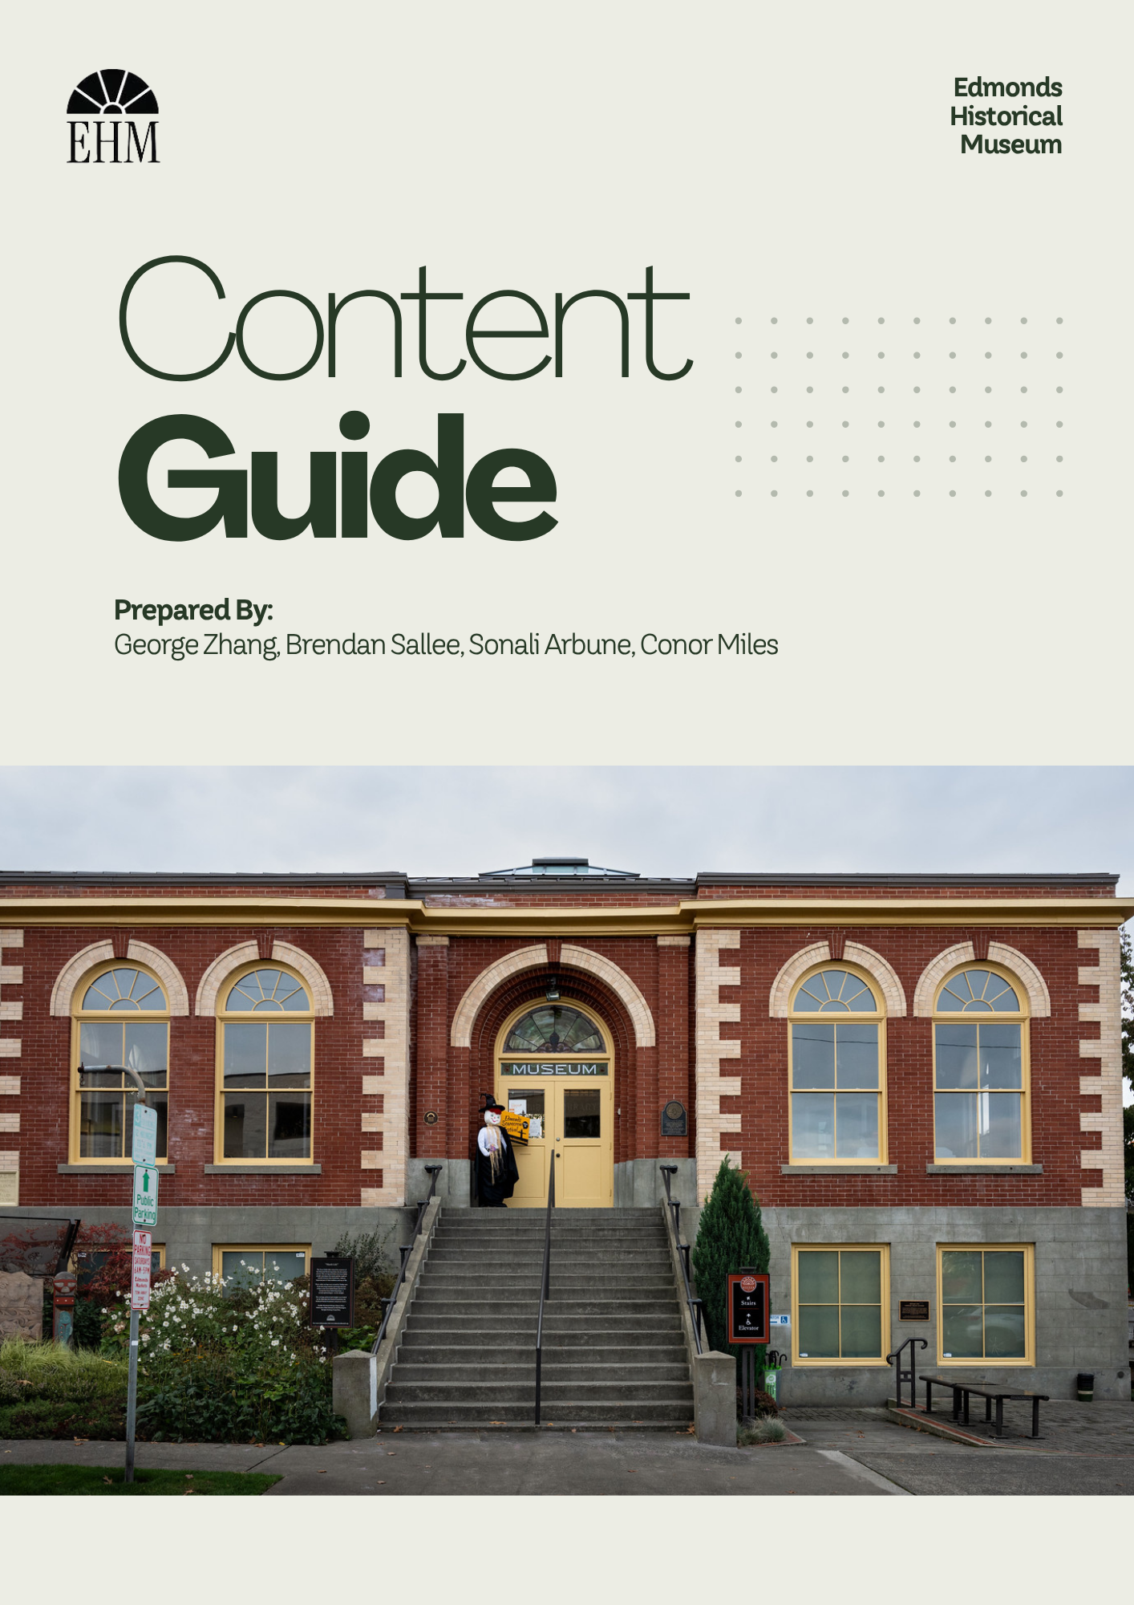

Edmonds Historical Museum - Design Toolkit for Short-Form Content & Blogs

Context

Introduction
The Edmonds Historical Museum (EHM) is seeking a scalable way to capture rich, immersive physical exhibits and transform them into an enduring, interactive digital archive.
More than just a digital archive, the museum board hopes this solution could engage the community through compelling narratives. Rather than simply cataloging which artifacts appear in exhibits, the goal is to keep stories around artifacts and exhibits alive in a new digital medium.
To achieve this goal, the 2026 Human-Centered Design and Engineering (HCDE) Master’s Capstone group researched potential design solutions. Based on our findings through secondary research, subject matter expert interviews, and in-person observations, we decided to focus on the behind-the-scenes (BTS) of exhibit curation.

The BTS of museum curation is typically not visible when at a museum. What visitors see is the final, polished product, often with no context of the processes required to achieve it. Rather than attempting to recreate museum exhibits digitally, our team aimed to show regular visitors and potential visitors something new, regardless of whether they experienced the original exhibit.

This design toolkit will provide the rationale, research, and methodology for creating BTS content through the mediums of short-form content (SFC) and blog posts.

Audiences
BTS content caters to audiences both internally and externally to EHM, since it has the potential to educate, garner interest, preserve work practices, and collaborate with other institutions.

Potential Visitors
Creating BTS content will generate opportunities for new people to discover the museum and can attract visitors who were not previously aware of its existence. SFC can expand the museum’s outreach through existing social media channels or new ones. Even small historical societies and institutions, some of which we will discuss later, have captured substantial audiences in the millions through the success of their TikToks and YouTube Shorts. On EHM’s website, showcasing videos on the homepage or under pages dedicated to Exhibits can prompt new visitors to assess what the museum has to offer, which mitigates potential fatigue from scrolling through large blocks of text or image galleries. While less conventional for this audience, blog posts can drive website traffic by being easily shareable, improving SEO, and establishing an additional avenue for exploring the museum’s collections.

Regular Visitors
Even frequent visitors and members of the museum will find BTS content compelling since it can deepen their understanding of and thus connection to the institution. For this audience, an inside view into the thinking, processes, and people behind exhibits deliver novel insights that add value to their continued patronage and foster a stronger sense of community and emotional investment. BTS glimpses can also be applicable at various stages in these visitors’ engagement with a temporary exhibit. They can notify about or build anticipation for an upcoming exhibit, be shared on-site to add more context, allow visitors who enjoyed an exhibit to revisit it, and offer those who were unable to attend during the exhibit’s lifespan a chance to experience what it had to offer. Detailed blog posts would appeal to this group, as they facilitate a deep dive into the museum’s work and serve to keep them engaged between physical visits. EHM could also offer further benefits to members through this initiative with first access or ‘members-only’ BTS content, like the benefits of being a Patron or Member of a content creator on social media.

Museum Staff
For internal stakeholders, particularly all involved with the development of an exhibit, this content functions to recognize their efforts and preserve their practice and knowledge. Highlighting the curation process acknowledges the labor, passion, and expertise of the staff in a direct way that is not often elevated once the final exhibit opens to the public. It also equips staff with a record of their work, which can help them build a stronger professional portfolio. Furthermore, documenting the curation journey through SFC and blogs creates an internal repository of institutional knowledge. As fresh staff and interns rotate through the museum, these digital records preserve methodologies, techniques, and relationships that can be a valuable reference for future teams.

Academic Institutions
By transparently sharing the curation process, EHM can open the door for connections with other institutions and entities. Other local museums, museology programs, academic groups, and researchers can use the BTS content as a reference for current curation practices, as it illustrates research methodologies, artifact sourcing, and design frameworks for creating an exhibit. They can also use it as a blueprint for how to share their own work more transparently and accessibly with the public. This not only elevates the museum’s reputation as a modern, community-led institution but also encourages developing networks that can lead to future grants, collaborative projects, and academic support.

Strategic Goals
While the target audiences for this content are diverse, the overarching purpose of implementing this design toolkit centers on four primary institutional objectives.

Extend the Lifespan of Temporary Exhibits
At this time of writing, when temporary exhibits are taken down, there is no trace of them. While staff already track the placement and physical artifacts in EHM’s collection, they cannot capture context-dependent stories. By producing BTS content, the museum enables everyone to relive or experience for the first time an exhibit through an enduring digital archive. This initiative ensures that the rationale, historical insights, and unique narratives of an exhibit are accessible after it closes, eliminating the barriers produced by exhibition timelines that would otherwise have bounded engagement.

Enrich the Visitor Experience through Transparency
When visiting a museum, patrons engage with a finalized, polished product. BTS content delivers engaging “edutainment” by inviting a look behind the curtain on the curatorial process and EHM’s inner workings. Sharing the full story behind artifacts, such as histories shared by donors, design decisions for displaying them, expert consultations, and pieces that did not make the cut, provides additional narratives that physical displays alone cannot accomplish. Whether someone watches before a visit, during their time in the gallery, or after they leave, there is something new for them to experience.

Expand Reach and Drive Visitors to the Museum
Social media algorithms, particularly those driving short-form content, are powerful tools for discoverability. Going viral, or even maintaining online visibility, generates useful name recognition for a smaller institution like EHM. By posting SFC and blogs, the museum can share its rich local history and community involvement with a much broader digital ecosystem. The focus of this goal is to strive to convert digital engagement into physical visits and expand the museum’s potential visitors beyond its immediate local area.

Document and Validate Staff Labor
We have observed firsthand that the museum staff are immensely proud of their work. Creating an exhibit requires immense dedication, from sourcing artifacts to securing local partnerships to designing the physical space. Yet, once an exhibit retires, those involved have little tangible evidence of their contributions. This initiative intends to document these workflows. In doing so, EHM can preserve the methodologies and practices utilized to the benefit of future projects, while also creating materials that staff and volunteers can showcase to friends, family, or in their professional career

Short-Form Content

Why SFC?
We believe that short-form video offers a strategic way for the museum to expand audience reach, relevance, and connection. By making behind-the-scenes work more visible and accessible, it adds a new dimension to the experience.

Market research has shown that people enjoy and seek out authentic content. So creating brief, visual content that gives audiences exclusive access to authentic moments such as exhibition installation, conservation work, artifact preparation, and staff expertise is quite compelling.

Among educational institutions, the most popular on social media are sometimes the smallest; they learned how to utilize this format well. This format aligns with current media consumption habits, encourages repeat engagement, and helps digital audiences discover the museum across social platforms. It also humanizes the institution by highlighting the people and care behind each visitor’s experience. By pairing access with educational storytelling, short-form content can deepen public understanding, entertain, and provide new channels for patronage and monetization.

Platforms
When thinking about short-form content, the most popular platforms are TikTok, Instagram, YouTube, and Facebook. The good news is that videos on these platforms transfer well. If you have a video formatted for Instagram, it is quite easy to post it on TikTok and YouTube as well. While each platform has its own unique features and designs, the function of uploading content is quite similar.

As of the time of writing, the museum has an active Facebook page and Instagram page, along with a dormant YouTube channel. This gives the museum a strong starting point for short-form content because it can begin publishing through existing platforms rather than creating new accounts or building an audience from the ground up. These platforms already provide the basic infrastructure needed to test content, monitor engagement, and build a consistent posting rhythm with current followers.

Once a regular workflow has been established, expansion to additional platforms such as TikTok would be a practical next step. This will allow the museum to broaden its reach while making efficient use of staff time and existing digital assets.

Topics
The idea of behind-the-scenes content leads to a plethora of potential topics. To narrow down topics, we conducted a sentiment mapping exercise with museumgoers to illuminate their interests. Based on these findings, we aim to highlight content topics that will be most appealing to potential museum visitors.
Sentiment mapping results:
Sentiment Mapping Scoring
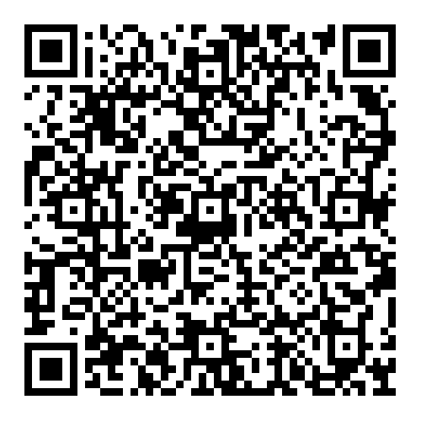

Looking at the results, we can see that interest in learning about artifacts is high. What this artifact is, where it’s from, and how to restore it are all top 5 topics. Outside experts and calls for participation are the other two reasons, but we feel these topics require more planning and effort to create. We believe that, during early adoption, it would be best to create content about artifacts the museum already has or plans to showcase. This should fit into the workflows of museum staff more smoothly while still creating a polished product. Should there be capacity to plan shoots with external experts or create a community involved video, we recommend exploring those topics.

We would also like to highlight that the other topics are still viable topics to choose from. Our participant pool was not all-encompassing, and we know that trends and interests evolve over time. If you or someone at the museum thinks one of the other topics feels compelling, we encourage you to explore it. Should there be other topics that come up not on our list, we think there’s value in trying those as well.

Storyboards
We have placed all our storyboard templates in a single folder that you can access below.
Video Storyboards and Guides
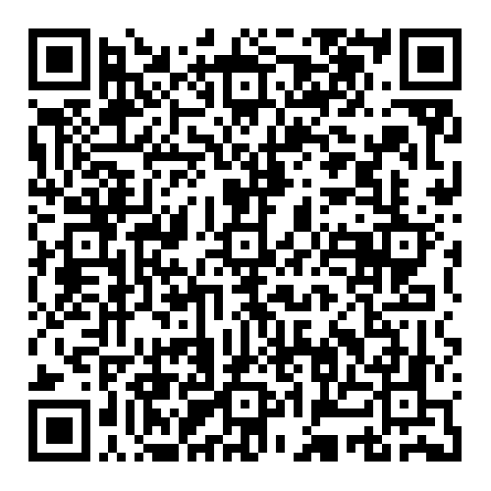

Recommended Materials
When thinking about creating this content, the materials used are not as important if they feel consistent in quality and storyline. If possible, we recommend the museum to buy their own hardware such that any intern, volunteer, or employee can use the same equipment each time. The storyboards should help with the storyline, and a nice phone can capture quality video. The following are materials that we prefer and can vouch for.

Software
Mobile: CapCut
CapCut is a simple but powerful editing tool on mobile devices. You can upload clips and videos directly into the software and work to edit and piece them all together. In creating content for mobile consumption, this allows for a streamlined workflow that volunteers or staff can complete on a single device.

Desktop: DaVinci Resolve
DaVinci Resolve has a free version that offers a robust editing experience. With the ability to create your own templates and add your own scripts and code, we find a lot of flexibility in the software.

Hardware
Mobile: iPhone 17 Pro, Google Pixel 10 Pro, Samsung Galaxy S26 Ultra
Modern phones have become quite powerful in their ability to capture video and photo at a high resolution. While the phones we recommend here have the best cameras in their respective categories, we know it’s possible to create these videos with a phone as we have done it ourselves.

Any DSLR
A DSLR camera is the classic hardware used for capturing photo and video. Modern day cameras capture detail and quality to a stunning degree and have many features and accessories to aid with the capture process. They also vary in cost, with some basic consumer-grade builds costing less than smartphones.

Examples
Short-form content is a recent method of outreach, and museum adoption has been slow and inconsistent. However, there have been institutions trying and succeeding in their usage of short-form content. What’s more fascinating is that some of the biggest videos and channels come from smaller institutions like local libraries and museums compared to the big institutions like The Met or Louvre.

Here is a playlist of examples to draw inspiration from:
Playlist of examples

Future Research
The research done here is a product of its time. Technology and content are evolving at a rapid pace. This means that in a few years' time, there may be an updated content medium that everyone is consuming, or new topics and trends that people fixate on. Content recommendations may need to evolve with shortform content. We also believe that future teams can replicate our research to discover new topics audiences connect with.

Blogs

Why Blogs
We believe that blogs offer a strategic way for the museum to showcase the work that they’re doing without needing to purchase more hardware. Making behind-the-scenes work more visible and accessible to visitors adds a new dimension to the experience.

Market research has shown that people enjoy and seek out authentic content. sharing content that gives audiences exclusive access to authentic moments such as exhibition installation, conservation work, artifact preparation, and staff expertise is quite compelling.

Blogs allow you to do this at a much lower cost than other mediums. With already existing infrastructure that facilitates text-based web content, blogging is a reliable way of getting any sort of information out there. And writing tends to be a nicer way to keep record as it’s searchable and sortable.

Platforms
Luckily, the museum has a modern feeling and looking website. This would be a perfect place to host the blog. By being within the currently existing infrastructure, it ensures easy access and less work. Some blog templates may require web development, but once complete, staff can reuse them perpetually. This would also make it easy to link between the blog and other parts of the website without it being a jarring jump for the reader. Visitors can read blogs and learn about upcoming exhibits within one domain.

Topics
The idea of behind-the-scenes content leads to a plethora of potential topics. To narrow down topics, we conducted a sentiment mapping exercise with museumgoers to illuminate their interests. Based on these findings, we aim to highlight content topics that will be most appealing to potential museum visitors.
Sentiment mapping results:
Sentiment Mapping Scoring

Looking at the results, we can see that interest in learning about artifacts is high. What this artifact is, where it’s from, and how to restore it are all top 5 topics. Outside experts and calls for participation are the other two reasons, but we feel these topics require more planning and effort to create. We believe it would be best to start with creating content about artifacts the museum already has or plans to showcase. This should fit into the workflows of museum staff more smoothly while still creating a polished product. Should there be capacity to plan shoots with external experts or create a community involved video, we recommend exploring those topics.

We would also like to highlight that the other topics are still viable topics to choose from. Our participant pool was not all-encompassing, and we know that trends and interests evolve over time. If you or someone at the museum thinks one of the other topics feels compelling, we encourage you to explore it. Should there be other topics that come up not on our list, we think there’s value in trying those as well.

Recommended Materials
When thinking about creating this content, there are not a lot of new materials needed. By having an updated website and a webmaster, the biggest part comes in writing the blog content itself.

There are options as to how to write the content.
Curatorial + Collections Staff: When thinking about having a human writer, the museum staff would be great people to take up that mantle. They hold so much knowledge and rationale in their mind; it would be amazing to get a glimpse into their mind.

Other Staff/Volunteers: There is an opportunity for other staff or volunteers or interns to take on the blog writing. By setting time aside with the curator or collections manager, they could interview them and turn that into a blog.

AI: AI is solid at synthesizing notes and writing content. There are writing specific AI products like Jasper or Quillbot and the standard ones like ChatGPT or Claude. The staff must have some notes already about the work they’re doing. If they could just feed that into the AI, it could produce some blogs that just need minor tweaking. Note that some products have free versions and others require a license to use.

Examples
The British Museum
Seattle Art Museum
Smithsonian American Art Museum
Guggenheim

Future Research
The research done here is a product of its time. Technology and content are evolving at a rapid pace. This means that in a few years' time, there may be an updated content medium that everyone is consuming, or new topics and trends that people fixate on. So what we recommend now may not be as suitable for the future. However, throughout it all, blogs have remained a staple on the internet for many different communities. It may not be as popular or viral, but they never truly fade away. We believe that they will continue to remain a low-cost option for sharing out information and the compelling work that makes Edmonds Historical Museum special.

