Leaded Solder – 63/37 - T4

Low residue Leaded no-clean solder paste

FEATURES
SOLDERIX Leaded range offers a good balance between wettability, printing capability and ability to withstand various thermal profiles. This range exhibits high printing speed, excellent abandon time and long steady tackiness.
These pastes can withstand high thermal profiles, with and without nitrogen, leading to consistent and shiny solder joints on all standard finishes.
Residues after reflow are non-corrosive and do not need to be removed to ensure the reliability of the PCB’s. However, those residues are easily cleanable with a large range of cleaners: hydro-carbonated solvents, halogenated solvents and detergent solutions including the SOLDERIX cleaning solutions.

PROPERTIES

SOLDERIX Leaded | SOLDERIX Leaded 63/37 – T3 | SOLDERIX Leaded 63/37 – T4
Alloy | Sn63Pb37 | Sn63Pb37
Powder size distribution (microns) | 25-45 | 20-38
Melting point | 183 | 183
Metal content (%) | 89,5 ± 0.5 | 89,5 ± 0.5
Residue after reflow soldering (%) | 47 – 54 | 47 – 54
Halogen content | no halogen | no halogen
Viscosity* (Pa.s at 25°C)  *Spiral pump Malcom – 10 RPM | 160  Typical value | 160  Typical value

CHARACTERISTICS
Long stencil life: more than 10 hrs
Abandon time on the stencil more than 4 hrs with excellent print restart

Fine pitch printing

Printing speed: 20-150 mm/sec
Solderballing resistance at high % relative humidity Good wettability on all finishes
Stable tack: more than12 hrs at 22°C between printing and component placement
Chemical reliability 6
Residue cleanliness 4
ICT Test 2
Printing speed
Stencil life

Abandon time

No slump out by preheat
Slight yellow residue after reflow, at probe compatible No halogen
0
Residue cosmetic

Tombstoning
Cold slump

Steady tack

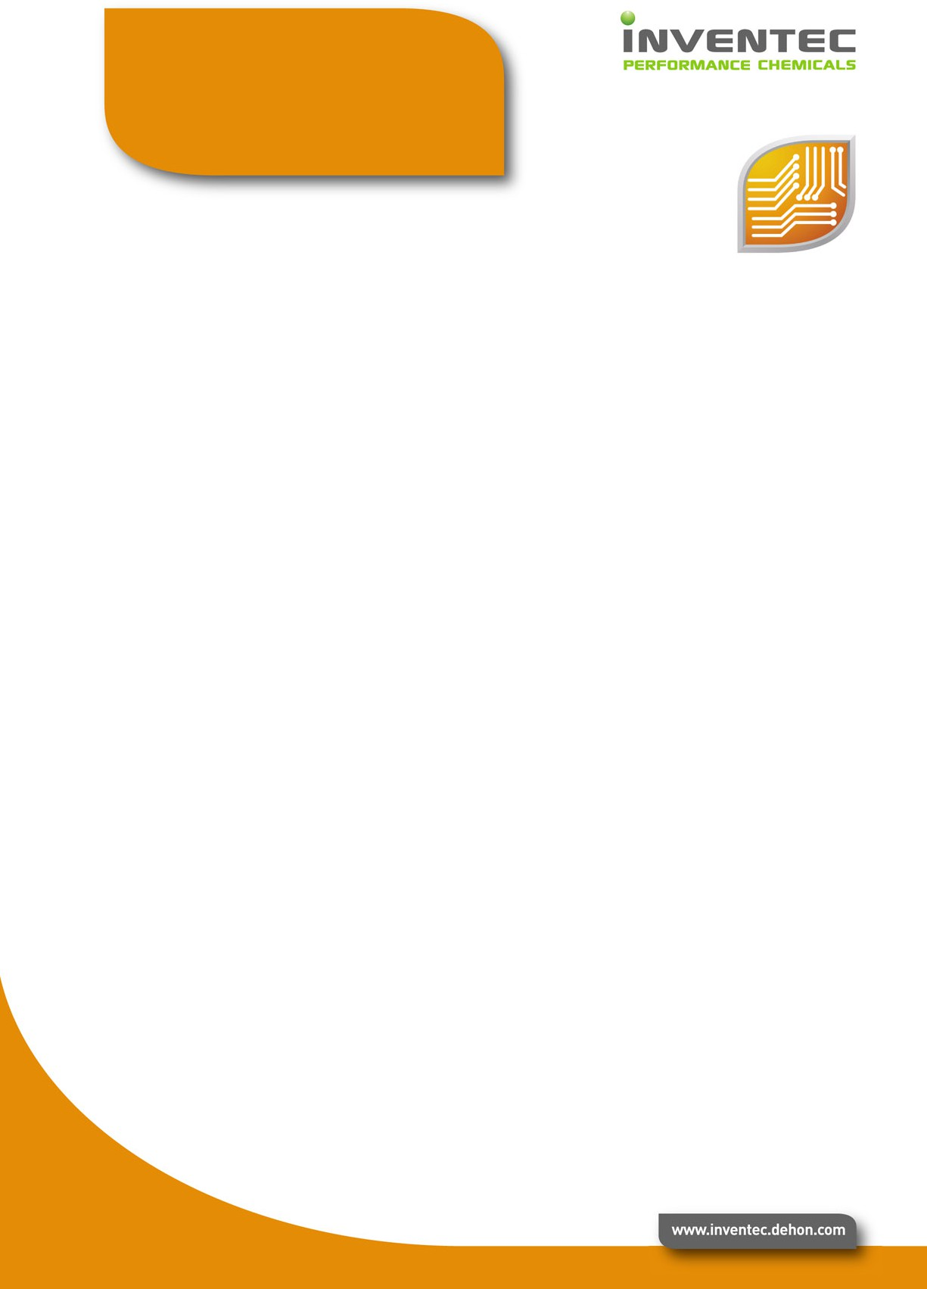
High SIR – No residue deterioration during accelerated ageing
Compatible with major conformal coating of the market
(1) SIR/EM test at 40°C, 93 % RH, 50 V bias, 500 hours:
> 108 ohms – no dendrites

Solder beading
Wettability

Hot slump Reflow process window



FUNCTIONAL TESTS | Results | Procedures
Flux classification | L 0  F-SW 32  113 | ANSI/J-STD-004 DIN 8511  ISO 9454
Solderballing test | class 1 | ANSI/J-STD-004
Copper mirror | pass | ANSI/J-STD-004
Copper corrosion | pass | ANSI/J-STD-004
S.I.R. Ohms  After 21 days  85°C - 85 % RH - 50 Volts  End of cycle  20°C – 65°C RH | pass  > 109  > 1010 | ANSI/J-STD-004

PACKAGING

Jar | 250 g or 500 g

STORAGE & SHELF LIFE
To ensure the best product performance, the recommended storage temperature range is 0°C to 10°C. A shelf life of 12 months is achieved under these conditions.

PROCESS PARAMETERS

Solder paste preparation
Before printing, it is essential to properly mix the solder paste, either manually with a spatula, or by doing several preliminary prints on the stencil.

Printing guideline
Apply on the stencil solder paste to form a roll of 1 to 2 cm of diameter all along the squeegee (about 100g of paste per 10 cm squeegee length). This way, the solder paste will roll easily under the squeegees to offer excellent printing quality.
Printing speed : 20 to 150 mm/sec. Minimum pitch : 0.3 mm
Pressure : depends on printing speed Examples of printing speed according to the pressure :

Squeegee length | Printing Speed | Pressure
250 | 50 mm/sec | 4 kg
250 | 100 mm/sec | 9 kg
400 | 50 mm/sec | 6 kg
400 | 100 mm/sec | 11 kg

Reflow guideline

The graph beside indicates, the optimal thermal profile zone according to PCB and component thermal mass.

A linear preheating ramp rate is preferable to a too long soak, in order to avoid solder beading and to get a shiny joint with a uniform residue distribution.

Nitrogen atmosphere improves wettability inside a larger reflow process window.

TEMPERATURE
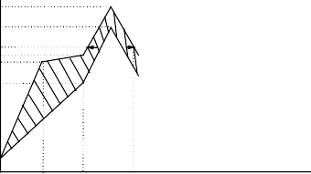
°C
THERMAL PROFILE ZONE SHORT PROFILE
50-70
secs
240

210

180
170
160

130

20

60 120 200

TEMPERATURE
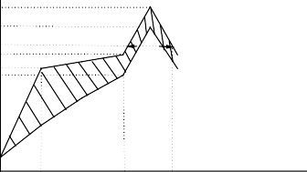
°C
THERMAL PROFILE ZONE MEDIUM PROFIL
50-80
secs
240

210

180
170
150
140

AIR REFLOW

TIME secs

AIR REFLOW

20

60 180 260 TIME secs

TEMPERATURE
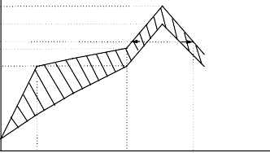
°C 240
THERMAL PROFIL ZONE LONG PROFILE
50-120
secs

210

18
170

140

AIR REFLOW

20

60 210

340

TIME secs

Cleaning
After soldering, the remaining flux residue does not have to be removed by a cleaning operation as it is chemically inert. When cleaning is required (e.g. high reliability assembly, improved conformal coating adhesion), the residue left after reflow can be easily removed with a large range of cleaning solutions, such as detergents, hydro-carbonated solvents or halogenated solvents cleaning range solutions.

HSE
Contains lead. Use in well-ventilated areas. Safety glasses and gloves should always be worn when handling the flux.

