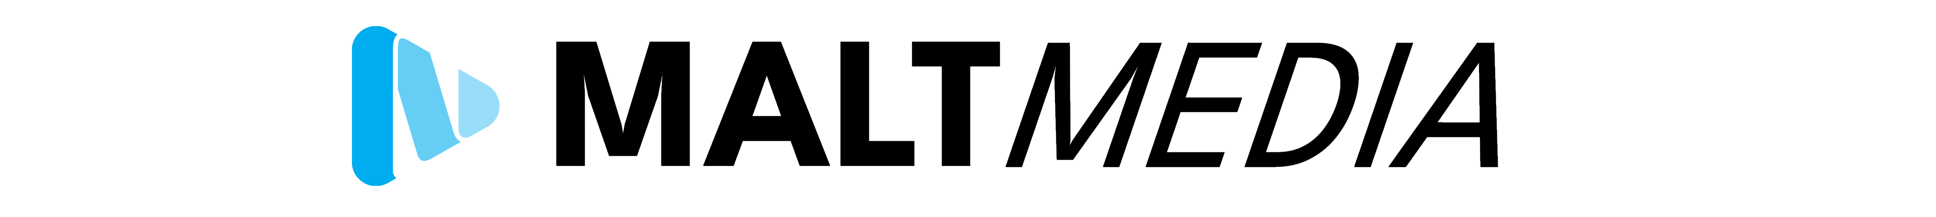
Statement of Work & Client Agreements
Client Name: | Chiltern Cheetahs
Client Address: | 37 Ashfield Way, Hazlemere, Buckinghamshire, HP15 7RL
Provider Address: | 50 Pimms Grove, High Wycombe, Buckinghamshire, HP13 7EF
Date: | 25/02/2026

This document specifies:
- Project Overview
- Scope of Work
- Client Responsibilities
- Deliverables
- Timeline
- Payment Terms
- Confidentiality
- Termination

- Project Overview
This Statement of Work defines the scope, deliverables, and terms for the project.

- Scope of Work
The service provider will perform the tasks described and deliver the agreed outputs. This includes the following:

To create two high energy videos for Chiltern Cheetahs. The videos should incorporate all areas of cheerleading and should summarise it just one short film. Areas to include are jumps, dance, stunts, pyramid and tumbling. The video should incorporate younger and older age groups within it to show the range of athletes on the programme, different ethnicities where possible and should ensure all athletes are not exposed in any way. Video footage of happy athletes, smiling, hugs, waving and coaches cheering are also welcome.

[1] Website Hero Banner Video (Primary Focus)
The website banner will be filmed in landscape.
- Main hero banner video
- The video will be provided in a format compatible with YouTube as an advert, either uploaded on MaltMEDIA for the client or via their own personal YouTube (Subject to discussion)
- Client has requested two edits, MaltMEDIA will prioritize the longer-form video first and any time leftover within the designated 8 hours of editing time will be used to shorten down the main video.
    - One longer version (few minutes)
    - One shorter version (approximately 30 seconds) – Subject to lack of time, this could be used as the social media video in landscape format.

[2] Social Media Video
The social media video will be filmed in landscape and cropped into portrait as per the clients request.
- 1 minute in length – Could also use shortened hero banner video (Subject to discussion)
- Featuring all of the above (jumps, dance, stunts, pyramid, tumbling, mixed age groups, diversity, positive culture and club atmosphere)
- To be used to advertise the club on social media sites including Instagram, Facebook and TikTok
- The video should end with the Chiltern Cheetahs logo
- Music will be discussed with the client before the edit commences

- Client Responsibilities
It is the client’s responsibility to ensure that all individuals appearing in this video are fully aware that they are being recorded and have provided their informed consent to participate.
The client must also confirm that no person featured is vulnerable, under legal protection, subject to safeguarding restrictions, or otherwise prohibited from being filmed.
By proceeding with filming, the client accepts full responsibility for obtaining the necessary permissions and ensuring compliance with all relevant legal and safeguarding requirements. This includes securing appropriate parental or guardian consent for any children appearing in the video. In the event that a child who does not have the required consent has already been filmed and edited, the client agrees to bear full responsibility for any associated corrective actions, including but not limited to editing, re-filming, content removal, or any other necessary amendments. All costs incurred as a result of such corrections shall be payable by the client.
The client is responsible for providing all necessary information, materials, branding assets and approvals required to complete the project in a timely manner. The client agrees to provide feedback within the agreed timeframes. Delays in providing materials, access, or approvals may result in adjusted delivery timelines.
MaltMEDIA will deliver services in accordance with the agreed brief and specifications and will maintain professional standards throughout the project.

- Deliverables
All deliverables will meet the specifications outlined in this document. Completed content will be provided to the client via a secure viewing link for approval. Upon confirmation of approval, an invoice will be issued, which will include a secure download link to access the final files. Payment is due within 7 days of the invoice date.
Reasonable revisions are included to ensure the final deliverables meet the agreed brief and specifications. Minor adjustments, such as small edits to timing, text, or basic visual changes, will not incur additional charges. However, substantial changes that require extensive re-editing, restructuring, re-filming, or alterations beyond the original agreed scope may be subject to additional fees. Any such charges will be discussed and agreed upon with the client in advance.

- Timeline
The project will begin on the Sunday 1st March 2026. Delivered to the client at MaltMEDIA’s discretion (Aiming between 2-3 weeks at a maximum)

- Payment Terms
Fees have been agreed with Chiltern Cheetahs as following. On-site work will take place on Sunday 1st March between 13:00 to 21:00 (8 hours). Editing will be completed off-site and will take approximately four hours. If the work exceeds the stated time lines, MaltMEDIA will request from Chiltern Cheetahs written authorization prior to any additional work being carried out.
MaltMEDIA onsite day rate is flat charged of £250, for up to 8 hours. Remote work is charged at a flat rate of £31.25 per hour. Payment will be made by bank transfer once the video is completed and approved by the client.

- Confidentiality
All shared information in this document will remain confidential. MaltMEDIA will speak prior with client to use any “behind the scenes” footage of the work for marketing purposes.

- Termination
Either party may terminate this agreement under defined conditions, including but not limited to material breach of contract, failure to perform agreed obligations, or circumstances beyond reasonable control that prevent completion of the services.
Termination must be provided in writing. In the event of termination, the client shall be responsible for payment of all work completed and any expenses incurred up to the date of termination.
By signing this agreement, both parties acknowledge that this clause forms a written agreement between the parties

Signed by provider: | 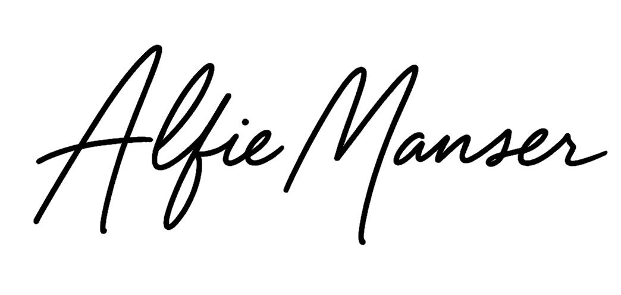
Signed by client: | 