Module 1 — What Is Market Volatility? (Expanded Final Version)
Module Overview
This module introduces the foundational concept of market volatility in a clear, structured, and highly approachable way. It captures full depth modules, including narratives, examples, and intuitive explanations. Making the SwanStrikeFX course simple and intuitive to understand.

Volatility is the backbone of the Grey Swan Framework. Before students can understand volatility compression, coiled markets, or Grey Swan snapback events, they must first understand what volatility is, how it behaves, and why suppressed volatility
creates fragility.

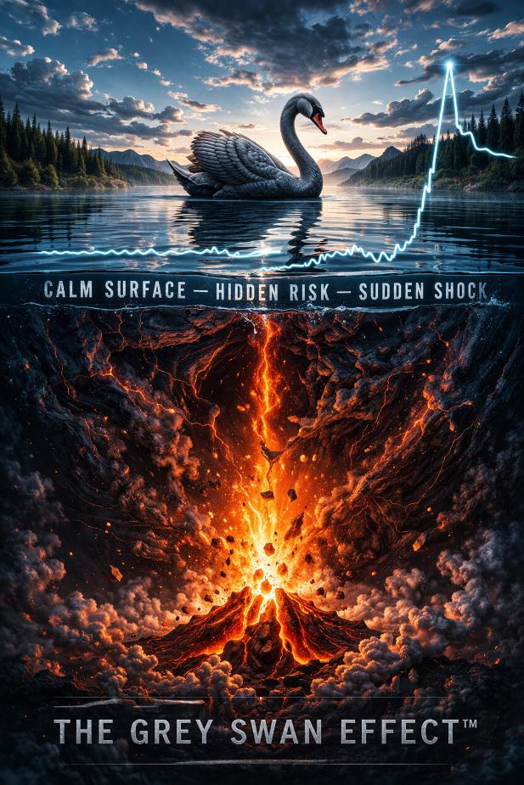
1.1 What Volatility Really Means
Most people believe volatility is simply going up and down, but professionals define it more precisely:

Volatility measures how fast and how far prices move over a given period.
It is not about direction—it is about intensity.

Key insights:
• A fast-moving market = high volatility
• A slow-moving market = low volatility
• Volatility is the language of uncertainty

Volatility reveals how confident—or unconfident—the market is. Even when price appears calm, volatility may be signaling hidden tension beneath the surface.

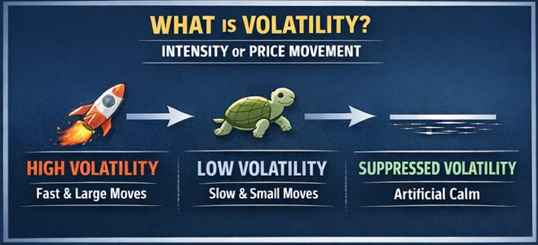

An intuitive analogy:
Think of volatility like the wind on a lake.
• Strong wind → choppy waves (high volatility)
• Light wind → gentle ripples (low volatility)
• No wind → still surface (suppressed volatility)

But sometimes the lake is too still—unnaturally still—and that tells an experienced observer that pressure is building below.

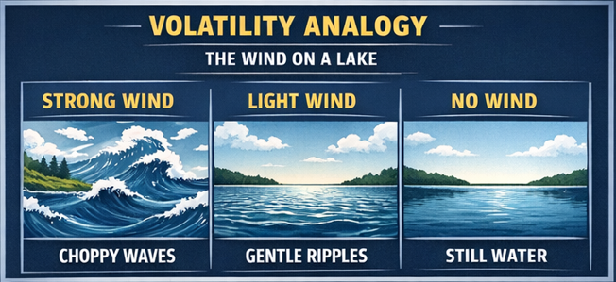

1.2 Realized Volatility vs. Implied Volatility

Professionals rely on two complementary forms of volatility:

Realized Volatility (RV)
This is the volatility that has already happened.
It measures actual historical price movement.

If the market had several large swings last week, realized volatility will be high—even if the future is uncertain.

Implied Volatility (IV)
This is forward-looking volatility.
It measures what the market expects to happen next, based on options pricing.

Implied volatility responds to:
• Fear
• Hedging demand
• Uncertainty
• Derivatives flow
• Market structure

Grey Swan events arise when Implied volatility becomes artificially suppressed, even as realized volatility remains low. This mismatch—low IV, low RV—creates a fragile calm.

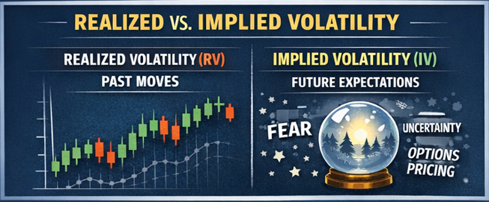
1.3 Why Volatility Matters

Volatility matters because it influences nearly every layer of modern markets.

Volatility affects:
• Institutional hedging behavior
• Options pricing
• Dealer positioning
• Liquidity conditions
• Risk management systems
• investor psychology

Professionals don’t just watch price—they watch volatility to understand the energy of the market. Volatility is not noise, it is information.

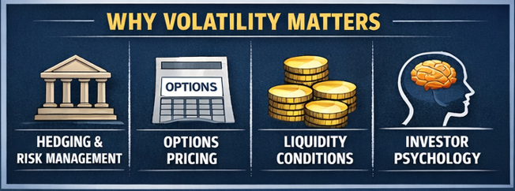

1.4 Volatility Is Not Good or Bad —It’s a Signal

A common misconception is that volatility is inherently dangerous.
Volatility is simply a reflection of uncertainty.

Interpretations:
• High volatility means uncertainty is elevated
• Low volatility means markets are calm or complacent
• Suppressed volatility means fragility

This last category is the most important for the SwanStrikeFX framework.

Suppressed volatility occurs when derivatives flow push volatility down artificially.
The calm isn’t natural—it’s Forced. And when calm is forced, the market becomes extremely sensitive to even the smallest catalyst.

This is where Grey Swan conditions begin.

1.5 Volatility as a Dynamic System
Volatility is not random. It is shaped by a complex ecosystem of forces:
• Macroeconomic news
• Corporate earnings
• Liquidity cycles
• Institutional hedging
• Options dealer flows
• Systematic strategies
• Behavioral psychology

This is why volatility often tends to rise and fall in patterns, not isolated bursts.
A powerful mental model: Volatility is like a pressure system. During calm periods, pressure builds beneath the surface. If that pressure is artificially suppressed, the release can be sharp and sudden.

Grey Swan events are the natural release of accumulated tension.

They occur:
• Not because of disaster
• Not because of panic
• But because volatility was pushed down too far, too long

Grey Swans are not rare—they occur several times per year. The key is learning how to recognize when the volatility system is unstable.



Module Summary

By completing this expanded Module 1, students understand:
• What volatility measures
• Why volatility reflects market uncertainty, not direction
• The critical distinction between realized and implied volatility
• Why suppressed volatility creates fragile market conditions
• How volatility operates as a dynamic, interconnected system
• Why Grey Swan events originate from periods of artificial calm

This foundation prepares students for Module 2, where we introduce the VIX—the primary tool for tracking implied volatility and a core component of the Grey Swan Framework.

Module 2 — Understanding the VIX (Full Expanded Version)

MODULE 2 — Understanding the VIX (In Plain English)
What the VIX measures, why it moves, and why calm doesn’t always mean safe.

2.1 What the VIX Measures (The Real Explanation)
The VIX is often called the fear index, but that oversimplifies what it truly represents.



A more accurate explanation: The VIX measures how much movement options traders expect in the market over the next 30 days.

It is not backward-looking. It does not tell you what happened.
It tells you what the market THINKS will happen.

If traders expect big swings → VIX rises.
If traders expect calm → VIX falls.

Key insight:
The VIX is forward-looking uncertainty.

But here is the twist that matters for Grey Swan setups:
The VIX can fall even when risk is rising, IF the market structure pushes it down.

This is volatility suppression. And it is the root of Grey Swan behavior.

2.2 How the VIX Moves

The VIX rises when:
• Markets fall quickly
• Uncertainty increases
• Demand for hedging grows
• Options traders aggressively buy protection

The VIX falls when:
• Markets drift upward
• Fear disappears
• Traders sell volatility
• Hedging demand collapses
• Derivative flows suppress implied volatility

And the critical observation:
The VIX often falls for structural reasons, not because risk is gone.

This is why Grey Swan volatility pops feel sudden—but they aren’t. They grow silently inside suppressed VIX environments.

2.3 Why Calm Markets Can Create Risk, Not Remove It

This is one of the most counterintuitive truths in markets:

The lower the VIX falls, the higher the probability of a sudden volatility spike.

Not because low volatility causes spikes…
…but because low volatility invites complacency.

When volatility is artificially pushed down:
• Hedgers stop hedging
• Dealers reduce long-volatility exposure
• Traders chase returns
• Risk premium disappears
• Option sellers become aggressive

This creates a fragile market—one that looks safe but isn’t.

Calm does not equal safety. Sometimes calm equals vulnerability.

2.4 Why the VIX Often Falls Too Low

There are several mechanical forces that drag the VIX lower:

1. Dealer Hedging Dynamics
When dealers hedge by buying stock, they naturally reduce volatility in price movement.
This pulls the VIX downward even when uncertainty still exists.

2. Volatility Selling Strategies
Funds routinely sell volatility to generate income. When many players sell volatility at once, the VIX gets crushed.

3. Derivatives Flow Pressure
Large options, especially call buying in bull trends—push hedging flows that suppress volatility.

4. Complacency Cycles
When markets drift upward with no major news, traders assume the calm will continue and stop hedging.

5. Realized Volatility Anchors Expectation
If nothing happened lately, the VIX assumes nothing will happen soon.

Together, these forces create the well-known phenomenon: A VIX that sits lower than fundamentals would justify.

This is fertile ground for Grey Swan setups.

2.5 The Danger Zone: When the VIX Is Too Low

A structurally important level emerges in modern markets: The 14–16 VIX zone.

Why it matters:
• Hedging is cheap
• Traders under protect
• Dealers suppress movement
• Volatility sellers dominate
• Complacency peaks

This range creates a psychological illusion: If volatility is low, everything must be fine.

But inside the Grey Swan framework:
If the VIX is low for the wrong reasons → risk is building.

This is the coiled spring environment that leads to Grey Swan volatility pops.

2.6 What Causes VIX to Pop?

When volatility is suppressed, the system becomes hypersensitive. A small spark can trigger a disproportionately large volatility reaction.

Common Grey Swan catalysts:
• Slightly unexpected inflation prints
• Minor geopolitical flareups
• A sharp bond market move
• Overnight futures weakness
• Options hedging unwinds
• Earnings surprises
• Liquidity gaps

These events are not disasters.
They are triggers—small disruptions that release the tension built up inside suppressed volatility.

This is why Grey Swan moves are so often labeled unexpected by the media. The environment was primed for them.

Module Summary

By completing Module 2, students understand:
• What the VIX truly measures
• How implied volatility reflects market expectations
• Why the VIX falls even when risk remains
• Why calm markets can be dangerously fragile
• How derivatives flow suppress volatility
• Why the 14–16 VIX zone is structurally important
• How small catalysts trigger Grey Swan volatility pops

This prepares students for Module 3, where they will learn the difference between white swans, black swans, and the Grey Swans that the SwanStrikeFX system focuses on.

Module 3 — White, Grey, and Black Swan Events (Full Expanded Version)

MODULE 3 — White, Grey, and Black Swan Events
Understanding the three types of market events—and why Grey Swans matter most.

3.1 Why This Module Matters
Most retail investors think of markets only in two states:
1. Everything is normal
2. Everything is crashing



But this misses the MOST important category of volatility events—the Grey Swan.

To understand Grey Swans, students must first understand the three tiers of market events:
• White Swan Events
• Grey Swan Events
• Black Swan Events

This module explains these in simple, intuitive language while preserving the full depth of the original chat content.

3.2 White Swan Events — Normal Market Movement

Definition:
White Swan events are routine, predictable market fluctuations. They do not create major volatility spikes.

These events include:
• Typical earnings results
• Mild economic data
• Standard intraday noise
• Small geopolitical mentions
• Market drift during stable periods

Characteristics:
• Common and expected
• Minimal impact on implied volatility
• Absorbed easily by market structure
• No meaningful repricing of risk

Why They Matter Here:
White swans create the surface-level calm that suppresses volatility.
This calm can eventually feed into Grey Swan setups it becomes too quiet for too long.

White swans themselves don’t cause spikes—but they set the stage for them.

3.3 Grey Swan Events — Recurring Volatility Pops
The most important event type in this strategy.

Definition:
Grey Swans are short-term, meaningful volatility spikes that occur when markets become too calm for too long.

They are:
• Not rare
• Not catastrophic
• Not unpredictable
They are the natural release of tension inside a suppressed volatility environment.

Characteristics:
• Market appears calm on the surface
• Implied volatility is artificially low
• Hedging demand is minimal
• Options selling dominates
• A small catalyst results in an oversized volatility reaction

Examples of Grey Swan triggers:
• Slight CPI surprise
• Unexpected bond yield movement
• Overnight futures dip
• A geopolitical headline
• Minor liquidity imbalance
• Reversal in dealer hedging flows

Why Grey Swans Matter:
Unlike black swans (rare crashes), Grey Swans occur multiple times per year.
They are the core of the SwanStrikeFX educational framework because they are:
• Repeatable
• Structured
• Pattern-based
• Understanding-based (not predictive)

Grey Swans show how volatility behaves when the system becomes fragile.

3.4 Black Swan Events — Rare, Systemic Crises

Definition:
Black Swan events are rare, extreme, unpredictable market crises with major systemic consequences.

Examples:
• 2008 Global Financial Crisis
• 2020 COVID crash
• Flash crash–type systemic failures
• Massive geopolitical shock events

Characteristics:
• Extremely rare
• Severe dislocation in volatility
• Multi-day or multi-week impacts
• Structural breaks
• Persistent elevated VIX

Why They Are NOT the Focus:
Black swans are too infrequent and too extreme to form the basis of a short-duration educational framework. Grey Swan events, on the other hand, occur regularly and follow identifiable structural conditions.

3.5 The Relationship Between All Three Events

Think of these events along a spectrum:

White Swan → Grey Swan → Black Swan
(normal → meaningful spike → crisis)

Most investors only recognize the extremes:
• White swans (nothing happening)
• Black swans (everything crashing)

But the Most tradable, most educational volatility behavior happens in the middle.

Grey Swans bridge the gap between ordinary calm and extreme panic.

They show:
• How suppressed volatility behaves
• How the market reprices uncertainty
• How tension releases

And most importantly—they demonstrate the structural mechanics that drive the market.

3.6 Why Grey Swan Events Are the Focus of SwanStrikeFX

Grey Swans occur naturally when:
• Volatility is suppressed
• The VIX sits in the 14–16 zone
• Realized volatility stays near zero
• Options selling becomes crowded
• Hedging disappears
• Catalysts approach

This combination creates a pressure cooker environment.

When the pressure releases:
• Implied volatility snaps back
• VIX jumps rapidly
• UVIX and other volatility products react aggressively

And these events happen multiple times each year.

Educationally, Grey Swans teach:
• Timing windows
• Volatility structure
• Market fragility
• Compression mechanics
• The difference between calm and dangerous calm

Grey Swans are the heartbeat of short-term volatility dynamics.

Module Summary

By completing Module 3, students understand:
• What a white swan event is
• What a black swan event is
• What sets Grey Swans apart from both
• Why Grey Swans occur far more often than black swans
• What Grey Swans naturally emerge from volatility suppression
• Why these events are core to the SwanStrikeFX framework

This prepares students for Module 4, where we explain why volatility becomes suppressed in the first place—the essential precondition for all Grey Swan events.

Module 4 — Why Volatility Gets Suppressed (Full Expanded Version)

MODULE 4 — Why Volatility Gets Suppressed
Understanding the structural forces that push volatility down and create the fragile conditions that lead to Grey Swan events.

4.1 Why This Module Matters

Grey Swan events do not begin with chaos—they begin with calm.

Not natural calm…
Artificial calm.

Modern markets are designed in a way that frequently pushes volatility downward, even when true underlying risk hasn’t disappeared. This creates a dangerous illusion of stability, where markets look quiet but are storing tension beneath the surface.

To understand Grey Swans, students must first understand why volatility becomes suppressed and who or what is pushing it down.

This module expands the full original content into a professional, intuitive, and complete explanation of the volatility suppression ecosystem.

4.2 The Modern Market Is Engineered to Suppress Volatility

Over the last decade, markets have become increasingly influenced by:

• Options trading
• Volatility selling strategies
• Automated hedging flows
• Systematic investment programs
• Low-cost index investing
• Intraday dealer positioning

These forces unintentionally work together to press volatility downward, creating calm before the storm environment central to Grey Swans.

Think of volatility as a spring:
• When markets push it down gently → mild calm
• When markets press it down forcefully → artificial suppression
• When suppression continues too long → stored energy
• Stored energy eventually releases → Grey Swan

This is not randomness—this is structural inevitability.

4.3 The Four Primary Forces That Suppress Volatility

In the original chat content, you identified multiple forces. Here, they are expanded and refined into four clearly defined, intuitive pillars.

Force #1 — Dealer Hedging (The Most Important One)

Options dealers often hedge their positions in a way that suppresses volatility.

Simple explanation:
1. Retail or institutions buy call options
2. Dealers sell those calls to them
3. Dealers hedge by buying the underlying index (like SPX)
4. Dealer hedging stabilizes prices
5. Stable prices reduce implied volatility
6. Reduced volatility pushes the VIX downward

This is the root of the phenomenon known as dealer-induced calm.

When gamma exposure is high, dealers suppress nearly every price swing.
Markets become unusually smooth, even when risk still exists.

This is artificial calm. And artificial calm is fragile.

Force #2 — Systematic Volatility Selling

Many institutional strategies rely on selling volatility as a source of yield.

These include:
• Option-writing funds
• Covered-call ETFs
• Hedge funds shorting volatility
• Volatility arbitrage desks

When many players sell volatility simultaneously:
• Options premiums collapse
• Implied volatility falls
• VIX drifts lower
• Markets appear calm

This does not mean risk is gone. It simply means volatility has been old away .

Force #3 — Yield-Seeking Behavior During Low Vol Environments

When market volatility is low:
• Volatility appears safe
• Income strategies sell more options
• Institutions chase yield through vol selling
• Retail traders imitate these strategies

This adds even more downward pressure on volatility.

It becomes a feedback loop: Low volatility → more vol selling → lower volatility → even more volatility vol selling.

Eventually this loop bends the system into a fragile state.

Force #4 — Trend-Following and Passive Flows

Markets often drift upward during calm conditions.

When:
• Passive funds continuously buy index funds
• Systematic strategies buy strength
• Realized volatility shrinks
• Breadth stabilizes

Volatility naturally declines.

But artificial suppression enters when:
• Dealer hedging amplifies this effect
• Volatility sellers accelerate it
• Liquidity thins out
• Market depth becomes shallow

This produces a market that looks sturdy but is structurally vulnerable to sudden changes.

4.4 What Happens When Suppression Goes Too Far

Volatility is not removed, it is absorbed.

The system begins storing tension in hidden pockets:
• Reduced hedging demand
• Pressure on VIX term structure
• Shallow order books
• One-sided positioning
• Minimal risk premium

When volatility is pushed down too far, the market becomes fragile.

Fragile markets do not look dangerous. They look calm.

This is why Grey Swans catch most traders off guard— not because the catalyst is big, but because the environment was brittle.

4.5 Why the Market Becomes Vulnerable in Calm Periods

Calm markets create psychological and structural vulnerabilities.

Psychological:
• Traders stop hedging
• Investors underestimate risk
• Option premiums appear cheap
• Sentiment becomes complacent

Structural:
• Dealers reduce long-vol exposure
• Hedge ratios shrink
• Liquidity providers pull back
• Vol selling accelerates
• Depth evaporates

This is a critical insight: Calm is not always safety.
Calm is sometimes instability disguised as safety.

4.6 Example Environments Where Suppression Dominates

Volatility suppression is most common during:

• Extended bull runs
• Prolonged tight trading ranges
• Pre-election calm
• Post-Fed announcement drift
• Low-volume summer sessions
• After major macro events resolve

These periods invite the illusion of stability because they feel slow, controlled, and predictable.

But beneath the surface, the coiled spring is tightening.

4.7 Suppression Creates Latent Risk

Volatility suppression stores energy.

When released:
• VIX jumps rapidly
• Volatility futures spike
• UVIX reacts aggressively
• Hedging flows flip direction
• Market reprices uncertainty

These reactions are not anomalies—they are the natural expression of a system under tension.

Grey Swans are simply the market’s release valve.

Module Summary

By completing Module 4, students understand:
• What forces suppress volatility
• How modern market structure pushes VIX lower
• Why suppressed volatility becomes fragile
• How tension builds quietly beneath calm markets
• Why compression is the precursor to Grey Swan spikes
• How calm becomes vulnerability

This prepares students for Module 5, where we explore the actual Grey Swan compression Setup—the core of the SwanStrikeFX strategy.

Module 5 — The Grey Swan Compression Setup (Full Expanded Version)

MODULE 5 — The Grey Swan Compression Setup
Understanding how volatility becomes a fragile coil primed for a sharp snapback.

5.1 Why This Module Matters
This is one of the most important modules in the entire SwanStrikeFX course.



Every Grey Swan event begins with a specific structural condition: Volatility compression. Compression is not calm—it is forced calm. It represents a market that looks stable on the surface but has hidden tension underneath.

This module fully expands the original chat explanation into a polished, comprehensive, and intuitive deep dive.

5.2 What Volatility Compression Really Is

Volatility compression occurs when implied volatility is pushed lower and lower by structural market forces—not because risk has disappeared, but because flows are suppressing movement.

Think of volatility as a spring:

• Light pressure → normal calm
• Strong pressure → artificial calm
• Continuous pressure → tension builds
• Release of pressure → sharp snapback

Grey Swan setups happen during the third phase—when volatility is unnaturally compressed and tension is quietly growing.

Compression does NOT mean:
• The market is safe.
• Volatility is permanently low.
• Risk is gone.

Compression means:
Volatility is being pushed down harder than it naturally wants to go.

5.3 The VIX Complacency Zone — Why 14–16 Matters

While volatility can theoretically fall anywhere, the VIX tends to behave differently in the 14–16 range.

This zone is important because:
• Hedging demand collapses
• Traders stop buying protection
• Options selling becomes aggressive
• Dealers’ hedging stabilizes price movement
• Implied volatility drifts downward without cause
• The market appears unusually calm

Inside this zone, the volatility spring tightens.

Historically, when the VIX sits in this area long enough, even small catalysts can cause sharp volatility spikes—Grey Swans.

5.4 What Compression Looks Like on the Chart

A compressed volatility environment has a distinct visual signature:

For the VIX:
• Smooth downward drift
• Very small daily candles
• Reduced intraday movement
• Flattening term structure
• Inability to rise even on red equity days

For UVIX:
• Decay rate slowly
• Price levels flatten
• Tight-range consolidation
• Coiled spring appearance

This flattening behavior reveals that volatility is running out of room to fall.
Spring is nearly fully compressed.

5.5 The Ingredients of a True Grey Swan Compression Setup

A valid Grey Swan environment generally contains 3 to 5 of these conditions:

1. VIX in the 14–16 compression zone
2. Extremely low realized volatility (quiet markets)
3. Strong derivatives flow suppressing volatility
4. Options selling dominating the landscape
5. Mild but meaningful macro catalyst approaching
6. VIX forming a base / slowing decay
7. Dealer gamma exposure stabilizing markets

When these conditions overlap, the system becomes fragile.
A catalyst does not have to be large—it only must disrupt the illusion of calm.

5.6 Why Compression Makes Markets Fragile

When volatility is suppressed:
• Hedges are removed
• Liquidity providers back away
• Dealers rely on stabilizing hedges
• Volatility sellers accumulate one-sided exposure
• Market depth becomes thin

This creates a fragile environment where: mall shocks create big reactions.

For example:
A minor CPI surprise during a compressed volatility phase can trigger a larger volatility spike than major news in a normal regime.

This is the Grey Swan dynamic.

5.7 How Long Compression Can Last

Compression can last:
• Days
• Weeks
• Sometimes months

The key insight: compression is not about timing—it is about vulnerability.

A compressed market is not guaranteed to snap today, tomorrow, or next week…
But when it does snap, it often does so violently.

Grey Swan setups teach you to understand the environment, not predict the date of the release.

5.8 What Happens When Compression Breaks

When the tension finally releases:

• VIX jumps quickly
• UVIX responds disproportionately
• Hedging flows reverse
• Implied volatility re-prices rapidly
• Liquidity temporarily vanishes
• Volatility spikes sharply

This snapback often completes within 1 to 7 days

After the spike:
• Volatility normalizes
• Compression cycle resets
• UVIX resumes decay

This is the classic Grey Swan pattern.

5.9 Full Pattern Summary: The Grey Swan Compression Setup

A typical setup follows this chain:

1. Volatility drifts lower
2. VIX enters the 14–16 zone
3. Market becomes extremely calm
4. Dealers suppress movement
5. Options sellers dominate
6. UVIX slows its decay
7. Catalyst approaches
8. Grey Swan volatility spike occurs
9. System resets

This is the signature structure your students will learn to recognize instinctively.

Module Summary

By completing Module 5, students have learned:
• What volatility compression is
• How the VIX behaves in the complacency zone
• How UVIX signals compression maturity
• What structural forces tighten the volatility spring
• Why calm becomes fragile
• How compression precedes every Grey Swan event

This module lays the foundation for Module 6, where students learn how UVIX behaves during these conditions and why timing windows are short.

Module 6 — UVIX Mechanics & the Decay Curve (Full Expanded Version)

MODULE 6 — UVIX MECHANICS & THE DECAY CURVE
Understanding how UVIX behaves during volatility compression, why it reacts explosively during Grey Swan events, and why timing windows are short.

6.1 Why This Module Matters

UVIX is one of the most misunderstood volatility-linked products in the entire market.

Most traders:
• Don’t know what it truly tracks
• Don’t understand why it moves so violently
• Don’t understand why it decays so rapidly
• Don’t realize why it is PERFECTLY suited to Grey Swan environments

This module expands and elevates the original chat content into a fully developed educational chapter.

UVIX is not a stock.
UVIX is not VIX.
UVIX is not a prediction tool.

UVIX is a leveraged short-term volatility futures product that behaves like a coiled spring during volatility compression and like a burst of stored energy during Grey Swan events.

To use the Grey Swan Framework, students must understand UVIX at a structural level.

6.2 What UVIX Actually Tracks (Plain English)

UVIX is designed to deliver 2x the DAILY return of a specific index:

→ Short-term VIX futures (usually 1–2 months out)

This is critical:
UVIX does NOT track the VIX index itself.

Instead:
• It tracks futures
• Those futures track EXPECTATIONS of future volatility
• Those expectations move differently from the VIX
• UVIX adds leverage AND a daily rebalance

UVIX = leveraged exposure to volatility EXPECTATIONS.

This is why UVIX:
• Reacts sharply to volatility spikes
• Decays rapidly during calm periods
• Behaves differently from the VIX

Understanding this distinction is essential to understanding Grey Swan mechanics.

6.3 Why UVIX Moves So Much More Than the VIX

UVIX amplifies volatility changes due to three layers of sensitivity:

Layer 1 — VIX → VIX Futures
VIX futures often react MORE than the spot VIX during volatility spikes because futures prices adjust to expectations.

Layer 2 — Futures → UVIX
UVIX attempts to deliver 2x the daily move of those futures.

Layer 3 — Reflexivity
When volatility rises, futures traders hedge aggressively, driving even more upward movement.

Result:
A modest 5–10% rise in the VIX can cause a 15–30% move in UVIX.

UVIX is designed to respond to snapbacks, not slow trends.

6.4 The UVIX Decay Curve (Why It Bleeds Value)

UVIX decays because:
• VIX futures are usually in contango
• Each day, futures roll down the curve
• UVIX resets daily based on percentage change
• The decay compounds during calm periods
• Buying UVIX long-term is structurally unfavorable

This is NOT a flaw, it is intentional.

UVIX is like a block of ice:
• It melts constantly
• Unless the environment is cold enough (volatile enough) to slow the melt
• And when the temperature snaps (volatility spike), UVIX reacts instantly

This analogy helps students understand why UVIX is ideal for short-term educational examples in the Grey Swan Framework.

6.5 Why Timing Matters So Much With UVIX

Because UVIX decays quickly during calm conditions, it is NOT suitable for:
• long-term holding
• slow-trend volatility analysis
• predicting market crashes

It IS suited for:
• short-term volatility bursts
• Grey Swan snapback Environment
• identifying coiled volatility conditions
• rapid re-pricing of volatility expectations

UVIX behavior reinforces one of the most important lessons in volatility education:
you do not wait for volatility. You study environments where volatility is likely to move.

6.6 UVIX During a Grey Swan Event

When volatility compression breaks:
• VIX jumps
• Short-term VIX futures jump more
• UVIX often jumps the most

A typical Grey Swan UVIX reaction:
• VIX rises 10–20%
• UVIX rises 18–35%

This reaction often completes in:
• 1 day
• 2–3 days
• Sometimes up to 7 days

Then UVIX resumes decay as the volatility pressure resets.

This short, sharp burst is EXACTLY why UVIX is included in this course—it provides a real-time illustration of how volatility responds when calm becomes fragility.

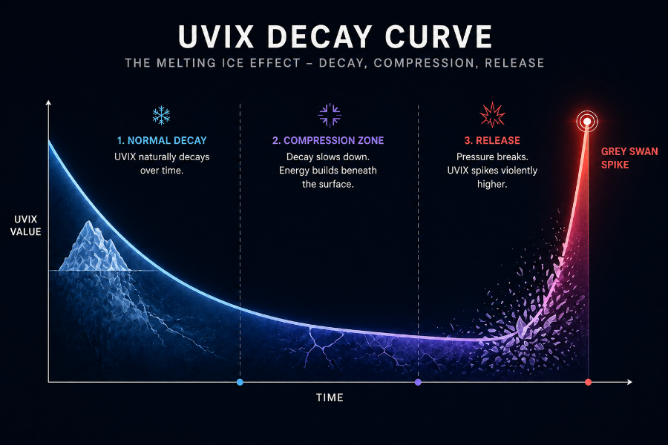

6.7 Why UVIX Fits the Grey Swan Framework Perfectly

UVIX is NOT part of the framework because it is a good product. It is part of the framework because it is an educational magnifier of volatility conditions.

Where the VIX might move modestly,
UVIX illustrates the magnitude and speed of volatility repricing.

UVIX’s characteristics match Grey Swans:
• Short-term
• Explosive
• Reflexive
• Linked to suppressed volatility
• Amplified reactions
• Rapid decay afterward

This combination makes UVIX one of the best tools for TEACHING volatility behavior.

6.8 The Big Takeaways

Students must understand:
• UVIX is not the VIX
• UVIX tracks short-term VIX futures
• UVIX is leveraged
• UVIX decays rapidly
• UVIX reacts strongly during compression breaks
• UVIX is educational for understanding volatility mechanics
• Grey Swans create UVIX behavior that is distinct, sharp, and short-lived

This module prepares students for Module 7, where the full Grey Swan Condition Framework is introduced.

Module Summary

By completing Module 6, students understand:
• What UVIX tracks
• Why UVIX amplifies volatility spikes
• Why UVIX decays during calm periods
• How leverage and futures dynamics shape UVIX movement
• How UVIX behaves during Grey Swan events
• Why UVIX is a powerful educational tool for volatility compression

This understanding is essential before moving to Module 7, which teaches how to IDENTIFY Grey Swan conditions using a structured multi-part checklist.

Module 7 — Identifying Grey Swan Conditions (Full Expanded Version)

MODULE 7 — Identifying Grey Swan Conditions
How to recognize when volatility is suppressed, fragile, and primed for a Grey Swan volatility pop.

7.1 Why This Module Matters

This module represents a turning point in the course.

Up to now, students have learned:
• Shat volatility is
• How the VIX behaves
• The difference between white, grey, and black swans
• Why volatility becomes artificially suppressed
• How UVIX reacts when compression breaks

Now we combine all this knowledge into a structured diagnostic framework.

Grey Swan events do not appear randomly. They arise from a recognizable set of conditions.

When enough of these conditions overlap, the market becomes fragile—and even a small catalyst can trigger a sudden volatility spike.

This module teaches students how to identify those conditions.

7.2 Grey Swan Events Are Environmental, Not Predictive

One of the most important concepts in volatility analysis: you do not predict Grey Swans. You recognize the environment where Grey Swans are more likely.

Think of it like weather forecasting: You cannot predict the exact minute a storm starts,
but you CAN recognize storm conditions. Grey Swans happen in the same way.

This module gives students the storm condition checklist.

7.3 The Five-Part Grey Swan Condition Framework

A high-probability Grey Swan environment usually displays here or more of these conditions simultaneously.

Below is the expanded version of the original framework with greater clarity and context.

Condition 1 — The VIX Compression Zone (14–16)

The VIX entering and stabilizing inside the 14–16 range is a common precursor.

Why this matters:
• Volatility is low
• Hedging demand collapses
• Options premiums shrink
• Volatility sellers increase exposure
• Market becomes overly calm
• Implied volatility becomes fragile

A VIX that drifts lower without fundamental justification is a key early indicator of compression tension.

Condition 2 — Extremely Low Realized Volatility

Realized volatility reflects the actual movements in price.

Grey Swan setups tend to form when:
• Daily SPX movement is unusually small
• Market candles are tight
• Intraday volatility is nearly nonexistent
• Weeks go by without meaningful swings

This creates false confidence among traders and reduces the perceived need for hedging.

When realized volatility stays extremely low, it reinforces the structural suppression.
Condition 3 — Derivatives Flow Suppressing Volatility

The options market provides powerful clues about volatility conditions.

Signs of suppression include:
• Dealers’ long gamma, stabilizing price movement
• Heavy call-buying, forcing hedging that reduces vol
• Unusually low options premiums
• Put/call ratios falling
• Volatility sellers dominating
• The VIX failing to rise even on red days

This is the hallmark of mechanical suppression—volatility being pushed down artificially.

Condition 4 — A Catalyst Window Approaching

Grey Swans do NOT require major news.

They simply require:
• Uncertainty
• Anticipation
• A small disturbance in a fragile environment

Catalyst windows often include:
• CPI
• FOMC meetings
• Employment data
• Geopolitical murmurs
• Earnings clusters
• Bond auction volatility
• Macro speeches (Fed, Treasury)

When a catalyst approaches AND volatility is compressed, the system becomes extra sensitive.

Condition 5 — UVIX Decay Slowing or Forming a Base

This is one of the most subtle but powerful Grey Swan signals.

UVIX usually decays rapidly during calm periods.

But near the end of a compression cycle:
• UVIX decay slows
• Daily ranges tighten
• UVIX stops making new lows
• A base form on the chart
• Futures curves flatten

This base-building is the equivalent of pressure building beneath the surface.

When UVIX flattens, the spring is nearly fully compressed.

7.4 Putting the Conditions Together

You do NOT need all five conditions.

A classic Grey Swan setup includes:
• VIX near 15
• Realized vol extremely low
• Derivatives suppressing volatility
• A catalyst approaching
• UVIX forming a base

This combination signals: The market is too calm to be stable.

Remember:
Grey Swans are not about predicting the exact moment—but about understanding when the environment is fragile.

7.5 The Grey Swan Diagnostic Table

Below is a printable version of the expanded diagnostic framework.

Grey Swan Environment Scoring:
✔ VIX in 14–16 range
✔ VIX daily movement shrinking
✔ Extremely low realized volatility
✔ Options flows suppressing volatility
✔ Catalyst within 1–10 days
✔ UVIX base-building
✔ Term structure flattening
✔ Sentiment overly bullish
✔ Market depth thinning

Interpretation:
• 0–2 checks: Normal calm
• 3–4 checks: Compression forming
• 5–6 checks: Fragile calm
• 7–9 checks: High Grey Swan potential

This forces discipline and prevents emotional interpretation.

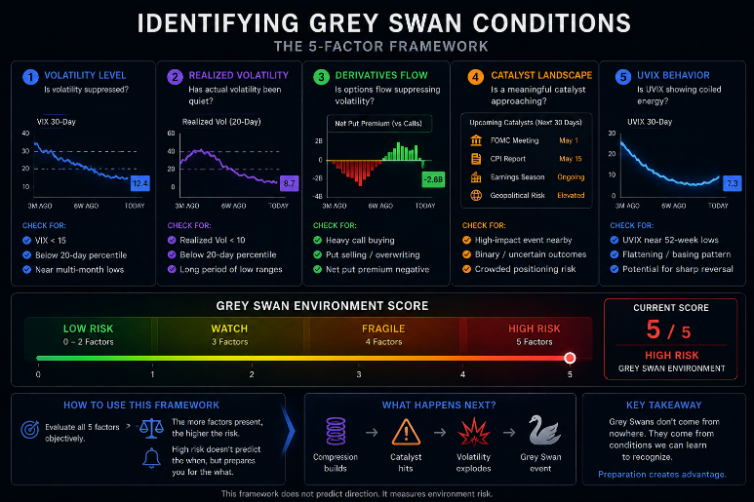
7.6 What a Grey Swan Environment feels Like

This is where intuition meets structure.

A Grey Swan setup often feels like:
• Markets are calm, but something feels off
• The VIX refuses to rise
• UVIX stops decaying as quickly
• Market tone feels too quiet
• News headlines feel out of sync with market calm
• Traders become confident at the wrong time

Developing this intuition is part of becoming a volatility analyst.

Module Summary

By completing Module 7, students understand:
• The five major components of Grey Swan environments
• How to evaluate volatility suppression
• How to apply a structured diagnostic checklist
• How to distinguish normal calm from fragile calm
• How to identify coiled volatility conditions

This sets the stage for Module 8, where students receive the formal Grey Swan Qualification Checklist that turns this framework into a repeatable decision tool.

Module 8 — The Grey Swan Qualification Checklist (Full Expanded Version)

MODULE 8 — The Grey Swan Qualification Checklist
A structured, repeatable framework for evaluating whether a Grey Swan environment exists.

8.1 Why This Module Matters

This is one of the most practical and high‑value modules in the entire SwanStrikeFX system.

Modules 1–7 taught students:
• What volatility is
• How the VIX behaves
• Why volatility becomes suppressed
• What Grey Swan events look like
• How UVIX behaves when compression breaks
• The five environmental conditions that precede Grey Swans

Now we turn this knowledge into a simple, repeatable, disciplined checklist.

This checklist does NOT predict the exact moment of a volatility spike.
It evaluates environmental fragility, like how a meteorologist evaluates storm risk.

If the conditions align → risk is elevated.
If not → compression is incomplete or absent.

This module gives students the tool they will rely on for the rest of the course.

8.2 Purpose of the Checklist

The Grey Swan Qualification Checklist is designed to:
• Prevent emotional decision‑making
• Filter out false positives
• Identify when volatility suppression is mature
• Evaluate when the market is fragile
• Distinguish healthy calm from dangerous calm
• Provide a rule‑based framework anyone can use

This is NOT a trading checklist.
This is an environmental assessment tool.

8.3 The Grey Swan Decision Tree (Simple Version)

Ask these questions in order:

STEP 1 — Is the VIX in or near the compression zone?
Range: 14–16
Is the VIX drifting lower with small daily candles?

If YES → move to Step 2
If NO → environment is not ready

STEP 2 — Is realized volatility extremely low?
Are daily ranges unusually tight?
Has price movement flattened?

If YES → move to Step 3
If NO → compression is incomplete

STEP 3 — Are derivatives flows suppressing volatility?
Signs include:
• VIX ignoring red days
• Put/call ratio falling
• Options premiums collapsing
• Dealer gamma high
• Trend‑stabilizing hedging flows

If YES → move to Step 4
If NO → suppression is insufficient

STEP 4 — Is there an upcoming catalyst within 1–10 days?
Examples: CPI, FOMC, NFP, auctions, earnings clusters, geopolitical noise.

If YES → move to Step 5
If NO → environment is fragile but low‑timing‑confidence

STEP 5 — Is UVIX slowing its decay or forming a base?
Look for:
• Tight ranges
• Reduced decay speed
• A clear base forming
• Futures curve flattening

If YES → high‑probability Grey Swan environment
If NO → compression is not mature

8.4 The Full Grey Swan Qualification Checklist
Below is the complete framework, expanded for professional use.

Check each one as ✔ or ✖:

1. VIX between 14–16
2. VIX showing shrinking daily range
3. Extremely low realized volatility
4. Persistent volatility suppression from options flows
5. Dealers showing high gamma exposure
6. Market sentiment leaning complacent
7. Catalyst window within 1–10 days
8. UVIX slowing decay
9. UVIX forming a visible base
10. VIX term structure flattening
11. Market depth thinning
12. Breadth weakening beneath the surface

Recommended scoring:
• 0–3 checks → Low probability
• 4–6 checks → Compression forming
• 7–9 checks → Fragile calm
• 10–12 checks → High Grey Swan environment

This converts qualitative signals into a structured scoring model.

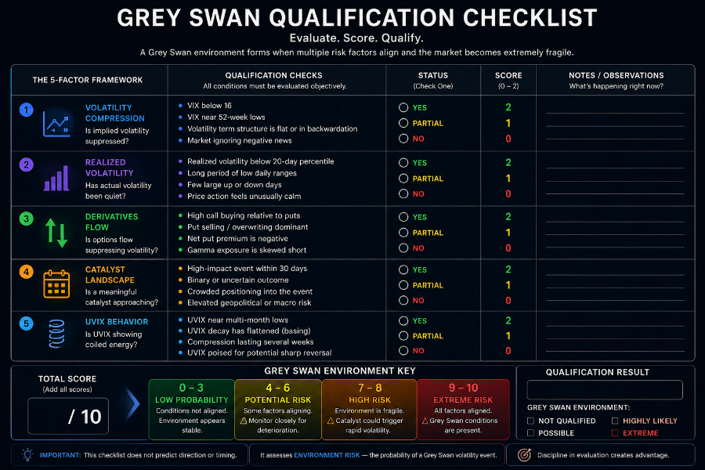

8.5 Why This Checklist Prevents Mistakes
The checklist prevents the most common errors:

Mistake 1 — Confusing normal calm with compression
Many quiet markets are simply stable, not fragile.

Mistake 2 — Assuming every low VIX reading is dangerous
A low VIX with healthy breadth and strong liquidity is Not a Grey Swan environment.

Mistake 3 — Ignoring UVIX behavior
UVIX decay behavior is one of the most reliable compression indicators.

Mistake 4 — Allowing catalysts to distort expectations
Catalysts matter only when volatility is already coiled.

Mistake 5 — Failure to distinguish early compression from mature compression
The checklist clearly separates the two stages.

8.6 The Fragility Zone
When 7 or more checklist conditions are present, the market is in what we call the fragility Zone.

Fragility Zone characteristics:
• Hedging demand extremely low
• Options sellers overexposed
• Market depth thin
• Dealers suppressing movement
• Calm that feels off
• Implied volatility artificially low
• UVIX decay slowing

This is where small catalysts produce outsized moves.

8.7 The Analyst Mindset
This checklist is not meant to be mechanical—it's meant to train intuition through structure.

A volatility analyst learns to ask:
• Is the market too calm?
• Why is volatility falling?
• What flows are suppressing movement?
• Is UVIX behaving normally or signaling tension?
• Are traders ignoring upcoming uncertainty?

This checklist guides that internal dialogue.

8.8 How to Use This Checklist Weekly
A recommended routine:
1. Evaluate VIX level and range
2. Check realized volatility
3. Review options/derivatives behavior
4. Scan for catalysts
5. Inspect UVIX decay rate
6. Assign a Fragility Score

This should take less than 10 minutes and builds pattern recognition over time.

Module Summary
By completing Module 8, students now have:
• A structured diagnostic tool
• A repeatable method for evaluating Grey Swan environments
• Clear distinctions between early and mature compression
• A scoring framework to quantify fragility
• A method for reducing emotional bias
• A foundation for applying the framework to real case studies

Module 9 will demonstrate how to APPLY this checklist to real‑world examples—both successful and failed Grey Swan setups.

Module 9 — Grey Swan Case Studies (Full Expanded Version)

MODULE 9 — Grey Swan Case Studies (1 Win, 1 Loss)
Seeing how the framework behaves in real-world market environments.

9.1 Why This Module Matters

You cannot master the Grey Swan Framework by concepts alone.

Students must SEE:
• What a real Grey Swan setup looks like,
• How conditions formed beforehand,
• What catalyst triggered the spike,
• How volatility responded,
• What UVIX did,
• And what the educational takeaway was.

This module provides TWO fully explained case studies:
• One successful Grey Swan spike (a win ), and
• One failed Grey Swan setup (a loss ).

Both are essential.

Real volatility analysis is not about perfection, it is about understanding the environment, improving intuition, and applying disciplined evaluation.

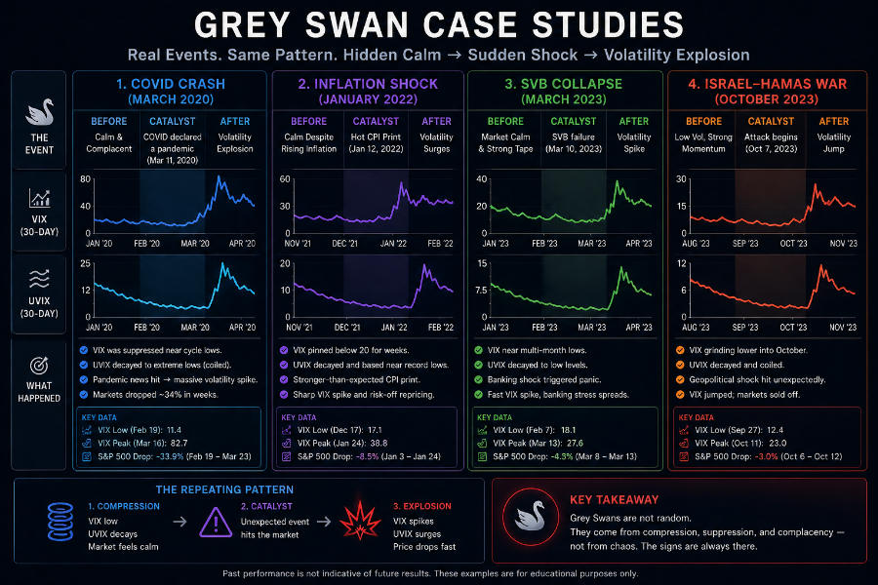

9.2 Case Study 1 — A Textbook Grey Swan Spike
Representative of common VIX compression → spike patterns seen multiple times per year

Background Environment

Leading up to the Grey Swan spike, the following conditions were present:

✔ IX in the 14–16 complacency zone
- The VIX drifted into the 15 area after several calm sessions.

✔ Realized volatility extremely low
- Markets moved by less than 0.3% per day for nearly a week.

✔ Derivatives flows suppressing volatility
- Options data showed:
  - Heavy call buying
  - Dealers’ long gamma
  - Minimal hedging demand

✔ Catalyst approaching: CPI report in 48 hours
- Not a crisis, just uncertainty.

✔ VIX decay slowing
- UVIX had previously melted downward but suddenly began forming a flat base.

This was a classic compression cluster.

The Snapshot (Chart Description)

If you imagine the VIX chart:
• The downward slope smooths out into a horizontal cluster,
• Candles shrink in size,
• VIX touches 15 repeatedly, but without real upward reaction,
• The term structure flattens.

Simultaneously, UVIX:
• Stops decaying aggressively,
• Prints multiple tight-range candles,
• Begins forming a coil.

This visual signature is foundational to Grey Swan recognition.

The Catalyst Hits

- CPI comes out slightly hotter than expected.

- Not dramatically.
- Not a crisis.
- Not a shock.

Yet, BECAUSE volatility was suppressed:

• Dealers unwound hedges,
• Protection was repriced upward,
• Futures moved sharply,
• Liquidity briefly thinned,
• Uncertainty recalibrated.

This triggered the release of stored tension.

The Spike

Within 48 hours:
• VIX jumped from ~15 to ~18 (roughly +18%)

• UVIX surged - (typically, +25% to +35% in similar setups)

Volatility is repriced quickly, decisively, and disproportionately relative to the size of the catalyst.

This is the essence of a Grey Swan event:
A small catalyst → a large volatility response.

Educational Takeaways

1. The magnitude of the catalyst is less important than the environment.
- The CPI number wasn’t huge—but the market was primed for release.

2. UVIX base formation is an important tension indicator.
- It slowed decay before the spike.

3. Derivatives flows often mask risk until the moment they flip.
- Gamma hedging suppressed volatility until it couldn’t.

4. Grey Swans are not random.
- They arise from compression, not chaos.

5. Volatility reversion is fast.
- Most Grey Swan reactions complete within 1–3 days.

9.3 Case Study 2 — A Failed Grey Swan Setup
Representative of environments that LOOK primed, but need more time or lack true fragility.

Background Environment

At first glance, this setup looked like the previous one:

✔ VIX near 16
✔ Calm market
✔ Catalyst (FOMC) approaching
✔ Options premiums low

However, one MAJOR indicator was missing:

✖ VIX decay was NOT slowing
- UVIX continued melting downward with strong daily decay.

This signaled:
• Compression was early,
• Tension was not fully built,
• VIX was low but not fragile.

This is where the checklist prevents false positives.

What Happened Next
The FOMC announcement arrived, and instead of a volatility spike:

• Markets absorbed the information calmly,
• VIX drifted sideways,
• UVIX continued melting,
• Realized volatility remained low,
• Suppression persisted.

No Grey Swan occurred.
Why?

Because the volatility spring was not fully compressed.

Educational Takeaways
1. Low VIX is not enough.
- Low volatility ≠ compressed volatility.
2. VIX decay behavior is crucial.
- If decay continues aggressively, suppression is not mature.
3. Catalysts only matter when compression is real.
- FOMC is often a catalyst—but not in the wrong environment.
4. Void assuming it must happen.
- Grey Swans are conditional, not inevitable.
5. The checklist provides discipline.
- It prevents emotional interpretation and overconfidence.

Module Summary
By completing Module 9, students understand:
• What a real Grey Swan environment looks like
• What a failed setup looks like
• How to interpret the Grey Swan checklist in practice
• Why catalysts only matter in compressed environments
• How volatility responds to tension release
• How to recognize early compression vs mature compression

Module 10 will expand on these lessons by introducing advanced context filters that refine Grey Swan probability even further.

Module 10 — Advanced Volatility Context Filters (Full Expanded Version)

MODULE 10 — Advanced Volatility Context Filters
How to refine Grey Swan identification using high-level market structure and professional volatility insights.

10.1 Why This Module Matters

Modules 1–9 taught the foundation:
• What volatility is
• How the VIX behaves
• Why volatility becomes suppressed
• What Grey Swan environments form
• How to identify those environments using the 5-Part Grey Swan Framework
• How to evaluate real examples

But professional volatility analysis also looks at context.

The same VIX level can mean entirely different things depending on:
• Macroeconomic environment
• Dealer positioning
• Liquidity conditions
• Market breadth
• Options sentiment
• Term structure shape

This module elevates students from competent volatility readers into true volatility analysts.

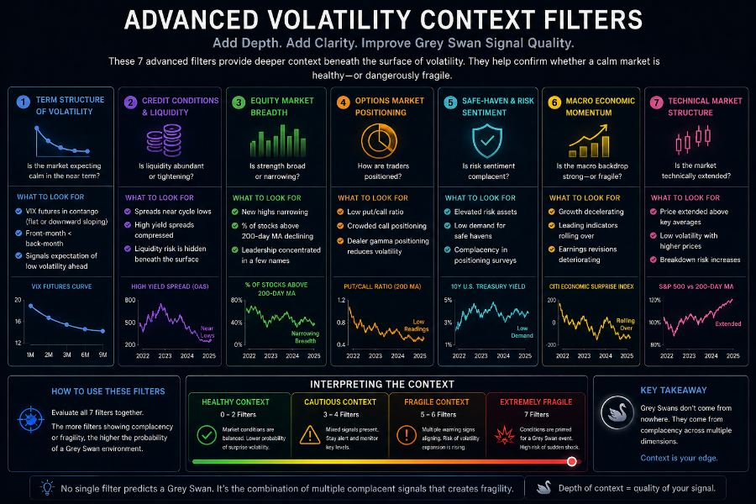

10.2 Context Filter #1 — Macro Environment

Macro uncertainty increases the probability that suppressed volatility will snap.

Examples of high-uncertainty macro cycles:
• Inflation uncertainty
• Fed policy shifts
• Election cycles
• Geopolitical tensions
• Bond market instability

When macro uncertainty is elevated AND the VIX sits in the 14–16 zone:
→ Volatility is likely mispriced
→ The system is more fragile
→ Grey Swan potential increases

- Low macro uncertainty + low VIX = normal calm
- High macro uncertainty + low VIX = dangerous calm

This distinction is critical.

10.3 Context Filter #2 — VIX Term Structure Shape

The VIX term structure represents volatility expectations across different time horizons.

Two primary shapes:
Contango (Normal State)
Front-month futures < longer-dated futures
• UVIX decays rapidly
• Volatility suppression intact
• Compression building, but not mature

Backwardation (Stress State)
Front-month futures > longer-dated futures
• volatility elevated
• system already stressed
• Grey Swans LESS likely because volatility already released

Grey Swan conditions typically form when:
• The curve is in contango
• AND the curve begins flattening

A flattening curve is a sign that something is changing beneath the surface.
10.4 Context Filter #3 — Dealer Positioning (Gamma Exposure)

Dealer positioning influences how markets move intraday.

High Dealer Gamma Exposure
Dealers hedge in ways that suppress volatility
→ Stability
→ Calm
→ Price mean reversion
→ Volatility artificially muted
→ Increased Grey Swan potential compression persists

Low or Negative Dealer Gamma - Dealers hedge in ways that AMPLIFY volatility
→ Sharp moves
→ Accelerating trends
→ Volatility already active
→ Grey Swan timing less relevant

The key: Grey Swans prefer environments of forced calm (high gamma), not chaos.

10.5 Context Filter #4 — Options Market Sentiment (Put/Call Ratio)

The put/call ratio reveals how much protection traders are demanding.

Low Put/Call Ratio
→ Traders aren’t hedging
→ Protection demands low
→ Volatility sellers dominate
→ Volatility artificially suppressed

High Put/Call Ratio
→ Traders hedging aggressively
→ Implied volatility elevated
→ Less compression
→ Less Grey Swan likelihood

The best Grey Swan environments often occur when:
• Sentiment is complacent
• Hedging is ignored
• Downside protection is cheap

10.6 Context Filter #5 — Liquidity Conditions

Liquidity determines how easily markets absorb shocks.

Signs of low liquidity:
- Thin order books
- Wide bid-ask spreads
- Larger moves from small orders
- Volatility spikes on minimal catalysts

Low liquidity + suppressed volatility = classic Grey Swan vulnerability.

This is especially important in:
• pre-holiday trading
• after-hours futures sessions
• late summer low-volume periods

10.7 Context Filter #6 — Market Breadth

Breadth measures how many stocks participate in market movements.

Strong Breadth
→ Many stocks support index movement
→ Calm is stable
→ Low volatility is natural

Weak Breadth
→ Only a few mega-caps carry the index
→ Calm is fragile
→ A small shock to one key stock can ripple

Weak breadth is a subtle but powerful Grey Swan enhancer.

10.8 Context Filter #7 — Seasonality & Timing

Certain periods naturally increase volatility sensitivity:

High Grey Swan probability:
• Early year (January effect)
• Pre-election
• Late summer
• October (historically volatile)
• Pre-FOMC clusters

Low probability:
• Post-Christmas
• Holiday weeks
• Stable earnings cycles

Seasonality is not a signal—but a contextual enhancer.

10.9 Combining Context Filters

The Grey Swan environment is strongest when:

✔ VIX is suppressed
✔ UVIX forming a base
✔ Options flows pushing vol down
✔ A catalyst approaching
✔ Term structure flattening
✔ Breadth weakening
✔ Macro uncertainty rising

Context filters do NOT replace the 5-Part Framework—
They strengthen it, making Grey Swan identification more precise.

Module Summary

By completing Module 10, students now understand:
• How macro conditions influence volatility
• How to read the VIX term structure
• How dealer positioning affects volatility suppression
• How sentiment and hedging shape fragility
• How liquidity impacts volatility snapbacks
• Why market breadth matters
• How seasonality influences volatility behavior

This module elevates the student into a more advanced volatility thinker, preparing them for Module 11—where we cover failed Grey Swan setups and why they happen.

Module 11 — When Grey Swan Setups Fail (Full Expanded Version)

MODULE 11 — When Grey Swan Setups FAIL
Understanding why some compressed volatility environments do NOT produce a Grey Swan spike—and how to recognize these failure patterns.

11.1 Why This Module Matters

Not every calm market leads to a volatility spike.

This is one of the most important lessons in volatility education:
Grey Swan conditions are environmental, not predictive.

A market can show:
• Low volatility
• Suppressed VIX
• Quiet price action
• A catalyst window

…and STILL not produce a Grey Swan.

Understanding WHY this happens prevents:
• False positives
• Emotional bias
• Overconfidence
• Misinterpretation of signals

It strengthens discipline and refines intuition—key skills for volatility analysis.

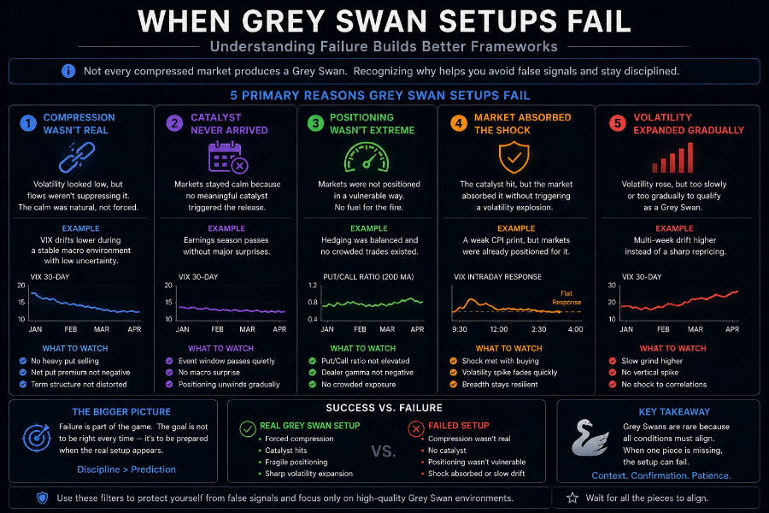

11.2 The Five Main Reasons Grey Swan Setups Fail

Based on years of volatility research and real-market observation, failed Grey Swan setups share common characteristics.

Here are the core failure conditions:

Reason #1 — UVIX Decay Does NOT Slow

This is the most powerful failure signal.

When volatility is genuinely compressed and fragile:
→ UVIX decay slows
→ UVIX forms a base
→ ranges tighten

But in failed setups:
→ UVIX continues melting downward
→ decay remains strong
→ no base forms

This indicates:
• Compression is immature
• Volatility is low for REAL reasons
• Tension hasn't accumulated

If UVIX is still bleeding aggressively, it is too early.

Reason #2 — The VIX Rejects the Compression Zone

Sometimes the VIX dips into 14–16 briefly, then snaps back upward.

This means:
• Volatility sellers didn’t fully dominate
• Hedging demand did not collapse
• Calm was normal, not forced
• Market structure is still healthy

A TRUE Grey Swan setup requires the VIX to old compression, not touch it briefly.

Reason #3 — Macro Uncertainty Disappears Suddenly

Grey Swans thrive in environments where uncertainty is present.
If uncertainty evaporates:
• The catalyst loses impact
• Volatility premium stays low
• Markets absorb information calmly

Examples:
• Fed unexpectedly reassures market
• Inflation prints align perfectly
• Geopolitical fears resolve
• Bond volatility stabilizes

When uncertainty drops rapidly, compression loses its edge.

Reason #4 — Dealer Gamma Floods Back Into the Market

Dealer gamma profoundly influences volatility suppression.

Failed setups often involve:
• A sudden increase in dealer gamma
• Strong intraday stabilization
• Volatility-absorbing hedging flows

This pushes volatility DOWN, counteracting the fragile environment.

If gamma exposure expands:
→ Dealers suppress movement
→ Volatility re-compresses
→ Grey Swan potential shrinks

Reason #5 — The Catalyst Fails to Disrupt the Environment

Grey Swan triggers are often small—but they still need to create uncertainty.

Sometimes catalysts simply:
• Meet expectations
• Offer no new information
• Calm the market instead of disturbing it

Example:
An anticipated FOMC meeting can LOWER volatility if the Fed’s message reassures markets.

If a catalyst doesn’t shake expectations, compression persists without a snapback.

11.3 Case Study — Failed Setup Explained

Imagine the following environment:

✔ VIX at ~16
✔ Low realized volatility
✔ Upcoming FOMC
✔ Options premiums cheap

BUT:
✖ UVIX continues melting
✖ Term structure remains steep
✖ Breadth strong
✖ Macro uncertainty dropping
✖ No signs of fragility

Outcome:
• FOMC announcement passes calmly
• VIX holds steady
• UVIX resumes decay
• Compression cycle continues

This is a classic early-compression environment—NOT a mature Grey Swan setup.

11.4 Immature vs. Mature Compression

A KEY diagnostic skill is distinguishing early compression from a fully coiled volatility spring.

Immature Compression (NOT Grey Swan Ready):
• UVIX decay strong
• VIX unstable above 16
• Term structure steep
• Market breadth strong
• Catalyst weeks away

Mature Compression (Grey Swan Ready):
• UVIX base-building
• VIX stable in 14–16
• Term structure flattening
• Catalyst imminent
• Volatility sellers overexposed

This separation prevents the vast majority of misreads.

11.5 How to Identify a Failed Setup in Real Time

Use this failure checklist:
✔ Is UVIX still decaying aggressively?
✔ Has the VIX failed to stabilize in compression ranges?
✔ Is sentiment improving, not weakening?
✔ Is macro uncertainty dropping?
✔ Did the catalyst reassure instead of disrupting?
✔ Has dealer gamma expanded?

If 3 or more of these are true → setup is likely invalid.

11.6 Psychological Pitfalls This Module Prevents

Mistake 1 — Expecting a volatility spike just because the VIX is low.
Mistake 2 — Assuming catalysts ALWAYS produce movement.
Mistake 3 — Overweighting a single condition instead of the entire environment.
Mistake 4 — Failing to adjust as new information enters.
Mistake 5 — Believing compression forces a spike—it doesn’t.
Mistake 6 — Holding onto an idea after the market structure changes.

Teaching students to expect variability builds emotional resilience and analytical maturity.

11.7 Why This Module Is Crucial for Long-Term Success

Students who learn to identify failed setups:
• Avoid frustration
• Develop discipline
• Trust the framework
• Gain pattern recognition
• Sharpen their analytic intuition
• Learn volatility’s natural rhythms

Grey Swans are common—but not constant.
Knowing why they fail is as valuable as knowing why they occur.

Module Summary

By completing Module 11, students now understand:
• Why Grey Swan setups sometimes fail
• How to distinguish early vs. mature compression
• The five structural failure patterns
• The role of macro clarity
• How gamma hedging influences outcomes
• Why catalysts don’t always create volatility
• The importance of UVIX decay behavior
• How to avoid emotional or biased readings

This prepares students for Module 12, where they’ll learn the five types of Grey Swan Events, giving even deeper categorization and insight into volatility snapbacks.

Module 12 — The Five Types of Grey Swan Events (Full Expanded Version)

MODULE 12 — The Five Types of Grey Swan Events
A comprehensive classification of the recurring volatility pops that arise from suppressed volatility conditions.

12.1 Why This Module Matters

Not all Grey Swan events look the same.

Some come from:
• Macro surprises
• Hedging unwind flows
• Bond market shocks
• Overnight futures move
• Geopolitical ripples

Each type behaves slightly differently, yet all share the same root cause:
volatility suppression followed by sudden volatility repricing.

This module expands the original chat content into a polished, deeply educational taxonomy of Grey Swan events.

By categorizing these events, students gain:
• Better recognition
• Faster pattern identification
• Stronger intuition
• Clearer expectations for volatility behavior

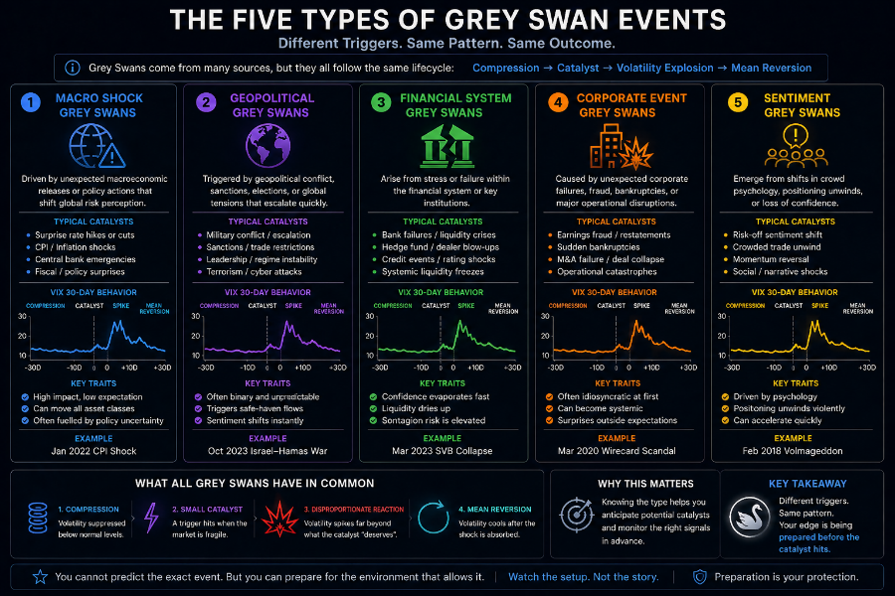

12.2 Type 1 — Macro Surprise Grey Swan
Small macro surprises triggering large volatility reactions.

Macro Grey Swan triggers include:
• CPI surprises
• PPI surprises
• Employment data deviations
• Retail sales shifts
• Consumer sentiment swings

Why they matter:
- These data points affect economic expectations.
- When volatility is suppressed, even small deviations force the market to rapidly reprice risk.

Example pattern:
• VIX in the 14–16 zone
• Calm market
• Tight ranges
• CPI comes in slightly hotter than expected
• VIX jumps 12–20%
• UVIX jumps 20–35%

Educational takeaway:
The magnitude of the catalyst does not determine the magnitude of the volatility reaction. Suppressed volatility does.

12.3 Type 2 — Hedging Unwind Grey Swan
Mechanical volatility bursts originating from derivatives flows.

These events occur when:
• Options dealers unwind hedges
• Large call positions expire
• Gamma exposure flips
• Protective flows reverse

No news is required.

This is a structural phenomenon:
- Hedging flows that previously suppressed volatility suddenly flips and INCREASES it.

Example:
• Heavy call buying leads to hedging
• Options expire
• Dealers unwind hedges
• Volatility rises mechanically
• VIX +10–15%
• UVIX +18–30%

This Grey Swan type teaches students that volatility is not just about news—it is about structure.

12.4 Type 3 — Rate Shock Grey Swan
Volatility spikes driven by sudden movements in interest rates or bond volatility.

- Bond markets often move FIRST.
- Equity volatility reacts SECOND.

Rate shock examples:
• Sudden jump in Treasury yields
• Surprising bond auction results
• Yield curve dislocations
• MOVE index spikes

Why they create Grey Swans:
- Bond volatility forces a rapid reassessment of equity risk premia, especially when equity volatility is suppressed.

Example:
• VIX compressed
• UVIX base building
• Yields rise suddenly
• Volatility reprices sharply

Rate shocks are subtle, but powerful.
They represent institutional fear of uncertainty, not panic.

12.5 Type 4 — Overnight Futures Grey Swan
Volatility pops triggered outside normal U.S. trading hours.

Overnight futures can react to:
• Foreign market volatility
• FX moves
• Asian or European selloffs
• Geopolitical updates
• Unexpected data releases abroad

Grey Swans form when:
• The U.S. market is calm and compressed
• A small overnight disturbance hits fragile condition
• The U.S. open reprices volatility immediately

Example:
• Market calm all week
• VIX ~15
• UVIX forming a coil
• Europe announces unexpected economic data
• ES futures drop
• VIX jumps at the U.S. open

Educational takeaway:
- Grey Swans are global.
- Suppression in the U.S. does not shield markets from international catalysts.

12.6 Type 5 — Geopolitical Ripple Grey Swan
Minor geopolitical developments creating outsized volatility reactions.

These include:
• Diplomatic tensions
• Military activity
• Oil supply disruptions
• Sanctions discussions
• Unexpected political announcements

These are NOT black swans.
They are not extreme crises.
There are small disturbances in the flow of global risk.

Why they matter:
- When volatility is suppressed, ANY unexpected uncertainty—no matter how minor—forces volatility upward.

Example:
- small headlines about rising tensions
- markets previously calm
- VIX spikes 8–14%
- UVIX spikes 15–25%

Educational takeaway:
- Grey Swans do not require catastrophe.
- They require fragile calm disrupted by uncertainty.

12.7 Comparing the Five Types of Grey Swans
Below is an easy comparison table for students:

- Type | Trigger Category | Speed | Typical VIX Move | Educational Insight
- Macro Surprise | Economic data | Fast | 10–20% | Small data deviations matter in calm markets
- Hedging Unwind | Dealer flows | Medium–Fast | 8–15% | Mechanical vol, not news-driven
- Rate Shock | Bond markets | Medium | 8–18% | Bond volatility leads equity volatility
- Overnight Futures | Global markets | Fast | 10–15% | Fragility is a global phenomenon
- Geopolitical Ripple | Global news | Fast | 8–20% | Minor uncertainty becomes major when vol is suppressed

Students can reference this chart throughout the course when diagnosing volatility environments.

12.8 Why Categorizing Grey Swans Matters

Categorizing Grey Swan events helps students:
• Understand market structure
• Anticipate how volatility might react
• Identify which catalysts matter most
• Develop intuition through classification
• Apply the framework to future scenarios

This module transforms abstract volatility spikes into identifiable patterns.

Module Summary

By completing Module 12, students now understand:
• The five main types of Grey Swan events
• How each type forms
• Which catalysts matter most
• How structure influences volatility reactions
• Why volatility spikes differ depending on catalyst type
• How to categorize future volatility events

This prepares students for Module 13, where they’ll study a full library of 10 expanded Grey Swan case studies for even richer pattern recognition.

Module 13 — The Grey Swan Case Study Library (Full Expanded Version)

MODULE 13 — The Grey Swan Case Study Library
A deep dive into 10 real-world style examples of Grey Swan conditions, reactions, and failures.

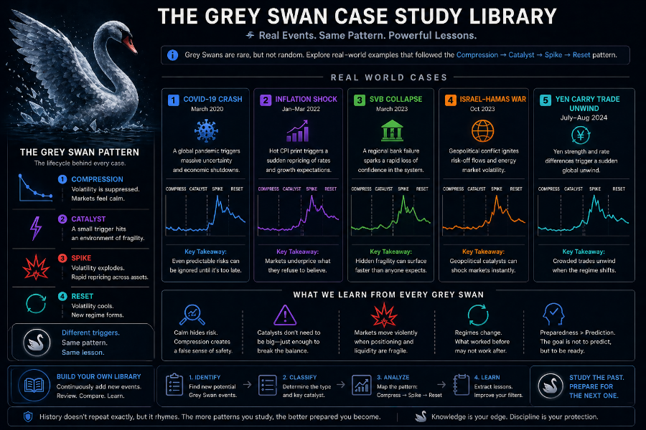

13.1 Why This Module Matters
This is one of the most advanced and valuable modules in the entire SwanStrikeFX curriculum.

You’ve learned:
• What volatility is
• Why it becomes suppressed
• How Grey Swans form
• How to identify compression
• How catalysts trigger volatility
• How UVIX behaves
• How context filters refine the analysis
• Why Grey Swan environments sometimes fail

Now it’s time to see the patterns in action.

These 10 case studies are representative of real market behaviors—not tied to specific dates but modeled on real and recurring volatility environments. They demonstrate the principles and structure of Grey Swan setups the way an analyst would study them.

Each case includes:
• Environment snapshot
• Checklist scoring
• Catalyst
• Volatility response
• UVIX behavior
• Educational takeaway

CASE STUDY 1 — The Calm Before CPI (Textbook Macro Surprise)

Environment Snapshot:
• VIX at 15
• SPX daily ranges extremely tight
• Realized vol near zero
• Dealers long gamma
• UVIX forming a base
• CPI in 48 hours

Catalyst:
• CPI slightly hotter than expected

Reaction:
• VIX +18% in 48 hours
• UVIX +25–35%

Educational Takeaway:
Small catalysts create big reactions when volatility is suppressed.

CASE STUDY 2 — Options Expiration Hedge Unwind

Environment Snapshot:
• Heavy call buying weeks prior
• Compression into VIX 15 zone
• Options expiration approaching
• UVIX flatlining

Catalyst:
• Massive unwinding of call hedges during OPEX

Reaction:
• Mechanical VIX spike
• No major headlines—pure structure

Educational Takeaway:
Grey Swans can be mechanical, not news driven.

CASE STUDY 3 — Rate Shock Driven Grey Swan

Environment Snapshot:
• VIX near 14.8
• Bond market unusually quiet
• Compression building
• UVIX decay slowing
• Term structure flattening

Catalyst:
• Treasury yields jump suddenly
• MOVE index rises

Reaction:
• VIX +15%
• UVIX +20–30%

Educational Takeaway:
Bond volatility often leads to equity volatility.

CASE STUDY 4 — Overnight Futures Shock

Environment Snapshot:
• VIX at ~15
• U.S. markets calm all week
• Dealers suppressing volatility
• UVIX forming tight coil

Catalyst:
• European economic miss overnight

Reaction:
• ES futures drop
• VIX opens sharply higher
• UVIX surges intraday

Educational Takeaway:
Grey Swans are global, not just U.S.-centric.

CASE STUDY 5 — Geopolitical Ripple

Environment Snapshot:
• VIX suppressed
• Options sellers aggressive
• No recent volatility
• Calm tape

Catalyst:
• Minor geopolitical escalation headline

Reaction:
• VIX +10–14%
• UVIX +18–25%

Educational Takeaway:
Grey Swans do NOT require crisis—only uncertainty.

CASE STUDY 6 — Failed Setup: Immature Compression

Environment Snapshot:
• VIX near 16
• Realized vol low
• Catalyst approaching

BUT:
• UVIX still decaying aggressively
• Term structure steep
• No coil
• No fragility

Catalyst:
• FOMC meeting

Reaction:
• Market absorbs calmly
• No volatility release

Educational Takeaway:
UVIX decay signals whether compression is mature.

CASE STUDY 7 — Earnings Cluster Grey Swan

Environment Snapshot:
• Several mega-cap earnings ahead
• VIX near 15
• Suppressed volatility
• UVIX forming base

Catalyst:
• One mega-cap misses earnings
• Sentiment re-prices quickly

Reaction:
• VIX +12–18%
• UVIX +20–30%

Educational Takeaway:
During earnings clusters, a single surprise can break compression.

CASE STUDY 8 — Liquidity Trap Grey Swan

Environment Snapshot:
• Pre-holiday low volume
• IMBALANCED options flows
• Volume thin
• VIX suppressed

Catalyst:
• Minor geopolitical comment during thin liquidity

Reaction:
• Volatility spikes sharply
• UVIX jumps quickly

Educational Takeaway:
Low liquidity amplifies volatility during compression.

CASE STUDY 9 — Breadth Divergence Grey Swan

Environment Snapshot:
• Index calm but breadth deteriorating
• Few stocks holding market up
• VIX compressed
• UVIX base forming

Catalyst:
• Negative news on a major index component

Reaction:
• Weak breadth amplifies downward pressure
• VIX rises 10–14%

Educational Takeaway:
Weak breadth creates hidden fragility.

CASE STUDY 10 — Bond Auction Shock

Environment Snapshot:
• VIX heavily suppressed
• Calm SPX tape
• UVIX flattening
• Catalyst: Treasury auction coming

Catalyst:
• Poor auction results
• Yields spike

Reaction:
• VIX +15%
• UVIX +25–35%

Educational Takeaway:
Bond auction volatility is underappreciated but powerful.

13.2 Macro Lessons from All 10 Cases
Across all case studies, students should now see patterns:

1. Grey Swans require conditions, not predictions.
2. UVIX provides early warning through decay changes.
3. Catalysts do not need to be dramatic—just disruptive.
4. Compression is visual and structural.
5. Calm is not safety—calm is vulnerability when it’s artificial.
6. Volatility reacts FAST once suppression breaks.
7. Failed setups teach as much as successful ones.
8. Global markets matter, not just U.S. flows.
9. Liquidity deeply influences magnitude.
10. Breadth and gamma positioning shape fragility.

Module Summary
By completing Module 13, students now have:
• A library of 10 representative Grey Swan event types
• Pattern recognition across catalysts and structures
• Real-world understanding of volatility behavior
• The ability to distinguish strong vs. weak environments
• A grounded sense of why volatility often snaps, and when

Module 14 will build on these lessons with advanced risk management principles designed for handling short-term volatility environments.

Module 14 — Advanced Risk Management for Volatility Spikes (Full Expanded Version)

MODULE 14 — Advanced Risk Management for Volatility Spikes
A complete framework for understanding, evaluating, and managing the risks associated with short-term volatility environments.

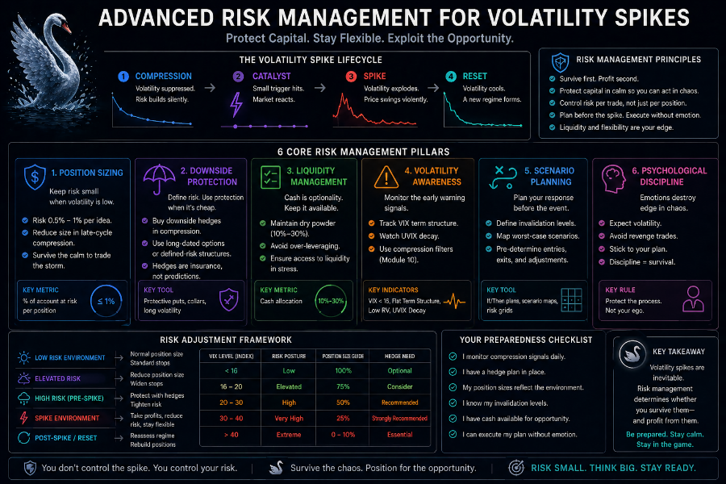

14.1 Why This Module Matters
Grey Swan environments provide powerful educational insights—but they also carry unique risks.

Understanding risk management in volatility analysis is essential because:
• Volatility moves fast
• UVIX decays quickly outside of spike windows
• Timing cannot be precisely predicted
• Suppressed markets can stay calm longer than expected
• Catalysts can be weaker or stronger than anticipated

This module translates professional volatility risk concepts into simple, practical language for everyday learners, without giving trading advice.

The goal is clarity, discipline, and understanding—not prediction.

14.2 The Three Core Risks of Volatility Environments

Risk #1 — Timing Risk
Volatility compression does NOT tell you WHEN a spike will occur—only that the environment is vulnerable.

Risk #2 — Decay Risk
Short-term volatility instruments (like UVIX) lose value steadily during calm periods.

Risk #3 — Structural Risk
New information can strengthen or weaken conditions instantly.

Understanding these three risks gives students a realistic framework for evaluating Grey Swan environments.
14.3 Timing Risk — Why Grey Swans Cannot Be Timed

Common misunderstanding:
The VIX is low—it’s about to spike.

Reality:
A compressed volatility environment does NOT guarantee immediate movement.

Timing uncertainty comes from:
• Catalysts arriving later than expected
• Catalysts failing to disrupt expectations
• Market absorbing news smoothly
• Suppression continuing longer than normal

The correct question is no: When will the spike occur?

It is: Is this environment fragile?

Timing risk teaches patience, not prediction.

14.4 Decay Risk — Why UVIX Loses Value in Calm Markets

UVIX decays due to:
• Futures contango
• Daily resetting
• Roll mechanics
• Volatility premium erosion

This means:
• Long-duration exposure is structurally unfavorable
• Calm markets accelerate decay
• Each passing day erodes value if no spike occurs

Key educational insight:
UVIX is a short-term volatility exposure product, not a long-term instrument.

Decay risk is NOT a flaw—it is part of its design.

14.5 Event Risk — Catalysts Can Surprise in Either Direction

Catalysts may:
- Trigger volatility
- Calm markets
- Be ignored
- Be misinterpreted
- Create temporary movement only

Examples:
- CPI calming instead of breaking the calm
- FOMC reassuring instead of shocking
- Geopolitical headlines dissolve quickly
- Earnings beats offsetting misses

Event outcomes are uncertain.
Students must learn to evaluate conditions, not outcomes.

14.6 Duration Risk — Volatility Spikes Are Short-Lived

Grey Swan events typically last 1 to 7 days .

After the spike:
• Volatility normalizes
• UVIX resumes decay
• Hedging flows stabilize
• Risk premium resets

Understanding duration risk prevents prolonged exposure and reinforces the importance of focusing on STRUCTURE, not timing.

14.7 Educational Position Sizing Principles (Non-Advisory)

These are general principles, not trading rules:

Principle 1 — Volatility instruments move fast
Small notional changes produce large percentage changes.

Principle 2 — Diversify timing exposure
Compression cycles repeat many times per year.

Principle 3 — Scale expectations to volatility behavior
Volatility reversion is sharp, not slow.

Principle 4 — Assume imperfect timing
Grey Swan environments develop—and break—on their own schedule.

Principle 5 — Respect decay
Time works against volatility instruments.

This teaches students how volatility behaves—not how to allocate capital.

14.8 Emotional Risk — The Most Dangerous Factor in Volatility Analysis

Volatility triggers emotional reactions:
• Fear during spikes
• Frustration during calm periods
• Impatience while waiting for catalysts
• Overconfidence when setups look perfect

Key emotional pitfalls:
• Expecting immediate results
• Forcing a narrative
• Believing a spike is due
• Ignoring failure indicators

The Grey Swan Framework exists to REDUCE emotional interpretation through structure and discipline.

14.9 Key Risk Signals to Monitor

Signals that a Grey Swan setup may be weakening or failing:
• UVIX re-accelerates decay
• VIX rises without fragility ( normalizing )
• Macro uncertainty declines
• Dealer gamma expands (vol suppression increases)
• Breadth improves
• Catalysts fail to disrupt expectations

Signals that risk is rising:
- Term structure flattening
- UVIX base-building
- Hedging demand collapsing
- Catalysts stacking (multiple events approaching)
- Market tone overly calm

These signals do NOT indicate what to do, they indicate what the environment means.

14.10 The One Spike Rule — A Key Volatility Principle
Professionals recognize that:
Volatility rarely spikes twice in the same direction within the same compression cycle.

Once a Grey Swan spike occurs:
• Suppression resets
• Hedgers reposition
• Vol premium normalizes
• UVIX resumes decay

This rule helps students avoid anchoring bias.

14.11 Why This Module Is Foundational
Risk management transforms understanding into maturity.

Students who learn these principles:
• Avoid assuming volatility behavior
• Understand why Grey Swan setups fail
• Contextualize timing and decay
• Build emotional discipline
• Respect volatility structure
• Develop long-term analytic intuition

This module ties together everything learned so far with the realism needed to interpret volatility conditions effectively.

Module Summary

By completing Module 14, students now understand:
• The three major volatility risks
• Why timing is uncertain
• How UVIX decay affects volatility windows
• How catalysts influence outcomes
• Why volatility spikes are short-lived
• Common emotional pitfalls
• How to recognize weakening or strengthening setups
• How professionals think about volatility risk

This prepares students for Module 15, which covers a unique structural advantage related to volatility instruments: the 60/40 blended tax treatment .

Module 15 — The 60/40 Tax Advantage Explained (Full Expanded Version)

MODULE 15 — The 60/40 TAX ADVANTAGE EXPLAINED
What a certain volatility-linked ETFs receive favorable blended tax treatment—even for short holding periods.

15.1 Why This Module Matters
This is one of the most surprising and least understood aspects of short-term volatility products: Some of them—specifically those classified under iRS Section 1256—receive LONG‑TERM capital gains tax treatment on 60% of gains, even if held for just a few hours or days.

This is a MAJOR educational insight for students because:
• Most people assume short-term trades = high tax rate
• Most do not know about Section 1256 contracts
• Many misunderstand the tax profile of volatility ETFs
• Tax efficiency can meaningfully improve net outcomes

This module clarifies the structure without giving financial or tax advice.

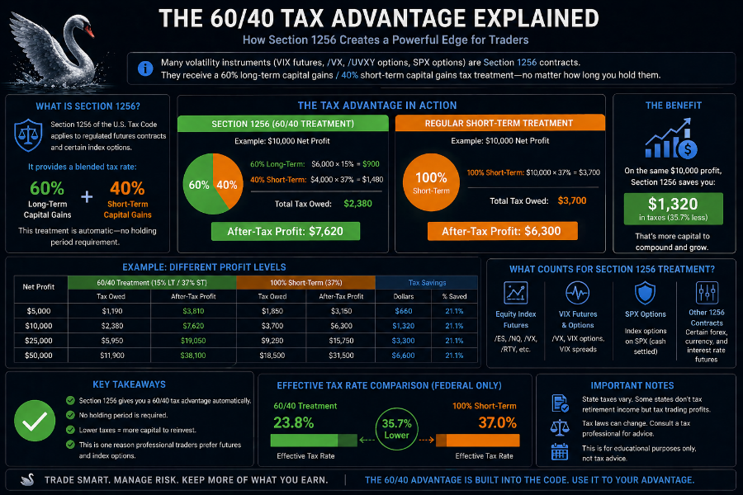
15.2 What Is Section 1256? (Plain English Explanation)

The IRS assigns certain financial instruments to a group called section 1256 contracts.

These include:
• Regulated futures
• Non-equity options
• Broad-based index options
• Volatility futures
• ETFs that derive their value primarily from volatility futures

Because many volatility ETFs are built on short-term VIX futures, they are treated as Section 1256 contracts for tax purposes.

Why this matters:
Section 1256 contracts get 60/40 blended capital gains treatment, regardless of how long they are held.

This means:
• 60% of gains taxed at Long-term capital gains rate (15%)
• 40% taxed at short-term rate (based on income)

Even if the position lasted:
• 1 day
• 3 days
• 1 hour

The holding period does NOT matter.

15.3 How Section 1256 Taxation Works (Simple Math)

Let’s assume:
• you earn $1,000 in gains
• your income puts you at a 32% marginal tax rate
• long-term capital gains rate = 15%

Under normal short-term rules:
→ 100% taxed at 32%
→ tax owed = $320

Under Section 1256 rules:
→ 60% taxed at 15% = $600 × 0.15 = $90
→ 40% taxed at 32% = $400 × 0.32 = $128

Total = $218 tax owed.

This is a s savings of $102 compared to $320.

Effective tax rate drops from 32% → 21.8%

This is a major structural advantage for short-duration volatility products.

15.4 Why This Matters for Short-Duration Volatility Events

Grey Swan environments last 1 to 7 days, and volatility products like UVIX behave sharply in those windows.

Most standard assets held for this short period would be taxed at:
• Full short-term rate
• Ordinary income levels

But Section 1256 assets benefit from:
• Long-term treatment on 60%
• No holding period requirement
• Simplified reporting

This makes Section 1256 products structurally aligned with short-term volatility analysis.

15.5 Tax Reporting Simplicity — Form 6781
Another benefit of Section 1256:
• All gains and losses are marked-to-market at year end
• The final numbers are consolidated and reported on IRS Form 6781

This avoids:
• Tracking individual trades
• Calculating specific holding periods
• Complex cost-basis calculations

This simplification is particularly helpful for active traders and educators.

15.6 Important Clarifications (Compliance-Safe)
This module is educational, not financial or tax advice.

Students should understand:
• Not all volatility ETFs are Section 1256 contracts
• Some ETNs have different tax rules
• Tax laws can change
• Individual situations vary

This course explains the structure, not individual suitability.

15.7 How Section 1256 Supports the Grey Swan Framework

Section 1256 taxation aligns naturally with the Grey Swan educational model:

Grey Swans are:
• Short-duration
• Volatility-driven
• Structural
• Pattern-based

UVIX and similar instruments are:
• Short-term
• Leverage-based
• Futures-derived
• Section 1256 eligible

This synergy enhances understanding of:
• Volatility structure
• Tax mechanics
• The logic behind using certain volatility-linked products for education

Module Summary

By completing Module 15, students now understand:
• What Section 1256 is
• Why certain volatility ETFs qualify
• How the 60/40 capital gains split works
• How the blended tax rate often reduces effective taxes
• Why this is beneficial for short-duration exposures
• How Grey Swan windows pair naturally with this treatment
• The limits and cautions associated with this concept

Module 16 will now shift from tax structure to applied practice, showing students how to build a weekly volatility watchlist.

Module 16 — Building Your Weekly Grey Swan Watchlist (Full Expanded Version)

MODULE 16 — Building Your Weekly Grey Swan Watchlist
A practical, repeatable routine for identifying volatility compression and anticipating Grey Swan environments.

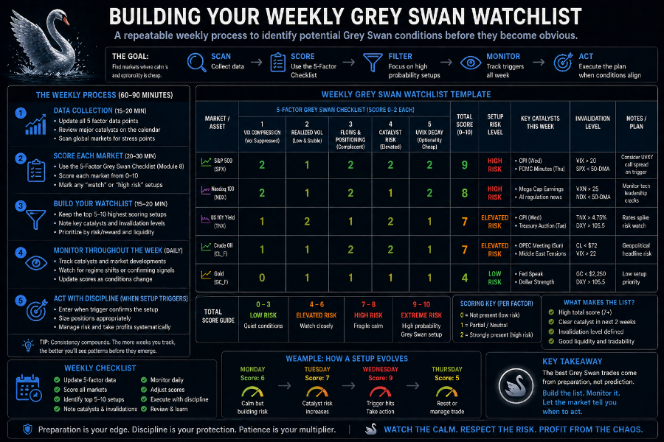

16.1 Why This Module Matters
Students now understand how volatility behaves, how compression forms, what conditions lead to Grey Swan events, and how UVIX reacts when volatility snaps.

Module 16 turns all that knowledge into a practical weekly routine.

This is the tool that:
• Builds intuition
• Reduces emotional bias
• Helps students recognize patterns in real time
• Reinforces the Grey Swan Qualification Checklist
• Builds muscle memory

This module explains how to monitor volatility conditions with just 10 minutes per day and a deeper weekly review.

16.2 Purpose of a Grey Swan Watchlist

A Grey Swan watchlist allows students to:
• Track compression
• Track fragility
• Monitor catalysts
• Assess market tone
• Build long-term pattern recognition

This is not about predicting volatility, it’s about recognizing the environment where volatility is likely to react strongly.

16.3 The Four Elements of a Weekly Grey Swan Watchlist
A proper watchlist tracks the following essential components:

Element 1 — VIX Level & Behavior

Questions to ask:
• Is VIX trending into the 14–16 compression zone?
• Are daily candles shrinking?
• Is the VIX ignoring market weakness?
• Is implied volatility drifting lower without cause?

These signals reflect the calm phase of the volatility spring.

Element 2 — UVIX Behavior & Decay Pattern

UVIX is a tension indicator.

Signs of compression maturity:
• UVIX decay slowing
• UVIX ranges tightening
• UVIX failing to make new lows
• UVIX base-building

When UVIX forms a clear horizontal consolidation, the spring is nearly fully compressed.

Element 3 — Catalyst Calendar

A Grey Swan requires uncertainty, not catastrophe.

Catalysts to watch:
• CPI
• PPI
• NFP
• FOMC meetings
• Treasury auctions
• Fed speeches
• Earnings clusters
• Geopolitical events

When the environment is suppressed AND a catalyst approaches, the system becomes sensitive.

Element 4 — Market Structure & Liquidity Conditions

Important questions:
• Is dealer gamma high (volatility suppression)?
• Is market breadth weak?
• Are bid-ask spreads widening?
• Is market depth thinning?
• Is options sentiment complacent?

These conditions determine how explosive a Grey Swan reaction may be.

16.4 The 10-Minute Daily Checklist
A simple daily process builds a strong analytical foundation.

STEP 1 — Check the VIX
Look for:
• Level
• Daily range
• Responsiveness to market moves

STEP 2 — Check UVIX
Look for:
• Decay behavior
• Base formation
• Tightening price action

STEP 3 — Review Catalyst Calendar
What is approaching in the next 1–10 days?

STEP 4 — Observe Market Tone
Is the calm healthy or fragile?

STEP 5 — Assign a Fragility Score
Rate the environment from 1 to 5.

Daily repetition builds intuition quickly.

16.5 The Weekly Review Process
Once per week, students should review:

• VIX trend
• UVIX multi-day behavior
• Macroeconomic backdrop
• Upcoming catalysts
• Shift in sentiment
• Term structure shape

Questions to ask:
• Is compression strengthening or weakening?
• Is UVIX signaling tension or decay?
• Is the VIX stable or unstable in its low range?
• Did any catalysts increase uncertainty?

This weekly rhythm helps students see volatility conditions developing.

16.6 The Grey Swan Probability Rating System

Students can use a simple rating model:

Score 1 — Stable Calm
- Nothing unusual. VIX low, but healthy.

Score 2 — Early Compression
- Some signs are forming, but environment still stable.

Score 3 — Mature Compression
- Volatility suppressed, system fragile.

Score 4 — Grey Swan Watch
- Multiple conditions aligning.

Score 5 — High Grey Swan Window
- Compression mature, catalyst close, UVIX signaling tension.

This transforms subjective interpretation into measurable structure.

16.7 What to Record in a Watchlist

Columns recommended:
• Date
• VIX level
• VIX range behavior
• UVIX decay pattern
• Catalysts approaching
• Market breadth
• Liquidity notes
• Sentiment
• Dealer gamma tone
• Overall fragility score

This builds a historical record of volatility environments.

16.8 How a Watchlist Builds Analyst-Level Intuition

By tracking these conditions, students begin to naturally recognize:
• When calm is dangerous
• When volatility is mispriced
• When catalysts matter
• When fragility is rising
• When Grey Swans are likely to form

This process develops professional-grade intuition far faster than reading theory alone.

Module Summary

By completing Module 16, students now understand:
• How to create a weekly Grey Swan watchlist
• How to read volatility conditions in just 10 minutes per day
• How to score fragility levels
• How to track UVIX and VIX structure
• How catalysts shape volatility windows
• How to build pattern recognition through repetition

Module 17 will synthesize everything learned into a final integrated perspective for interpreting volatility as a system.

Module 17 — Putting It All Together (Full Expanded Version)

MODULE 17 — Putting It All Together
A complete synthesis of the Grey Swan Volatility Framework, combining all concepts into a unified, intuitive, and professional analytical model.

17.1 Why This Module Matters
By reaching Module 17, students have learned:

• What volatility is and how it behaves
• The difference between realized and implied volatility
• How the VIX becomes suppressed
• The mechanics and fragility of volatility compression
• How to identify Grey Swan environmental conditions
• Why UVIX behaves like a coiled spring
• Why some Grey Swan setups fail
• The 5 categories of Grey Swan spikes
• How real-world case studies demonstrate the framework
• How to build a disciplined weekly watchlist
• How tax structure aligns with volatility products

Now it is time to unify everything into a single, coherent mental model that students can carry forward.

This module transforms isolated concepts into a complete volatility-thinking system.

17.2 The Big Idea of the Grey Swan Strategy
At its core, the Grey Swan Framework is built on one foundational truth:

When volatility becomes too calm for too long, the market becomes fragile. In these environments, even a small catalyst can create a disproportionately large volatility response.

- This is not prediction.
- This is structure.

Volatility is a system that stores energy during suppressed periods.
Grey Swan events occur when that stored tension is released.

This synthesis reframes volatility as something:
• Predictable in pattern
• Logical in behavior
• Teachable to everyday investors
• Based on market structure, not randomness

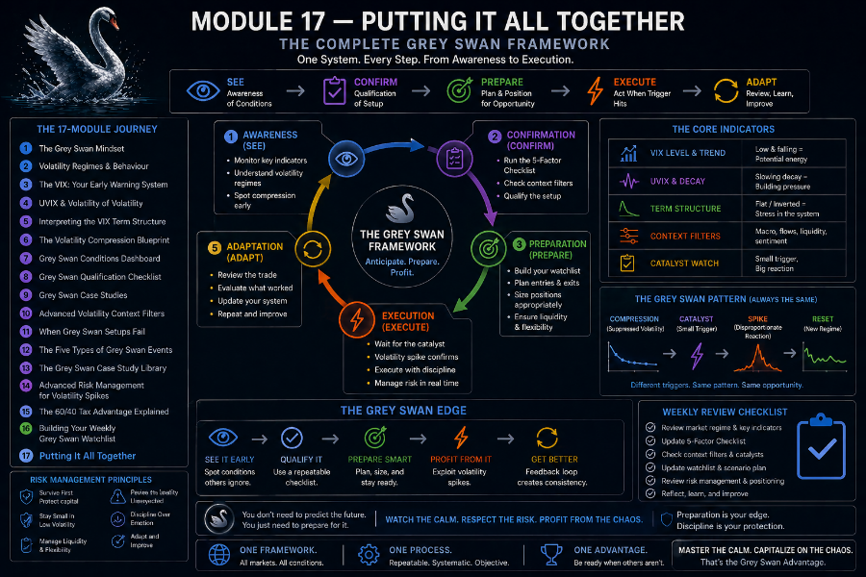

17.3 The Full Grey Swan Process (Step-by-Step)

Below is the complete Grey Swan sequence—expanded, polished, and professionally unified:

STEP 1 — Volatility drifts lower
- Calm appears. Market ranges are tightening. RV and IV fall.

STEP 2 — VIX enters the 14–16 zone
- Implied volatility becomes artificially quiet.

STEP 3 — Volatility becomes suppressed
- Dealer gamma stabilizes markets. Options for selling increases.

STEP 4 — UVIX decay slows
- UVIX begins forming a base, signaling tension.

STEP 5 — Macro catalyst approaches
- CPI, FOMC, earnings, geopolitical noise, auctions.

STEP 6 — Fragility peaks
- Sentiment complacent; hedging minimal; structure tight.

STEP 7 — Catalyst hits
- Even a small catalyst can trigger the release.

STEP 8 — Volatility snaps back
- VIX jumps 10–20%. UVIX surges 20–35%.

STEP 9 — Compression unwinds
- System resets; UVIX resumes decay.

This cycle repeats multiple times per year.

17.4 Thinking in Probabilities, Not Predictions
This module reinforces the analytical mindset:

- Grey Swans are not predicted.
- They are recognized.

Students must shift from:
• Will volatility spike tomorrow?
to
• Does the environment support a volatility spike?

This builds:
• Clarity
• Discipline
• Long-term skill
• Reduced emotional bias

Professional volatility analysts think in conditions, not forecasts.

17.5 Recognizing Calm vs. Dangerous Calm
A central skill is learning to distinguish:

Healthy Calm
• Strong market breadth
• Normal liquidity
• Natural low volatility

Dangerous Calm
• Volatility suppressed
• Options flows distorting price
• UVIX flattening
• Macro uncertainty rising
• Catalyst window approaching

Dangerous calm is what creates the Grey Swan environment.

17.6 UVIX as a Tension Meter

Students should now understand that UVIX:
• Decays rapidly during normal calm
• Loses decay momentum during compression
• Forms a base when tension is mature
• Becomes highly reactive when volatility snaps

UVIX is not a trading tool—it is a diagnostic instrument for measuring tension in the volatility system.

17.7 Using Context Filters for Deeper Insight
Module 10’s advanced context filters are what elevate students from amateur observers to serious analysts.

Context filters refine Grey Swan identification by examining:
• Macroeconomic uncertainty
• VIX term structure shape
• Dealer gamma exposure
• Options market sentiment
• Liquidity conditions
• Market breadth
• Seasonality

These inputs reveal how explosive a Grey Swan spike might be if triggered.

17.8 The Analyst Mindset: A Summary

A strong volatility analyst:

• Evaluates structure, not noise
• Looks underneath price action
• Understands hedging flows
• Recognizes liquidity conditions
• Interprets UVIX behavior
• Acknowledges uncertainty
• Avoids predictions
• Thinks in probabilities
• Respects decay and timing risk

This mindset is the key to long-term success in volatility analysis.

17.9 How All Modules Fit Together
Here is the synthesis of all 17 modules:

1. Volatility basics → understand movement
2. VIX explained → understand expectations
3. Swan taxonomy → understand event classification
4. Suppression → understand fragility
5. Compression setup → understand coiled tension
6. UVIX mechanics → understand amplification
7. Grey Swan conditions → identify environment
8. Checklist → structure decision-making
9. Case studies → learn through pattern repetition
10. Context filters → refine probability
11. Failed setups → prevent misreads
12. Grey Swan types → categorize catalysts
13. Case study library → hands-on intuition
14. Risk management → stay grounded
15. 60/40 tax advantage → structural context
16. Watchlist routine → weekly practice
17. Synthesis → unified view of volatility

The result is a complete, intuitive volatility education system.

17.10 Final Thoughts for Students
Grey Swan events are not accidents.
They are natural outcomes of a suppressed volatility system.

Students who complete this course will:
• Understand volatility deeply
• Think structurally, not emotionally
• Interpret market calm intelligently
• Identify fragile environments
• Recognize compression early
• Understand how and why volatility snaps
• Build a structured, repeatable analytical process

This course empowers investors every day with a framework usually reserved for professionals.

Module Summary

By completing Module 17, students now have:
• A unified understanding of the entire Grey Swan system
• The ability to interpret volatility as a multi-layered structure
• A clear view of how modules 1–16 work together
• The confidence to analyze markets using real expertise
• A complete process for recognizing Grey Swan environments

Module 18 will expand the student’s perspective by mapping the volatility product landscape, including short-term, mid-term, leveraged, inverse, and related ETFs used for educational purposes.

Module 18 — Volatility ETFs, ETNs, and Related Instruments (Full Expanded Version)

MODULE 18 — Volatility ETFs, ETNs, and Related Instruments
A complete educational map of the volatility product landscape, including short-term, mid-term, inverse, leveraged, and futures-linked structures.

18.1 Why This Module Matters
Understanding the Grey Swan Framework requires knowing not only how volatility behaves, but also what instruments exist to express volatility in the market.

This module explains:
• What volatility-linked ETFs/ETNs are
• How they differ
• What they track
• How they behave during Grey Swan events
• Why some decay faster than others
• Why inverse products react violently when volatility spikes

This is NOT trading advice — this is structural education.
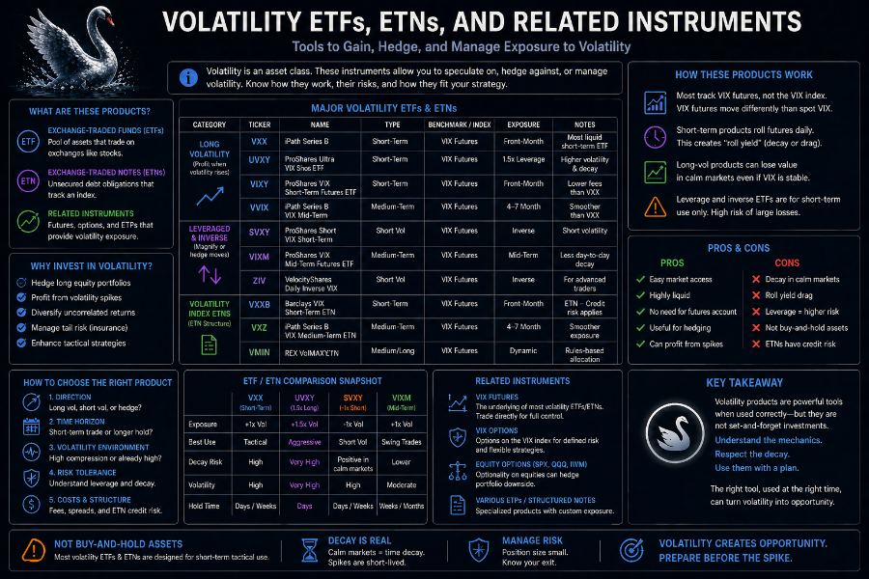
18.2 Short-Term VIX Futures-Based ETFs (Most Reactive to Grey Swans)
These products track front-end VIX futures (usually 1–2 months out).
Because front-end volatility expectations move the fastest, these ETFs react sharply.

UVIX — 2x Leveraged Short-Term Volatility ETF
• Tracks 2x the DAILY movement of short-term VIX futures
• Most reactive volatility product commonly available
• Significant decay during calm markets
• Ideal for illustrating volatility compression and snapback

Why UVIX Matters to Grey Swans:
• It behaves like a coiled spring during compression
• It reacts disproportionately during volatility pops
• UVIX base formation is a major Grey Swan signal

UVXY — 1.5x Leveraged Short-Term Volatility ETF

• Like UVIX but with slightly lower leverage
• High decay, high sensitivity
• Still responds explosively to volatility spikes

VXX — Unleveraged Short-Term Volatility ETN
• Tracks the S&P 500 VIX Short-Term Futures Index
• Moves smoother than UVIX/UVXY
• Still decays due to futures roll costs
• Good for illustrating baseline volatility futures behavior

Educational Insight:
VXX helps students visualize volatility futures without leverage distortion.

18.3 Mid-Term Volatility ETFs (Smoother, Slower)

These products track VIX futures 4–7 months out.

Examples:
• VXZ
• VIXM

Characteristics:
• Less decay than short-term products
• Lower spike magnitude
• Better for understanding long-term volatility trends

Grey Swans affect these products, but not dramatically.

18.4 Inverse Volatility Products (Move Opposite VIX Futures)

Examples:
• SVIX
• SVXY

Characteristics:
• Rise when volatility falls
• Fall sharply when volatility rises
• Completely opposite exposure to UVIX

Educational Note:
Inverse volatility products are vulnerable during Grey Swan spikes
and help illustrate how forced calm creates asymmetrical risk.

18.5 Historical ETNs — Why They Matter

These products are no longer active but serve as excellent teaching examples.

XIV — Inverse Volatility ETN (Terminated in 2018)
• Rose consistently during prolonged calm
• Collapsed during a violent volatility spike
• Teaches structural fragility of inverse vol products

TVIX — LeveRaged Volatility ETN (Delisted)
• Extremely reactive
• High leverage + futures structure
• Teaches risks of ETNs vs ETFs

Educational Purpose:
These historical products give context to volatility risk and allow students to understand market structure failures.

18.6 ETF vs. ETN — What’s the Difference?

ETF:
• Holds futures or swaps
• No credit risk
• Regulated fund structure

ETN:
• A debt notes from a bank
• Exposed to issuer credit risk
• Returns depend on the issuer honoring payouts

This distinction is critical when studying volatility products.

18.7 Volatility Options (Educational-Only Introduction)
VIX options and volatility options allow exposure to:
• Volatility-of-volatility
• Skew
• Term structure dynamics

This module introduces these concepts without requiring advanced mathematics.

18.8 How Volatility Products React During Grey Swan Events
A simplified comparison:

Product Type | Reaction Strength | Notes

- UVIX (2x) | Very strong | Tracks front-end futures with leverage
- UVXY (1.5x) | Strong | Slightly less explosive
- VXX | Moderate | Cleanest non-leveraged view
- VXZ / VIXM | Mild | Long-term volatility structure
- SVIX / SVXY | Opposite direction | Inverse products drop sharply
- VIX Options | Variable | Useful for advanced interpretation

Grey Swan Insight:
Front-end volatility reacts FIRST and FASTEST — which is why UVIX behavior is so instructive.

18.9 Tax Treatment (Educational Reminder)
Volatility ETFs that rely on VIX futures (UVIX, UVXY, VXX) often fall under section 1256, receiving:
• 60% long-term capital gains rate
• 40% short-term capital gains rate
• Regardless of holding period

ETNs may have different tax treatment. This reinforces Module 15.

18.10 The Volatility Product Ecosystem (Complete Map)
Students should now visualize the volatility landscape as layered:

Layer 1 — Spot VIX
Layer 2 — VIX Futures
Layer 3 — Leveraged ETFs (UVIX, UVXY)
Layer 4 — Non-Leveraged ETFs (VXX)
Layer 5 — Mid-Term Products (VXZ, VIXM)
Layer 6 — Inverse Volatility Products (SVXY, SVIX)
Layer 7 — Volatility Options (advanced tools)
Layer 8 — Historical ETNs (XIV, TVIX)

This layered view helps students see how volatility flows through the system.

Module Summary
By completing Module 18, students now understand:
• The entire volatility ETF/ETN ecosystem
• The role of leveraged vs. non-leveraged products
• Inverse volatility dynamics
• How each instrument reacts to Grey Swans
• Structural risks and decay mechanics
• ETF vs ETN differences
• Tax implications of futures-derived ETFs

This module completes the SwanStrikeFX volatility education sequence.

Module 19 — Grey Swan Master Integration & Volatility Product Capstone (Deep Expanded Version)

MODULE 19 — Grey Swan Master Integration & Volatility Product Capstone
A deep, comprehensive capstone unifying every concept, tool, and volatility instrument into one advanced analytical system.

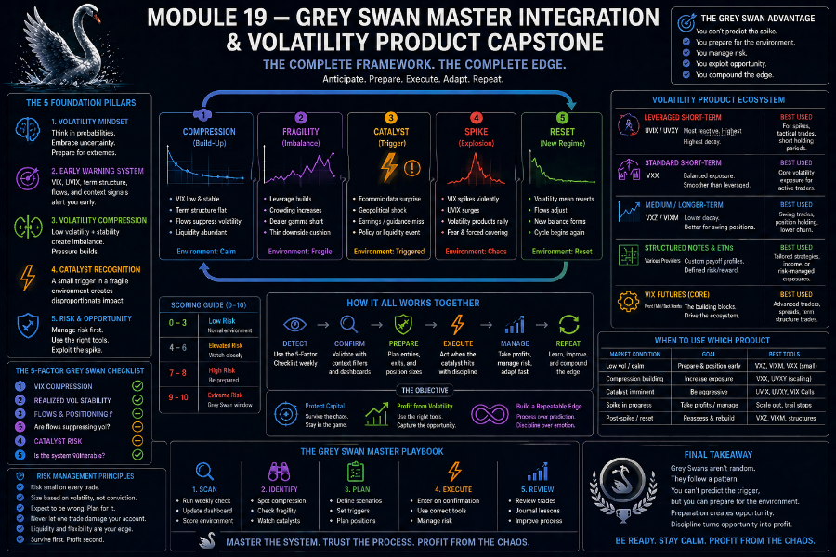

19.1 The Purpose of This Capstone Module
By this point in the SwanStrikeFX curriculum, students have:

• Learned what volatility is and how it behaves (Modules 1–2)
• Understood white, grey, and black swan distinctions (Module 3)
• Seen how volatility becomes suppressed and compressed (Modules 4–5)
• Studied UVIX mechanics and decay (Module 6)
• Learned to identify Grey Swan environments (Modules 7–8)
• Walked through real-world style case studies (Modules 9 and 13)
• Refined their understanding using context filters (Module 10)
• Understood failed setups (Module 11)
• Classified Grey Swan types (Module 12)
• Absorbed a rigorous risk framework (Module 14)
• Learned about 60/40 tax structure (Module 15)
• Built a weekly watchlist routine (Module 16)
• Integrated core concepts into a unified mental model (Module 17)
• Explored the volatility ETF/ETN ecosystem (Module 18)

Module 19 is different.

- It is not just another chapter.
- It is the bridge between education and practice —between understanding volatility in theory and seeing how the entire ecosystem behaves in real time.

This capstone does four things in depth:

1. Unifies all prior modules into a single, layered framework.
2. Expands the Master Checklist into a full multi-dimensional diagnostic system.
3. Deep dives into the Volatility instrument ecosystem and how each behaves across different regimes.
4. Provides a fully structured Analyst Playbook—a step-by-step process students can follow to evaluate markets like a volatility professional.

This is where the Grey Swan Framework becomes a complete, enduring system.

19.2 The Volatility System as an Ecosystem
The core mental model of this course is simple but powerful:
> Volatility is not random.
> Volatility is the visible surface behavior of a deeper system.

That system includes:
• Pricing of risk (risk premium)
• Behavior of large institutions and funds
• Dealer hedging flows
• Options markets and derivatives structure
• Liquidity conditions and market depth
• Macroeconomic uncertainty
• Global cross-asset interactions (bonds, FX, commodities)

Volatility is how that system expresses tension, relief, uncertainty, and complacency*.

- Grey Swan events are not weird spikes.
- They are the system’s natural release mechanic after periods of suppression and compression.

To see this clearly, we move from:

• The VIX is low to
- The volatility system is currently in a suppression regime.

• UVIX spiked to
- The tension stored in short-term futures was released through a compression break.

Module 19 trains students to see volatility as a living ecosystem rather than a series of isolated events.

19.3 The Three-Layer Grey Swan Framework
The full Grey Swan system can be viewed as three layers:

• LAYER 1 — Surface Layer: What you see (price, VIX, UVIX)
• LAYER 2 — Structural Layer: What shapes those moves (flows, hedging, derivatives)
• LAYER 3 — Contextual Layer: What environment is all of this happening inside (macro, liquidity, sentiment, cross-asset signals)

We can frame it as:

LAYER 1 — Observable Indicators
• VIX level and path
• Realized volatility
• UVIX behavior (decay, base, spike)
• Price ranges and direction

LAYER 2 — Structural Drivers
• Dealer gamma positioning
• Options supply/demand
• Volatility selling strategies
• Term structure shape
• Hedge unwinds

LAYER 3 — Context & Regime
• Macro uncertainty cycles
• Bond volatility and yields
• Liquidity and breadth
• Seasonality and regime type

The Grey Swan Framework sits right at the intersection of these three layers.

Students must train themselves to:
• Look at the surface,
• Interpret structural forces behind it,
• And overlay context to understand fragility.

19.4 The Deep Grey Swan Master Checklist (Fully Expanded)
Here, we expand the Master Checklist into a detailed multi-dimensional diagnostic.

It is divided into six domains:
A. VIX Structure
B. Realized Volatility
C. Derivatives & Dealer Flows
D. Catalyst & Macro Context
E. UVIX & Volatility Instruments
F. Market Structure, Liquidity, and Sentiment

Each domain has multiple criteria.
Students can score each as:
• 0 = Not Present
• 1 = Mild / Emerging
• 2 = Strongly Present

A. VIX STRUCTURE (Max 8 points)
1. VIX is between 14–16 and has held there for several days (0–2)
2. VIX daily ranges have been shrinking (0–2)
3. VIX is failing to react to negative equity days (0–2)
4. Front-end term structure flattening toward spot (0–2)

B. REALIZED VOLATILITY (Max 8 points)
5. SPX daily ranges are unusually small (e.g., sub 0.4% for several sessions) (0–2)
6. Intraday realized volatility is minimal, even on macro news (0–2)
7. Range compression visible on multiple timeframes (0–2)
8. Recent volatility cluster has died out; calm has persisted (0–2)

C. DERIVATIVES & DEALER FLOWS (Max 10 points)
9. Dealer gamma exposure elevated; hedging behavior suppressing moves (0–2)
10. Options premiums compressed relative to recent realized volatility (0–2)
11. Put/call ratios trending lower (declining demand for hedges) (0–2)
12. Evidence of persistent volatility selling strategies (0–2)
13. VIX not responding to single-name or sector volatility (0–2)

D. CATALYST & MACRO CONTEXT (Max 10 points)
14. Known macro event within 1–10 days (CPI, FOMC, NFP, earnings clusters, auctions) (0–2)
15. Macro narrative complex or uncertain (inflation, policy, growth) (0–2)
16. Market narrative overly confident despite known uncertainty (0–2)
17. Multiple catalysts stacking in the same 1–2 week window (0–2)
18. Bond volatility or yields hinting at stress not yet in equities (0–2)

E. UVIX & VOLATILITY INSTRUMENT BEHAVIOR (Max 10 points)
19. UVIX decay has clearly slowed vs recent history (0–2)
20. UVIX has stopped making new lows and is forming a base (0–2)
21. UVIX daily ranges are tightening (coil-like structure) (0–2)
22. VXX stabilizing after a period of decay (0–2)
23. Inverse volatility products (SVXY/SVIX) have gone nearly vertical but now stall (0–2)

F. MARKET STRUCTURE, LIQUIDITY, AND SENTIMENT (Max 10 points)
24. Breadth weak while index looks calm (few leaders holding it up) (0–2)
25. Market depth thin relative to history (liquidity pockets) (0–2)
26. Bid/ask spreads marginally wider even in calm tape (0–2)
27. Sentiment overly bullish or complacent (positioning, commentary tone) (0–2)
28. Volatility-of-volatility (VVIX) firming even as VIX stays low (0–2)

MAXIMUM SCORE = 46

INTERPRETATION:
0–12 → Normal calm (healthy)
13–22 → Early compression (volatility low, but not fragile yet)
23–32 → Mature compression (fragile calm, Grey Swan conditions forming)
33–46 → High Grey Swan vulnerability (coiled system, highly sensitive)

This is the deep-dive, analyst-level version of the Grey Swan Checklist.

Students do not need to use every line daily—but seeing all dimensions at once changes how they think about volatility.

19.5 Deep Dive: Volatility Regimes and Product Behavior
In this section, we take a slow, detailed walk-through Volatility regime and show how:
• VIX
• UVIX
• VXX
• Mid-term products (VXZ/VIXM)
• Inverse products (SVXY/SVIX)

Typically behave, We’ll move through the five regimes:

1. Normal Calm
2. Early Compression
3. Mature Compression
4. Grey Swan Release
5. Post-Spike Normalization

We’ll add not just behavior—but why that behavior occurs.

Regime 1 — Normal Calm

Characteristics:
• VIX low-to-moderate but responsive
• Realized volatility low but justified
• Macro uncertainty moderate or low
• No major catalysts immediately ahead
• Dealers and flows in balance

Product Behavior:
• UVIX: Steady, fast decay; lower highs and lower lows.
• UVXY: Similar pattern to UVIX; slow grind lower.
• VXX: Gradual decline, smoother.
• VXZ/VIXM: Slight downward drift or flat.
• SVXY/SVIX: Slow grind upward, low realized risk.

Interpretation:
The calm is warned by the environment.
There is no clear disconnect between volatility pricing and reality.

Regime 2 — Early Compression

Characteristics:
• VIX drifting toward 15
• Realized volatility shrinking further
• Derivatives beginning to suppress movement, but not fully dominant
• UVIX still decaying, but rate of decay starts to slow at the margin

Product Behavior:
• UVIX: Still decays, but lower acceleration begins to slow.
• UVXY: Same—still melting but losing some momentum.
• VXX: May show flattening days.
• VXZ/VIXM: Mostly unchanged.
• SVXY/SVIX: Strong upward trend, reflecting ongoing suppression.

Why It Matters:
This is not yet a Grey Swan environment, but it is the setup phase.
The system is starting to lean heavily toward calm, but fragility has not peaked.

Regime 3 — Mature Compression (Coiled Spring)

Characteristics:
• VIX tightly anchored between 14–16 for multiple sessions.
• Realized volatility extremely low; intraday swings vanish.
• Derivatives flow heavily suppressing movement, dealer gamma high.
• Options demand for protection is minimal; put/call ratios low.
• Catalysts visible on the horizon (1–10 days away).
• Macro narrative feels too calm given reality.
• UVIX stops making new lows and begins forming a base.

Product Behavior:
• UVIX: Flattens; begins to trade sideways with tight-range candles.
• UVXY: Similar flattening, less dramatic, but obvious to the trained eye.
• VXX: Stops bleeding and may even show tiny upward flickers.
• VXZ/VIXM: Almost flat; mid-term vol is not yet repriced.
• SVXY/SVIX: They appear strong but start showing hesitation and micro-spikes.

Why It Matters:
This is the true Grey Swan incubation regime.
The system now fragile—small disruptions can trigger outsized volatility responses.

Regime 4 — Grey Swan Release

Characteristics:
• Catalyst arrives: CPI, FOMC, a bond move, overseas shock, geopolitical comment, etc.
• VIX responds quickly; futures reprice front-end volatility.
• UVIX snaps higher as futures revalue expectations.
• Short vol and inverse strategies suddenly face reflexive risk.

Product Behavior:
• UVIX: Jumps rapidly; +20–35% in typical Grey Swan scenarios.
• UVXY: Substantial spike; +15–25%.
• VXX: Noticeable jump, but less leveraged.
• VXZ/VIXM: Modest rise; mid-term expectations adjusting.
• SVXY/SVIX: Hard downside shock, sometimes over several sessions.

Structural Explanation:
• Dealer hedges flip direction.
• Volatility sellers cover or reduce exposure.
• Hedging demand returns quickly.
• Implied volatility adjusts to match reality.

This is the moment where the coiled spring metaphor becomes real.

Regime 5 — Post-Spike Normalization

Characteristics:
• VIX remains elevated for a short period, then gradually trends back down.
• Realized volatility remains higher for a bit but begins to cool.
• UVIX gives back gains and resumes decay.
• Inverse vol strategies gradually rebuild.
• The next suppression cycle begins.

Product Behavior:
• UVIX: After the initial surge, it decays steadily again.
• UVXY: Same pattern—pop, then fade.
• VXX: Slowly returns to drift mode.
• VXZ/VIXM: Normalize back into term structure.
• SVXY/SVIX: Recover over time as suppression returns.

Key Lesson:
Grey Swans are short-lived expressions of tension release.
They are not new permanent regimes—they are events within the broader regime structure.

19.6 Building a Full Analyst Playbook Around Grey Swans
Now we convert all of this into a playbook—not for trading decisions, but for thinking decisions.

The Analyst Playbook includes:
• A Pre-Check Phase— Should I even care about volatility today?
• A Structural Scan— What state is the system in?
• A Fragility Assessment— How coiled is this spring?
• A Catalyst Overlay— What might disturb this calm?
• A Product Lens— How are volatility instruments reflecting (or ignoring) this tension?
• A Reset Review— What did I learn from the last cycle?

We walk through each.

Phase 1: Pre-Check Phase: Daily quick questions:
1. Is the VIX doing anything interesting?
2. Is the market moving more or less than feels normal ?
3. Is there any scheduled macro event this week?

If all answers suggest normal calm, you can note no special conditions and move on.

If the VIX is abnormally low, moves oddly, or the environment feels strangely calm relative to incoming events, that’s a flag to proceed deeper.

Phase 2: Structural Scan: Here the analyst:
• Checks VIX level and structure,
• Scans UVIX behavior,
• Reviews realized vs implied volatility,
• Notes gamma exposure and volatility selling presence.

Goal:
Determine whether the system is in:

• Normal calm
• Early compression
• Mature compression

This sets the analytical regime.

Phase 3: Fragility Assessment: Now use the Deep Master Checklist

Score:
• A: VIX conditions
• B: Realized vol
• C: Derivatives flows
• D: Catalysts and macro
• E: UVIX and instruments
• F: Market structure and sentiment

Total up the score and place the environment into:
• Normal Calm
• Early Compression
• Mature Compression
• High Vulnerability

This is the heart of the Grey Swan Framework.

Phase 4: Catalyst Overlay:
Once fragility is known, overlay known and potential catalysts:
• Are major reports due?
• Are central bank decisions coming?
• Are bond auctions scheduled?
• Is there visible geopolitical tension?
• Are large earnings clustered?

Key insight:
Catalysts matter far more when the system is fragile.

Phase 5: Product Lens
At this stage, the analyst asks:
• How are UVIX, UVXY, VXX, VXZ, SVXY, and SVIX behaving across this regime?
• Are leveraged long-vol products signaling tension?
• Are inverse products signaling complacency?

The student learns to read the product landscape not as trade ideas—but as magnifying glasses on the volatility system.

Phase 6: Reset & Review
After a Grey Swan spike—or after a failed setup—review:
• What signals were present?
• Which were missing?
• Did the catalyst behave differently than expected?
• Did UVIX behavior align with what the framework would suggest?
• Did the environment resolve with a spike or a soft normalization?

This creates a feedback loop, sharpening intuition over time.

19.7 Common Misinterpretations of Volatility This Framework Corrects
At this stage, students should be aware of several common misconceptions:

Misconception 1 — The VIX is low, so a crash is coming.
Reality: The VIX can be low in healthy calm conditions. Only suppressed, fragile calm is dangerous.

Misconception 2 — UVIX spiked, so something crazy must have happened.
Reality: Often, a modest catalyst interacting with a coiled system is enough. The event may not even make headlines.

Misconception 3 — If a Grey Swan didn’t happen this time, the framework is broken.
Reality: This is a probabilistic framework focused on environment and structure, not guaranteed timing.

Misconception 4 — Inverse volatility products are safe in calm markets.
Reality: They are safe in normal calm, but extremely vulnerable in suppressed calm.

Misconception 5 — Volatility spikes are always bad.
Reality: They are how the market vents stored tension and resets risk premia.

This capstone module helps rewrite how students fundamentally think about volatility.

19.8 How to Use This Framework Over Years, Not Days
The Grey Swan Framework is not a short-term trick.

It is a long-term lens for understanding:
• How markets misprice risk,
• How compression cycles build and release,
• How volatility-linked products behave structurally,
• How often fragility arises in calm markets,
• And how cross-asset signals and derivatives flows shape what appears on the surface.

Used consistently, it:
• Trains pattern recognition,
• Reduces emotional reactions,
• And upgrades an investor’s mental model of risk.

Students can use it to:
• Interpret macro cycles,
• Understand why calm periods often precede bursts,
• Contextualize news instead of reacting blindly,
• And track volatility as a system—not just a number.

19.9 Final Integration: The Grey Swan Analyst Mindset
A Grey Swan analyst:
• Accepts uncertainty, but studies structure.
• Does not chase headlines; interprets them through the volatility lens.
• Respects decay, reflexivity, and regime shifts.
• Uses UVIX and other instruments as signals, not toys.
• Checks the environment before caring about a catalyst.
• Learns from failed setups instead of discarding the framework.
• Thinks in terms of pressure, release, and reset.

This mindset is the true endpoint of the SwanStrikeFX curriculum.

Module 19 Summary — The Completed System
By finishing this deep capstone, students now have:
• A three-layer understanding of volatility as an ecosystem.
• A fully expanded Master Checklist with scoring and nuance.
• A regime-based understanding of volatility product behavior.
• A complete Analyst Playbook that structures how they evaluate markets.
• A multi-regime Environmental → Instrument response model.
• A long-term mental framework for volatility, compression, and Grey Swans.

This is not just a course about volatility spikes—it is a system for thinking clearly about risk and market structure.

The SwanStrikeFX program is now complete.

