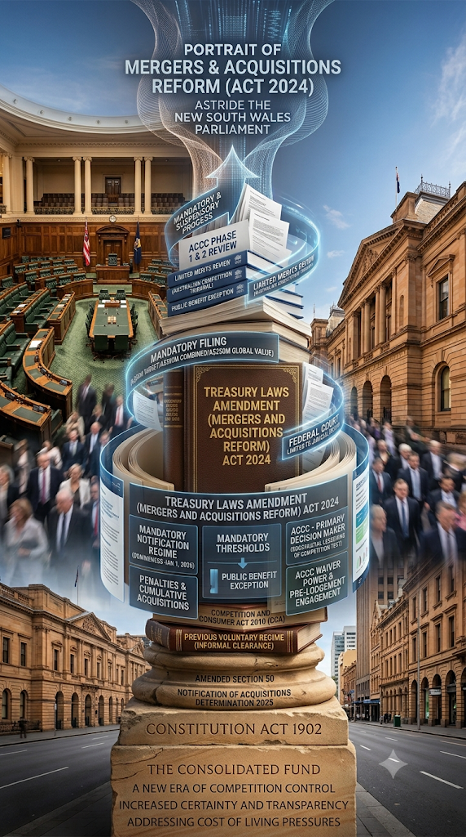

Cleared, Referred, or Void
Assessing Australia’s New Merger Control Regime After One Year and Two Phases
Law Student Review
By Gracy Gaba

I INTRODUCTION
For decades, Australia's merger control system operated on a relatively simple basis: businesses could choose whether to notify the ACCC of a proposed acquisition, and the regulator would intervene through the courts if competition concerns arose. While that approach offered flexibility, it was increasingly criticised for lacking transparency, allowing potentially anti-competitive acquisitions to escape scrutiny, and placing Australia out of step with many comparable jurisdictions.
That changed on 1 January 2026 when the Treasury Laws Amendment (Mergers and Acquisitions Reform) Act 2024 (Cth) introduced a mandatory and suspensory administrative regime, making the ACCC the primary decision-maker for pre-merger review. A second tranche of reforms followed on 1 April 2026, introducing voting power thresholds and discrete asset acquisition rules.
More broadly, the reforms raise a familiar question in competition law: how much commercial friction is justified in the pursuit of competitive markets? This article argues that while the new regime has largely achieved its intended objectives, aspects of its design risk imposing costs that are disproportionate to the competition concerns they seek to address.

II FROM VOLUNTARY TO MANDATORY: THE REFORM AND ITS RATIONALE

A The Case for Reform
Delivering the second reading speech, the Treasurer identified several failings of the existing framework: it was insufficiently transparent, capable of causing expensive delays while also enabling anti-competitive deals to proceed undetected, and anomalous by international standards. The ACCC, under Chair Gina Cass-Gottlieb, had expressed sustained concern that serial acquisitions which individually attracted little scrutiny could, when viewed cumulatively, entrench market power and escape review entirely. Australia’s reform brought it into alignment with the mandatory notification systems long operated by the United States, European Union, and United Kingdom.

B The Core Architecture of the New Regime
From 1 January 2026, acquisitions of shares or assets connected with Australia that meet prescribed monetary thresholds must be notified to the ACCC and cannot proceed without clearance or a waiver. Non-compliant acquisitions that are put into effect without clearance are automatically void under the Act and expose parties to substantial penalties. This last feature — automatic voidance — is among the most commercially consequential elements of the new regime and is examined further in Part IV.
The regime establishes a two-phase review process. Phase 1 must be completed within 15 to 30 business days. If the ACCC is satisfied that an acquisition could, in all the circumstances, have the effect or likely effect of substantially lessening competition in any market, it may refer the matter to Phase 2, which permits up to 90 business days of in-depth review. The ACCC also has power to grant waivers for transactions unlikely to raise material competition concerns, allowing those parties to follow an abbreviated process.

III THE REGIME IN PRACTICE: FIRST QUARTER RESULTS AND THE APRIL EXPANSION

A First Quarter Operation: January to March 2026
The ACCC's first-quarter data provides a concrete empirical picture of the regime's early performance. Between 1 January and 31 March 2026, the ACCC received 50 merger notifications and 108 waiver applications. Of the notifications, 39 were cleared at Phase 1 and two were referred to Phase 2 for detailed review. Phase 1 approvals were made on average in 18 business days; waiver decisions averaged 11 business days. The ACCC had committed to deciding approximately 80% of acquisitions within 15 to 20 business days, and early data suggests that target is being met. Based on the ACCC's early data, the regime appears to be operating largely as intended. Concerns that the mandatory notification requirement would produce severe deal-timeline delays have not, to this point, materialised.

B The First Phase 2 Referrals: Ampol and Coles
The two Phase 2 referrals are instructive. The first — and most significant — Phase 2 referral involved Ampol's proposed acquisition of EG Australia's fuel and convenience retail network. The ACCC identified competition concerns in a number of local fuel markets and referred the matter for detailed review. Following negotiations and a divestiture proposal involving 41 sites, the ACCC approved the acquisition on 3 June 2026. The matter provides an early illustration of how complex transactions may be resolved under the new regime through the use of structural remedies rather than outright prohibition.

The second Phase 2 referral concerned Coles' acquisition of a supermarket and liquor site in Kalgoorlie. Together, the Ampol and Coles referrals suggest that the ACCC is prepared to scrutinise transactions closely where competition concerns arise, regardless of industry or transaction size.

C The 1 April 2026 Expansion
On 19 December 2025, the Government released the Competition and Consumer (Notification of Acquisitions) Amendment (2025 Measures No 1) Determination 2025 (Cth), introducing changes operative from 1 April 2026. Two developments are significant. First, voting power thresholds: from 1 April 2026, notification is required — where the monetary thresholds are satisfied — if an acquisition causes the acquirer's voting power to cross 20% (from 20% or below) or 50% (from below 50%), irrespective of whether a change of control is achieved. These 'bright line' thresholds are intended to capture acquisitions of material influence and majority control. Second, discrete asset acquisition thresholds: acquisitions of standalone assets now trigger notification where the global transaction value is at least AUD 50 million and the primary monetary thresholds are met, addressing an acknowledged gap under which partial asset acquisitions had been caught only by the higher AUD 250 million transaction value threshold.

IV TWO STRUCTURAL CONCERNS

A The Breadth of the Voting Power Thresholds
The voting power thresholds, while conceptually sound, carry significant practical risks in their current form. By triggering notification at the 20% and 50% levels regardless of whether control changes, the regime captures a broad range of minority investments, including acquisitions by institutional and passive investors.
Capturing acquisitions that confer material influence is a legitimate policy objective. There is also a practical rationale for bright-line thresholds. Concepts such as 'material influence' are inherently difficult to define and can create uncertainty for transaction parties. Objective thresholds provide a clearer and more administrable notification framework. The concern lies in whether the current thresholds achieve that objective proportionately. The risk is that the interaction of the bright line thresholds, the monetary thresholds, and the automatic voidance provision may produce outcomes disproportionate to the competition risk. A party that inadvertently crosses a 20% voting power threshold while pursuing a passive equity investment in a mid-market target, and who in good faith does not notify, faces the possibility that the acquisition is automatically void and penalties are imposed. Such an outcome would not have been conceivable under the prior voluntary regime. It is not clear that any competition harm justifies this level of sanction for a non-controlling minority stake.

B Automatic Voidance: A Disproportionate Default
The automatic voiding provision is the most commercially severe feature of the new regime. A notifiable acquisition put into effect without clearance or a waiver is automatically void, with no judicial discretion to cure the defect based on the circumstances. During parliamentary debate, submissions from practitioners raised concern that inadvertent breaches could pose a deal-breaking risk for merger parties who reasonably but incorrectly assessed their obligations. The application fees associated with the regime further compound the cost burden for smaller transactions caught by the thresholds.
The Government has signalled its intention to remove or modify the automatic voiding provision during 2026. The proposed reform is sensible. In the interim, the provision creates an asymmetric risk profile: parties must choose between the cost and delay of notification for transactions they regard as benign, and the catastrophic legal consequence of non-notification. A penalty-based enforcement model — analogous to those used in the US and EU — would better balance deterrence with commercial certainty and proportionality.

V REFORM PRIORITIES
Three reform priorities emerge from the analysis above. First, the Government should follow through on its commitment to modify the automatic voiding provision. A model that imposes civil penalties for non-notification, with discretion to void only in cases of intentional or egregious non-compliance, would preserve deterrence while removing the risk of catastrophic consequences for good-faith threshold assessment errors.
Second, the ACCC should issue enhanced practical guidance on the operation of the voting power thresholds in listed-market contexts, including how it will treat inadvertent crossings by institutional investors and passive aggregation scenarios. The current guidance addresses the threshold mechanics but provides limited comfort to market participants managing complex portfolios.
Third, the cross-border dimension of the regime deserves explicit attention. The ACCC’s notification obligation applies to any acquisition of shares or assets ‘connected with Australia’ regardless of the acquirer’s nationality. Ashurst’s 2026 M&A Deal Report found that 25 of the 40 binding public M&A deals above AUD 50 million announced in 2025 involved a foreign bidder — over 60% of the deal pipeline. For those foreign acquirers, the new regime does not operate in isolation — it sits alongside a parallel Foreign Investment Review Board (FIRB) approval process under the Foreign Acquisitions and Takeovers Act 1975 (Cth), operating on different timelines, applying a distinct national interest test, and attracting its own sizeable filing fees. Although ACCC and FIRB notifications may be submitted concurrently, aligning two parallel approval clocks — each with extension mechanisms, information requests, and the ever-present risk of automatic voidance for ACCC non-compliance — materially increases the complexity and cost of transacting in Australia for international deal parties. These concerns are not arguments against mandatory notification. Rather, they highlight the need for a regime that remains proportionate and commercially workable, particularly in the context of multinational transactions that require coordination across multiple regulatory frameworks. For international businesses and the global law firms advising them, Australia's merger reforms represent not merely a domestic competition law development, but another layer of regulatory planning that must be incorporated into cross-border deal strategy from an early stage.

VI CONCLUSION
Australia’s new merger control regime represents a generational shift in competition law. The first quarter’s operation is encouraging: the ACCC appears to be meeting its stated processing targets, the waiver mechanism is functioning as a genuine fast track for non-contentious transactions, and the Phase 2 referrals demonstrate a regulator prepared to scrutinise complex, market-concentrating deals rigorously. ACCC Chair Cass-Gottlieb’s assessment that the early figures indicate ‘systems and processes are working as intended’ appears justified, at least at this early stage.
But two structural features — the breadth of the April 2026 voting power thresholds and the automatic voiding provision — risk over-calibrating the regime in ways that impose costs disproportionate to competition benefit. The changes contemplated for the voiding provision later in 2026 will be a critical corrective. Whether the regime ultimately strikes the right balance between commercial freedom and competitive markets will depend less on its architecture, which is broadly sound, and more on how its most severe provisions are reformed and applied. Mandatory, suspensory, and still evolving, Australia's merger regime remains a work in progress.

LAW STUDENT REVIEW
Disclaimer: The views expressed herein are solely those of the author and do not necessarily reflect other authors or the Law Student Review

Treasury Laws Amendment (Mergers and Acquisitions Reform) Act 2024 (Cth) ('Reform Act').
Jim Chalmers and Andrew Leigh, 'Second Reading Speech, Treasury Laws Amendment (Mergers and Acquisitions Reform) Bill 2024' (Speech, House of Representatives, 10 October 2024) <https://ministers.treasury.gov.au/ministers/jim-chalmers-2022/speeches/second-reading-speech-treasury-laws-amendment-mergers-and>.
Ibid.
Reform Act (n 1) s 51ABZE.
Reform Act (n 1) ss 51ABZE–F; Australian Competition and Consumer Commission, 'Merger Control in Australia' (Guidance, 2026) <https://www.accc.gov.au/business/mergers-acquisitions>.
Australian Competition and Consumer Commission, 'New Merger Control Regime off to Positive Start' (Media Release, 9 April 2026) <https://www.accc.gov.au/media-release/new-merger-control-regime-off-to-positive-start>.
Ibid.
Ibid.
Ibid.
Australian Competition and Consumer Commission (n 6); Gilbert + Tobin, 'New Merger Regime: First-Quarter Insights' (Legal Insight, May 2026) <https://www.gtlaw.com.au/insights/new-merger-regime-first-quarter-insights>.
Australian Competition and Consumer Commission, 'ACCC Approves Ampol’s Acquisition of EG Australia Subject to Conditions' (Media Release, 3 June 2026) <https://www.accc.gov.au/media-release/accc-approves-ampols-acquisition-of-eg-australia-subject-to-conditions>.
Competition and Consumer (Notification of Acquisitions) Amendment (2025 Measures No 1) Determination 2025 (Cth).
Gadens, 'Tripping the Wire: New Voting Power Triggers in Australia’s Merger Control Regime' (Legal Insight, 25 March 2026) <https://www.gadens.com/legal-insights/tripping-the-wire-new-voting-power-triggers-in-australias-merger-control-regime/>.
MinterEllison, 'A New Year, a New Australian Merger Control Regime' (Legal Insight, 22 December 2025) <https://www.minterellison.com/articles/a-new-year-a-new-australian-merger-control-regime>.
Parliament of Australia, 'Preliminary Digest: Treasury Laws Amendment (Mergers and Acquisitions Reform) Bill 2024' (Parliamentary Digest, 29 October 2024) <https://www8.austlii.edu.au/au/legis/cth/digest/pdtlaaarb2024775/pdtlaaarb2024775.html>.
Reform Act (n 1) s 51ABZE.
Parliament of Australia (n 15).
Landers & Rogers, 'Mergers and Acquisitions Reforms' (Legal Insight, 11 December 2024) <https://www.landers.com.au/legal-insights-news/mergers-and-acquisitions-reforms>.
Norton Rose Fulbright, 'Australia’s New Mandatory Merger Control Regime' (Legal Insight, 2026) <https://www.nortonrosefulbright.com/en-au/knowledge/publications/06692609/australias-new-mandatory-merger-control-regime>.
Norton Rose Fulbright (n 19).
Gadens (n 13).
Ashurst, 'Australian Public M&A Deal Report 2026' (Report, February 2026) <https://www.ashurst.com/en/insights/australian-public-m-and-a-deal-report/>.
Australian Competition and Consumer Commission, 'New Merger Control Regime off to Positive Start' (Media Release, 9 April 2026) <https://www.accc.gov.au/media-release/new-merger-control-regime-off-to-positive-start>.
Corrs Chambers Westgarth, 'Merger Reform Update: Last-Minute Amendments to Australia’s New Merger Regime Both Help and Hinder Transaction Parties' (Legal Insight, 23 December 2025) <https://www.corrs.com.au/insights/merger-reform-update-last-minute-amendments-to-australias-new-merger-regime-both-help-and-hinder-transaction-parties>.

