

Taylor v August and Pemberton Pty Ltd [2023]
A Case Summary
By Luciana Romanski

I FACTS
The Applicant, being Fiona Taylor, commenced proceedings against her boss and her employer for sexual harassment, which is found unlawful under the Sex Discrimination Act (‘SDA Act’). The Applicant was a worker for Grew & Co (cited as Pemberton Pty Ltd), being the Respondent and a jewellery store. Initially, the Claimant was in a customer service role as an employee at the Respondent. In late 2018, the Applicant was promoted to production manager, where she shared an office space with Mr Grew, who is the sole director of the first respondent and the principal of the Respondent. For a period of 22 months, the Applicant alleged that she was sexually harassed by Mr Grew. The Applicant reportedly developed chronic and serve psychiatric disorders resulting from Mr Grew’s alleged actions such as depression, anxiety, insomnia, poor concentration and a lack of appetite and socialisation. The Applicant alleged to have incurred $878.80 in psychologist fees, which the Respondents agreed had been incurred.
The complaint was formed on the basis of four main points. Firstly, the giving of 19 gifts. These gifts were a quilted black Chanel coin purse, an emerald and diamond platinum ring, a Hydra ring, a six stone diamond necklace, a peach sapphire, a diamond cluster necklace, a jade bangle, $2000 in cash described as an early Christmas bonus to assist the Applicant with saving for the purchase of a property, a message at a local shop during work hours, Gemini stud earrings, a silver signet ring, a Michael Kors bomber jacks, a $200 MECCA gift card, a white gold hammered band ring, a 5mm silver ring, a 10mm silver ring, Stuller gold earrings, a gold signet ring and a channel set diamond ring. Secondly, the several inappropriate comments which included informing the Applicant that she “had bedroom eyes” and a “really nice body”. There were text messages that were served as evidence for the alleged comments of Mr Grew. Thirdly, for slapping the Applicant on the buttocks. Fourthly, for telling the Applicant on two occasions, being in 2019 and 2020, that he had “developed feelings” for her, despite knowing that the Applicant was not interested on both instances. Overall, these four points of specified conduct were found to have occurred.
Consequently, the Applicant made a complaint to the Australian Human Rights Commission (AHRC), alleging that she suffered victimisation. The employer ultimately threatened to report the Applicant to the police by demanding that the Applicant return the gifts and was accused of misconduct. The Applicant sought $250,000 in general damages for sexual harassment and $50,0000 of damages for her victimisation.

II LEGAL ISSUES
The legal issues under consideration for the Court was whether unwanted gifts, physical contact or sexualised comments constituted sexual harassment under the SDA and if the Applicant suffered victimisation. If so, the question for the Court was whether the employer was liable to pay damages.

III THE FEDERAL COURT OF AUSTRALIA’S DECISION
The Applicant successfully established the onus of proof and provide on the balance of probabilities that the alleged sexual conduct occurred over a 22 month period, and she was awarded damages accordingly.
The definition of ‘sexual harassment’ is located under Section 28A of the SDA, meaning making “an unwelcome advance, or an unwelcome request for sexual favours, to the person harassed” or “engages in other unwelcome conduct of sexual nature in relation to the person harassed”.
Justice Katzmann (‘Katzmann’) found that the four main points of conduct constituted sexual harassment under the governance of the SDA. Section 28B states that “It is unlawful for an employee to sexually harass, or harass on the ground of sex, a fellow employee or a person who is seeking employment with the same employer”. The Applicant claimed that Mr Grew had unlawfully contravened section 28B(2) of the SDA as the legislation prohibits sexual harassment, as defined, by an employee to another employee. In contrast, the Respondents relied on the fact that not the entire gift-giving nor the comments were found to amount to sexual harassment, and consequently, the foundations of victimisation was not made on the balance of probabilities. Katzmann agreed that the Applicant did not prove that the gifts and most of the comments amounted to acts of sexual harassment, however, she proved that she was “showered with gifts” and that majority of the alleged comments were made. The Court noted that the “conduct of a sexual nature may be explicit or implicit”.
Consequently, Katzmann ordered the Applicant a record-high award of over $268,000 in damages. Firstly, the Applicant was awarded sum of $235,719.03 for the contravention of section 28B(2) of the SDA. Her Honour also ordered Mr Grew pay damages to the Applicant in the sum of $42,138.74 for contravening section 94 of the SDA, being that “a person shall not commit an act of victimisation against another person”. The SDA provides a high award of general damages, which conveys the Court’s perspective on the seriousness of sexual harassment occurring in the workplace.
Additionally, the Court looked at the Future Economic Loss (FEL) of the Applicant, which amounted to $39,667.94 for lost earning capacity over a three year period and $9,051.39 in superannuation.
Ultimately, Katzmann was given the power to order this civil practice under the section 37M(3) of the Federal Court of Australia Act.

IV IMPLICATIONS OF THE COURT’S DECISION
The case highlighted the severity of sexual harassment occurring in the workplace, and the importance of preventing this issue across all Employers. Consequently, as of 12 December 2023, the AHRC commissioned the court to enforce the duty for employers to take preventative action regarding sexual harassment. This translates to the commencement of the enforcement of the positive duty to take reasonable and proportionate steps to eliminate sexual harassment, sex discrimination, victimisation and hostile workplaces. The enforcement includes investigating workplace issues, releasing compliance notices, applying to Federal Courts to seek compliance with a notice issued and entering into enforceable ventures with an organisation.
Consequently, employers are required to record important implications following this case.

V AN INTERESTING NOTE ON THIS CASE
On 13 December 2022, the new positive duty was introduced in the Anti-Discrimination and Human Rights Legislation Amendment (Respect at Work) Bill.
Consequently, this made amendments to the SDA under Section 47C, which required employers to take “reasonable and proportionate measures” to eliminate “as far as possible”, unlawful sex discrimination, such as sexual harassment. This emphasises the seriousness of the Courts in criminalising and awarding damages for claims on sexual harassment in the workplace. There is evidence that the Courts are willing to award significant damages as governed per the SDA. These proactive measures which are encouraged to be taken by employers include mandatory seminars and updated company policies that explicitly state the consequences of sexual harassment.
Employers can be found vicariously liable unless they took all reasonable steps to prevent the occurrence of the sexual harassment. This measure is aimed at minimising the risk of vicarious liability on the instance where an employee was found to have committed sexual harassment in the workplace.

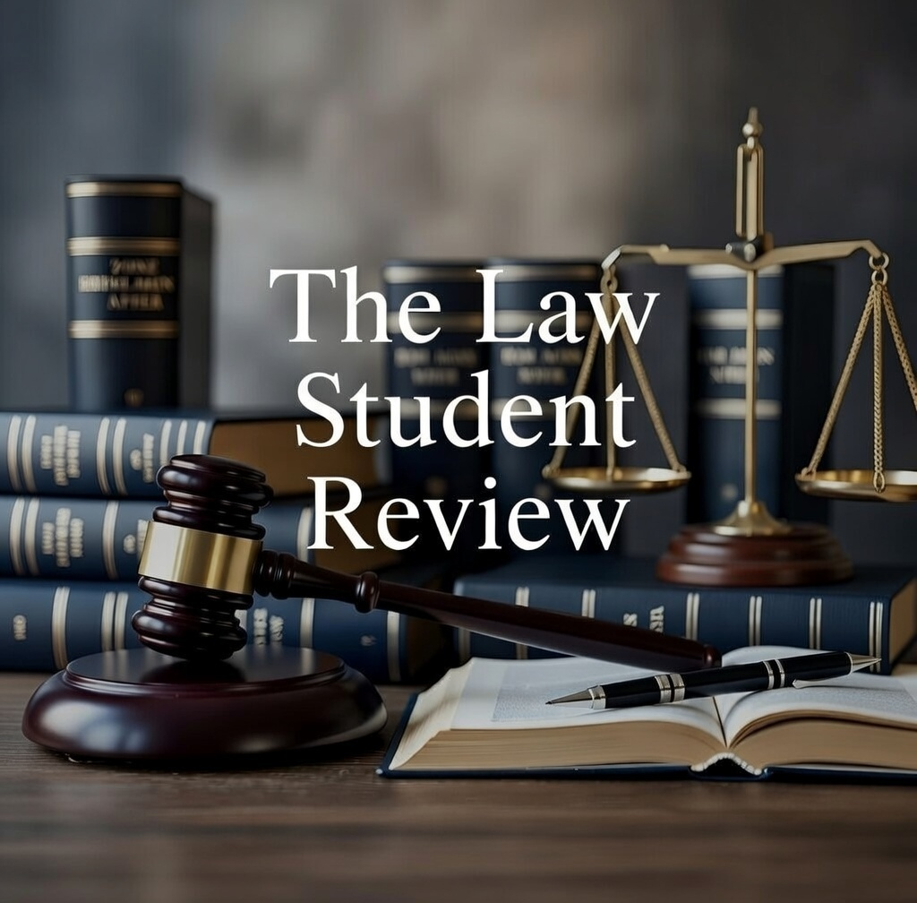

Sex Discrimination Act 1984 (Cth) (‘SDA’).
Taylor v August and Pemberton Pty Ltd [2023] FCA 1313 (‘Taylor v August and Pemberton’) [541].
Ibid [185].
SDA (n 1) s 28A(1)(a).
Ibid s 28B(2).
Taylor v August and Pemberton Pty Ltd [2023] FCA 1575 (‘Taylor v August and Pemberton’) [20].
Taylor v August and Pemberton Pty Ltd (n 2) [51].
Taylor v August and Pemberton Pty Ltd (n 6) [1].
SDA (n 1) s 94(1).
Taylor v August and Pemberton Pty Ltd (n 2) [554].
Federal Court of Australia Act 1976 (Cth) s 37M(3).
Anti-Discrimination and Human Rights Legislation Amendment (Respect at Work) Bill 2022 (Cth).
SDA (n 1) s 47C(1).

