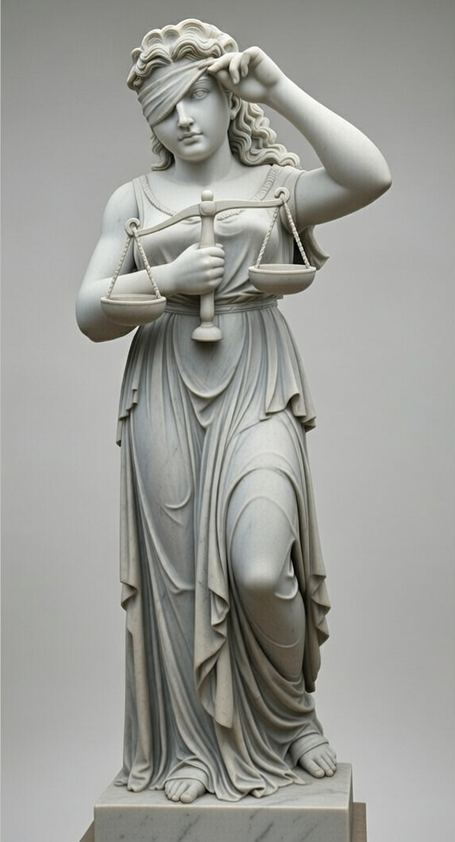
By Vanakpong Sarak Khan

Understanding Statutory “Unfair Prejudice”
Sections 135(a) and 137 of the Evidence Act

I INTRODUCTION
The danger of unfair prejudice usually takes place in criminal proceedings involving a jury who operate as fact-finders or decision makers. A party to any proceeding can make an application to exclude evidence from being presented to the jury on the ground that its probative value is outweighed by the danger of unfair prejudice, pursuant to sections 135(a) or 137 of the Evidence Act (‘the act’). Evidence of this type has already been proven to be admissible, but the final question before evidence gets presented to the jury is whether it is subject to any exclusionary rules (sections 135-137). If the judge agrees with the application, then the evidence may be excluded under section 135(a) or must be excluded under section 137, which only applies to evidence adduced by a prosecutor in a criminal proceeding.
However, the concept of "unfair prejudice" is easily misunderstood because it has a different meaning in the ordinary day-to-day context and the legal context. A member of the general public might naturally view any evidence damaging to a defendant's case as "prejudicial." In contrast, judges operate on the established principle that "evidence is not unfairly prejudicial merely because it makes it more likely that the defendant will be convicted". This difference in meaning raises the fundamental question: what actually constitutes "unfair prejudice" under the Evidence Act?

II DEFINING PREJUDICE AND UNFAIRNESS
At its core, prejudicial evidence creates "a real risk that the evidence will be misused by the jury in some unfair way" (R v BD). This statement highlights two critical elements:
- There must be both a risk of misuse by the jury and
- That misuse must be unfair.
The term “unfair prejudice” in sections 135(a) and 137 of the act has a narrower meaning than the broader concept of “unfairness”. The High Court in R v Swaffield, noted that although considerations of unfairness to the accused may overlap with considerations or obligations to exclude prejudicial evidence, “unfair prejudice” is concerned with the misuse of evidence by the fact-finder, whereas “unfairness” relates to systemic issues of fairness throughout the trial.
In Fattal v The Queen, the court permitted the use of covertly recorded statements made by the accused that suggested they celebrated the deaths of approximately 200 Australians from bushfires. The court held that the recordings were “necessarily prejudicial”, but not unfairly so, because they were central to proving motive. Without the recordings, a rational jury might struggle to accept that an Australian citizen would engage in preparatory acts for a terrorist attack. This case demonstrates the difference between inevitable yet necessary prejudice and unfair prejudice. If prejudicial evidence serves a genuine purpose that is hard to achieve by any other means, and is adduced not just to inflame the jury, then there is no unfair prejudice.
The meaning of “prejudice,” which was well explained by Justice McHugh in Festa v the Queen, held that evidence:
is prejudicial only when the jury are likely to give the evidence more weight than it deserves or when the nature or content of the evidence may inflame the jury or divert the jurors from their task.”
The Australian Law Reform Commission helpfully summarized that evidence becomes problematic when it appeals to sympathies, arouses horror, provokes an instinct to punish, or triggers other emotional responses that may cause the fact-finder to decide the case on grounds other than the established legal propositions.

III THE SPECTRUM OF POTENTIALLY PREJUDICIAL EVIDENCE
Here are past case examples showing numerous categories of evidence that may warrant an exclusion under sections 135(a) or 137 of the act:
Gruesome Visual Evidence: Crime scene photographs present a recurring challenge. While such images may be highly disturbing and extremely capable of inflaming a juror’s instinct to punish someone, they are not automatically excludable. In R v Ames, photographs showing blood flow patterns were admitted because they addressed the crucial question of whether the death was murder or suicide. The key inquiry is whether the photographs serve a genuine evidential purpose beyond merely inflaming the jury's emotions.
Accomplice Testimony: Evidence from co-offenders who have received immunity or favorable treatment carries heightened risks of fabrication. In R v McLean and Funk, the court noted that “there was an obvious and powerful inducement for the witness to ingratiate himself with the prosecution.” Justice Carter in his judgment, further highlighted that in the context of giving a co-offender favorable treatment to get them to testify, the risk that the witness became “locked into” a version of events to create an appearance of consistency could mislead a jury into over-valuing the evidence, thus making it unfairly prejudicial.
Equivocal Evidence: Evidence open to multiple interpretations, such as a defendant shrugging during police questioning may be prejudicial if the jury might misinterpret it or give it improper weight. However, the mere fact that evidence supports competing interpretations does not make it unfairly prejudicial; it is still for the jury to evaluate it.
Evidence Lacking Proper Foundation: In Gilham v The Queen, the prosecution adduced video evidence of fire-replication experiments to challenge the accused’s account that a house fire that killed his parents was already uncontrollable when he arrived. However, the videos were excluded by the court because insufficient evidence supported that the variables used in the experiments matched the variables on the night of the fire. The recreations might have looked compelling to a jury but rested on unproven assumptions, making them more misleading to the jury than probative.
Cross-examination revealing legal instructions: Cross-examination on a document prepared by the accused’s lawyer risks unfair prejudice because it may lead the jury to draw adverse inferences from the exercise of the right to legal advice, attributing consciousness of guilt to strategic or legally required conduct rather than to probative facts.
Requiring the accused to dress in a particular way: In Evans v The Queen, an accused was required to dress in overalls, a balaclava, and sunglasses, so as to enable the jury to compare his appearance with the appearance of a robber recorded by a security camera. Justice Kirby considered the demonstration to be unfairly prejudicial because its vivid visual impact encouraged guilt by appearance rather than rational inference, carrying powerful criminal stereotypes which had minimal probative value, and could not be cured by directions, thus mandating exclusion
Evidence suggesting guilt by association: Evidence that the accused associated with a co-offender (Example: Prison records showing visits between the accused and a co-offender) risks unfair prejudice by inviting the jury to infer guilt by proximity or relationship, rather than by reference to evidence proving the accused’s own conduct or mental state.

IV DISCUSSIONS ABOUT UNTESTED HEARSAY EVIDENCE AND “UNFAIR PREJUDICE”
There have been discussions as to whether "unfair prejudice" includes procedural disadvantages, particularly the inability to cross-examine witnesses who have provided hearsay evidence. Hearsay evidence, in this context, refers to the use of an out-of-court statement to prove the truth of an asserted fact from a previous representation.
Justice McHugh in Papakosmas v The Queen warned against relying on unfair prejudice to justify the exclusion of hearsay evidence. His honor, referring to past decisions that excluded hearsay statements due to the inability to cross-examine witnesses that provided hearsay evidence, noted that those judges had a restrictive common-law-based attitude towards hearsay provisions in the act which had been re-designed to make hearsay evidence more admissible in proceedings. His honor further noted that those judges gave unauthorized weight to the traditional meaning of “prejudice,” which consequently “emasculated” hearsay provisions of the Evidence Act to fit common-law notions of relevance and admissibility. This was Justice McHugh’s way of emphasising that “unfair prejudice” only concerns the misuse of evidence by the fact-finder, which must be distinguished from unfairness, which relates to systemic unfairness in the conduct of the trial, even in the context of hearsay.
Following Justice McHugh’s warning, the NSW Court of Appeal in Ordukaya v Hicks positively responded to his honor’s restrictive views on “unfair prejudice”. The majority held that the inability to cross-examine hearsay evidence doesn't automatically justify exclusion, as such evidence may remain relevant and its limitations can be taken into account as weight in the fact-finder’s assessment. This was the court’s way of directing the attention away from the procedural disadvantages to the jury when evaluating the prejudicial effect of untested hearsay evidence. Chief Justice Woods in R v Suteski excluded unfairly prejudicial hearsay evidence, by further adopting this approach in Ordukaya v Hicks. His honor emphasized that evidence on a case-to-case basis required an individual assessment of its character and the specific influence it has on the jury’s fact-finding process. Therefore, even in the context of untested hearsay evidence, the effect on the jury’s fact-finding process is still the determining factor as to whether the evidence is unfairly prejudicial, not because there are procedural disadvantages.

V THE LIMITATIONS OF JURY DIRECTIONS
In most cases where prejudicial evidence is sought to be presented to the jury, the judge must consider whether appropriate judicial directions can neutralise the risk of unfair prejudice before the evidence is placed before the jury. If convinced that the jury will not be able or be willing to follow such directions, the evidence may be excluded pursuant to s 135(a), or must be excluded under s 137 in a criminal proceeding. This crucially demonstrates that “unfair prejudice” is defined not just by what the evidence is, but by whether its effects can realistically be controlled by directions to the jury.

VI CONCLUSION
This article has consistently demonstrated that “unfair prejudice” under ss 135(a) and 137 of the act refers to the risk that certain types of evidence will have harmful effects towards a party by making the jury reason improperly by emotions, stereotypes, impressions, or overvaluation. Highly prejudicial evidence will not be unfair unless it serves a legitimate and probative purpose towards a party's case or if its prejudicial effect can be neutralized by judicial directions. The concept of “unfair prejudice” remains balanced so that parties may admit crucial forms of evidence while making sure that parties affected by the prejudice have a form of protection from irrational fact-finding by the jury and ensuring that verdicts are reached on proof rather than improper reasoning.

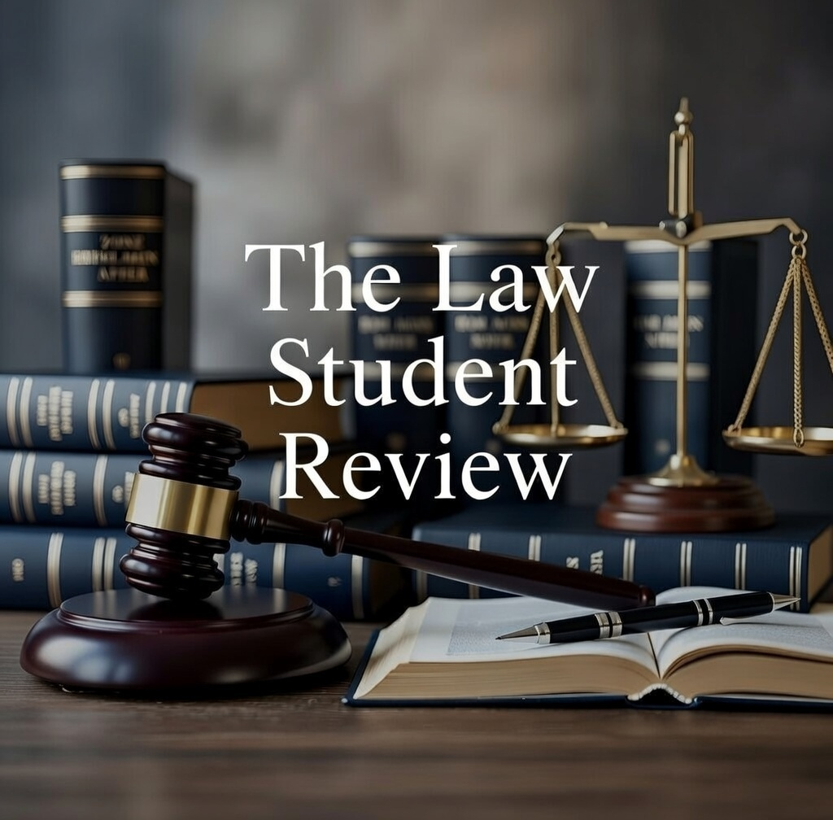

Evidence Act 1995 (Cth) ss 135(a), 137.
Ibid.
Papakosmas v The Queen (1999) 196 CLR 297, [91] (McHugh J).
R v BD (1997) 94 A Crim R 131, 139 (Hunt CJ at CL).
Evidence Act 1995 (Cth) ss 135(a), 137.
R v Swaffield (1998) 192 CLR 159, [54].
Fattal v The Queen [2013] VSCA 276, [45].
Festa v The Queen (2001) 208 CLR 593, [51].
Australian Law Reform Commission, Evidence, ALRC 26 (Interim) Vol 1 (1985), [644].
Jeremy Gans, Andrew Palmer and Andrew Roberts, Uniform Evidence (4th ed, Thomson Reuters Australia, 2025), [16.130], examples adapted for explanatory purposes in the discussion of “unfair prejudice”.
R v Ames [1964-65] NSWR 1489.
R v McLean; Ex parte Attorney-General (1990) 47 A Crim R 240, 249.
Ibid, 254.
R v Astill (Robert) NSWCCA, unreported, 17 July 1992.
Gilhem v The Queen [2012] NSWCCA 131, [173].
Director of Public Prosecutions v McEwan (No 2) (2012) 221 A Crim R 421, [8] (Kaye J).
Evans v The Queen (2007) 235 CLR 521, [108]-[109] (Kirby J).
R v Chami, Skaf, Ghanem and Skaf [2004] NSWCCA 36, [178].
Papakosmas v The Queen (1999) 196 CLR 297.
Evidence Act 1995 (Cth) pt 3.2 divs 1–3.
Papakosmas v The Queen (1999) 196 CLR 297, [93].
Ibid [93], [97].
Ordukaya v Hicks [2000] NSWCA 180.
Ibid, [41].
R v Suteski (2002) 56 NSWLR 182.
Ordukaya v Hicks [2000] NSWCA 180.
R v Suteski (2002) 56 NSWLR 182, [126]–[127].
R v XY [2013] NSWCCA 121, [193] (Blanch J); Evidence Act 1995 (Cth) ss 135(a), 137.
Ibid.

