
By Nila Manimaran

Robertson v R [2024]
A Case Summary

I FACTS
On 5 April 2017, the applicant Guy Keith Robertson and three other assailants (Adam Symons, Beau McDonald, and Jake McDonough) arrived at a Caltex Service Station in Peats Ridge. The assailants then proceeded to surround the vehicle of Clint Starkey, and as they approached the vehicle’s front passenger door where Mr Starkey was seated, one assailant, Adam Symons, shouted "[H]e’s got a gun".
CCTV footage showed the assailants then pulling Mr Starkey from the passenger seat and onto the ground, where they proceeded to punch, kick and stomp on his head for approximately 30 seconds. Robertson specifically was identified as stomping on the victim’s head and neck while he lay on the ground. Mr Starkey died from his injuries on 12 June 2017, though notably, expert medical evidence could not identify which specific blow caused the death.

II PROCEDURAL HISTORY
Robertson was charged with murder, with The Crown claiming that all the assailants were acting in a joint criminal enterprise (JCE), to inflict grievous bodily harm on the deceased. However, Robertson only pleaded guilty to manslaughter. The basis for his plea was that since the warning of a gun was shouted, Robertson’s subsequent attack was an act of ‘excessive self-defence’ under Section 421 of the Crimes Act 1900 (NSW).
However, this plea was not accepted by the Crown, and on the 11th of November 2022, Mr Robertson was sentenced to 19 years imprisonment with a non-parole period of 13 years commencing on 21 December 2017 and expiring on 20 December 2030. The trial judge, being Justice Desmond Fagan, had declined to allow the jury to consider a verdict of manslaughter based on excessive self-defence, based on his interpretation of the statutory language of section 421, which applies when “the person uses force that involves the infliction of death". He concluded that since it was not proven that specifically Mr Robertson’s attack was the fatal blow that had killed Mr Starkey, his conduct offers no viable pathway to manslaughter. Robertson appealed on the grounds that the failure to leave to the jury an alternative verdict of manslaughter was a miscarriage of justice

III LEGAL ISSUES
Robertson’s appeal raises the question of whether an individual participant in a JCE can claim the usage of “force that involves the infliction of death”, as a criterion for manslaughter based on excessive self-defence, even if they did not personally make the fatal attack.

IV THE COURT OF CRIMINAL APPEAL’S DECISION
The Court of Criminal Appeal by a 2-1 majority allowed the appeal, quashed Robertson’s conviction, and ordered a new trial. Chief Justice Ian Harrison ruled that while the applicant’s claim of an ‘instantly formed’ defensive agreement between himself and his fellow assailants ‘rises no higher than speculation and never achieves the level of an available inference’, the trial judge nevertheless erred in not leaving the availability of a manslaughter via excessive self-defence verdict to the jury.
Justice Dhanji agreed with His Honour’s decision, further clarifying that even for acts attributed to a JCE, the criminal liability of the individual is not dependent on the guilt of the other parties. However, Justice Cavanagh did disagree with this decision, agreeing with the trial judge’s reasoning for the applicant being ineligible for manslaughter based on self-defence.

V IMPLICATIONS OF THE COURT’S DECISION
The Court’s decision confirms that participants in a JCE can rely on self-defence justifications even if they did not personally make the lethal blow, clarifying that in a JCE, the law attributes the acts of the group to each individual. With their decision, The Court further stresses the importance of not forcing a jury into a ‘murder-or-nothing’ decision when a viable pathway to manslaughter exists.

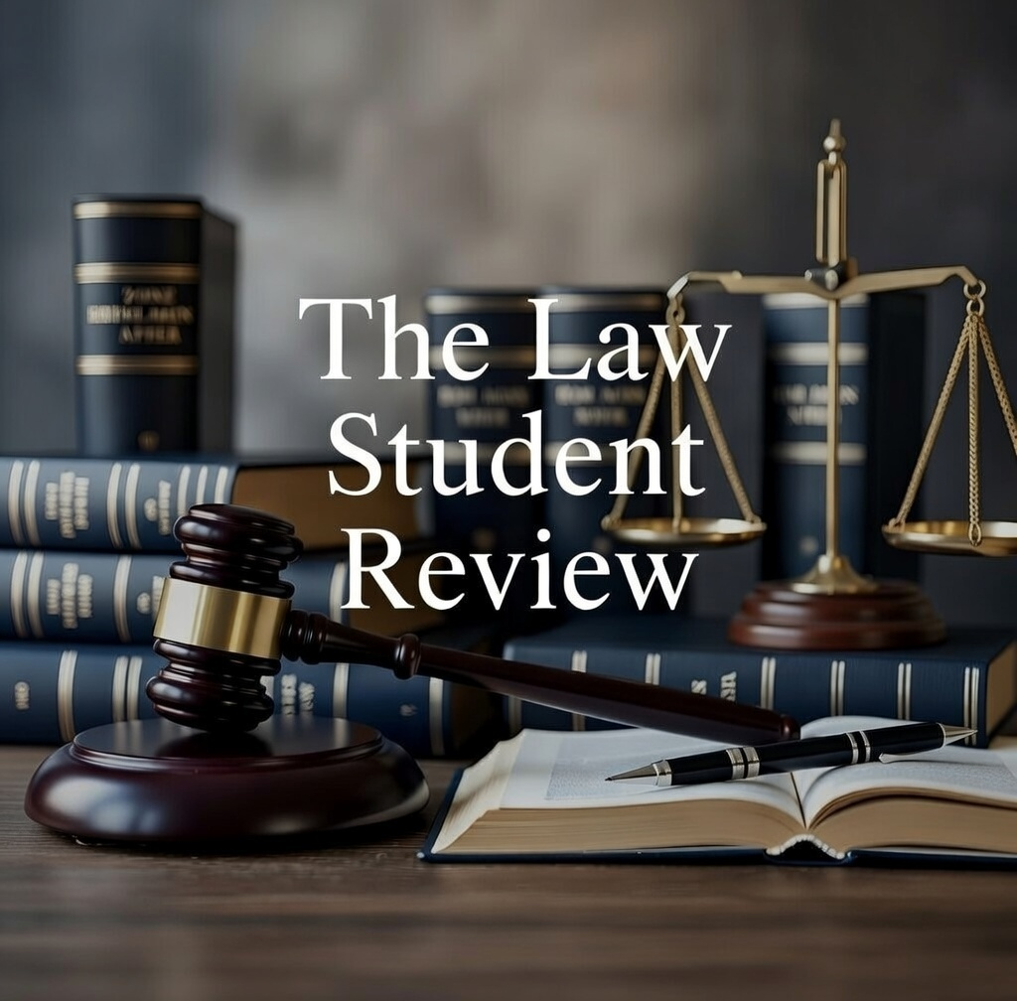

Robertson v R [2024] NSWCCA 99 [3].
Benchmark Publication - Weekly Criminal Law - Friday, 6 September 2024.
Robertson v R [2024] NSWCCA 99.
Crimes Act 1900 (NSW) s[4]-[21].
Robertson v R [2024] NSWCCA 99 Cavanagh J (5).
Robertson v R [2024] NSWCCA 99, [27].

