Woodham Golf Club
Burnhill Way
Newton Aycliffe
Durham
DL5 4PN

Thursday 7th April 2022

Dear Woodham Golf Club,
Women in Golf Charter – Club Signatory
I was personally delighted to read the commitments that you have made as part of your contribution to the delivery of the Women in Golf Charter.
Woodham Golf Club will be inspiring other clubs from across the country to develop a more inclusive culture within golf for more women and girls to develop across all levels of the sport. The commitments and targets you have set yourselves are ensuring we continue to develop as a sport and it’s fantastic to see you are working on all aspects of the club from club governance to recruitment and retention.

Thank you to all those at Woodham Golf Club who have worked to implement the Women in Golf charter to this point and we are looking forward to continuing to work with you to achieve your commitments.
I wish you all the very best for 2022 and look forward to following your future progress.

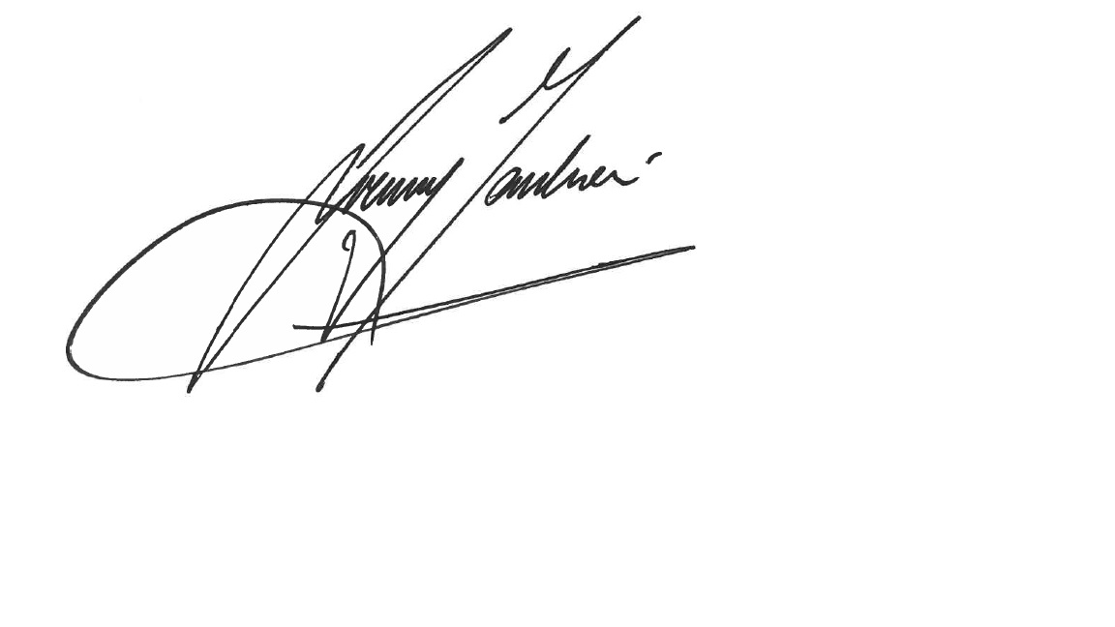
Jeremy Tomlinson
England Golf CEO

