Press Release: Embargoed until 10:00 (GMT) 21 February 2025
Return Of The Human Launches New Single and Announce New Major Distribution Deal
…with UK music icon Rick Wakeman showing support as he gives an exquisite performance on piano
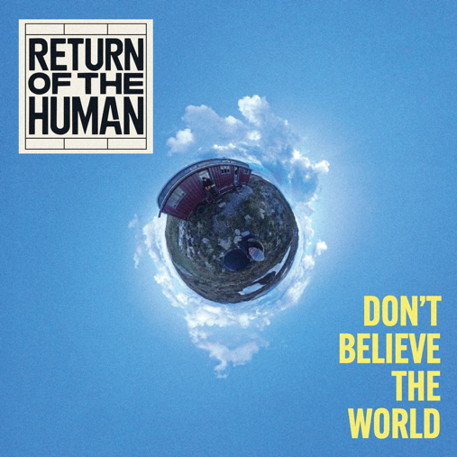
“A lovely piece of music, very different and inspiring to play on”
– Rick Wakeman

Roaring into 2025 with the ink still wet on their freshly signed major distribution deal, Return Of The Human hot-foot from their debut summer track with ‘Don’t Believe The World’ released 11 April. An absolute masterpiece of melody, the track is plucked from the forthcoming album to whet the appetite of audiences clamouring to experience this band live. With guest keyboards delivered majestically by iconic Yes man, Rick Wakeman, and their label firmly cemented under a new deal with Right Track/Universal Distribution, Return Of The Human ensure they’re punching an indelible stamp onto 2025.

Delicately unfolding piano chords performed by the iconic man of rock, Rick Wakeman, tickle and trickle ‘Don’t Believe The World’ into a perfect sound-bed introduction of true and honest vocals from front man, Dave Colquhoun. The juxtaposition of authentic vocals weaving their way across the delicate fabric of Wakeman’s exquisite keyboard performance, expose the heart-wrenching melancholy of dreams that come crashing down with the reality of life. An original co-penning by Return Of The Human writing-duo, Dave Colquhoun and John Vincent, the song is an invitation to follow what you think and believe, even when the whole world seems to disagree with you. Recorded at Snap, Rosewood and The Granary studios, and mixed at Music Farm Studio, ‘Don’t Believe The World’ is the band’s first release under their new major distribution deal with Right Track/Universal.
Return Of The Human is a musical movement on a mission to win at this game of living. In a world where we weather the storms of stress, and where confusion reigns, Return Of The Human strips us back to the simplicity of song. Using music, lyrics and personal experience to deliver a combined belief that we can all win, Return Of The Human shrink-wrap prolific life-lessons into masterfully-crafted nutshells of melodies. Return Of The Human are long-term friends Dave Colquhoun and John Vincent, supported by a flexible line-up of world-class musicians for studio and live. Dave, an industry-renowned musician on the global stage, sits comfortably within the Top 10 best guitarists in the world. John, an entrepreneur who transformed the way we eat throughout the UK, across both nationwide fast-food and school meals. After decades of friendship, the pair’s chemistry exploded over their love of music and passion to share their own experiences through song.
The story of Return Of The Human is an epic one, a tale yet to be told. For now, the band simply want the music to speak for itself, as a prelude to the mighty year that this pair have planned. ‘Don’t Believe The World’ is a biographical snapshot into the lives of two men on a mission to bring us back to humanity. Digest and enjoy – and feel the human inside awaken.
‘Don’t Believe The World’ is released 11 April on Right Track/Universal Music.
https://returnofthehuman.com
https://open.spotify.com/album/0fh5W80VuxTEeJs8EJwBLP?si=MrXx2RTXRxecsj6b31Y9MA&nd=1&dlsi=5eef6a8efb1645a3
https://www.youtube.com/watch?v=esoBjsA-CXA
https://www.instagram.com/returnofthehuman/

For more information contact Sam Giannini Tel: 07932 820952 email: sam@giannini.co.uk

