EAST YORKSHIRE CENTRE Rally Plaque Order Form

Marshal: | Venue: | Rally Date:
Tel.: | Mobile: | E-Mail:

To ensure that you have the plaques you require for your rally please adhere to the following:-
- Order at least 4 weeks before your rally to ensure that the plaques can be ready for you.
- Contact the Plaque Officer to arrange how your plaques will be sent or collected.
- Please complete the information below.
- Return your form to the Plaque Officer. This can be done either by post (address in rally book),
email (RWa6592776@aol.com).

Please Supply:-
Quantity:
Name of Event:
Date of Event:
Extra text line required (if needed):
Picture (if required) please attach to email:
Date plaques required by:

For posting or personal delivery please supply the following:-
Rally Marshal's Name:
Address:
Post Code:
Telephone to contact on:
Signed:
Date:

Rally Marshal to Complete
I have arranged with the Plaque Officer how I will get my plaques:-
I will collect from: | They will be posted or hand delivered:
Signed: | Date:

Plaque Officer to Complete
Collection or post/delivery agreed:
Signed: | Date Received:

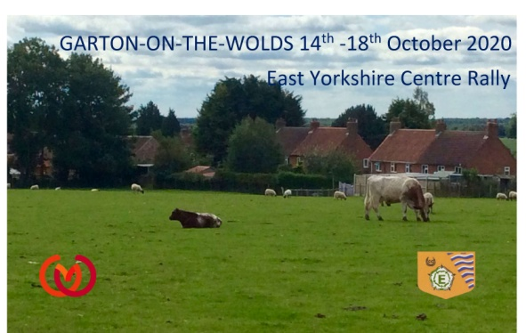
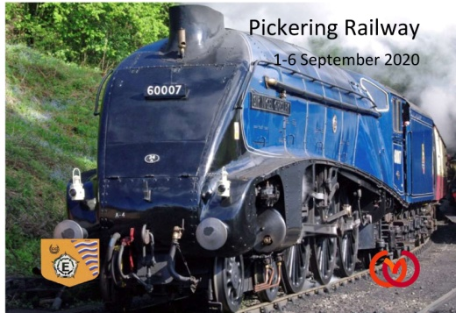
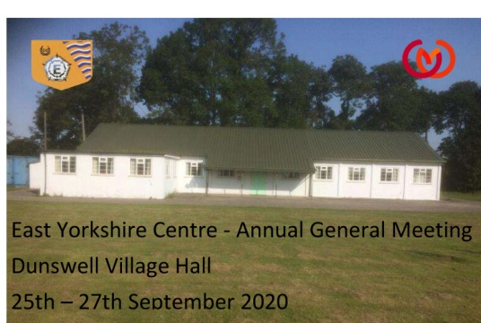
BELOW ARE 3 SAMPLES OF PLAQUES DONE LAST YEAR

