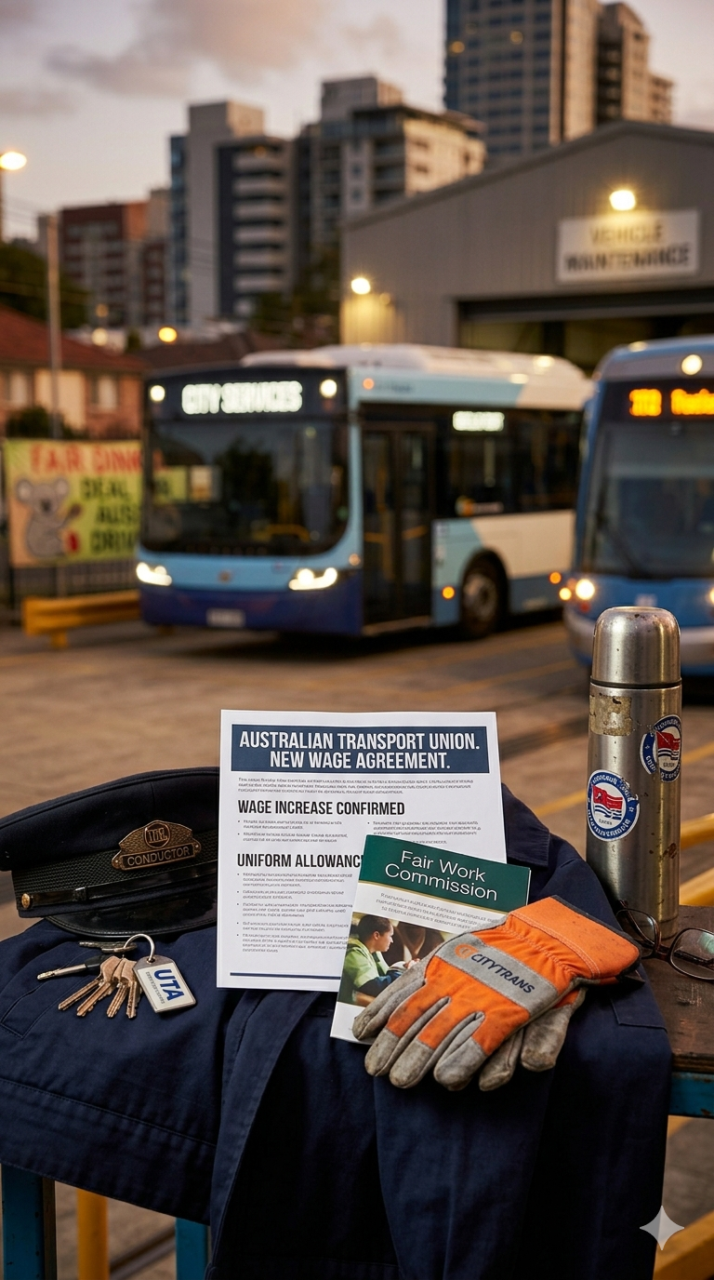

Simpson v Transport Accident Commission [2025] VSCA 241
A Case Summary
Law Student Review
By Jiya Yadav

I INTRODUCTION
Simpson v Transport Accident Commission examines the ‘serious’ injury threshold that regulates access to damages under a statutory compensation scheme. The central issue was whether a psychiatric disorder met the statutory definition of ‘serious’ injury. While common law litigation is costly and complex, statutory compensation schemes provide a more accessible pathway for individuals to recover damages, however access is limited by strict thresholds that prioritise efficiency and consistency over full compensation. The Court clarifies the distinction between ‘severe’ and ‘serious’ injury, confirming the high threshold required for injuries to qualify under the Act.

II CASE BRIEF
A Facts and Procedural History
Ian Simpson sustained injuries as a result of a transport accident on 2 September 2016, in which a truck collided with the motorcycle that he was riding in Todd Road, Melbourne.
As a consequence of the accident, the applicant suffered from a Conversion Disorder which involved ongoing symptoms of hand twitching and pseudo-neurological symptomatology.
Pursuant to s93(4)(d) of the Transport Accident Act 1986, the applicant filed an originating motion in the County Court seeking leave to commence a proceeding at common law for the recovery of common law damages.

The County Court judge was not satisfied that the nature, symptoms and consequences of the applicant’s conditions were ‘severe’ and concluded that the condition did not meet the statutory test of ‘severe’ when compared with a spectrum of comparable cases. As a result, the applicant sought leave to appeal against the decision of the judge. The appeal was brought to the Victorian Supreme Court of Appeal (‘VSCA’), on the grounds that the trial judge had erred in determining that the applicant had not sustained severe mental or behavioural disturbance as a result of the incident and failed to adopt and properly apply the test for causation.

B Legal Issues
There were three key legal issues left for determination by the VSCA. First, whether the trial judge erred in determining that the applicant’s injury did not constitute a severe long-term mental or severe long-term behavioural disturbance or disorder within the meaning of s93 of the Transport Accident Act 1986. Second, whether the trial judge failed to adopt and apply the correct test for causation, in particular whether the transport accident was a cause of the applicant’s injuries and their consequences. Third, whether the trial judge’s reasons were inadequate in failing to disclose a sufficient process of reasoning to justify the refusal of the application.

C Outcome
The VSCA refused leave to appeal, thereby upholding the decision of the County Court that the applicant had not sustained a ‘serious injury’ within the meaning of s 93 of the Transport Accident Act 1986.

D Legal Reasoning
The trial judge found that the plaintiff had not sustained a serious injury. In particular, the judge emphasised that the applicant’s symptoms had abated and were presently intermittent, enabling the applicant to find new employment and continue driving his motorcycle. While her Honour was satisfied that the injury had a moderate impact on the applicant’s social life, it did not however significantly impact the ability to perform activities of daily living. Her Honour concluded that the nature, symptoms and consequences of the injury are not subjectively ‘severe’ for the plaintiff and even if they are, when assessed objectively, the disorder does not meet the requisite statutory test of being ‘severe’.

It was contended that the trial judge erred by failing to take into account each of the symptoms suffered by the applicant, their cumulative impact and resulting consequences. The applicant further argued that the trial judge failed to properly apply the correct test for causation by excluding certain symptoms and consequences from consideration. In response, counsel for the respondent submitted that the trial judge had correctly examined the impact of the injury on the applicant as a whole by considering the consequences of the disorder and how the applicant would have been had the injury not occurred. It was further submitted that any symptoms of anxiety and depression were not part of the applicant’s claim and were correctly not considered. A third ground concerning the adequacy of reasons was initially raised but later abandoned.

The Court of Appeal affirmed that in determining whether a physical injury satisfies the test of a ‘serious long-term impairment or loss of a body function’, the injury, when judged by comparison with other cases in the range of possible impairments or losses, must be one which can be fairly described as at least ‘very considerable’. The Court emphasised that the threshold for psychiatric injury is more stringent and requires a ‘severe’ condition. Applying this test, the Court found that the applicant did not meet the threshold as the symptoms had abated and he retained the capacity to perform activities of daily life. Accordingly, the application for leave to appeal was refused.

E Ratio Decidendi
Where a claimant alleges a psychiatric injury under s 93 of the Transport Accident Act 1986, the injury must constitute a severe long-term mental or behavioural disturbance or disorder. This requires the injury to be more than ‘very considerable’ and assessed through a two-stage process involving both the subjective impact on the claimant and an objective comparison with the range of comparable cases.

F Obiter Dicta
The Court also emphasised that the assessment of psychiatric injury requires consideration of the claimant’s retained functional capacity, including their ability to work and perform daily activities. These observations highlight that the existence of symptoms alone is insufficient, and that the overall impact of the injury must be evaluated in determining whether it is ‘severe’.

III COMMENTARY ON CASE SIGNIFICANCE

The decision in Simpson v Transport Accident Commission reinforces the high threshold required for psychiatric injuries to qualify as ‘serious’ under a statutory compensation scheme. Claimants must now demonstrate that injuries sustained from transport accidents are ‘very considerable’ when assessed across a range of comparable cases. The Court places emphasis on the functionality of the applicant rather than basing the test on symptoms alone. This reflects the limits of compensatory justice within a statutory framework. More broadly, the case demonstrates that recovery is contingent not on the existence of injury, but on whether the injury meets strict statutory thresholds.

LAW STUDENT REVIEW
Disclaimer: The views expressed herein are solely those of the author and do not necessarily reflect other authors or the Law Student Review

Simpson v Transport Accident Commission [2025] VSCA 241, [57].
Ibid [1].
Ibid [2].
Ibid [45].
Ibid [97].
Ibid [91]-[95].
Ibid [45].
Ibid [48].
Ibid [51].
Ibid [56].
Ibid [57].
Ibid [41].
Ibid [97].
Ibid [44].
Ibid [41].

