Environment

At Plane Talking Products (PTP), we recognise the profound impact that we, as a products company, can have on the environment. We have established a comprehensive environmental policy that guides our operations and decision-making processes. Our Environmental Policy outlines our strategies and actions aimed at minimising our ecological footprint and promoting sustainability across all aspects of our business.

By integrating these principles and practices into our operations, we aim to contribute to a healthier planet and a more sustainable future.

Values
- INTEGRITY
We operate with honesty, transparency, and accountability in all our interactions, building trust with our clients, partners, and employees.
- INNOVATION
We foster a culture of innovation, constantly seeking new ways to improve our products and processes to meet the evolving needs of our clients and the industry.
- COLLABORATION
We believe in the power of teamwork and partnerships, working closely with our clients, suppliers and employees to achieve shared goals and create value.
- EXCELLENCE
We strive for the highest standards in everything we do, consistently delivering high-quality products, services and customer support. We work nimbly and adaptively to provide tailored solutions and that enhance the passenger experience and add value to our client’s operations.
- SUSTAINABILITY
We are committed to minimising our environmental impact by developing products and processes that prioritise sustainable practices that contribute to Net Zero goals.

Environment Policy

At PTP, we are dedicated to sustainable and environmentally conscious business and manufacturing practices as part of our broader corporate social responsibilities. We strive for continuous improvement in sustainability across all aspects of our operations, encompassing both the products we produce and supply, as well as our procurement choices. Our operations include a range of manufacturing activities, service provisions, and procurement processes, all designed to support our commitment to sustainability and environmental stewardship.

We are committed to continually improving our environmental impact. This commitment is embedded in our business strategy and operational planning, ensuring that we consistently seek ways to enhance our sustainability efforts.

PTP is dedicated to preventing pollution and effectively managing our significant environmental impacts. We will implement best practices to minimise waste, reduce emissions, and conserve resources across all our operations.

We evaluate our suppliers and partners regarding standards of environmental responsibility. We expect our external parties to adhere to sustainable practices and will collaborate with them to promote and achieve our shared environmental goals.

We recognise our obligation to comply with all relevant environmental legislation as a minimum level of performance. PTP is committed to not only meeting but exceeding these regulatory requirements wherever possible.

We prioritise the education and training of our employees in environmental issues and the environmental effects of their activities. Our goal is to ensure that every team member understands their role in supporting our environmental objectives and is equipped with the knowledge to contribute effectively.

PTP will monitor progress and review our environmental performance against targets and objectives on a regular basis. This process will involve setting measurable goals, tracking our advancements, and making necessary adjustments to our strategies and operations.

We are committed to transparently communicating our business aims and environmental objectives to all stakeholders. Regular updates and reports will be provided to ensure that our commitment to sustainability is clear and actionable for all involved.

We encourage our clients to adopt a broad and holistic approach to sustainability. We will share our knowledge of sustainable materials to help clients understand and promote their sustainability goals.

At PTP, we believe that through these commitments and actions, we can make a positive and lasting impact on the environment while achieving our business objectives.

Waste Management
At PTP, we are committed to minimising waste generation and managing waste responsibly to reduce our environmental footprint. We prioritise the principles of reduce, reuse, and recycle across all our operations. This includes:

Waste Reduction - Actively seeking ways to prevent waste by optimising processes, minimising single-use materials, and promoting digital alternatives where possible.
Reuse - Encouraging the repurposing of materials and equipment to extend their lifecycle and reduce unnecessary disposal.
Recycling - Providing clearly labelled recycling bins and ensuring that recyclable materials are appropriately processed.
Hazardous & Electronic Waste - Ensuring the safe disposal of hazardous and electronic waste in compliance with local regulations, while exploring sustainable disposal options.

We also engage our employees and stakeholders in waste management initiatives, promoting awareness and shared responsibility. Through continuous monitoring and improvement of our practices, we aim to achieve measurable waste reduction goals and contribute to a cleaner, more sustainable environment. As part of our monitoring, we have set the following targets:

- By 2026, we will have recycled 8640 litres of waste.
- We will reduce the number of sheets of paper we print by 50% of 2024 levels by 2030.

We will monitor our progress to achieving these targets on a monthly basis in our reporting document.

Environmental Aspects and Impacts Register

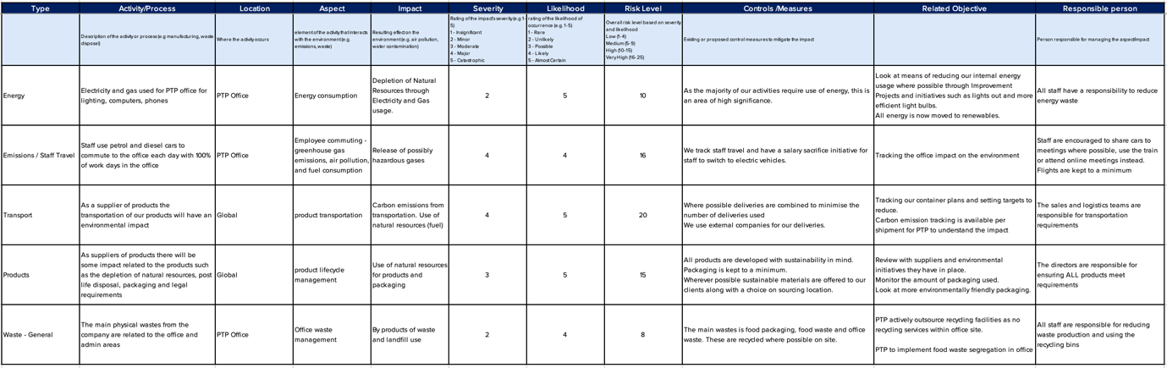

Lifecycle Perspective

Policy Vision
This policy outlines our approach to integrating lifecycle perspective and lifecycle analysis (LCA) into our operations, projects, and product development. The goal is to ensure sustainable practices, minimise environmental impact, and enhance resource efficiency throughout the entire lifecycle of our products and services.

Scope
This policy applies to all employees, departments, and stakeholders within PTP, as well as external partners and suppliers engaged in our supply chain.

Policy
PTP is committed to making sustainable choices and recognises the importance of incorporating the entire lifecycle of our products into all decision-making processes. This approach is fundamental to our strategy, as it allows us to consider the environmental impacts from the inception of a product through its end-of-life, ensuring that every stage is managed with environmental responsibility in mind.

To achieve this at PTP, we integrate lifecycle analysis (LCA) into our operations by partnering with sustainability experts. We actively collaborate with academic institutions, industry specialists and consulting firms that focus on LCA, ensuring that our analyses are both robust and accurate. These collaborations provide us with the necessary insights and technical expertise to refine our processes and products continually.

As part of our commitment, in 2024 we partnered with Earthster, a leading platform for life cycle analysis. This collaboration enables us to gain deeper insights into the environmental impacts of our products and processes, from raw material extraction to end-of-life. By leveraging Earthster's comprehensive LCA tools and datasets, we can make data-driven decisions to minimize our carbon footprint, enhance resource efficiency, and align with global sustainability standards.

Data collection and management are important components of our LCA approach. We are committed to establishing and maintaining a systematic method for gathering, managing, and analysing data related to the lifecycle of our products. This data encompasses material inputs, energy consumption, emissions, and waste generation. We are committed to ensuring that our LCAs are based on reliable and relevant information, enabling informed decision-making.

PTP is dedicated to educating and expanding our employees' understanding of product lifecycle and LCA. We provide ongoing training and resources, including workshops, seminars, and access to key publications and tools. This educational effort ensures that our staff is well-equipped to contribute to our sustainability goals.

At PTP, we ensure that all our LCA practices align with relevant environmental regulations, including international standards such as ISO 14040 and ISO 14044. Adherence to these standards underscores our commitment to maintaining environmental responsibility and accountability.

Through this comprehensive approach, PTP seeks not only to meet but to exceed industry standards in sustainability, continuously improving our environmental performance and contributing positively to the broader goal of sustainable development.

Through continuous monitoring and improvement of our products, we aim to achieve measurable LCA goals and contribute to a cleaner, more sustainable environment. As part of our monitoring, we have set the following targets:

- 100% of new products will have an LCA, starting from 2025.
- 80% of our inflight and travel products will have an LCA by 2026.
- 50% of our products will see an improvement in their LCA by 2030. This improvement can be in any one of the factors analysed by Earthster, for example, in water consumption or resource use.

We will monitor our progress to achieving these targets on a monthly basis in our reporting document.

Review and Continuous Improvement
This policy will be reviewed annually to ensure it remains up-to-date with legal requirements, best practices, and our sustainability objectives.
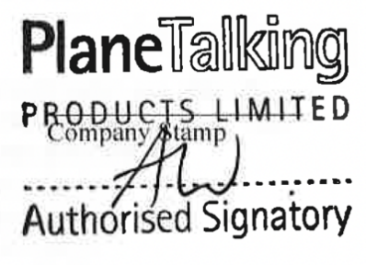
Alison Wells
Managing Director

This policy shall take effect on 14/11/2024 and will be reviewed on 14/11/2025.

Reviewed 25.11.2025 – Alison Wells

