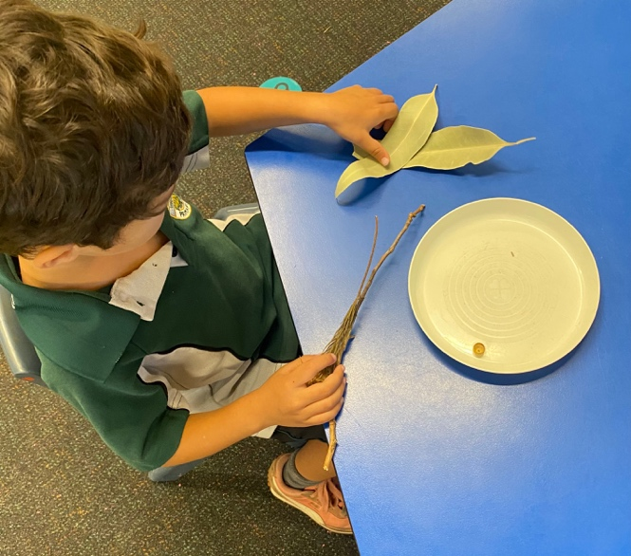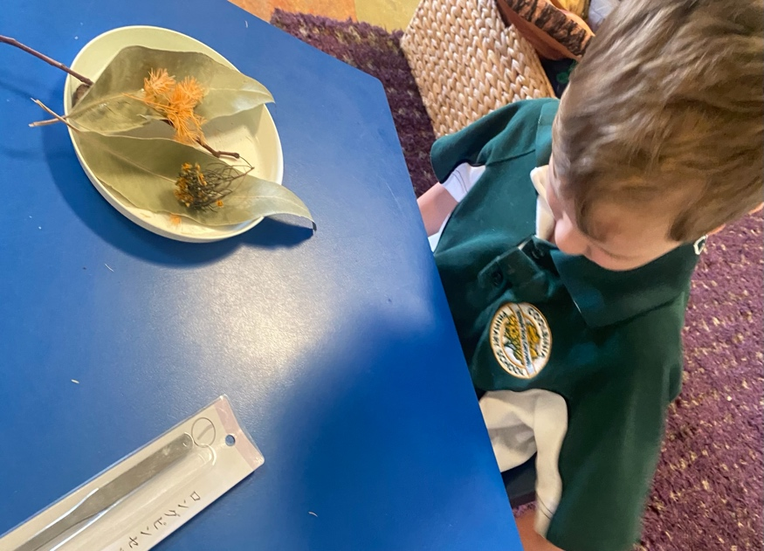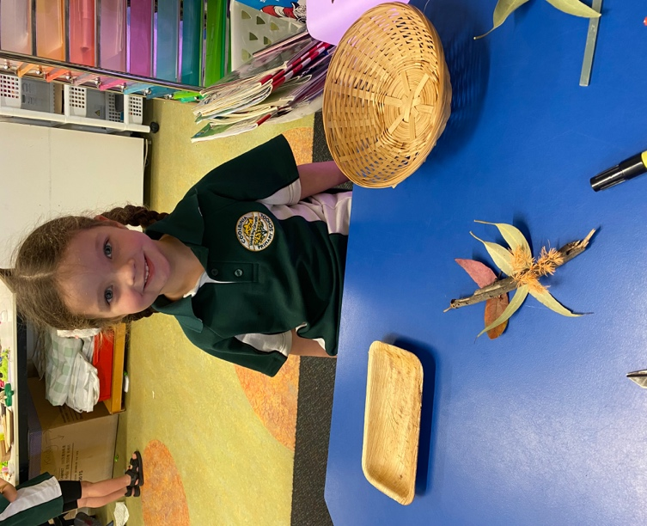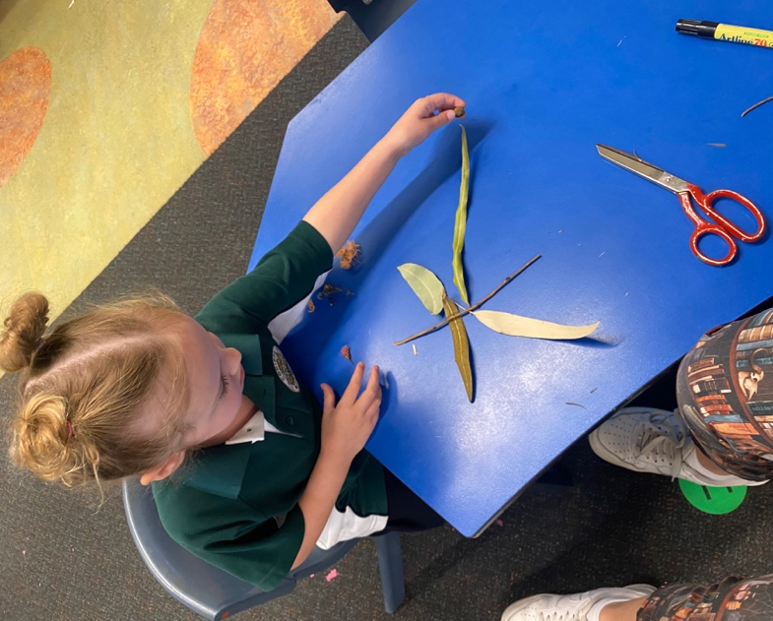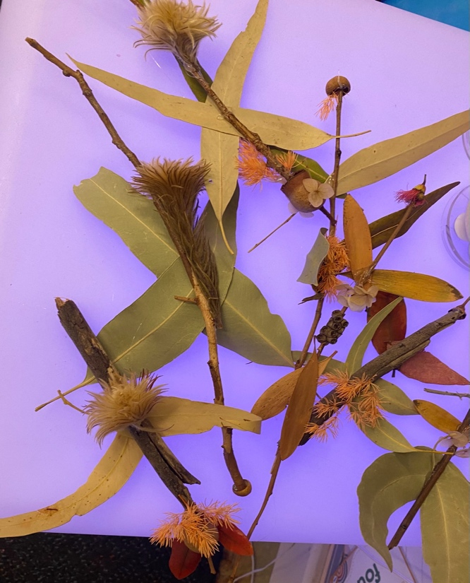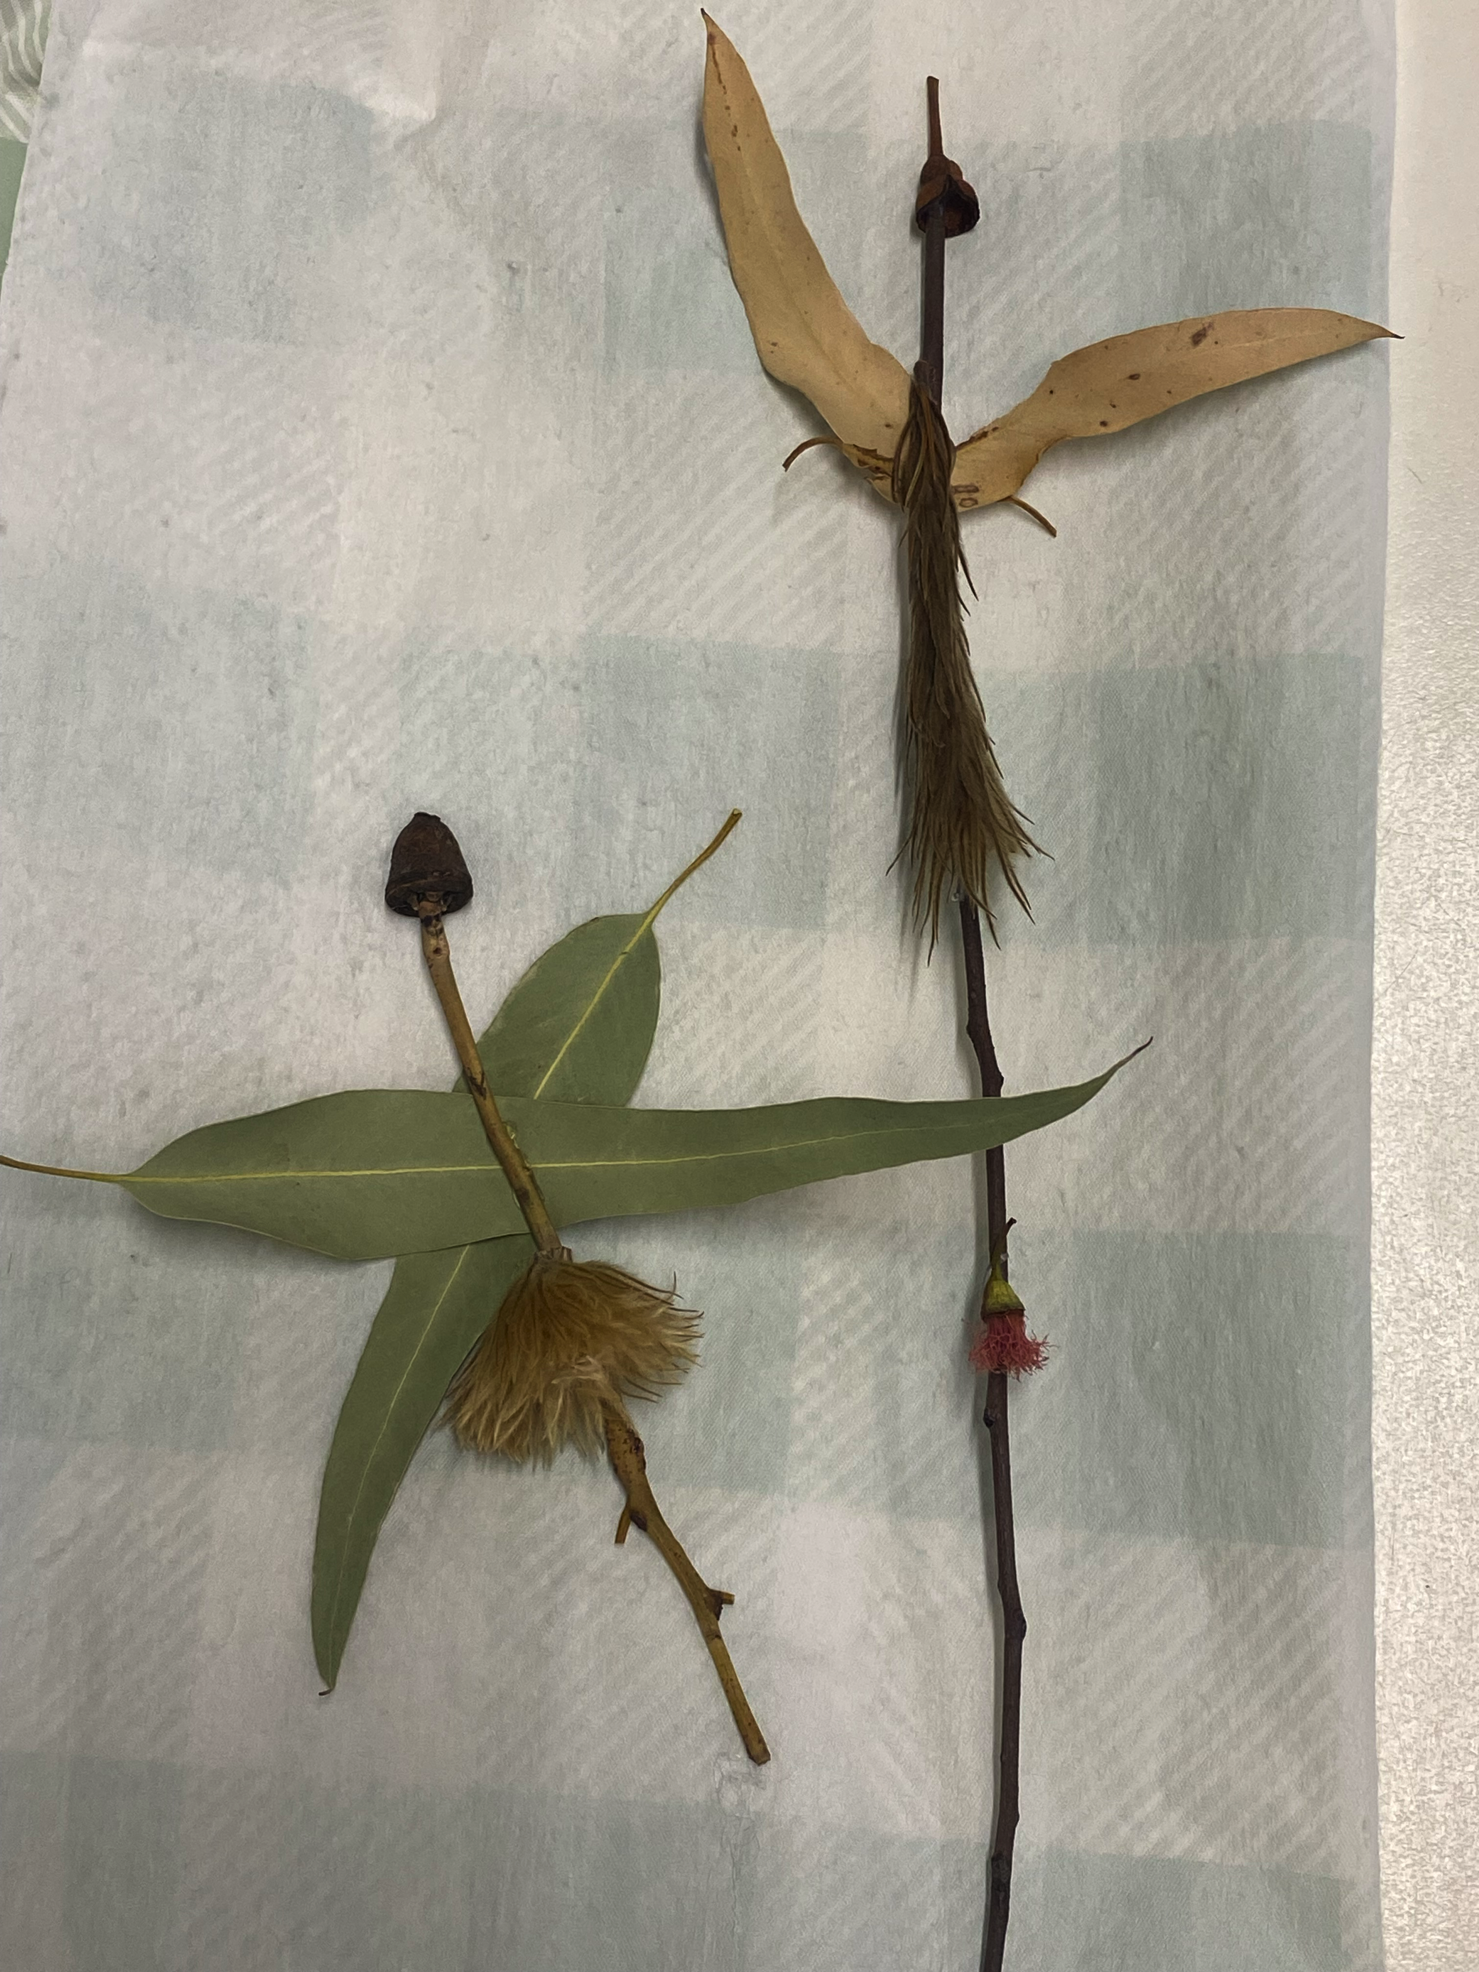
ELC Green and Yellow
ART
Kindy students used their engineering thinking, imagination and art skills to find the magic in foraged natural parts from our playground, creating a leaf fairy! Students designed their own unique leaf fairy and will be using it for further literacy and art lessons in the coming weeks.

