“Investigating the porpoising effect in high downforce racing cars”
Jan Gierszewski

TABLE OF CONTENTS:
PAGE:
3
4

5
5
6

8
9
11
12
14
16
17
20
22
23
24
26
1
1
1
1
1
1
- List of Figures and Tables
- Nomenclature
  - List of Acronyms and Abbreviations
  - List of symbols
- Abstract
- Introduction
- Aerodynamic Forces and Principles
  - Drag and Downforce
  - Airflow Types
  - External Flow
  - Bernoulli’s Principle
- Airflow in Ground Effect Cars
- What Is Porpoising and When It Occurs
- Performance Effects
- Experimental Overview
- Computational Fluid Dynamics Analysis
- Wind Tunnel – Properties
- Which of the Models Performed Best
- CFD vs Wind Tunnel Comparison
- Conclusions
- Further Research and Experimental Methods
- References
- Alphabetised Bibliography

- List of figures and Tables
- Figure 1 – Venturi tube – diagram ^{[3]}
- Figure 2 – Mick Schumacher’s crash during the 2022 Saudi Arabian GP – photo ^{[9]}
- Figure 3 – Model in Ansys Discovery programme
- Figure 4 – Model underbody in Ansys Discovery programme
- Figure 5 – Side-by-side comparison of models with various wing angles
- Figure 6 – Window of simulation inside Ansys Space claim
- Figure 7 – Close-up of the particle velocity distribution on the car
- Figure 8 – Wind tunnel schematic
- Figure 9 – Wind tunnel – picture with air inlet facing camera
- Figure 10 – AFC-452-300T ventilator ^{[17]}
- Figure 11 – Air inlet – schematic ^{[18]}
- Figure 12 – Diffuser – schematic ^{[18]}
- Figure 13 – Graph of voltage (downforce) against time for HS.BA.NC
- Figure 14 – Wave diagram for porpoising movement of the car

- Table 1 – Table presenting all of the CFD simulation results for models – drag + downforce
- Table 2 – Table presenting wind tunnel results for models – drag + downforce
- Table 3 – Table presenting wind tunnel results for some models – porpoising data
- Table 4 – Table presenting drag and lift coefficient data along with their uncertainty (CFD vs tunnel)

- Nomenclature

- List of Acronyms and Abbreviations
CFD Computational Fluid Dynamics
FIA Federation Internationale de l’Automobile
F1 Formula One
LS… Low Steepness (of underbody gradient)
HS… High Steepness (of underbody gradient)
…BA… Bigger Angle of wing attack
…SA… Smaller Angle of wing attack
…GC Ground clearance (increased ride height)
…NC No Clearance (minimum ride height)

- List of Symbols
P Pressure
ρ Fluid density [kg/m³]
FL Lift force [N]
CL Lift coefficient
FD Drag force [N]
CD Drag coefficient
v Velocity [m/s]
g Gravitational acceleration [m/s²]
A Area [m²]

- Abstract
With the regulation changes introduced to Formula 1 in 2022, a new phenomenon of ‘porpoising’ occurred, resulting in a vertical oscillation of race cars at fast speeds. The engineers at racing teams have soon managed to solve the issue, bringing aerodynamic improvements to their cars. Hence, attempting to investigate the engineering patterns and undertaken solutions, an industry level, 5 meter long wind tunnel was built, allowing for testing speeds of up to 100km/h. Additionally, models based on the 2022 F1 cars were designed, each with distinct aerodynamic properties. They were then printed in 3D, and tested. All in all, this paper aims to provide an understanding of the phenomenon, further expanding upon it with a summary of conducted CFD analysis and aerodynamic property tests. Further observations and conclusions regarding porpoising and solutions against it can therefore be made using the observed drag, downforce, and porpoising properties of models.

- Introduction
In the racing world, aerodynamics is a vital factor for performance, having a signiﬁcant impact on the car’s velocity in corners. The most complex of the aerodynamic solutions are usually found in open wheel, single-seater racing series, such as Formula 1. However, the rules of the competition do not allow for complete freedom in the aero departments of the bolide construction^{[1]}. These rules specifically determine the necessary dimensions and properties of each bodywork piece on the car, but most importantly - the front wing, floor, sidepods and rear wing. Each of these elements has a substantial effect in determining the behaviour of the car – the balance, downforce, drag, maximum speed and acceleration etc^{[2]}.
Due to the massive rule change introduced by the FIA in 2022, the new generation Formula 1 cars are also heavily dependent on ground eﬀect – an aerodynamic occurrence generating downforce through low pressure on the surfaces closest to the ground (floor)^{[2]} . The goal was to promote closer racing, with cars leaving less turbulent air behind, consequently allowing the competitors to follow more closely^{[1]}.
It was also not the first time that ground effect appeared in Formula 1. It was initially used by Lotus in 1977, but was soon banned from the sport in 1982 due to safety concerns. The so-called porpoising effect, leading to the car’s bouncing on straights and in high-speed corners was the main reason behind the ban^{[1]}.
Surprisingly, upon the return of ground effect nearly 40 years later, porpoising remained to be a struggle for engineers and drivers^{[3]}. Furthermore, despite the availability of numerous research papers analysing the occurrence of porpoising, it is rare for them to delve into specific aerodynamic solutions or patterns.
The goal of my paper is therefore to investigate the phenomenon by providing a theoretical overview on porpoising – its causes, characteristics, and solutions to it . I will also describe a wind tunnel experiment, where scaled F1 models with different aerodynamic features will be 3D-printed and tested for downforce and drag levels. Then, the results will be compared with Computational Fluid Dynamic data of the models. This will therefore serve as an experimental proof of which patterns apply in combating porpoising in ground effect cars.

- Aerodynamic Forces and Principles
At first, it is crucial to understand the basic aerodynamic terms and properties, necessary for explanations of the porpoising effect. These principles and forces are integral to understanding the behaviour of ground effect cars. They’re the focus of ongoing research in the field of vehicle aerodynamics, aiming to optimize performance, efficiency, and safety^{[2]}.

- Drag and Downforce
Drag and downforce are two fundamental forces in vehicle aerodynamics. Drag is a resistive force that opposes the car’s motion. There are two main types of drag: pressure drag (caused by the air pressure difference between the front and back of the car) and friction drag (caused by the friction between the air and the car’s surface). On the other hand, downforce is the force that pushes the car towards the ground. It’s essentially the opposite of lift (hence the term “reverse lift”). Downforce increases the car’s traction, allowing it to navigate corners at higher speeds without skidding. It’s generated thanks to the wings and the floor^{[2]}.

- Airflow Types
In aerodynamics, the behaviour of air around an object (like a car) is crucial. This behaviour can be categorized into two types: laminar and turbulent. Laminar flow is characterized by smooth, parallel layers of fluid. The layers slide over one another without mixing, resulting in less friction and lower drag. This is why it’s desirable in many engineering applications. However, at high speeds or rough surfaces, the flow can become turbulent. Turbulent flow is chaotic, characterized by eddies and swirls. These cause higher friction and drag, which can slow down the car. Understanding and controlling these airflow types is key to optimizing a car’s performance^{[2]}.

- External Flows
The external flow refers to how the air flows around the outside of the car. This flow is crucial as it affects both drag and downforce. For example, smooth, streamlined shapes can help maintain laminar flow, reducing drag. However, certain features (like spoilers and wings) intentionally disrupt the flow, creating turbulence and increasing downforce. Another aspect of external flow is the wake, or the disturbance caused by the car moving through the air. This wake can affect following cars, as it creates a region of turbulent, low-pressure air behind the car. This can reduce the following car’s downforce and increase its drag, affecting its speed and stability^{[2]}.

- Bernoulli's Principle:
Bernoulli's principle is fundamental in fluid dynamics and plays a pivotal role in explaining how air pressure varies with fluid flow speed, essential for understanding flight mechanics. This principle states that an increase in the speed of a fluid occurs simultaneously with a decrease in the fluid's pressure or potential energy.
$$P_{1}+\frac{1}{2}ρv_{1}^{ 2}+ρgv_{1}=P_{2}+\frac{1}{2}pv_{2}^{ 2}+ρgv_{2}$$

- Airflow in Ground Effect Cars
The ground effect refers to the increased lift (or in this case, downforce) generated by the interaction between the car’s underbody and the road.
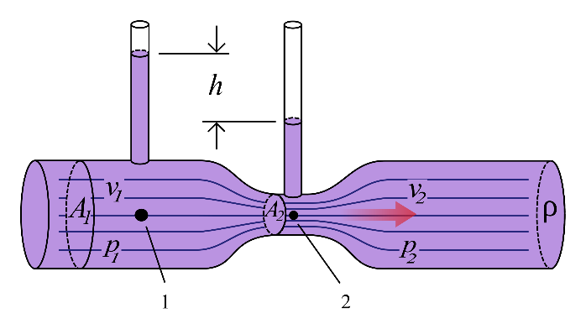
The Venturi effect is a principle in fluid dynamics that’s often used in car design. It states that as the speed (v) of a fluid (in this case, air) increases, its pressure (P) decreases. This is why sections of a pipe with a narrow area (A) have faster fluid flow and lower pressure. In cars, this principle is applied in the design of the underbody. The underbody is shaped like a Venturi tube, with a narrow middle section. As the car moves, air speeds up while passing under this section, creating a low-pressure area. This low pressure effectively “sucks” the car towards the ground, generating downforce^{[4]}.

Figure 1^{[5]}

Due to the flow inside the tube following
$$Q_{1}=A_{1}v_{1}$$
$$Q_{2}=A_{2}v_{2}$$
Where Q₁ and Q₂ are constants
A₁>A₂
We can conclude that
v₁<v₂
We can apply Bernoulli
$$P_{1}+\frac{1}{2}ρv_{1}^{ 2}+ρgv_{1}=P_{2}+\frac{1}{2}pv_{2}^{ 2}+ρgv_{2}$$
Provided that the air density is constant
P₁ > P₂
As the car moves, air enters the wider front end of the underbody and is funnelled into the narrower middle section. According to Bernoulli’s principle, the speed of the air increases in this narrow section, and its pressure decreases. This creates a low-pressure area under the car, effectively “sucking” the car towards the ground and generating significant downforce. The aerodynamic efficiency of the floor is further enhanced by the diffuser, channelling the high pressure air, as it exits the floor^{[2]}.
Aside from the floor of the car, a part of the downforce is obtained mainly from the front and rear wings – each responsible for roughly 25% of the downward forces acting on the cars. These, however are much less efficient when compared to the floor – producing much more pressure and friction drag, while also disturbing the airflow around them, causing turbulence to form behind^{[2]}.

- What is Porpoising and When It Occurs
Porpoising in race cars refers to the cyclical oscillation of the car's body, primarily in the vertical plane, as it travels at high speeds. Porpoising is predominantly observed when a race car achieves a critical speed where the aerodynamic downforce sharply increases with minimal ground clearance, leading to a significant reduction in the air gap under the car.
When the car accelerates through high-speed sections of the track, including straightaways and fast corners, the airflow rate increases. This maximizes downforce, pressing the car closer to the track surface, which can temporarily block the Venturi tunnel's narrow section. Consequently, the car experiences a sudden loss of downforce due to the interruption of the Venturi effect.
Following this, the suspension system causes the car to rise back to its original stance, reopening the Venturi tunnel and allowing airflow to resume unimpeded. This restoration of the Venturi effect then forces the car downward once more. These cycles—comprising the car dropping, losing downforce, rebounding, and regaining downforce—recur rapidly, often within less than a second. As the car navigates through various high-speed zones over the course of a race, this cyclical pattern of oscillation repeats multiple times, resulting in what appears to be the car 'bouncing' on the track ^{[6]}.
The intensity and characteristics of porpoising are influenced by several factors, including the car's aerodynamic setup, suspension system stiffness, and the damping properties^{[7]}.
First of all, it is important to understand that the suspension of an F1 car aims to optimise the car’s capability of handling kerbs and bumps on the tracks. It is also the only way of translating the downforce to the wheels of the car. Consequently, in order to optimise the process, teams tend to settle for harder suspensions, with little to no dampening abilities. The cars also tend to be set to a minimal ride height, in order to ensure maximum cornering performance by setting the centre of gravity as close as possible to the ground^{[4]}.
On the other hand, when it comes to the aerodynamic setup, teams always aim at maximising the negative lift, while reducing drag. That usually occurs with minor circuit-to-circuit changes, focusing on reducing or increasing the angle of the wings. However, due to the opportunity to have “cleaner” downforce (generating less drag and turbulence) from the floor than from the wings, it would be optimal to obtain a major portion of it, using the venturi effect.
However, when all of the above factors are maximized, it quickly becomes obvious that the porpoising of the car will be the most intense – with little aerodynamic dependence on the wings (increasing the percentage of the downforce coming from the floor) and a suspension, that is unable to reduce the body’s oscillations.
Consequently, mitigating porpoising involves a delicate balance between maintaining optimal downforce for performance while ensuring stability and safety. Adjustments to the car's aerodynamic package have to be made, compromising the performance in at least one of the named areas^{[2]}.

- Performance effects
Effects of aerodynamic oscillation on the car lead to significant issues, especially considering their occurrence at high speeds. When the car starts porpoising, the risks can be divided into two categories: peak performance and long-term performance.
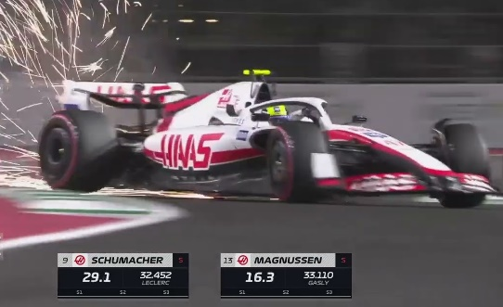
Firstly, porpoising contributes directly to periodical, temporary downforce losses or bottoming out. It can consequently lead to a loss of grip, as the car is “bouncing” back up throughout porpoising. Considering the frequent occurrence of high-speed (200+km/h) corners on circuits, where the cars rely heavily on the peak grip levels, it becomes obvious that the risk of the driver losing control over the machines is unavoidable. The issue is further observed in breaking zones, at the end of the straights, where porpoising cars become less predictable due to the constant grip changes, increasing the risk of crashing or losing valuable lap time at the breaking points. On the other hand, when it comes to bottoming out, it’s the process in which the floor of the car touches the surface of the track due to the downforce levels. Although the cars equipped with skid blocks – tiny titanium pieces located on the floor causing sparks and preventing further injury of the car’s underside, the process becomes especially dangerous in ground effect cars. This is because the increased risk of the bottoming out occurring in corners, on kerbs^{[8]}. This was for example observed on Mick Schumacher’s Haas VF22 in Jeddah during qualifying, where the car immediately lost traction upon bottoming out on the apex of the corner (as shown on Figure 2) ^{[8]}.
Figure 2 ^{[8]}
Secondly, it is also crucial to understand how it affects the car’s long term performance – tyre wear and reliability. The extreme amount of oscillation causes direct damage to components on the car, hurting not only the suspension, but also reducing the engine and gearbox life, while making the battery of the car more prone to fires and breaking. Simultaneously, a porpoising cars relies more on its tires when moving through corners, increasing the use of rubber and causing overheating problems within the tyres^{[9]}.
As proved in the Azerbaijan Grand Prix in 2022, the bouncing cars are also a direct risk to the drivers, with Lewis Hamilton voicing his concerns about the driver’s health. Many other athletes came out later in interviews, supporting Hamilton’s view on the dangers of porpoising. As a result, before the end of the 2022 season, FIA conducted an investigation, deeming the risk of spinal and minor brain injuries as a serious threat ^{[10]}.

- Experimental Overview
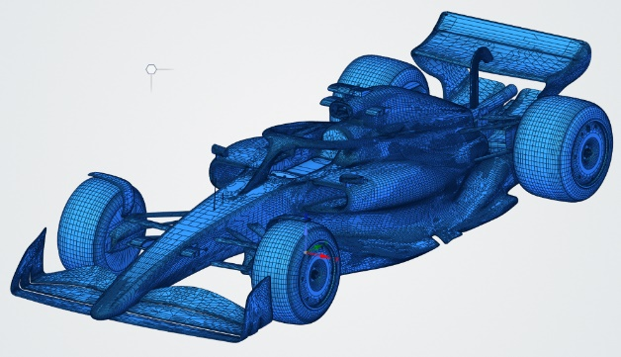
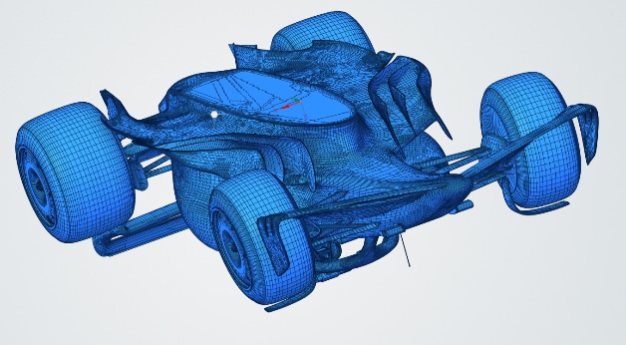
In order to provide an experimental understanding of the porpoising concept, a investigation will be conducted, where a model of a 2023 F1 car will be tested using computational fluid dynamics software, as well as in a self-built wind tunnel. Throughout the investigation, data about the downforce levels on both the front and rear axles, drag force will be obtained. Additionally, further inspections of porpoising effect will be conducted inside the running wind tunnel, where the aim is to demonstrate increasing or decreasing intensities of the phenomenon occurring with various aerodynamic changes. Finally a summary of the optimal aerodynamic setup, along with a comparison of both experimental data sources (CFD and tunnel) will be provided.
Figure 3
The tested models will rely on a small-scale, 3D printed model of an F1 2023 car, based on the Voyager AirShaper F1^{[11]} model. In total, eight different constructions will be established, allowing for a wide range of data samples for analysis.
Figure 4
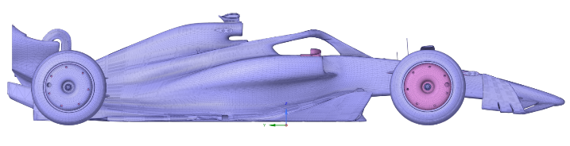
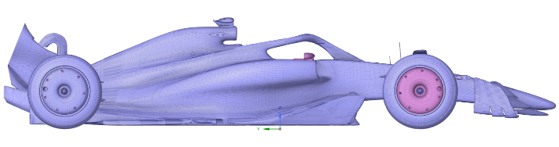
The first modified element is the underbody. As explained previously, the steepness of the floor heavily affects the strength of the ground effect. When a steeper gradient is established, more decompression occurs within the Venturi tube, allowing for a stronger ground effect^{[2]}. In turn, using a flatter surface should minimise the occurrence of the ground effect, reducing the porpoising effect in its entirety^{[12]}. Taking this into consideration, two versions of the underbody were modelled and 3D-printed. The first has an average steepness of 3.5°, allowing for nearly no pressure drag on the underbody, however with less downforce. The second, in turn, had an average steepness of 8° incline – a value close to the maximum for current cars, as it allows for much less space in the engine bay. Nevertheless, this setup should allow for more downforce, with higher drag and likely a greater porpoising risk^{[7]}.
Figure 5
Secondly, a modification was made to both the front and rear wings. The first configuration was given a -17° angle of attack, in order to generate little pressure drag while maximising downforce. Whereas, the second spec saw a steeper, -44° angle, which was the maximum downforce load before significant air stalling occurring on the wing flaps (configurations shown on Figure 5). The two positions of the wings were therefore supposed to portray the differences in extremes of the angle spectrum, making it significantly easier to test the car with different dependence on the wing-generated downforce. With a greater angle of attack, the car generates more drag, relying more heavily on the reverse lift generated by the wings. It should also imply a lesser risk of significant porpoising^{[13]}.
Finally, two specifications of the ride heights were made. Consequently, it is possible to vary between a higher or lower ground clearance, again affecting the strength of the ground effect^{[14]}.
In total, 8 models were constructed, accordingly with their aerodynamic features (explained in section 2a):
- LS.BA.GC
- LS.BA.NC
- LS.SA.GC
- LS.SA.NC
- HS.BA.GC
- HS.BA.NC
- HS.SA.GC
- HS.SA.NC
All of the models listed above have been 3D printed up to 0.025mm precision using PVC in a 1:20 scale, and tested in the wind tunnel.
- Computational Fluid Dynamics Analysis
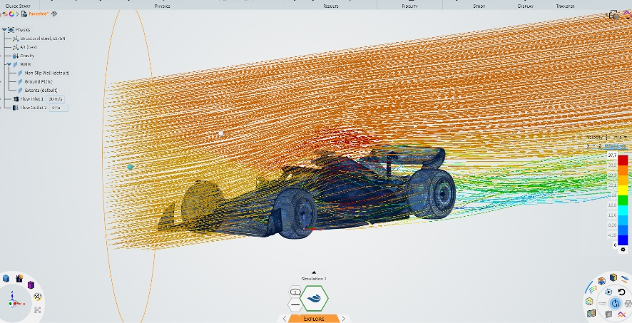
For this paper, the Computational Fluid Dynamics (CFD) analysis will be conducted in Ansys Discovery^{[15]}. Each of the car models (with varying features) will be tested with airflow velocity set at 30m/s and a standard fluid (here – gas air) density of 1.244 kg/m³. The simulations will also be conducted with up to 0.002mm fidelity – ensuring precise results^{[16]}.
Figure 6
A significant modelling assumption was made when adjusting for the lack of wheel rotation. Due to the flat-ground testing method being utilised in the wind tunnel, it is reasonable to ignore wheel rotation within the CFD results. This is usually not a standard practice in the CFD analysis process, nevertheless it simulates more accurately the real-life test bed setting. There is also a minimal interference of the wheel rotation with the test results - excess pressure and turbulent air generated by the tire spin would not affect the experiment directly. The ground floor inlets are not influenced by the wheel rotation, therefore the extent of the porpoising should not be affected by this limitation^{[17]}.
The simulation will be providing an analysis of the downforce (including the front : rear percentage ratio of lift) along with a drag force estimate. The measurements will then be re-calculated into universal measures of drag and lift coefficients, in order to allow for a unified set of measurements across different scales.

Obtained data is presented below:
Model Number | Total Downforce Estimate | Front Downforce % | Rear Downforce % | Drag Force Estimate
- LS.BA.GC | 1804 N | 42% | 58% | 862 N
- LS.BA.NC | 2531 N | 40% | 60% | 867 N
- LS.SA.GC | 1463 N | 36% | 64% | 698N
- LS.SA.NC | 2277 N | 35% | 65% | 709 N
- HS.BA.GC | 1958 N | 44% | 56% | 1033 N
- HS.BA.NC | 3101 N | 32% | 68% | 1041 N
- HS.SA.GC | 1770 N | 29% | 71% | 909 N
- HS.SA.NC | 2821 N | 26% | 74% | 903 N
Table 1
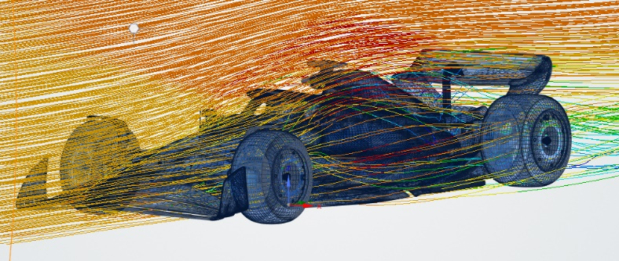
Certain trends can immediately be recognized. Firstly, the high steepness of the floor setting visibly increases the downforce for the car, however at the cost of unnecessary, extra drag. All of the HS models have significantly greater downforce levels that the respective LS counterparts with the same specs. Independently of the angle of wing attack, the downforce levels increase by about 300N with greater ground clearance, and nearly 600N with a decreased ride height. This comes at a cost of a briefly higher drag (about 200N of additional pressure drag generated by the floor). Furthermore, the wings, as expected, also increase the car’s drag and downforce levels, regardless of the ride height.
Figure 7
Judging the front and rear downforce percentage split, we can draw further conclusions from the simulation results. Instantly we can see that with the current floor design, the rear downforce increases with a steeper floor gradient. On the racetrack, this is likely to increase the understeer of the car, as the exerted weight shifts towards the rear axle. Simultaneously, the current BA wing configuration reverses the changes cause by the floor. The steeper front wing design is therefore a reliable counter to the shift in the balance change.
- Wind tunnel properties
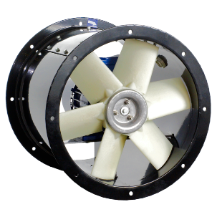
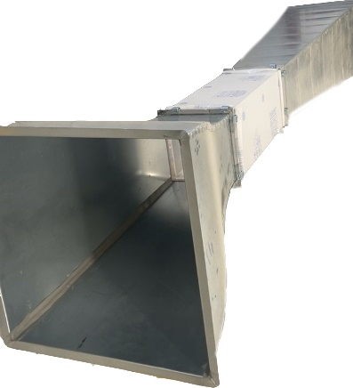
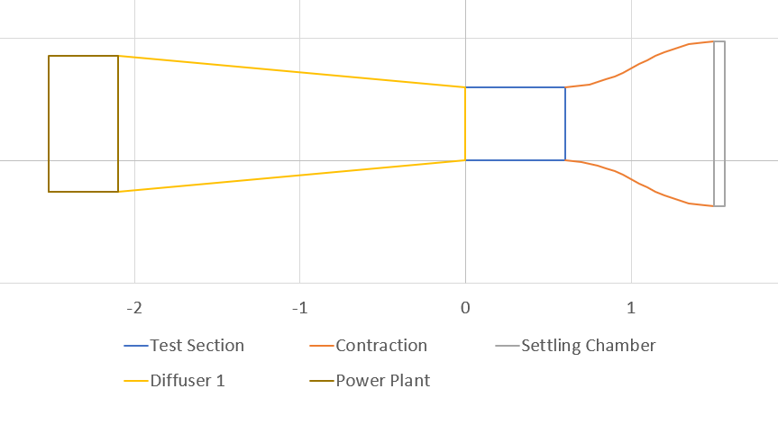
When it comes to the construction of the wind tunnel, it follows a simple, 4-section design (Figure 8). The air enters through an air inlet (Figure 11), shaped parabolically, helping accelerate the air without causing excessive turbulence. Then, at about 100km/h, the air enters the main test section where a model car is attached to a flat ground platform, a so called “test compartment” with all of the data measuring devices hidden underneath. Finally, the air exits through a long, diffuser (Figure 12), directing the air to the powerhouse of the construction – an AFC–452–300T ventilator (Figure 10), displacing 13000 m³ of air per hour and handling up to 550 Pascals of static pressure.
Figure 10 ^{[18]}
Figure 9
Figure 8

Within the test compartment, located is a data acquisition device, followed by three strain gauges – to measure downforce generated by the front and rear axle, as well as drag. The strain gauges are directly connected to the platforms the car is raised on, however located underneath the test section to not cause turbulence, allowing for effortless changes to the test subject. A Pitot tube also enters the tunnel through the top compartment in order to provide pressure readings, helping obtain the dynamic pressure, and consequently the air velocity inside the test section.
Figure 12^{[19]}
Figure 11^{[19]}
The tunnel was further optimized to reduce any turbulence. The corners inside each compartment were rounded, an air settling section was placed ahead of the car in the test section, a laminarizing honeycomb grid was implemented on the test section – air inlet boundary. Further tests were conducted using flow-vis, a coloured powder helping understand air patterns, in order to determine the air behaviour in the diffuser. Finally, the system was calibrated using known masses and shapes (cylinder, cube, sphere) with known aerodynamic properties to ensure a thoroughly checked scaling process. The process of data acquisition was further automated by graphing
the data from the DAQ and pressure meter on a laptop. Further data extraction was then done in Excel^{[20]}, where the analog voltage reading was converted into force measurements and finally, drag and downforce levels.

- Which of the models performed best
The wind tunnel tests were conducted three times for each of the vehicle specifications in order to decrease the risk of anomalous results. No repeats had to be made, as the calculated percentage uncertainty of the repeats never exceeded 3%. With such a precise dataset, the averages of data samples were found and recorded below.
Importantly, due to porpoising occurring on some of the models, vibrations were occurring, producing non-uniform values of downforce. Consequently, the mean values were taken and presented in Table 2.
Model Number | Total Downforce Estimate | Front Downforce % | Rear Downforce % | Drag Force Estimate
- LS.BA.GC | 4.41 N | 44% | 56% | 2.16 N
- LS.BA.NC | 6.33 N | 38% | 42% | 2.13 N
- LS.SA.GC | 3.72 N | 43% | 57% | 1.72 N
- LS.SA.NC | 5.79 N | 37% | 63% | 1.73 N
- HS.BA.GC | 4.85 N | 49% | 51% | 2.60 N
- HS.BA.NC | 7.78 N | 34% | 66% | 2.68 N
- HS.SA.GC | 4.44 N | 31% | 69% | 2.31 N
- HS.SA.NC | 7.09 N | 22% | 78% | 2.28 N
Table 2
Like in the case of the CFD, we initially see the same trends reoccurring. The steepness of the floor again proportionally influences downforce acting on the models, but at a cost of a briefly higher drag. The wings, just as previously, increase both downforce and lift with a bigger angle of attack. The percentage split of the front and rear downforce has also remained similar to the previous readings.
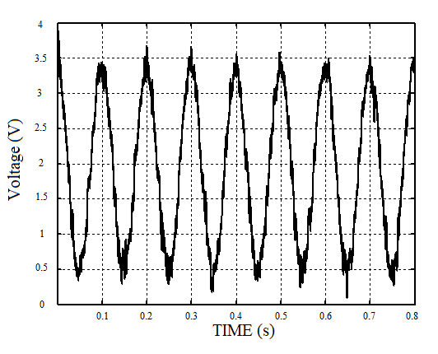
More importantly, however, the wind tunnel test has managed to showcase the porpoising occurring on the models. Although on the recordings made of the test section you were unable to see the oscillations, the data acquisition device with a measurement frequency of 1000Hz (1000 readings per second) has managed to pick up the constant changes in downforce values, both for the front and rear of the car. In general, the results followed a sinusoidal curve, as expected. This is shown on Figure 13, where Voltage (proportional to downforce) corresponds sinusoidally to time during the testing of HS.BA.NC.
Figure 13
It is hereby worth mentioning that there was no porpoising present (less than 1% downforce range – within the acceptable measurement uncertainty in the data collection process) for any of the models with increased ride height (GS), consequently they will not be included in the data set.
When it came to the other models, the porpoising was not visible in real life. Due to such a small scale of the model, it is impossible to notice the oscillations, as they occur at higher frequencies and with relatively insignificant magnitudes. Even despite attempts to record the car’s side profile in slow motion, the variation in ride height was not observable, only very minor vibrations were seen. Due to the size of the wind tunnel testing section, it was also not possible to utilise bigger models.
Nevertheless, conclusions were made from the collected data, presented below:
Model Number | Total Downforce | Downforce range | Downforce % uncertainty (half of range) | Absolute range | Vibration frequency
(2) LS.BA.NC | 6.33 N | 6.14N – 6.53 N | 6.2% | 0.39 N | 41Hz
(4) LS.SA.NC | 5.79 N | 5.53N – 6.04 N | 8.8% | 0.51 N | 29Hz
(6) HS.BA.NC | 7.78 N | 6.92 N – 8.64 N | 22% | 1.72 N | 10Hz
(8) HS.SA.NC | 7.09 N | 6.10 N – 8.09 N | 28% | 1.99 N | 7Hz
Table 3
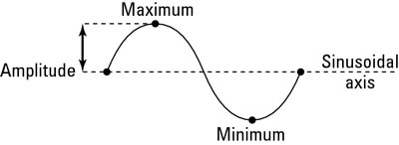
It is hereby worth mentioning, that the car follows an oscillation pattern presented on Figure 14. The downforce range therefore represents the minimum and maximum value of the downforce. The absolute range represents double the amplitude, and the uncertainty - the maximum deviation of value from the mean, expressed as a percentage. The vibration frequency, in turn, explains how many cycles of oscillation the car goes through in one second.

Figure 14
Immediately, certain conclusions can be drawn about the porpoising intensity on each of the models.
First of all, as mentioned previously, models with higher ride height portrayed zero porpoising activity. That is because the air flowing under the car can more freely ‘leave’ the underbody, therefore Venturi effect won’t occur. Consequently, there is no possibility for the porpoising sequence to start.
Secondly, when it came to the other models, they showed a variety of different trends. As expected, the downforce range was higher for the HS models, where the floor has a more significance in generating it.
That is: due to the extra exerted weight, the suspension compresses, pushing the car down. Then, because the height above ground decreases, less air can enter the underbody, again causing a reduction in downforce, leading to the suspension decompressing and the car going back up.
Consequently, the steeper floor models displayed a nearly 5 times greater amplitude of vibrations, and a nearly 3 times greater percentage uncertainty of downforce in comparison to the LS models. Additionally, due to increased amplitude of porpoising, the frequency of vibrations decreased. This meant that the cars were suffering from less frequent, but more intense vibrations.
Finally, as shown in the cases of models 2 & 6, the wings with bigger angles of attack showed to be beneficial in briefly reducing the effect of porpoising. This came at a cost of additional drag, but allowed to reach a higher maximum downforce level.

- CFD vs wind tunnel comparison
Although no conclusions regarding porpoising could be made following the CFD simulations, they were a crucial marker in determining the initial properties of the cars, while helping pick up potential anomalous readings in the wind tunnel simulation. Consequently, in order to confirm the veracity of the experiment, drag and downforce coefficients will be calculated from both sources and compared. That is because the wind tunnel readings should be approximately 400 times smaller than the CFD readings – prints of the models were conducted in 1:20 scale and both drag and downforce are proportional to the frontal area of the car^{[2]}. The scale of the readings is therefore squared (0.05²=0.0025 = 1/400).
Using the mathematical formulas^{[2]}:
$$C_{L}=\frac{2F_{L}}{Aρv^{2}} and { C}_{D}=\frac{2F_{D}}{Aρv^{2}}$$
Where
A = 1.698m²
ρ = 1.244kg/m³
v = 30 m/s

Applying the data from both wind tunnel and CFD, we obtain the following
Model name | CFD lift coefficient | Tunnel lift coefficient | Percentage difference | CFD drag coefficient | Tunnel drag coefficient | Percentage difference
1) LS.BA.GC | -1.898 | -1.856 | -2.22% | 0.907 | 0.909 | 0.23%
2) LS.BA.NC | -2.663 | -2.664 | 0.04% | 0.912 | 0.896 | -1.73%
3) LS.SA.GC | -1.539 | -1.565 | 1.71% | 0.734 | 0.724 | -1.43%
4) LS.SA.NC | -2.395 | -2.437 | 1.71% | 0.746 | 0.728 | -2.40%
5) HS.BA.GC | -2.060 | -2.041 | -0.92% | 1.087 | 1.094 | 0.68%
6) HS.BA.NC | -3.262 | -3.274 | 0.35% | 1.095 | 1.128 | 2.98%
7) HS.SA.GC | -1.862 | -1.868 | 0.34% | 0.956 | 0.972 | 1.65%
8) HS.SA.NC | -2.968 | -2.984 | 0.53% | 0.950 | 0.959 | 1.00%

Table 4
As seen, the uncertainties in the readings ranged from to -2.40% to 2.98%, producing a total uncertainty of 5.38%. It can therefore be ultimately concluded that the wind tunnel readings were reliable and can be used as grounds for further conclusions.

- Conclusions
Firstly, all of the initial expectations regarding the models were met. We can therefore conclude that the experiment was a success.
As established, there are three main solutions to combat porpoising.
First of all, as expected from aerodynamics theory, the most efficient solution is to increase the car’s ground clearance (ride height). This will drastically decrease the efficiency of the underbody, as the magnitude of the Venturi effect will be reduced. Nevertheless, this is not a viable solution for Formula 1, as it leads to a significant loss of downforce. Additionally, the vehicle’s centre of mass is moved upwards, resulting in further loss of balance and lap time in corners.
Secondly, we observed that reducing the steepness of the floor gradient decreases the magnitude of the Venturi effect. Consequently, it produces significantly smaller amplitude porpoising, but at a higher frequency. This, despite being an advantage, again causes a significant loss in downforce, though with a briefly lower drag.
Finally, increasing the wing angle of attack will result in a reduction of the amplitude of porpoising oscillations. Still, it carries a disadvantage of additional drag. Undeniably, however, it is the most viable of the listed solutions. On circuits such as Monaco or Singapore, high downforce and compromised top speed are required for optimal performance. This could therefore act as a genuine solution in F1 races.
This was also shown in "Analyzing Porpoising on High Downforce Race Cars: Causes and Possible Setup Adjustments to Avoid It”. Amongst the findings, the researchers specifically underlined the sensitivity of aerodynamic loads to ride height variations. Thus they addressed the solutions of increasing the car’s ride height or stiffening the suspension system. Modifying the aerodynamic setup in order to establish a more stable downforce curve was another major conclusion – by smoothing out the downforce curve, teams can reduce the abrupt changes that trigger porpoising^{[12]}. In my case, the smoothing occurred primarily through altering the underbody’s gradient and wing angle, nevertheless other methods could be undertaken.
But how does this compare to the solutions that were developed in Formula 1 across the last two years?
The general trend in both the real life and the conducted investigation was to reduce the importance of the car’s underbody. Tackling porpoising, despite not being a necessity, offered a significant gain in performance. The teams have therefore settled for an optimisation of the porpoising, while maximising the advantages of the floor. This was done primarily with the use of sidepods and side skirts – elements that play a crucial role in regulating and limiting the flow of air into and out of the underbody. They allowed for more air flow to circulate into and out of the underbody, therefore reducing the efficiency of Venturi tube, but performing the effect on a larger volume of air, therefore obtaining more downforce at a cost of briefly higher drag.

- Further research and experimental methods
Overall, I believe that the conducted research was already a very significant undertaking. It took me approximately 200 hours of manual labour and designing to build the wind tunnel alone. Additionally, the absolute uncertainty between the computer simulation and wind tunnel was within 5%. At industry-level testing speeds of 100+km/h ^{[21][22]} this was a major success.
Throughout the project, further work also had to be done on the models, as 8 distinct designs were made. Unluckily, despite the attempts, due to the limited 3D printing precision and modelling time constraints, I was unable to produce a number of models that would more accurately represent the solutions undertaken by the teams in real life. This remains possible, but would require hundreds of additional hours spent optimising the model.
Nevertheless, even using the current models, there remains room for improvement. Requiring a significantly more complex design, there is a possibility of arranging a moving-belt floor system within the wind tunnel. By adding a electric motor and a small conveyer belt, it is possible to account for wheel movement on the car. The drag would therefore be calculated from an algorithm, controlling the speed of the belt accordingly with the movement of the vehicle. The downforce, in turn, would still be measured using strain gauges, holding up the belt arrangement. The simulation is therefore more precise and closer to a real-life setting^{[23]}.

- References
- “The Origins of Ground Effect | Formula 1®,” Formula 1®. Apr. 05, 2022. [Online]. Available: https://www.formula1.com/en/latest/article/watch-the-origins-of-ground-effect.6i1MZBs5xe6cjO2deb57hV
- C. L. Roberto and U. P. De Catalunya Departament De Mecànica De Fluids, “Aerodynamic study of the wake effect on a Formula 1 car in curves,” Sep. 28, 2021. https://upcommons.upc.edu/handle/2117/360878?show=full
- M. Jenkins and S. Floyd, “Trajectories in the Evolution of Technology: A Multi-Level Study of Competition in Formula 1 Racing,” Organization Studies, vol. 22, no. 6, pp. 945–969, Nov. 2001, doi: 10.1177/0170840601226003.
- X. Zhang, W. Toet, and J. Zerihan, “Ground effect Aerodynamics of race cars,” Applied Mechanics Reviews, vol. 59, no. 1, pp. 33–49, Jan. 2006, doi: 10.1115/1.2110263.
- HappyApple, Diagram illustrating the Venturi effect. 2006. [Online]. Available: https://upload.wikimedia.org/wikipedia/commons/4/4b/Venturi5.svg
- A. Fonda and P. J. Torres, “Periodic solutions of discontinuous second order differential equations. The porpoising effect,” Nonlinear Analysis: Real World Applications/Nonlinear Analysis. B, Real World Applications, vol. 74, p. 103948, Dec. 2023, doi: 10.1016/j.nonrwa.2023.103948.
- R. S. Floyd and E. H. Law, “Simulation and analysis of suspension and aerodynamic interactions of race cars,” SAE Technical Papers on CD-ROM/SAE Technical Paper Series, Dec. 1994, doi: 10.4271/942537.
- Formula 1, “Formula 1 STC Saudi Arabian Grand Prix 2022”, F1 TV. Mar. 27, 2022. [Online]. Available: https://f1tv.formula1.com/page/4334/formula-1-stc-saudi-arabian-grand-prix-2022
- O. H. Ehirim, K. Knowles, and A. J. Saddington, “A review of Ground-Effect Diffuser Aerodynamics,” Journal of Fluids Engineering, vol. 141, no. 2, Jun. 2018, doi: 10.1115/1.4040501.
- “FIA takes steps to reduce porpoising in the interests of safety,” Federation Internationale De L’Automobile, Jun. 16, 2022. https://www.fia.com/news/fia-takes-steps-reduce-porpoising-interests-safety
- AirShaper. "Voyager F1 [Online model]." Available: https://airshaper.com/f1-aerodynamics-challenge, 2024.
- M. Gadola, D. Chindamo, P. Magri, and G. Sandrini, “Analyzing porpoising on high downforce race cars: causes and possible setup adjustments to avoid it,” Energies, vol. 15, no. 18, p. 6677, Sep. 2022, doi: 10.3390/en15186677.
- Z. Jonathan, “An investigation into the aerodynamics of wings in ground effect,” Doctoral thesis, University of Southampton, 2001. [Online]. Available: https://eprints.soton.ac.uk/426058/
- H. Tshikalang, “The Effects of Wake Due to Ground Clearance of a 2022 Formula 1 Car,” Bachelor’s thesis, University of the Witwatersrand, Johannesburg, 2023. doi: 10.13140/RG.2.2.34605.26082.
- ANSYS, Inc. "ANSYS Discovery" Version 2024, Canonsburg, PA, USA, 2024.
- N. U. Ravelli, N. M. Savini, and Department of Engineering and Applied Sciences, University of Bergamo, “Aerodynamic Simulation of a 2017 F1 Car with Open-Source CFD Code,” Journal of Traffic and Transportation Engineering, vol. 6, no. 4, pp. 155–163, 2018, doi: 10.17265/2328-2142/2018.04.001.
- P. Aschwanden, J. Müller, and U. Knörnschild, “Experimental study on the influence of model motion on the aerodynamic performance of a race car,” SAE Technical Papers on CD-ROM/SAE Technical Paper Series, Apr. 2006, doi: 10.4271/2006-01-0803.
- Xplo, Ventillator photo. [Online]. Available: https://wentylacja-sklep-internetowy.pl/venture-industries-wentylator-kanalowy-afc-en.html#watermark-1
- M. a. G. Hernandez, A. I. M. Lopez, A. Jarząbek, J. M. P. Perales, Y. Wu, and S. Xiaoxiao, “Design Methodology for a Quick and Low-Cost Wind Tunnel,” in InTech eBooks, 2013. doi: 10.5772/54169.
- Microsoft Corporation. "Microsoft Excel" Version 2024, Redmond, WA, USA, 2024
- M. Shehadi, “Testing ground-effect aerodynamics on a scaled F1 car,” 2021 ASEE Virtual Annual Conference Content Access Proceedings, Aug. 2021, doi: 10.18260/1-2--36524.
- L. F. East, “The measurement of ground effect using a fixed ground board in a wind tunnel,” 1970. https://naca.central.cranfield.ac.uk/handle/1826.2/2963
- Kim and D. Geropp, “Experimental investigation of the ground effect on the flow around some two-dimensional bluff bodies with moving-belt technique,” Journal of Wind Engineering and Industrial Aerodynamics, vol. 74–76, pp. 511–519, Apr. 1998, doi: 10.1016/s0167-6105(98)00046-4.

- Alphabetised Bibliography
- AirShaper. "Voyager F1 [Online model]." Available: https://airshaper.com/f1-aerodynamics-challenge, 2024.
- ANSYS, Inc. "ANSYS Discovery" Version 2024, Canonsburg, PA, USA, 2024.
- Aschwanden, P., Müller, J., and Knörnschild, U., “Experimental study on the influence of model motion on the aerodynamic performance of a race car,” SAE Technical Papers on CD-ROM/SAE Technical Paper Series, Apr. 2006, doi: 10.4271/2006-01-0803.
- East, L. F., “The measurement of ground effect using a fixed ground board in a wind tunnel,” 1970. https://naca.central.cranfield.ac.uk/handle/1826.2/2963
- Ehirim, O. H., Knowles, K., and Saddington, A. J., “A review of Ground-Effect Diffuser Aerodynamics,” Journal of Fluids Engineering, vol. 141, no. 2, Jun. 2018, doi: 10.1115/1.4040501.
- Federation Internationale De L’Automobile, “FIA takes steps to reduce porpoising in the interests of safety,” Jun. 16, 2022. https://www.fia.com/news/fia-takes-steps-reduce-porpoising-interests-safety
- Floyd, R. S., and Law, E. H., “Simulation and analysis of suspension and aerodynamic interactions of race cars,” SAE Technical Papers on CD-ROM/SAE Technical Paper Series, Dec. 1994, doi: 10.4271/942537.
- Fonda, A., and Torres, P. J., “Periodic solutions of discontinuous second order differential equations. The porpoising effect,” Nonlinear Analysis: Real World Applications/Nonlinear Analysis. B, Real World Applications, vol. 74, p. 103948, Dec. 2023, doi: 10.1016/j.nonrwa.2023.103948.
- Formula 1®, “Formula 1 STC Saudi Arabian Grand Prix 2022,” F1 TV. Mar. 27, 2022. [Online]. Available: https://f1tv.formula1.com/page/4334/formula-1-stc-saudi-arabian-grand-prix-2022
- Formula 1®, “The Origins of Ground Effect | Formula 1®,” Apr. 05, 2022. [Online]. Available: https://www.formula1.com/en/latest/article/watch-the-origins-of-ground-effect.6i1MZBs5xe6cjO2deb57hV
- Gadola, M., Chindamo, D., Magri, P., and Sandrini, G., “Analyzing porpoising on high downforce race cars: causes and possible setup adjustments to avoid it,” Energies, vol. 15, no. 18, p. 6677, Sep. 2022, doi: 10.3390/en15186677.
- HappyApple, Diagram illustrating the Venturi effect. 2006. [Online]. Available: https://upload.wikimedia.org/wikipedia/commons/4/4b/Venturi5.svg
- Hernandez, M. A. G., Lopez, A. I. M., Jarząbek, A., Perales, J. M. P., Wu, Y., and Xiaoxiao, S., “Design Methodology for a Quick and Low-Cost Wind Tunnel,” InTech eBooks, 2013. doi: 10.5772/54169.
- Jenkins, M., and Floyd, S., “Trajectories in the Evolution of Technology: A Multi-Level Study of Competition in Formula 1 Racing,” Organization Studies, vol. 22, no. 6, pp. 945–969, Nov. 2001, doi: 10.1177/0170840601226003.
- Jonathan, Z., “An investigation into the aerodynamics of wings in ground effect,” Doctoral thesis, University of Southampton, 2001. [Online]. Available: https://eprints.soton.ac.uk/426058/
- Kim, D., and Geropp, D., “Experimental investigation of the ground effect on the flow around some two-dimensional bluff bodies with moving-belt technique,” Journal of Wind Engineering and Industrial Aerodynamics, vol. 74–76, pp. 511–519, Apr. 1998, doi: 10.1016/s0167-6105(98)00046-4.
- Microsoft Corporation, "Microsoft Excel" Version 2024, Redmond, WA, USA, 2024.
- Ravelli, N. U., Savini, N. M., and Department of Engineering and Applied Sciences, University of Bergamo, “Aerodynamic Simulation of a 2017 F1 Car with Open-Source CFD Code,” Journal of Traffic and Transportation Engineering, vol. 6, no. 4, pp. 155–163, 2018, doi: 10.17265/2328-2142/2018.04.001.
- Roberto, C. L., and De Catalunya Departament De Mecànica De Fluids, U. P., “Aerodynamic study of the wake effect on a Formula 1 car in curves,” Sep. 28, 2021. https://upcommons.upc.edu/handle/2117/360878?show=full
- Shehadi, M., “Testing ground-effect aerodynamics on a scaled F1 car,” 2021 ASEE Virtual Annual Conference Content Access Proceedings, Aug. 2021, doi: 10.18260/1-2--36524.
- Tshikalang, H., “The Effects of Wake Due to Ground Clearance of a 2022 Formula 1 Car,” Bachelor’s thesis, University of the Witwatersrand, Johannesburg, 2023. doi: 10.13140/RG.2.2.34605.26082.
- Xplo, Ventillator photo. [Online]. Available: https://wentylacja-sklep-internetowy.pl/venture-industries-wentylator-kanalowy-afc-en.html#watermark-1
- Zhang, X., Toet, W., and Zerihan, J., “Ground effect Aerodynamics of race cars,” Applied Mechanics Reviews, vol. 59, no. 1, pp. 33–49, Jan. 2006, doi: 10.1115/1.2110263.

