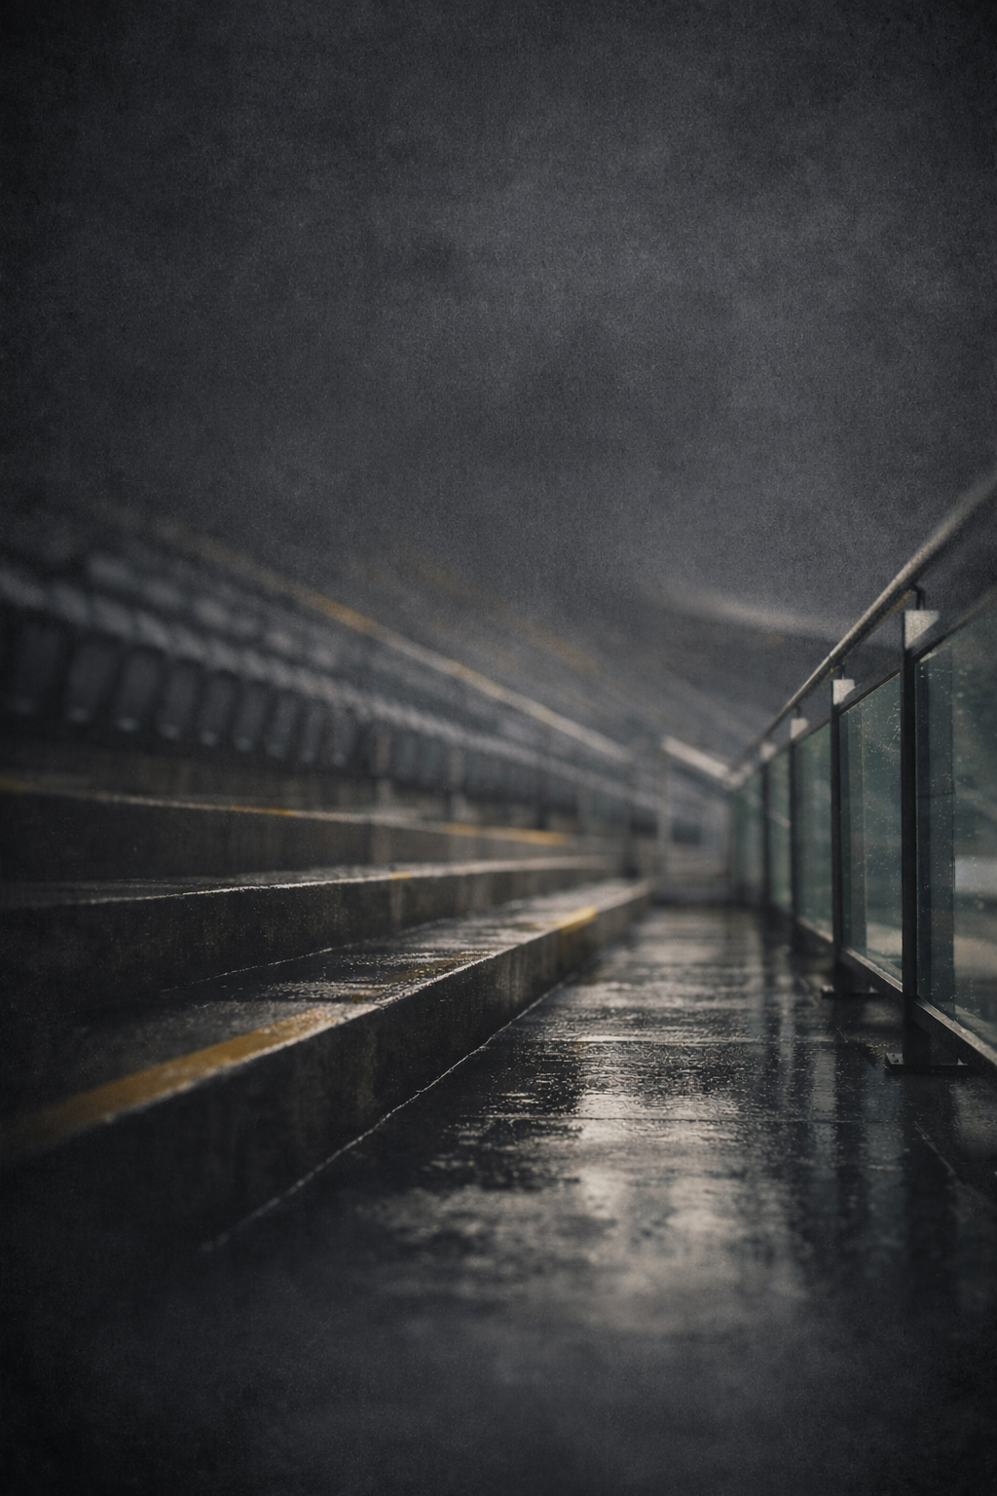

Venues NSW v Kane [2013] NSWCA 192

By Luciana Romanski

I FACTS
On 6 July 2019, the respondent, being Ms Kerri Kane (‘Kane’) fell as she was walking downstairs within the lower concourse of the western grandstand of the McDonald Jones Stadium located in Broadmeadow. The defendant on behalf of the stadium is Venues NSW. Kane’s fall was captured by CCTV video filmed from the other side of the oval, however, little footage captured that she fell almost immediately after commencing her descent on the left-hand side of the steps. This was a sudden fall, and Kane stood up approximately five (5) seconds later. Subsequently, Kane proceeded down the stairs whole holding on to the glass balustrade with her right hand and holding on to her friend in her left hand.

II PRIMARY JUDGMENT IN THE DISTRICT COURT
The primary judge found that Kane was taking reasonable care and accepted her evidence that she slipped, while rejecting the defence’s expert opinion that she had overstepped. The Court ordered an amount of $91,117 against the Venues NSW on the basis of a breach of duty by failing to install a handrail alongside the steps.
Venue NSW appealed the primary judgement in this matter by seeking leave to appeal, as the judgement amounted to less than $100,000.

III JUDGES
The Judges in this matter were Justices of Appeal Leeming and Adamson and Acting Justice of Appeal Simpson. Adamson JA and Simpson AJA agreed with the judgement of Leeming JA.

IV LEGAL ISSUES
The main legal issue was whether the primary judge erred in finding that a reasonable person in the position of Venues NSW would install a handrail as a precaution against the risk of harm resulting from the stadium steps.
The legislation considered was ss 5B and 5C of the Civil Liability Act (‘CLA’).

V THE SUPREME COURT’S DECISION
Leeming JA addressed the decision in six steps.
- A summary of the evidence bearing upon the circumstances of the fall and the layout of the stadium.
The floor of the stadium was wet due to rainy weather and the lower rows of the stadium were exposed to the weather, however, there was some protection higher up. The Court examined photographs taken in 2022, being after the incident, from Kane’s perspective when she fell. They noted that the yellow nosing strips were not installed at the time of Kane’s fall. Additionally, the steps down in which Kane descended were not of even width. The other immediate steps were 425mm wide, however, the step in question was 300mm wide. Consequently, the maximum gradient of the area was 30 degrees, and the stand where Kane fell was much less steeply slopped at 20.6 degrees.
- Addressing the status of Venues NSW
On the pleadings, Venues NSW admitted that it had care, management and control of the stadium in 2019, however, the Court was informed that Venues NSW was constituted in 2020, being after the incident. An amendment was created through the Venues Authorities Amendment (Venues NSW) Act 2020, which succeeded to the liabilities of its identical predecessor and deemed to be the same entity as its predecessor. The Court noted that the stadium’s capacity was 30,000 people, and that a total of 373,432 people visited the stadium across 2019. Consequently, the most step use in the stadium would occur when the aisle was crowded with other spectators.
- Summarising the findings and reasoning of the primary judge
The primary judge described Kane as a generally credible witness. Her Honour accepted Kane’s evidence that her foot slipped, despite the wet and windy weather. The Court also agreed that neither the glass above the balustrade to her right or the seats to her left could fulfill the function of a handrail. In regard to causation, the primary judge should that Kane was being cautious as she looked for something to hold onto, and if there had been a handrail, she would have used it to descend down the stairs and prevent the fall. Additionally, the primary judge highlighted the risk of harm that was caused by Venues NSW due to not implementing a railing. The CLA interprets the reasonable person as:
5B General principles
- A person is not negligent in failing to take precautions against a risk of harm unless
  - the risk was foreseeable (that is, it is a risk of which the person knew or ought to have known), and
  - the risk was not insignificant, and
  - in the circumstances, a reasonable person in the person's position would have taken those precautions.
- In determining whether a reasonable person would have taken precautions against a risk of harm, the court is to consider the following (amongst other relevant things)—
  - the probability that the harm would occur if care were not taken,
  - the likely seriousness of the harm,
  - the burden of taking precautions to avoid the risk of harm,
  - the social utility of the activity that creates the risk of harm.
5C Other principles
In proceedings relating to liability for negligence—
  - the burden of taking precautions to avoid a risk of harm includes the burden of taking precautions to avoid similar risks of harm for which the person may be responsible, and
  - the fact that a risk of harm could have been avoided by doing something in a different way does not of itself give rise to or affect liability for the way in which the thing was done, and
  - the subsequent taking of action that would (had the action been taken earlier) have avoided a risk of harm does not of itself give rise to or affect liability in respect of the risk and does not of itself constitute an admission of liability in connection with the risk.

- Dealing with the side issues concerning the chamfer and luminosity of the stairs
The Court ruled that Kane did not overstep nor place her foot on the chamfer. His Honour acknowledged that Kane placed her foot fully on the horizontal surface of the step. He ruled that the placement of a yellow nosing strip at the time of the incident would have prevented the fall.
As determined in Section 5B and 5C of the CLA, the Court ruled that there was an identified risk of harm. This risk is identified as the potential circumstance whereby an individual loses their balance, falls and sustains injuries whilst walking down steps within the stadium. The Court acknowledged that people could fall as they ascend and descend steps, and hence, Venues NSW were aware that there would be a risk of harm and should have taken all measures to implement precautionary steps. This includes Venues NSW arranging for a risk assessment.
- Dealing with the main issue, being whether one or more handrails should have been installed to prevent Kane’s fall
The Court noted that Venues NSW would be held liable if there was an “entirely foreseeable risk of harm of spectators slipping on the steps and injuring themselves”. Venues NSW noted that handrails on those aisles with rows of seating on both sides were unable to be installed. They noted that the stepped aisle was intended for two-way traffic and designed to permit an ascending individual pass by a descending individual to allow faster individuals to overtake slower individuals. The Court noted that even if the steps were not crowded, it would not be unlikely that spectators would have their hands full as they may be holding bags or food. Consequently, Leeming JA did not accept that a reasonable person in the position of Venues NSW would install a handrail along those aisles which had a concrete side as the use of stepped aisles without handrails is common in similar stadiums. However, His Honour ultimately ruled that the Building Code of Australia (‘BCA’) mandates that steps be of the same horizontal width to the extent possible, which was not implemented by Venues NSW.
- Dealing with the remaining grounds of appeal and orders made
Venues NSW stated that Kane did not attempt to hold the glass balustrade as she descended and due to the sudden fall, there was no reason to believe that Kane would have had time to use the handrail to prevent the fall. Furthermore, Leeming JA agreed with the primary judge, in that aa past economic loss could not be made out.

VI ORDERS OF THE SUPREME COURT
The decision of the Court allowed the appeal by Venues NSW and ruled that a reasonable person in the position of the operator would not have installed a handrail. Leeming JA granted leave to appeal and instructed Venues NSW to file a notice of appeal in the form of the draft notice of appeal within seven days and otherwise dispense with the requirement of service. The Court overturned the $91,117 primary judgement which was awarded to Kane.

VII Implications of the Court’s Decision
The Court ruled on the obvious risk and personal responsibility that walking on concrete stadium steps, even when wet, is an obvious risk and places greater responsibility on patrons to navigate steps with care. The commonplace defence was significant in ensuring that the use of steps without handrails in similar stadiums are considered a safe practice, and therefore, an operator would have taken reasonable precaution to install them. Consequently, venue operators, particularly those in public entertainment places, have a stronger defence against slip and fall claims in standard seating areas due to the precedent set by this case.



District Court Act (No 9) 1973 (NSW) s 127(2)(c).
Venues NSW v Kane [2023] NSWCA 192 [4] (‘Venues NSW v Kane’).
Civil Liability Act (No 22) 2002 (NSW) (‘CLA’).
Venues NSW v Kane (n 2) [6].
Ibid [10].
Ibid [11].
Venues Authorities Amendment (Venues NSW) (No 29) Act 2020 (NSW).
Venues NSW v Kane (n 2) [25].
CLA (n 3) ss 5B-5C.
Ibid s 5B(1)(c).
Venues NSW v Kane (n 2) [71].
Ibid [76].

