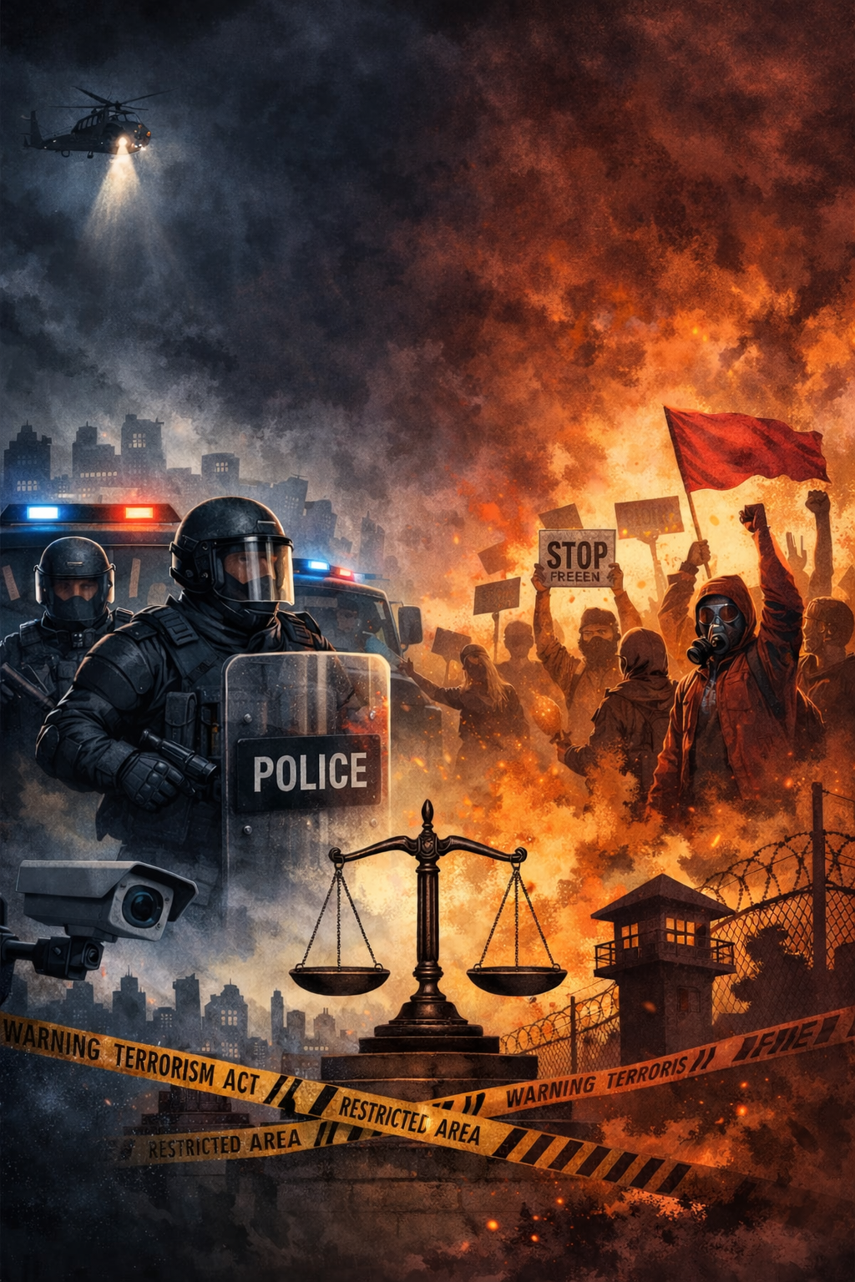

Security or Suppression?
Protest Regulation under the Terrorism and Other Legislation Amendment Act 2025 (NSW)

By Mariam Elshweikh

I THE LEGAL FRAMEWORK SURROUNDING PROTEST IN NSW
The right to protest peacefully is recognised as a fundamental feature of liberal democracy, reflecting tolerance of dissenting minority opinion and protection of political expression. The legal foundation of this right arises from the common law right to peaceful assembly, and is further protected at a constitutional level through the implied freedom of political communication recognised by the High Court of Australia.
In NSW, this right operates within a legislative framework, most notably Part 4 of the Summary Offences Act 1988 (NSW), which establishes processes for consultation and co-operation between police and protest organisers, including mechanisms for prohibition and authorisation orders. A public assembly may lawfully occur without an authorisation order, as such orders are not a precondition to exercising the common law freedom of assembly. However, authorisation orders provide limited statutory protection from certain offences, including obstruction and participation in an unlawful (generally violent) assembly. Similarly, prohibition orders do not render protests unlawful, but instead remove the limited statutory protections that authorisation orders provide, leaving participants subject to general criminal liability based on their conduct.
The right to protest in Australia is also influenced by international law, particularly Article 21 of the International Covenant on Civil and Political Rights (ICCPR) which Australia has ratified. This article recognises the right to peaceful assembly subject only to necessary restrictions.
In practice, the exercise of protest rights in NSW is subject to extensive regulation through criminal and civil law as well as potential civil liability and compensation claims. This regulatory landscape has been further expanded by the Terrorism and Other Legislation Amendment Act 2025 (NSW) (‘The Act ’), the protest-related provisions of which will be analysed in this article.

II PROTEST RELATED PROVISIONS IN THE ACT
The Terrorism and Other Legislation Amendment Act was enacted as an urgent legislative response following the horrific Bondi Beach terrorist attack and represents a significant expansion of NSW’s counterterrorism and public order framework. The Bill progressed through Parliament with exceptional speed. It was introduced into the Legislative Assembly on 22 December 2025 and passed all stages in that House on the same day. It was then introduced into the Legislative Council on 23 December 2025, where it also proceeded rapidly before being reported with amendment, adopted, and passed by 24 December 2025. The Bill received assent on 24 December 2025, meaning the full parliamentary passage occurred within approximately three days.
Substantively, the Act amends multiple statutes, including the Crimes Act 1900, Law Enforcement (Powers and Responsibilities) Act 2002 (‘LEPRA’), Summary Offences Act 1988, and the Terrorism (Police Powers) Act 2002, introducing new offences, expanding police powers, and creating mechanisms to restrict public assemblies in defined circumstances.
Of particular relevance to protest regulation, Schedule 6 inserts Part 2, Division 3A into the Terrorism (Police Powers) Act 2002, establishing the public assembly restriction declaration (PARD) scheme, which permits the temporary restriction of the authorisation of public assemblies in specified areas following certain terrorism-related authorisations or declarations. Complementary amendments are made through Schedule 5 to the Summary Offences Act 1988, inserting ss 27A and 27B to prevent public assemblies from being authorised in areas subject to a public assembly restriction declaration and to revoke existing authorisations where such declarations apply. Schedule 4 also amends LEPRA, including expanding police powers under s 19A(1)(c) to require the removal of face coverings during protests where an officer ‘reasonably suspects’ an offence, and inserting s 200(5) to clarify police direction powers in areas subject to public assembly restriction declarations.

III ARGUMENTS SUPPORTING THE LEGISLATIVE FRAMEWORK
- Targeted Preventative Protest Restrictions

The protest-related measures in The Act can be characterised as targeted, preventative public order tools designed to operate in high-risk security environments rather than as a blanket restriction on protest activity. The framework does not prohibit protests generally, but instead allows for temporary, geographically specific restrictions in circumstances following a terrorism-related declaration. Consequently, this could allow for selected civic protest spaces to remain available to protest groups. Proponents argue this reflects the State’s positive obligation to protect life and community safety while preserving the broader common law freedom of peaceful assembly.

- Proportionality and Time-Limited Security Powers

The measures also facilitate rapid operational response, allowing executive and policing authorities to act without lengthy court processes during acute security periods, while remaining time-limited and therefore are framed as proportionate rather than permanent restrictions. This approach is argued to be consistent with international human rights law, including Article 21 of the ICCPR, which permits restrictions on peaceful assembly where necessary for national security, public safety or public order. Reading speeches emphasised broader community protection objectives, including responding to “emerging threats”, while promoting “social cohesion” and ensuring community confidence following terrorism incidents.

C. Expanded Police Identification Powers at Protests
In addition, The Act enhances police powers to require the removal of face coverings during public assemblies. These expanded police powers are framed by supporters as improving identification and accountability where there is reasonable suspicion of offending, particularly in circumstances where particular extremist groups have historically used uniform clothing and facial concealment to avoid identification.
Taken together, these measures are presented by proponents as strengthening public safety and community confidence, supporting respectful public mourning following terrorist violence, and promoting social cohesion during periods of heightened social tension.

IV CRITIQUES OF THE LEGISLATIVE FRAMEWORK
Critics argue that the legislation contributes to the cumulative expansion of protest regulation in New South Wales, adding to an already extensive criminal and regulatory framework governing protest activity.
- Linking Protest Activity and Terrorism Risk

The protest-related provisions in The Act have been scrutinised for creating an unjustified conceptual link between peaceful protest activity and terrorism risk without sufficient evidentiary basis. During parliamentary debate, critics argued that “there is nothing connecting the circumstances surrounding a terror attack to the circumstances surrounding a protest”.

- Burden on Political Communication and Executive Discretion

Of greater jurisprudential significance, the framework has also been criticised for potentially burdening political communication in a manner inconsistent with the implied constitutional freedom of political communication. Parliamentary debate emphasised that peaceful protest is “a fundamental civic right in a democratic society” and warned that long-duration restriction frameworks risk capturing “lawful, peaceful and legitimate dissent that has no connection whatsoever to terrorism, extremism or public disorder”.
Uncertainty surrounding when restriction declarations may be imposed and the duration for which they may remain in force has also attracted significant criticism. Protest groups have argued that the ability to choose protest locations should be preserved, as this is often critical to maximising political visibility and political impact.
This concern is intensified by the breadth of discretionary power conferred on executive and policing authorities, including the Police Commissioner and relevant Ministers, in the absence of tightly confined statutory criteria or robust judicial oversight mechanisms. The Act permits public assembly restriction declarations to operate initially for 14 days but to be extended, at the discretion of the Commissioner or Deputy Commissioner, for a cumulative period of up to 90 days. This framework risks enabling prolonged, executive-controlled restrictions on protest activity operating with limited external scrutiny.

- Erosion of Judicial Oversight and Executive Concentration of Power

Further concern centres on the functional erosion of judicial oversight within the broader constitutional framework of responsible government and the rule of law. This concern is compounded by the shift of decision-making power away from courts toward executive and policing authorities, with parliamentary debate noting that the power to determine which protests may proceed could rest with “an unelected police commissioner, with the concurrence of a single Minister of the Cabinet,” raising concerns about the concentration of decision-making authority within the executive.
In this context, the absence of prior judicial authorisation mechanisms may also reduce procedural safeguards typically associated with court-supervised decision-making, including transparency, reviewability, and structured procedural fairness protections.

- Accelerated Legislative Process and Reduced Parliamentary Scrutiny
The accelerated legislative process has also attracted substantial criticism, with the NSW Council for Civil Liberties President cautioning against “radical, rushed and regressive laws” introduced in response to crisis situations. This is particularly relevant given the speed with which the legislation was introduced and passed, with some arguing that rapid passage may reduce parliamentary scrutiny and increase the risk of overly broad or draconian legal outcomes.
This concern is heightened by the fact that the legislation passed through both Houses in approximately three days, despite engaging core civil liberty considerations.

V PROSPECTIVE CONSTITUTIONAL CHALLENGES TO PROTEST RESTRICTIONS
The protest-related measures in The Act may burden the implied freedom of political communication, a constitutional limitation on legislative and executive power. The High Court has consistently held that such laws must pursue a legitimate purpose and be proportionate, necessary, and adequate in balance. Accordingly, restrictions that limit where, when, or how protests occur may constitute such a burden in their practical effect.
Recent jurisprudence demonstrates courts’ willingness to invalidate protest-related provisions where they are broader than necessary to achieve their purpose. In Kvelde v State of New South Wales [2023] NSWSC 1560, parts of section 214A of the Crimes Act 1900 were held invalid because restrictions on disruption to major facilities went beyond what was necessary to achieve public safety objectives and therefore impermissibly burdened political communication.
Similarly, in Lees v State of New South Wales [2025] NSWSC 1209, the Supreme Court held that police powers to direct protesters “in or near” places of worship were unconstitutional because the provision captured protest activity even where it did not affect worshippers, demonstrating the importance of narrowly tailored legislative drafting.
These decisions reflect the broader proportionality framework articulated in cases such as McCloy v NSW (2015) 257 CLR 178 and Brown v Tasmania (2017) 261 CLR 328, where the High Court emphasised that even laws pursuing legitimate ends such as public safety or protection from intimidation must not impose a greater burden on political communication than reasonably necessary.
In this context, the new protest-related measures may face constitutional scrutiny if their practical operation is found to extend beyond specific security risks or if less restrictive alternatives are available. The implication is that, while counter-terrorism and public safety are constitutionally legitimate objectives, legislation that creates broad or discretionary restrictions on protest locations or conditions risks failing the proportionality test and therefore risks constitutional invalidity if it is found to disproportionately burden democratic political communication.
These concerns are not merely theoretical; former NSW Supreme Court judge Anthony Whealy has indicated that the legislation could be vulnerable to challenge on multiple grounds and may not produce the stabilising effect intended. Further, a coalition of groups has commenced a constitutional challenge in the NSW Supreme Court, arguing that the laws impermissibly burden the implied freedom of political communication, with the potential for the matter to ultimately be considered by the High Court.

VI CONCLUSION
The Terrorism and Other Legislation Amendment Act (NSW) represents a significant and contested expansion of state power in the regulation of protest within a counter-terrorism framework. While framed as necessary to protect public safety during periods of heightened security risk, the Act raises substantial constitutional and civil liberties concerns, particularly regarding the concentration of decision-making power in executive and policing authorities and the potential burden placed on political communication. The durability of these provisions will likely depend on judicial scrutiny, with ongoing and anticipated constitutional challenges likely to determine whether the legislation represents a proportionate security measure or an unjustified encroachment on democratic freedoms.

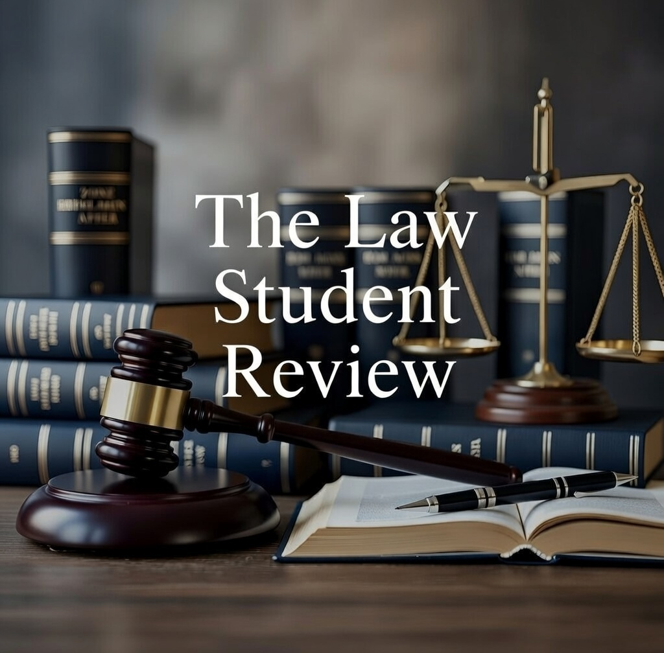

Tom Gotsis and Rowena Johns, ‘Protest Law in New South Wales’ (2024) 3 Parliament of New South Wales Parliamentary Research Service1,4.
Summary Offences Act 1988 (NSW) pt 2.
Ibid.
International Convention on Civil and Political Rights, opened for signature 16 December 1966, 999 UNTS 171 (entered into force 23 March 1976) art 21.
Terrorism and Other Legislation Amendment Act 2025 (NSW).
Crimes Act 1900 (NSW); Law Enforcement (Powers and Responsibilities) Act 2002 (NSW) (‘LEPRA’); Summary Offences Act 1988 (NSW); Terrorism (Police Powers) Act 2002 (NSW).
Terrorism and Other Legislation Amendment Act 2025 (NSW) sch 6, inserting Terrorism (Police Powers) Act 2002 (NSW) pt 2 div 3.
Terrorism and Other Legislation Amendment Act 2025 (NSW) sch 5, inserting Summary Offences Act 1988 (NSW) ss 27A–27B.
Terrorism and Other Legislation Amendment Act 2025 (NSW) sch 4, amending LEPRA s 19A(1)(c) and inserting s 200(5).
International Convention on Civil and Political Rights, opened for signature 16 December 1966, 999 UNTS 171 (entered into force 23 March 1976) art 21.
New South Wales, Parliamentary Debates, Legislative Council, 23 December 2025, 7 (Penny Sharpe, Minister for Climate Change, Minister for Energy, Minister for the Environment and Minister for Heritage).
Terrorism and Other Legislation Amendment Act 2025 (NSW) sch 4.
New South Wales, Parliamentary Debates, Legislative Council, 23 December 2025, 36.
Ibid 37.
Ibid 38.
Timothy Roberts, ‘The NSW Premier’s Outrageous Rhetoric on Peaceful Protests Sows Division in Our Community. It’s Unbecoming of His Office’, The Guardian (online, 20 December 2025) https://www.theguardian.com/law/2025/dec/20/the-nsw-premiers-outrageous-rhetoric-on-peaceful-protests-sows-division-in-our-community-its-unbecoming-of-his-office-ntwnfb
Kvelde v State of New South Wales [2023] NSWSC 1560.
Lees v State of New South Wales [2025] NSWSC 1209.
McCloy v New South Wales (2015) 257 CLR 178; Brown v Tasmania (2017) 261 CLR 328.
Anthony Whealy KC, quoted in 'Divisive Laws Clamping Protests Face Uncertain Future', AAP News (online, 24 December 2025) https://aapnews.aap.com.au/news/divisive-laws-clamping-protests-face-uncertain-future.
Terrorism and Other Legislation Amendment Act 2025 (NSW).

