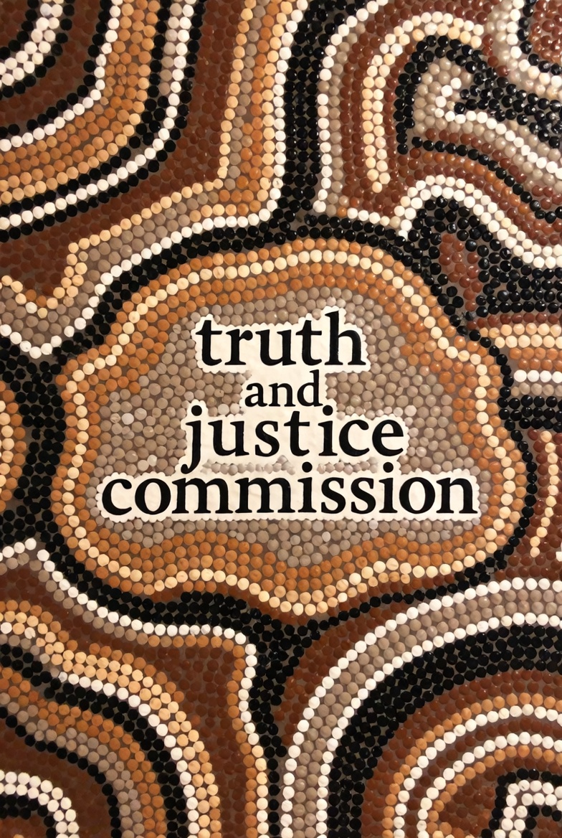

Commissioned to Fail?
The Truth About the Truth & Justice Commission
By Benjamin MacVean

I EXECUTIVE SUMMARY
The Truth and Justice Commission Bill 2024 (Cth) (‘Bill’) faces a challenging pathway toward enactment, grappling with a lukewarm reception, jurisdictional complexities and proposing a coercive power regime that is without appropriate limitations. This submission carefully assesses three significant obstacles to the Bill’s viability. Firstly, the Bill is not supported by the public, governments, and many Indigenous leaders. Many of these stakeholders support a Commission in principle, but are concerned with its substantial cost and limited perceived benefit. Consequently, this submission will recommend that the funds be reappropriated to the Closing the Gap initiative, which is underfunded yet has substantially more support. Secondly, failing adoption of the first recommendation, this submission notes that the Commission would lack jurisdiction to make inquiries implicit in a national inquiry. Accordingly, this submission recommends the terms of reference (‘TOR’) be expanded to give the Commission jurisdiction. Finally, the Bill does not provide use or derivative use immunity protections against statements of self-incrimination and client legal privilege, which are usually provided in non-judicial inquiries imbued with significant coercive investigative powers. Therefore, this submission recommends that the Bill be amended to provide immunity to witnesses.

II SCOPE OF PROBLEM
Firstly, criticisms of the Bill’s wasteful spending, ideological agenda, and repeat of previous initiatives have led to its unfavorability amongst Indigenous leaders, governments, and the Australian public, which undermines the Commission’s legitimacy. The Commission’s resources should be reallocated to the Closing the Gap initiative, which is underfunded and supported.
Secondly, the TOR’s for inquiry is limited to historical injustices perpetrated by the Commonwealth, excluding state acts. Consequently, the Commission lacks jurisdiction to investigate the subject matters its framers desired it to address, like discriminatory state laws, such as the Aborigines Protection (Amendment) Act 1940 (NSW), and colonial frontier massacres. This is not befitting of a national inquiry, designed to inquiry into Ingenious issues holistically.
Thirdly, the Bill does not determine if claims of privilege are reasonable excuses to refuse to produce evidence. Further, the Bill does not provide use or derivative use immunity. Theses immunities prevent privileged evidence whose production was compelled from being adduced as evidence in a court’s proceedings. The Bills ambiguity on these two issues will likely result in court challenges, consuming the Commission’s time and resources.

III CRITICAL ANALYSIS

A. No Public Mandate
Some Indigenous leaders have expressed dissatisfaction with the Bill’s form, like Tyronne Garston, stating the Bill does not “go far enough”. Anna Poelina criticized the Bill’s lack of Indigenous control, and Blake Candsale stated the Commission would be a symbolic exercise. These individuals support a Commission in principle, yet oppose its current form.
Many governments offer no practical support. Queensland abolished its Truth-telling Inquiry in 2024. Victoria accepted only 4 recommendations of its Yoo-rrook Justice Commission “in full” and 24 “in principle”. Agreement “in principle” only conveys ideological support of the intent of the recommendation, not tangible support. The Albanese government endorsed the principle of a Truth telling mechanism but has not supported the proposed Commission. These acts imply Governments would, at most, symbolically support a national commission.
Senator Cox asked “why are we not listening to the… First Nations people and the 5 million Australians who… voted for change,” suggesting that the referendum’s support indicates broader desire for Indigenous reform. However, Cox ignored the 9.45 million no voters, inadvertently suggesting the majority’s rejection indicates no broad desire for reform. This aligns with 2019 research reporting that Australian’s believe the Governments position on Indigenous issues is “about right”. Cox’s remarks reflect a national debate, characterised by a “silent majority” seeing reform as a “distraction from cost-of-living problems”, and a minority of “elite[s]”, who have “largely excluded [the public] from [the] discussion”. The referendum indicated the public’s “aboriginal justice inquiry fatigue”, or “consultation fatigue”, and likely reflects their view of the Commission.

B. Terms of Reference: A National Commission without a National Scope
The proposed scope of inquiry is inconsistent with intentions of establishing a national commission producing a national narrative and national recognition Specifically, the TOR only permits inquiries into historical injustice’s perpetrated by the Commonwealth government, its bodies, and non-government bodies. The TOR excludes actions by state governments and their bodies. Further, the pre 1901 investigative purview would be limited to the acts of non-government bodies, given the Commonwealth was instituted in 1901.
These limits likely originate in an effort to prevent constitutional challenges from states, arguing the Bill unlawfully encroaches on state power. The success of a challenge to the inclusion of state governments in the inquiry’s scope, would hinge on whether the impugned provisions could be characterized under a constitutional head of power. Scholars answer this question in the affirmative, stating the Bill could be characterized under the race power, external affairs power, and implied nationhood power. Alternatively, the provision could be valid if it was deemed reasonably necessary and appropriately incidental to achieving the purpose of the head of power. For example, just as the High Court in Griffin v Constantine upheld a prohibition on industrial spirits as a valid exercise of the incidental tax power, since its sale would undermine the portable spirit tax, so too might inquiries into state-perpetrated injustices be construed as incidental to a national inquiry. Without the power to investigate states, the very concept of a national investigation would be undermined.

C. Unbridled Coercive Power Regime
Given the Bill does not determine whether self-incrimination or legally privileged evidence are reasonable excuses, a Court would determine this. To do so, a Court would apply the statutory interpretation principle of legality. This is an interpretive presumption that Parliament does not intend to interfere with privilege, unless the statute makes an intention to do so unambiguously clear. Accordingly, in the absence of an express provision in the Bill, a Court would likely read the presumption into the statute. These proceedings would (a) consume the Commissions time and resources, and (b) reduce the Commissions effectiveness upon a finding that these are reasonable excuses, as it would prevent the Commissions from investigating intuitions with records on topics of interests, like the stolen generation and stolen wages.
Secondly, even with an express abrogation of privilege, the Bill lacks use or derivative use immunity. This raises concerns about the proportionality of the Commission’s powers, as these immunities are a common protection for witnesses in coercive inquires. For example, The Royal Commission Act grants power to compel persons to produce evidence even where it may incriminate them or is subject to legal privilege, but also prohibits its use in subsequent civil or criminal proceedings against the person. The Law Council considers inquiries without these immunities to be unjustifiable. The National Association of Community Legal Centers supports coercive information gathering powers being subject to these immunities. Further, witnesses are more likely to lie without these protections. Thus, lacking this immunity may work against the interests of the Commission.

IV RECOMMENDATIONS

Redirect Funds to Closing the Gap
The Bill lacks practical support from Indigenous leaders, governments, and the Australian Public. Until the Bill produces a Commission whose form reflects that desired by Indigenous leaders, and until the public recovers from “aboriginal justice inquiry fatigue”, it is recommended that the large funds allocated to the Commission be reallocated to the Closing the Gap initiative. This initiative has support from the Indigenous community and currently lacks funding to achieve its objectives. This recommendation will likely produce a unifying public sentiment, and resolve real issues faced by the Indigenous community.

Expanded Terms of Reference
It is recommended that the TOR in Clause 8 be amended to include State governments and its bodies within the scope of Inquiry. This will likely result in a constitutional challenge from a state government, arguing that the provision is not supported by a head of constitutional power. Although this will consume the Commission’s time and resources, it is a necessary challenge to ensure the Commission is equipped with a national scope. Also, as discussed, there is sound legal reasoning that suggests a Court would find the Commission’s powers fall under a head of power.

Include Use Immunity
It is recommended that the Bill be amended to explicitly state that self-incriminating evidence and legally privileged documents are not reasonable excuses to refuse to give evidence. This is necessary to ensure the Commission can access all relevant information. In addition, it is recommended that the Bill be amended to included use and derivative use immunity. These immunities will provide significant protections to those who come before the Commission and will encourage more individuals to participate in providing evidence.

D. Conclusion
This submission investigated three obstacles to the viability of the Truth and Justice Commission Bill and made subsequent recommendations. This submission first recommended that the Bill be put aside, so that its significant resources could be directed to fulfilling the Closing the Gap initiative. It recommended the TOR be expanded to cover state governments and their bodies. Finally, it recommended use and derivative immunity be included to provide necessary protections to those appearing before the Commission.

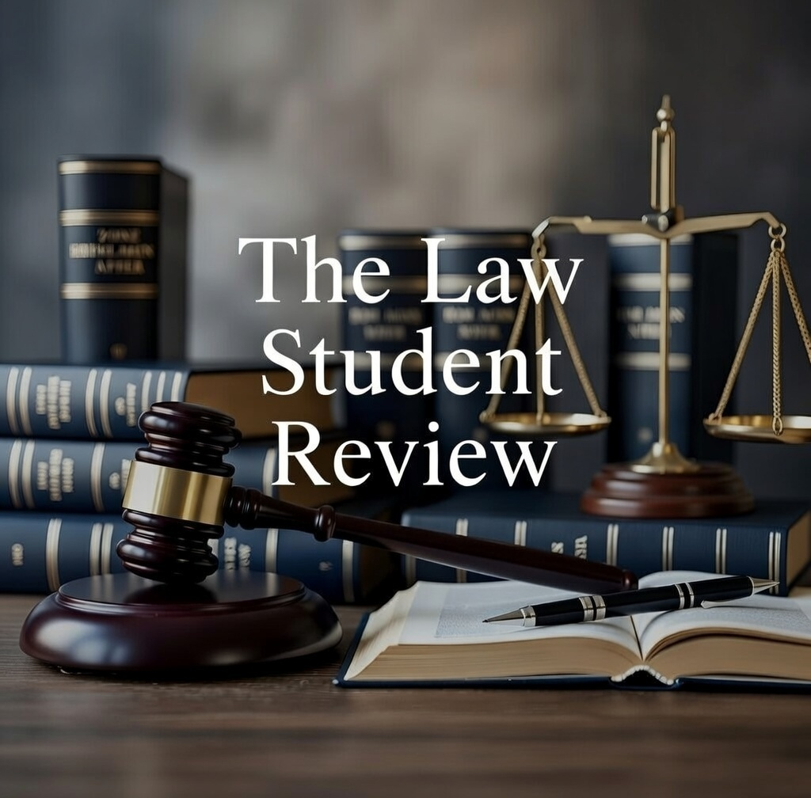

Joint Standing Committee on Aboriginal and Torres Strait Islander Affairs, ‘Truth and Justice Commission Bill 2024’ (12 November 2024).
First Nations National Constitutional Convention, Uluru Statement from the Heart (National Constitutional Convention, 26 May 2017, 3.
AAP, ‘WA Indigenous groups say truth telling bill doesn’t go far enough’, SBS (online, 5 April 2025) <https://www.sbs.com.au/nitv/article/indigenous-groups-want-more-from-truth-telling-inquiry/tsl9jhiml>.
National Indigenous Australians Agency, ‘Closing the Gap in 2020’, Australian Government Closing the Gap in 2020 (Report, 2020) 3 <https://www.niaa.gov.au/sites/default/files/reports/closing-the-gap-2020/sites/default/files/pdf/closing-the-gap-report-2020.pdf>
Peter Gregory, ‘The Greens call for ‘Truth and Justice’, The Spectator Australia (online, 05 April 2025) 3, <https://www.spectator.com.au/2022/03/the-greens-call-for-truth-and-justice/>.
Dechlan Brennan, ‘Police to provide security for Jacinta Nampijinpa Price as visit to Noongar Country sparks protest plan’, National Indigenous Time (online, 05 April 2025) 3, < https://nit.com.au/09-04-2025/17300/police-to-provide-protection-for-jacinta-nampijinpa-price-amidst-proposed-protests-against-her-visit-to-noongar-country>.
Commonwealth, Parliamentary Debates, Legislative Assembly, 17 October 2023, 4740, (Kerrynne Liddle, ‘Matters of Urgency, First Nations Australians’).
Catherline Liddle, ‘Governments inaction on Closing the Gap impacting Aboriginal and Torres Strait Islander children' (Media Release, 07 March 2025), 1.
Truth and Justice Commission Bill 2024 (Cth), cl 8(1)(a) (‘Truth and Justice Commission’).
Aborigines Protection (Amendment) Act 1940 (NSW).
R Lyndall, ‘Untangling Aboriginal Resistance and the Settler Punitive Expedition: The Hawkesbury River Frontier in New South Wales, 1794-1810’ (2013) 15(2) Journal of genocide research 219.
Australian Law Reform Commission, Approaches to Immunities (Report No 129, January 2016).
AAP, ‘WA Indigenous groups say truth telling bill doesn’t go far enough’, SBS (online, 5 April 2025) <https://www.sbs.com.au/nitv/article/indigenous-groups-want-more-from-truth-telling-inquiry/tsl9jhiml>.
Martuwarra Fitzroy River Council, Submission No 00 to Senate Standing Committee on Aboriginal and Torres Strait Islander Affairs, Parliament of Australia, Inquiry into a Truth and Justice Commission Bill 2024, (11 August 2024) 3.
Keira Jenkins, ‘Risk truth-telling will be symbolic if no one listens’, National Indigenous Times ( 19 February 2025) <https://nit.com.au/19-02-2025/16359/risk-truth-telling-will-be-symbolic-if-no-one-listens>.
Queensland Government, ‘A Fresh Start for Queensland: Path to Treaty Act repealed as Indigenous communities receive direct funding boost’, (Media Release, 28 November 2024) 1.
Adeshola Ore, ‘Victoria government blasted for rejecting truth-telling inquiry’s key recommendations’, The Guardian (online, 03 April 2024) < https://www.theguardian.com/australia-news/2024/apr/03/yoorook-justice-commission-truth-telling-inquiry-report-recommendations-victoria-government-response >.
Victoria Government, ‘Guidelines for submissions and responses to inquiries’ (Web Page) < https://www.vic.gov.au/guidelines-written-submissions-and-responses-inquiries>.
Mark McKenna, ‘The path to truth-telling in Austrlai Is thorny and Long. But there is some ground for hope’, The Guardian (online, 19 December 2024) < https://www.theguardian.com/commentisfree/2024/dec/19/the-path-to-truth-telling-in-australia-is-thorny-and-long-but-there-is-some-ground-for-hope>.
Commonwealth, Parliamentary Debates, Legislative Assembly, 02 July 2024, 2444, (‘Cox Speech’).
ABC News, ‘Voice Referendum Live Results and Updates’ (Web Page) < https://www.abc.net.au/news/elections/referendum/2023/results?filter=all&sort=az&state=all&party=all>.
Sarah Cameron, Ian McAllister, ‘Trends in Australia Political Opinion. Results from the Australia Election Study 1978 – 2019’ (2019) Australian National University 119.
M Evans, M Grattan, ‘The Voice to Parliament and the Silent Majority’ (2024) Charles Sturt University 4.
Ron Levy, Ian McAllister. ‘Public opinion on indigenous issues and constitutional recognition: three decades of liberalisation’ (2021) Australian Journal of Political Science 76.
Senate Standing Committees on Finance and Public Administration, Parliament of Australia, Aboriginal and Torress Strait Islander experience of law enforcement and justice services (Report, October 2016).
Queensland Productivity Commission, Lessons from the inquiry into service delivery to aboriginal and Torres strait islander communities (Report, 2018) 3.
Truth and Justice Commission (n 9) Cl 8.
Cox Speech (no 20) 2444.
V Barolsky, K Berger, and K Close, ‘Recognising Community Truth-Telling: An Exploration of local truth telling in Australia’ Deakin University 10.
Ibid 13.
Truth and Justice Commission (n 9) s 8(1).
New South Wales v Commonwealth (2006) 229 CLR 1.
Grain Pool of Western Australia v Commonwealth (2000) 202 CLR 479.
Megan Davis, Gabrielle Appleby, Submission No 153 to Joint Standing Committee on Aboriginal and Torres Strait Islander Affairs, ‘Inquiry into Truth and Justice Commission Bill 2024’ (12 November 2024) 7.
Actors and Announcers Equity Association v Fontana Films Pty Ltd (1982) 150 CLR 16.
Griffin v Constantine (1954) 91 CLR 136.
Pyneboard Pty Ltd v Trade Practices Commission (1983) 152 CLR 328; Crafter v Kelly [1941] SAS 237.
James Haughton, Edward Fellows, Truth and Justice Commission Bill 2024 (Bills Digest No 44 of 2024-25, 20 December 2024) 9.
Australian Law Reform Commission, Traditional Rights and Freedoms: Encroachments by Commonwealth laws, (Report No,127, 1 March 2016) 362 (‘Encroachments by Commonwealth laws’).
Ibid 355.
Royal Commission Act (1902) Cth s 6A.
Ibid s 6AA.
Ibid s 6DD.
Encroachments by Commonwealth laws (no 39) 140.
Ibid 143.
Australian Law Reform Commission, Evidence, (Interim Report No 26, 1985) 855.
Commonwealth, Parliamentary Debates, Senate Standing Committees on Finance and Public Administration, 2015, 3.7.
Catherline Liddle, ‘Governments inaction on Closing the Gap impacting Aboriginal and Torres Strait Islander children' (Media Release, 07 March 2025), 1.
Catherline Liddle, ‘Governments inaction on Closing the Gap impacting Aboriginal and Torres Strait Islander children' (Media Release, 07 March 2025), 1.

