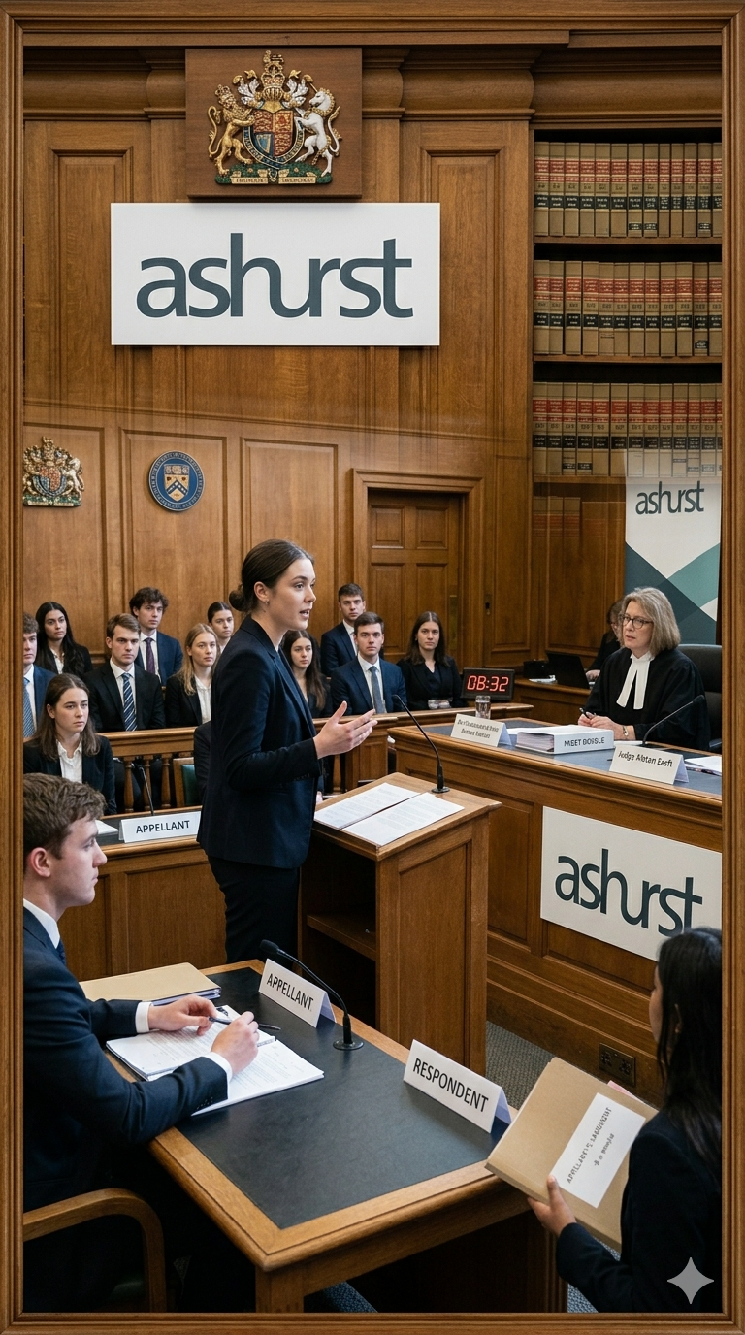

Quarter Final Submissions
Ashurst Beginners Moot 2025
Law Student Review
By Andrew Lin

WRITTEN SUBMISSION FOR THE RESPONDENT

I Vicarious liability could not be established.
- To establish vicarious liability requires four elements:
  - Wrongful act by tortfeasor.
  - Injury.
  - Requisite relationship between tortfeasor and defendant.
  - That tortfeasor’s wrongful act was within scope of employment or sufficiently connected to employment for vicarious liability to arise.
- The elements in dispute here are (c) and (d).
A WHO IS AN EMPLOYEE?
- The test for identifying an employment relationship has undergone significant clarification by the High Court of Australia. While earlier authorities adopted a multi-factorial approach, this methodology has since been refined.
- The current approach places primary emphasis on the rights and obligations under the contract, where one exists. Under this revised test, determining whether a person is an employee involves a key inquiry: whether the putative employer had the contractual right to control how, when, and where the worker performed their duties.
- A general contractual obligation to complete a task does not indicate control over the manner in which that task is performed. The distinction lies in whether the employer had the right to direct not just what work is done, but how it is done.
- In this case, several contractual features suggest a lack of control by the University:
  - Firstly, under the Responsibilities clause, the Blue Shirt was assigned to assist with “other incidental tasks and duties… on an ad hoc basis.” The computer lab inspection falls within this catch-all category. The absence of direction on how the task was to be performed supports the argument that the University lacked control over the manner of work.
  - Secondly, the Payment clause states that Blue Shirts are to be paid only for hours actually worked, and there is “no provision… for sick leave, study leave etc.” The arrangement reflects transactional, task-based payment. This is more consistent with a contractor-style engagement than with employment.
  - Thirdly, the Personality clause states that the individual’s “number one obligation” is to “have fun.” It reflects an absence of strict oversight or managerial authority, suggesting that the arrangement was designed more as a student engagement program than as a formal employment relationship.
  - Lastly, the Times clause provides that Blue Shirts are only assigned duties based on the availabilities they voluntarily submit. The University cannot require them to work at times for which they have not indicated availability. This arrangement places control over working hours squarely in the hands of the Blue Shirts themselves.
- Accordingly, the University did not retain a sufficient contractual right of control over the Blue Shirt, and the relationship therefore does not meet the legal test for employment.
B WHAT IS THE COURSE OF EMPLOYMENT?
- To determine whether a wrongful act occurred in the course of employment, the key is identifying what the employee was actually employed and represented as doing. This requires examining the parties’ conduct after the contract was formed, particularly the actions of the person who caused the injury. Moreover, an employer will not be vicariously liable where the employee was on a "frolic of their own”.
- In this case, the Blue Shirt was not performing any core duty defined in the Blue Shirt contract. The role of inspecting computer labs was not expressly listed as part of the standard responsibilities. There is no evidence that such duties were part of the Blue Shirt’s usual functions or publicly represented responsibilities.
- Furthermore, the manner in which the task was performed, with the Blue Shirt casually asking, “Are you doing anything dodgy, mate?”, demonstrates that the Blue Shirt acted with independent discretion. This conduct departs significantly from any reasonable method of fulfilling a university-assigned responsibility and instead reflects a careless and personal approach that is disconnected from the University's expectations.
- The conduct should be seen as a “frolic of their own”. The Blue Shirt’s informal and unserious manner, combined with a lack of formal assignment or structured supervision, removes the necessary connection to any official employment relationship.
- Accordingly, the act was not performed in the course of employment, and the University should not be vicariously liable.

LIST OF REFERENCES
A Cases
BIRD v DP (a pseudonym) (2024) 419 ALR 552
Bugge v Brown (1919) 26 CLR 110
CCIG Investments Pty Ltd v Schokman (2023) 97 ALJR 551
Construction, Forestry, Maritime, Mining and Energy Union v Personnel Contracting Pty Ltd (2022) 275 CLR 165
Hollis v Vabu Pty Ltd (2001) 207 CLR 21
New South Wales v Lepore (2003) 212 CLR 511
Sweeney v Boylan Nominees Pty Ltd (2006) 226 CLR 161
ZG Operations Australia Pty Ltd v Jamsek (2022) 398 ALR 603

RELEVANT CASE FACTS
The University of Gleften maintained a policy requiring a university employee to inspect all computers in a lab once per hour and report any issues to the IT department. Each lab contained approximately 10 to 15 computers, and a single employee was expected to review the entire lab.
On 20 January, Ms Angelica Blackbeard, a student of the University, attended campus and logged into a computer in the Phoenix Computer Lab at 10:07am, logging out at 11:58am. During this session, she downloaded the entire thirteenth season of “Game of Student Loans” from a website known to host copyrighted material.
On the same day, the staff member ordinarily assigned to conduct computer lab inspections informed their supervisor, Rebecca Sun, that they were ill and would not be attending work. Ms Sun, who was both the head of the IT department and the manager of the University’s Blue Shirt program, requested a Blue Shirt member to carry out the inspection of the computer labs. She provided that member with a copy of the Policy and required them to download a designated app onto their smartphone for reporting purposes. Ms Sun was unable to recall which Blue Shirt member had been assigned the task.
Blue Shirts are students of the University who assist with various tasks around campus. They are selected through a competitive process and engaged under a “Contract for Services”. Under that contract, Blue Shirts perform duties such as running tours, operating reception services, assisting staff at events, and undertaking other incidental tasks on an ad hoc basis. They are paid only for hours actually worked and are not entitled to sick leave or study leave. They are required to provide their own smartphone capable of running relevant applications. They are also required to submit their availability in advance and are not required to work outside the times they nominate.
A student present in the Phoenix Computer Lab gave evidence that a Blue Shirt member entered the lab, asked each person, “Are you doing anything dodgy, mate?”, and then left shortly thereafter. The student could not recall seeing Ms Blackbeard at the time, but based on the times at which she logged into the computer, it was accepted that it was a reasonable inference that she was present.

LAW STUDENT REVIEW
Disclaimer: The views expressed herein are solely those of the author and do not necessarily reflect other authors or the Law Student Review

Sweeney v Boylan Nominees Pty Ltd (2006) 226 CLR 161, 173 [33] (Gleeson CJ, Gummow, Hayne, Heydon and Crennan JJ); CCIG Investments Pty Ltd v Schokman (2023) 97 ALJR 551, 555-556 [12]-[14] (Kiefel CJ, Gageler, Gordon and Jagot JJ).
BIRD v DP (a pseudonym) (2024) 419 ALR 552, 568 [56] (Gageler CJ, Gordon, Edelman, Steward and Beech-Jones JJ).
Hollis v Vabu Pty Ltd (2001) 207 CLR 21.
Construction, Forestry, Maritime, Mining and Energy Union v Personnel Contracting Pty Ltd (2022) 275 CLR 165, 415 [43] and 419 [55] (Kiefel CJ, Keane and Edelman JJ) (‘CFMMEU’).
Ibid, 423 [74] (Kiefel CJ, Keane and Edelman JJ).
ZG Operations Australia Pty Ltd v Jamsek (2022) 398 ALR 603 (‘ZG Operations’).
Facts [8].
ZG Operations (n 6) 611 [34]-[36] (Kiefel CJ, Keane and Edelman JJ).
Facts [8].
ZG Operations (n 6) 609 [19] and 610 [25]-[27] (Kiefel CJ, Keane and Edelman JJ).
Facts [8].
Ibid.
ZG Operations (n 6) 610 [28]-[31] and 615 [54]-[55] (Kiefel CJ, Keane and Edelman JJ).
New South Wales v Lepore (2003) 212 CLR 511, [232] (Gleeson CJ).
CFMMEU (n 4) 425 [83] and 455 [191] (Gageler and Gleeson JJ).
Bugge v Brown (1919) 26 CLR 110, 128 (Isaacs J).

