SKUODAS CLUSTER HYBRID PROJECT
Public Disclosure - Stakeholder Engagement Plan – Annex S
Prepared for
-

Date
07/08/2026
Reference
0819625
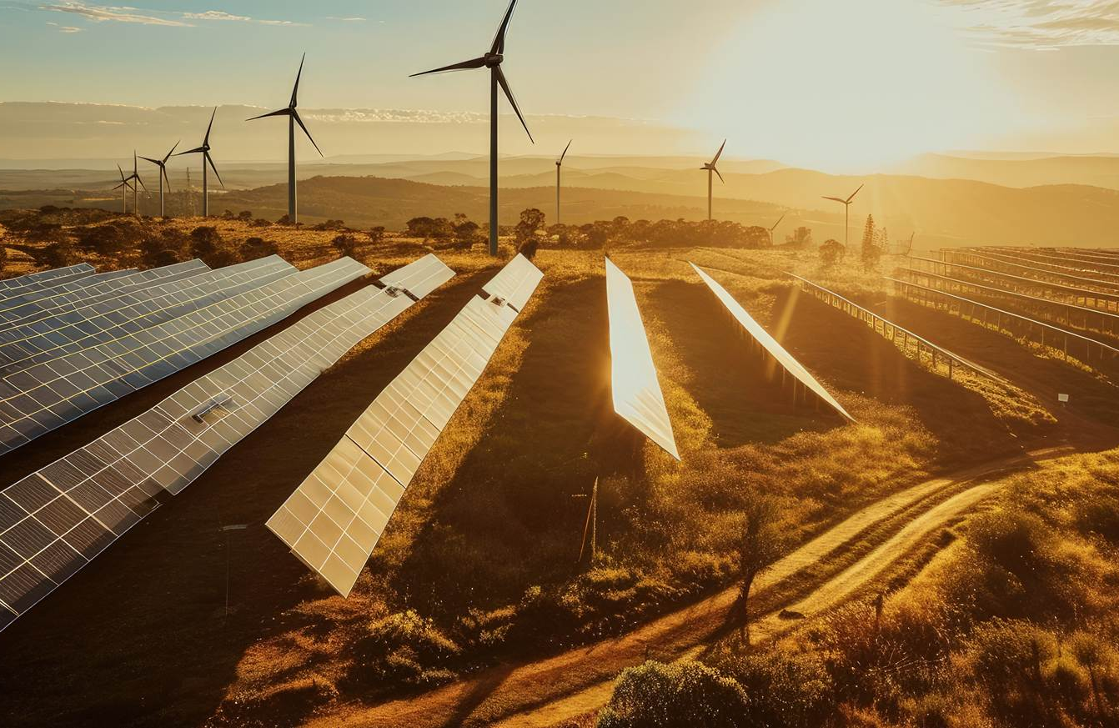
Document details
The details entered below are automatically shown on the cover and the main page footer. PLEASE NOTE: This table must NOT be removed from this document.
DOCUMENT TITLE | Skuodas Cluster Hybrid Project
DOCUMENT SUBTITLE | Public Disclosure - Stakeholder Engagement Plan – Annex S
PROJECT NUMBER | 0819625
DATE | 07/08/2026
VERSION | Final
AUTHOR | CORPI and ERM working group
CLIENT NAME | European Energy A/S

Document history
 |  |  |  | ERM Approval to issue
Version | Revision | Author | Reviewed by | Name | Date | comments
Final | 0 | CORPI working group and ERM working group | Constanza Mateos, Julius  Morkunas | Alessandro Sestagalli, Julius  Morkunas | 07/08/2026

Signature page

Skuodas Cluster Hybrid Project
Public Disclosure - Stakeholder Engagement Plan – Annex S
0819625

Alessandro Sestagalli  Partner |  | Julius Morkunas  CORPI
Constanza Mateos
Project Manager
ERM Italia S.p.A.  Via San Gregorio, 38  20124 Milan - Italy  Tel: +39 02 674401 |  | Public institution Coastal Research and Planning Institute  Vilhelmo Berbomo str. 10-201, LT-92221, Klaipėda, Lietuva;  +370 46 39 08 18; info@corpi.lt  Company code 303211151

© Copyright 2026 by The ERM International Group Limited and/or its affiliates (‘ERM’). All Rights Reserved.
No part of this work may be reproduced or transmitted in any form or by any means, without prior written permission of ERM.

Contents
1. Introduction 1
1.1 Purpose of this SEP Summary 1
1.2 Stakeholder Engagement standards, Principles, and commitments 1
2. Project Overview 2
2.1 Key Components 3
2.2 Area of Influence and communities potentially affected 4
3. Project Stakeholder Identification, mapping, prioritization, and Analysis 5
3.1 Stakeholder Identification 5
3.2 Vulnerable Groups 7
4. Engagement Programme 7
4.1 Summary of project engagement 7
4.2 Stakeholder Engagement Action Plan 8
4.3 Communication and Engagement Tools 12
5. Stakeholder engagement team 13
6. External Grievance Mechanism 13
6.1 Grievance Procedure 14
7. Monitoring, Evaluation, and Reporting 16

List of Tables
Table 3-1 Stakeholder groups analysis 6
Table 4-1 ENGAGEMENT OBJECTIVES DURING EACH PROJECT PHASE 8
Table 4-2 ENGAGEMENT ACTION PLAN 9
Table 6-1 available channels through which stakeholders may submit a grievance, question, or feedback. 15

List of Figures
Figure 2-1 Spatial Overview of Project Infrastructure and 5 km BUFFER AREA 3
Figure 6-1 Grievance Procedure diagram 15

Acronyms and ABBREVIATIONS
Acronym | Description
AoI | Area of Influence
BESS | Battery Energy Storage System
CORPI | Coastal Research and Planning Institute
EBRD | European Bank for Reconstruction and Development
EIA | Environmental Impact Assessment
EP | Equator Principles
GBVH | Gender-Based Violence and Harassment
GIIP | Good International Industry Practice
GM | Grievance Mechanism
IFC | International Finance Corporation
PS | Performance Standard
PV | Photovoltaic
SEP | Stakeholder Engagement Plan
WTG | Wind Turbine Generator

Introduction

Purpose of this SEP Summary
This document summarises the Stakeholder Engagement Plan (SEP) that has been prepared by ERM Environmental Resources Management S.R.L. (ERM) and CORPI (hereafter referred to as “CORPI”) for the Skuodas Cluster Hybrid Project (the “Project”), developed by European Energy A/S (the “Developer”). The Project comprises onshore wind, solar photovoltaic (PV), and battery energy storage system (BESS) facilities located in Skuodas District Municipality, Klaipėda County, Lithuania.
It has been prepared to support public disclosure of the Project’s Environmental and Social Impact Assessment documentation and to explain, in a concise and accessible manner, how stakeholders can obtain information, provide feedback, raise questions, and submit grievances during Project development, construction and operation.
The full Stakeholder Engagement Plan is a more detailed Project implementation document. This summary presents the key information most relevant to local communities, landowners, land users, authorities, civil society organisations and other stakeholders interested in or affected by the Project.
The SEP applies to external stakeholders, including affected communities, landowners, land users, authorities, organisations and other interested parties. Engagement with Project workers will be addressed through dedicated labour management arrangements, including a separate workers’ grievance mechanism.
Stakeholder engagement is an ongoing process, and as such, this SEP is a ‘living’ document and will be reviewed and adjusted as the Project progresses.

Stakeholder Engagement standards, Principles, and commitments
The approach adopted by the Project is aligned with applicable Lithuanian environmental permitting requirements, relevant European Union (EU) legislation on public participation, including the Aarhus Convention, as well as international lender and good international practice standards, notably the EBRD Environmental and Social Policy (2024) and Environmental and Social Requirement 10 (Stakeholder Engagement and Information Disclosure).
The key principles guiding the stakeholder engagement approach adopted for this Project are to:
- be open and transparent with stakeholders, by sharing relevant, accurate and timely information on the Project and its development;
- act responsibly and ensure accountability in the design and implementation of stakeholder engagement activities, including addressing impacts associated with Project activities;
- establish and maintain relationships with stakeholders that are grounded in trust, mutual respect, and a commitment to acting in good faith;
- respect stakeholders’ interests, views, priorities, and aspirations;
- work collaboratively and constructively with stakeholders to identify solutions that respond to shared concerns and common interests;
- be responsive, ensuring that stakeholder inputs, questions, and concerns are acknowledged and addressed clearly and within appropriate timeframes;
- take a proactive approach to engagement by anticipating information needs and potential issues, and by facilitating dialogue early in order to manage risks before they arise;
- engage with stakeholders in a manner that ensures fair treatment and balanced consideration of issues and concerns raised; and
- ensure engagement processes are inclusive and accessible, including for vulnerable and minority groups, so that all stakeholders are able to participate meaningfully, understand the information provided, and have their views heard.

Project Overview
The Project is being developed by European Energy A/S (EE), an international renewable energy company active in the development, construction, and operation of renewable energy assets across Europe. European Energy is the Project owner and is responsible for the overall development, permitting, financing, construction, and operation of the Skuodas Cluster Hybrid Project throughout its lifecycle.
The Project is located in north‑western Lithuania, within the Skuodas District Municipality, Klaipėda County. The Project will be developed across land plots situated within the villages of Plaušiniai, Palegija, Žemytė, and Juodeikiai, all of which fall under the Lenkimai eldership.
The Project area covers approximately 230–250 hectares (ha) and is primarily characterized by flat, intensively cultivated agricultural land, intersected by local roads and drainage features. Terrain elevation across the Project area ranges between approximately 30 and 45 metres (m) above sea level.
The Project is located in proximity to the Lithuanian-Latvian border, which lies less than 3 kilometers (km) from the nearest Project components. The Project area is situated approximately 50 km north of Klaipėda, including Klaipėda Port, and approximately 15–20 km from the Baltic Sea coastline.
Figure 2-1 Spatial Overview of Project Infrastructure and 5 km BUFFER AREA
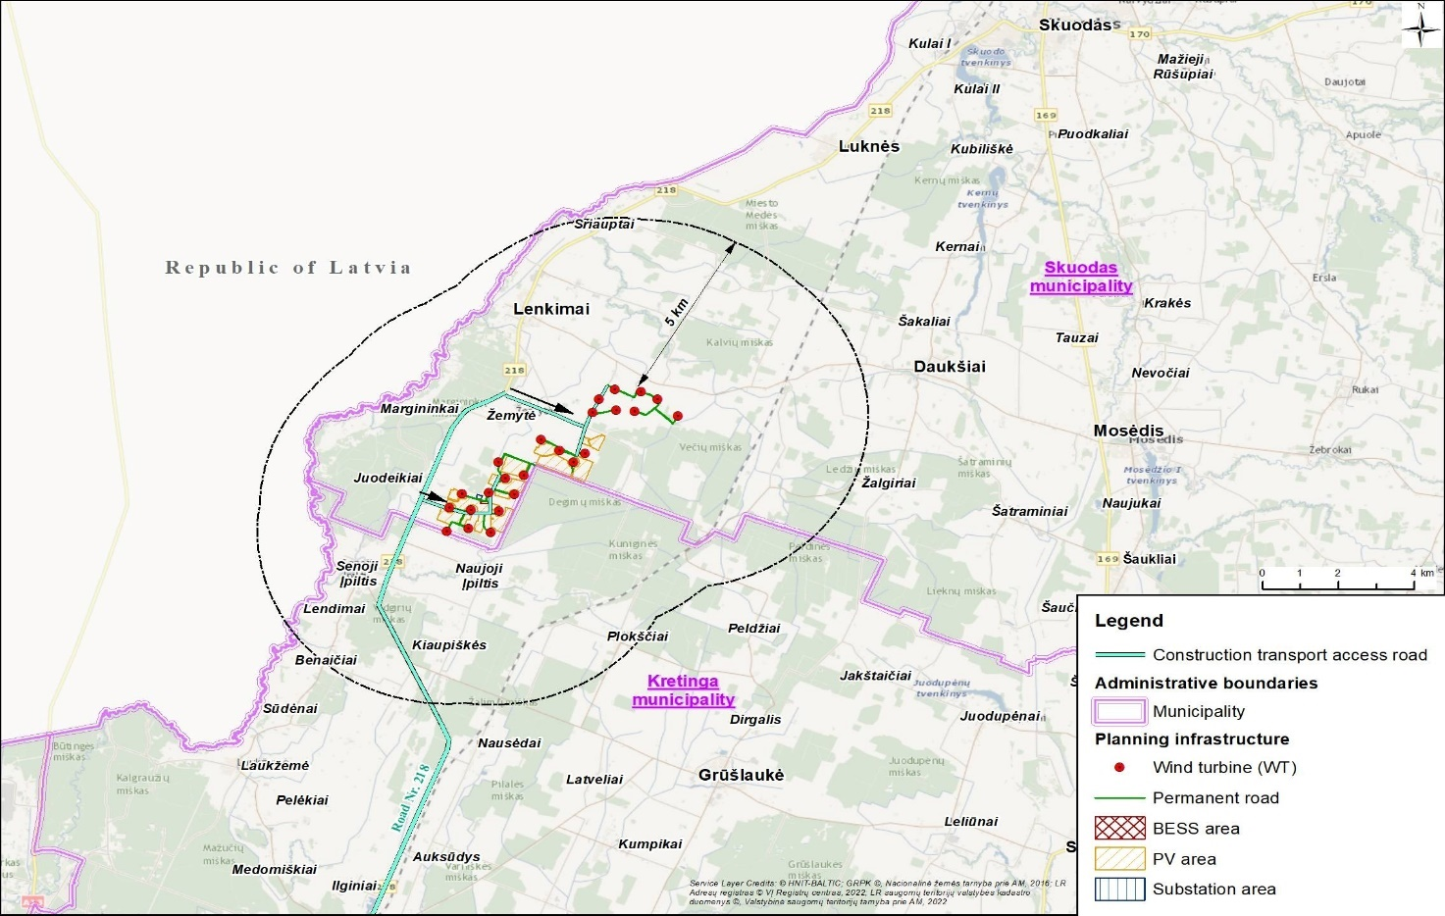

Key Components
The Skuodas Cluster Hybrid Project is a large‑scale renewable energy development combining wind, solar photovoltaic (PV), and energy storage technologies, along with associated electrical infrastructure and access roads. Key Project components include:
- Onshore Wind Turbine Generators (WTGs): the Project includes the installation of up to 24 onshore WTGs distributed across the Project area, together with foundations, crane pads, and access roads.
- Photovoltaic (PV) Installations: development of fenced PV arrays mounted on single-axis tracking systems to maximize solar energy production. Supporting infrastructure includes inverters, transformers, and internal cabling.
- Battery Energy Storage System (BESS): a centrally located, containerized battery storage facility designed to store excess renewable electricity and release it when generation is lower or electricity demand is higher.
- Electrical Infrastructure: an underground electrical network will collect electricity from the wind and solar facilities and export it to the national grid through a Project substation and an approximately 9 km high-voltage underground export cable connecting to the existing Darbėnai substation.
- Access Roads and Associated Infrastructure: the Project will primarily use existing roads, supplemented by new or upgraded internal access roads where necessary. Temporary construction areas and material supply routes will be established during construction and restored after completion.

Area of Influence and communities potentially affected
For the purposes of this Stakeholder Engagement Plan (SEP), the Area of Influence (AoI) is divided into a Direct AoI and an Indirect AoI, including areas that may be affected by the transportation and delivery of Project components. This helps identify which people and organisations may be directly or indirectly affected by Project activities and therefore require information, engagement and access to feedback channels.
In table below are described the direct and indirect Socioeconomic and Health AoI.
The Direct AoI comprises communities and receptors located within and immediately adjacent to the Project footprint and associated facilities, where Project activities may directly interact with people during construction and operation.
The Indirect AoI covers areas that are not directly affected by Project components but may experience secondary or induced effects, primarily related to transport, logistics and construction supply chains.
TABLE 2-1 Direct and Indirect Socioeconomic and Health AoI
Direct Socioeconomic and Health AoI | Indirect Socioeconomic and Health AoI
Villages of Plaušiniai, Palegija, Žemytė, and Juodeikiai, located within or adjacent to the Project area | Transport corridors and settlements along the delivery route used for oversized Project components, particularly wind turbine tower sections, blades, and other large equipment
Land users and landowners whose plots are used for WTGs, PV clusters, the battery energy storage system, internal cabling, substation and access roads | Communities located along public roads that may experience temporary traffic disruption, increased heavy vehicle movements, noise, dust, and road safety risks during component delivery
Residents living in proximity to Project components who may experience temporary disturbances during construction (e.g. increased traffic, noise, dust) and ongoing operational presence | Locations where temporary modifications to road infrastructure may be required to facilitate transportation
Local community infrastructure and services located within the Project area or in its immediate surroundings

Project Stakeholder Identification, mapping, prioritization, and Analysis
Stakeholder engagement is a critical component of both the ESIA process and the successful delivery of the Project. Effective engagement ensures that potentially Project‑affected people and other interested stakeholders are informed about Project activities’ potential risks and impacts, and are provided with opportunities to participate meaningfully in Project planning, implementation, and monitoring.

Stakeholder Identification
The Project has identified stakeholders who may be affected by the Project, have an interest in it, or have the ability to influence Project development and implementation. Stakeholder identification is an ongoing process and will be updated as the Project progresses.
Engagement approaches will be tailored to stakeholder characteristics and needs. For example, engagement with local authorities may include regular coordination meetings and formal information sharing, while directly affected landowners, neighbouring residents and land users may require more targeted engagement through one-to-one meetings, direct communications, and the provision of Project-specific information to support informed participation and timely resolution of concerns.
Stakeholder identification is an ongoing process. As the Project progresses through the ESIA, construction, and operational phases, additional stakeholders may be identified, and existing stakeholder profiles may evolve.
Stakeholder groups and their corresponding engagement approaches are summarised in Table 4-1 below. The engagement methods will be adapted to each stakeholder group to ensure effective information disclosure and enable participation in the decision-making process.
Stakeholder identification, analysis, and engagement should be considered a living and iterative process, to be reviewed and updated as the Project progresses through the permitting and ESIA phases. New stakeholders may be identified, or existing stakeholders’ interests, influence, and attitudes toward the Project may change over time. Accordingly, the SEP will be updated as required, with updates materialized and systematically documented through the Stakeholder Engagement Register and Matrix.
Table 3-1 Stakeholder groups analysis
Stakeholder Categories and Groups | Relevance to the Project
National and Regional Authorities | Responsible for environmental permitting, compliance, policy alignment and regulatory oversight at national level. Their approval and guidance are critical for Project implementation and compliance with legal and international requirements.
Local Authorities | Represent local communities and play a key role in local governance, stakeholder coordination and social acceptance of the Project. They may influence public perception and facilitate engagement at local level.
Local Communities | Primary social receptors of Project impacts, particularly during construction and operation. Their perception and acceptance of the Project are critical for maintaining social license to operate.
Landowners and Land Users | Potentially directly affected by land acquisition, land use restrictions or temporary disturbances during construction and operation. Adjacent landowners and nearby residents may also experience perceived or actual impacts associated with the proximity of Project infrastructure. They are key stakeholders for land access and Project implementation.
Infrastructure and Technical Stakeholders | Responsible for grid connection, infrastructure protection and transport logistics. Their coordination is essential for technical feasibility and safe implementation of Project activities.
Economic Actors and Area Users | May experience indirect impacts (e.g. disruption, perception changes) or benefit from economic opportunities related to the Project.
Vulnerable and Sensitive Groups | May be more sensitive to Project impacts or face barriers in accessing information and participating in engagement processes.
Financial Stakeholders | Provide financing and impose environmental and social requirements. Their involvement drives compliance with international standards and best practice.

Vulnerable Groups
In the context of the Project area, particular consideration is given to vulnerability factors such as the ageing population, continued depopulation trends and the predominantly rural character of the Skuodas District Municipality. These conditions may limit access to information, services and engagement opportunities. On this basis, potentially vulnerable groups include older people, residents of remote or sparsely populated settlements, people with disabilities or reduced mobility, individuals with limited access to healthcare and social services, low-income households or those receiving social support, unemployed persons and older jobseekers, as well as children and young people. These groups may be more sensitive to Project-related impacts, particularly regarding community health and safety, access and mobility, construction disturbance, information disclosure, and participation in consultation processes.
The Project will apply differentiated engagement measures where needed. These may include use of Lithuanian-language materials, simple non-technical information, direct engagement through local authorities or trusted community points, small-group or one-to-one discussions, printed materials, notice boards, grievance boxes, and additional support for stakeholders with mobility, literacy or access constraints.

Engagement Programme

Summary of project engagement
The Project has already undergone the national permitting procedure under Lithuanian legislation, including the Environmental Impact Assessment (EIA) process, through which the required approvals for the development and construction of the Project have been obtained. As part of this process, stakeholder engagement and disclosure activities were carried out in accordance with national legal requirements. These included providing Project information and opportunities for public input during the screening and assessment stages.
At this stage, engagement undertaken specifically in support of the ESIA has been limited to scoping-level and early baseline data-collection activities.
As part of this phase, two separate site visits were undertaken. The first, the Scoping Site Visit, April, 2026, performed by CORPI and ERM, aimed to obtain an initial understanding of the Project area, verify baseline assumptions and identify key environmental and social receptors. This visit did not include stakeholder engagement activities.
A subsequent site visit (Site Visit, May 2026) was conducted by CORPI to support social baseline data collection. During this visit, stakeholder engagement activities were undertaken, including interactions with representatives of local authorities (elderships) and local landowners to gather site-specific information and validate baseline conditions.
A dedicated ESIA public disclosure process is planned for August 2026 to be conducted in line with applicable international standards, ensuring that the ESIA is disclosed in a meaningful and transparent manner and that stakeholders are provided with opportunities to review and provide feedback.

Stakeholder Engagement Action Plan
This SEP defines the overall approach to stakeholder engagement and information disclosure for the Project and provides a high-level outline of engagement activities to be implemented throughout all Project phases.
The engagement objectives for each Project phase are presented in Table 4-1. This Stakeholder Engagement Action Plan is a living framework, which will be reviewed and updated as needed.
Table 4-1 ENGAGEMENT OBJECTIVES DURING EACH PROJECT PHASE
Project Phase | Engagement Objectives
EIA (completed) | - Inform stakeholders about the Project and its potential environmental impacts.  - Fulfil national legal requirements for public consultation and disclosure.  - Provide affected landowners and interested stakeholders with opportunities to review information and submit comments or objections.
ESIA (current phase) | - Inform stakeholders about the ESIA process and Project development.  - Disclose Project information, including environmental and social impacts, in a transparent and accessible manner.  - Enable stakeholders to provide input into the Project, including impact assessment, management plan, and mitigation measures.  - Establish early engagement and build relationships with affected stakeholders.  - Provide stakeholders with access to disclosed ESIA information and understand how stakeholder concerns have been considered in Project planning and impact management.
Pre-construction | - Inform stakeholders on Project approval status and next steps.  - Confirm arrangements related to land access and land use.  - Disclose Project information relevant to upcoming activities.  - Address emerging concerns and maintain stakeholder awareness.
Construction | - Inform stakeholders of ongoing Project activities and potential disturbances.  - Maintain communication with Project-affected people.  - Manage expectations and address concerns in a timely manner.
Operation | - Maintain long-term relationships with stakeholders.  - Provide updates on Project performance, where relevant.  - Receive and address stakeholder concerns or grievances.

Table 54-2 ENGAGEMENT ACTION PLAN
Activity / Action | Target Stakeholders Groups | Purpose of activity / action | Timeframe / Frequency
Public disclosure of Project design proposals and information | Affected landowners, neighbouring land users, local community, authorities, and general public | - To provide stakeholders with access to Project design information and enable review in accordance with national public consultation procedures  - Collect opinions and concerns regarding the Project’s environmental effects. | During the public consultation period (July–August 2025)
Baseline data collection with stakeholder input (surveys, interviews, focus groups) | Local residents, local authorities, and vulnerable groups | To ensure an accurate social baseline and understand context-specific risks and opportunities and to identify potential vulnerable groups, through stakeholder interviews, focus group discussions and meetings with local authorities and community representatives. | During ESIA preparation. Activities will be undertaken as required to support baseline data collection and verify findings prior to completion of the ESIA.
Targeted engagement with vulnerable and affected communities | Elderly, ethnic minorities, women, low-income households, land-affected users, etc. | To identify potential impacts and ensure inclusive engagement, through targeted interviews, small-group meetings and, where appropriate, household visits. | During ESIA preparation at least once with each identified vulnerable stakeholder group and repeated where new issues, concerns or vulnerable stakeholders are identified.
Public disclosure meetings on ESIA documents (Public Disclosure Package) | Project-affected people, local authorities | Disclose project information, collect community feedback, understand concerns, and improve project mitigation measures and management plans where needed. The meetings will also provide stakeholders with an opportunity to understand how key environmental and social concerns raised during previous engagement activities have been considered in the ESIA and associated management measures. The disclosure process will include dedicated engagement sessions with local authorities and community representatives. | August 7, 2026: Two public disclosure events to disclose key ESIA material will be undertaken during the disclosure period, including dedicated focus group discussions with local authorities and community representatives, supported by a stakeholder feedback period and follow-up engagement as required.
Establish a Grievance Mechanism and disseminate it | All stakeholders, especially the project-affected people | Provide a formal channel for concerns and complaints. The grievance mechanism will be disseminated through the Project website, public disclosure meetings, printed information materials, notice boards, grievance boxes, and direct communication channels (email and telephone), as applicable. Dissemination will be reinforced during every stakeholder meeting/interaction. | Prior to the start of works and reinforced during all major stakeholder engagement activities, community meetings, and public disclosures throughout the Project lifecycle.
Update SEP with Project-specific actions | All stakeholders | To refine engagement based on updated project scope and stakeholder mapping. | Prior to the start of works
Post-disclosure meetings: stakeholder engagement and follow-up dialogue | Stakeholders (mainly those potentially affected), local authorities | Disclose project information, collect community feedback, understand concerns, and improve project mitigation measures and management plans where needed.  Maintain dialogue with vulnerable stakeholders and land-affected parties, discuss planned activities, address concerns and provide updates on land access requirements, construction planning and grievance resolution. | Following the public disclosure meetings conducted on August 7, 2026 and prior to commencement of construction activities. Additional meetings will be organised where significant Project changes occur or further stakeholder engagement is considered necessary.
Project information disclosure package is published online on the Company website: https://www.skuodasrenew.lt/ | All stakeholders | The Project Information Disclosure Package will include the following documents in an accessible format (PDF):  - EIA – in Lithuanian;  - Grievance Mechanism for the Project, including the Grievance Form – in both English and Lithuanian;  - Non-technical Summary (NTS) – in both English and Lithuanian;  - SEP brief summary  - Management Plan Framework developed as per ESIA  These documents will be made available on the dedicated Project website. The Project website will include details for written submissions:  - e-mail address: skuodas@europeanenergy.com  - postal address: postal address to be confirmed
Establish a Grievance Mechanism and disseminate it | All stakeholders, especially the project-affected people | Provide a formal channel for concerns and complaints. Information on the grievance mechanism, including submission channels and contact details, will be communicated through the Project website, community meetings, notice boards, printed materials, grievance boxes, and direct engagement with affected stakeholders. | Prior to start of works
Update SEP with Project-specific actions | All stakeholders | To refine engagement based on updated project scope and stakeholder mapping. | Prior to start of works
Set up Grievance Boxes | Local Community | Grievance boxes should be set up in key pre-identified community spots and the project site entrance. | Grievance boxes will remain in place throughout construction and operation.
Conduct tailored engagement activities | Vulnerable groups  Affected landowners and users | If vulnerable groups are identified during the ESIA process, the Community Liaison Officer (CLO) will assess whether additional engagement measures are required to ensure their informed and meaningful participation in decision-making. The CLO may also undertake enhanced engagement activities to address land-related comments and grievances, ensuring transparent communication and effective impact management. | At least quarterly during construction and annually during operation, or more frequently where specific concerns, grievances or land-related issues are identified.
Ongoing reporting to affected communities, disclosure of operational phase transition and GM dissemination | Local community, affected stakeholders, authorities, and general public | The Project will maintain transparent stakeholder communication during operation by providing regular updates, sharing key information on Project performance and operational developments, and ensuring that the Grievance Mechanism remains accessible and well-publicised through multiple communication channels. | Annual updates, with additional communication following significant Project changes, incidents, or stakeholder concerns.
Disclose information on the environmental and social performance of the Project | All stakeholders | Inform stakeholders of the Project's annual environmental and social performance via the Project website | Yearly

Note: Where specific frequencies are not prescribed by national requirements, the frequencies presented above represent the minimum engagement commitments of the Project and may be increased based on stakeholder needs, Project activities, or grievances received.

Communication and Engagement Tools
The consistent application of best-practice communication and engagement tools, tailored to the local context and specific stakeholder needs, enhances the overall effectiveness of the stakeholder engagement action plan and supports transparent, inclusive, and meaningful participation throughout the Project lifecycle.
The tools will be applied throughout the different phases of the Project, with their content and messaging updated as the Project evolves. Any such updates will be reflected in revisions to this SEP and will be subject to management approval prior to implementation.
The communication and engagement tools are listed below:
- Public Disclosure and Community Meetings
- Project website
- Notice Boards
- Grievance Box
- Information/Contact channels (e.g., telephone, email)
- Printed Materials (posters, leaflets).

Stakeholder engagement team
The Social Team, represented by the Community Liaison Officer (CLO) and the Social Lead, will be responsible for overseeing the implementation, monitoring and continuous improvement of the Stakeholder Engagement Plan (SEP).
This approach is intended to encourage open dialogue and provide a trusted point of contact for raising concerns or grievances. In addition, the CLO will provide training to Project workers, contractors and relevant staff on how to appropriately interact with community members, including how to receive, register and refer grievances in line with the Project’s Grievance Mechanism, ensuring consistent and respectful handling of stakeholder concerns.
The Social Lead holds a senior role in overseeing the Project’s overall social performance, with a key focus on integrating stakeholder engagement, community relations and social risk management into Project decision-making. This role ensures that social performance is proactively managed across all phases of the Project in line with national requirements and international standards.

External Grievance Mechanism
The Project has a Grievance Mechanism (GM) in place which is a structured process for receiving, reporting, investigating, and responding to all types of community feedback raised in connection with the activities of the Project, in any of its phases.
The full GM document will also be publicly disclosed as part of the Public Disclosure Package and made available as a standalone document. This document forms part of the full Stakeholder Engagement Plan and provides further details on the grievance submission channels, the grievance form, the process for registering and assessing grievances, response timeframes, roles and responsibilities, and how grievances will be tracked and closed.
The information provided below is therefore a highlight summary of the full GM document.
The GM delineates the principles and processes for effective grievance management, as well as the organizational structure necessary for implementing a functional and culturally appropriate mechanism that adequately responds to stakeholder needs.
This mechanism is designed to address concerns promptly and effectively, using an understandable and transparent process that is culturally appropriate and readily accessible to all segments of the affected communities, at no cost and without retribution. The mechanism must not impede access to judicial or administrative remedies.
The GM will be implemented under the responsibility of the Project’s management team, with day-to-day coordination supported by the CLO, who will act as a key point of contact for communities.

Grievance Procedure
Figure 6-1 below have been developed to ensure an effective and timely response to community grievances and maintain good community and stakeholder relations. The mechanism must be part of the Project’s broader process of stakeholder engagement and quality assurance.
Figure 6-1 Grievance Procedure diagram
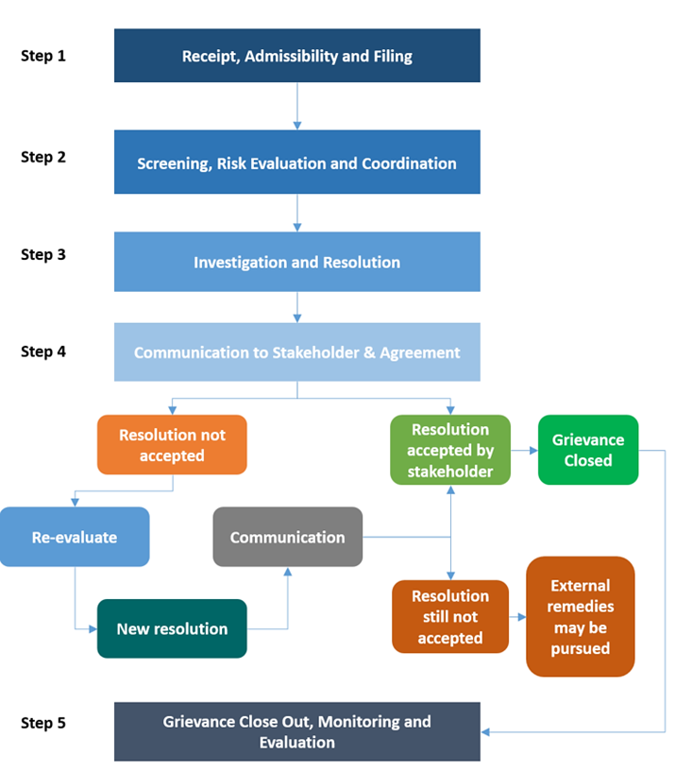
Source: ERM, 2026
The table below outlines the available channels through which stakeholders may submit a grievance, question, or feedback.
Table 6-1 available channels through which stakeholders may submit a grievance, question, or feedback.
Means | Details
By telephone | To EE office: +3706 0102224
By letter | To an individual or;  To the EE office in Ukmergės g. 219, LT·07152 Vilnius
Designated community grievance forms | On site through the designated grievance boxes and other key pre-identified community spots;  Through the Project website
In person | Face to Face to Project representatives
By e-mail | To the Project’s email address skuodas@europeanenergy.com

Monitoring, Evaluation, and Reporting
To support the documentation of engagement activities and evaluate the effectiveness of this SEP and related community interaction efforts, the Project will implement a structured data management and monitoring system.
The Project will establish a structured stakeholder engagement monitoring and data management system to document, track, and evaluate all engagement activities throughout the Project lifecycle. All interactions, commitments, follow-up actions, and stakeholder feedback will be systematically recorded in the Stakeholder Engagement Register and Matrix to ensure transparency, accountability, and traceability.
The CLO will regularly report to Project management on engagement activities, stakeholder interactions, grievances and their resolution status, compliance with SEP requirements, upcoming activities, and any emerging issues.
Stakeholder feedback, changes in legal and regulatory requirements, and evolving stakeholder expectations will be continuously considered to maintain alignment with best practices and strengthen stakeholder engagement throughout the Project lifecycle.
ERM has over 140 offices across the following countries and territories worldwide
Argentina  Australia  Belgium  Brazil  Brunei  Canada  Chile  China  Colombia  France  Germany  Guyana  Hong Kong  India  Indonesia  Ireland  Italy  Japan  Kenya  Malaysia | Mexico  Mozambique  Netherlands  Panama  Peru  Poland  Portugal  Romania  Singapore  South Africa  South Korea  Spain  Switzerland  Taiwan  Thailand  United Arab Emirates  United Kingdom  United States  Vietnam |  | ERM Italia S.p.A.  Via San Gregorio, 38  20124 Milan - Italy  T: +39 02 674401  www.erm.com

