
Roberts-Smith v Fairfax Media Publications Pty Limited (No 41) [2023] FCA 555
A case study
By Melani Maddumage

I FACTS OF THE CASE
In 2018, Fairfax Media and journalists Nick McKenzie, Chris Masters and David Wroe published articles appearing in The Sydney Morning Herald, The Age and The Canberra Times, concerning allegations of Ben Roberts-Smith’s misconduct during his military deployments in Afghanistan between 2009 and 2012 while serving with the Australian Defence Force. The first and second groups of articles, published between 8 and 10 June 2018, included headlines such as “Troops kept ‘kill board’: SAS’s Day of Shame” and “Did the SAS kick a cuffed man off cliff?”, referring to allegations that an Afghan detainee was kicked off a cliff at Darwan and subsequently executed. The third group of articles, published in August 2018 under headlines including “War hero fires back over abuse claims”, contained further allegations that the applicant engaged in unlawful and unethical conduct during military deployments in Afghanistan and claims of domestic violence against a woman. Roberts-Smith commenced defamation proceedings against Fairfax Media, the journalists and the associated newspapers, arguing that the imputations were false and had caused significant harm to his reputation and career. The proceedings involved the operation of the National Security Information (Criminal and Civil Proceedings) Act 2004 (Cth), which permits courts to restrict, redact or hear sensitive evidence in closed sessions where disclosure of information may prejudice national security. On 1 June 2023, the judgment was delivered.

II LEGAL ISSUES
The key legal issue concerned whether the newspaper publications conveyed defamatory imputations about the applicant. A further issue is whether these imputations were substantially true under section 25 of the Defamation Act 2005 (NSW) (‘Defamation Act’). Additionally, the defence of contextual truth under section 26 of the Defamation Act would apply as some imputations may not be proven due to the applicant’s reputation being harmed by other substantially true imputations.

III ARGUMENTS
The applicant provided extensive oral evidence denying allegations that he killed Afghan civilians, kicked a detainee off a cliff, ordered executions, bullied soldiers, or committed domestic violence. He claimed his actions during deployments were lawful combat actions carried out under the rules of engagement. Furthermore, mission documents and military records indicate that Afghan operations were conducted pursuant to authorised SAS patrol objectives, and that deceased individuals were recorded as enemy combatants. These were relied upon to support the accuracy of the applicant’s account. Military achievements such as receiving the Victoria Cross, Medal for Gallantry and Commendation for Distinguished Service evidenced the applicant’s reputation as the most decorated Afghanistan veteran within the Australian Defence Force and broader community.
The applicant argued the respondents failed to satisfy the required civil standard of proof for allegations amounting to serious criminal conduct. His legal team relied on the principle in Briginshaw v Briginshaw that stated serious allegations require evidence that is “clear and cogent” before a court can be reasonably satisfied on the balance of probabilities. The applicant argued that the respondents’ evidence consisted of unreliable witness recollections from soldiers, personal associates and experts who held resentment towards him and intended to cause reputational harm. The delays between the alleged incidents and SAS personnel testimony challenged the credibility of the evidence, as the longer the period between an event and its recall, the greater margin for error. The applicant further submitted that the photographs and military records the respondent provided during the applicant’s patrol in war zones are inconsistent with other material evidence. The applicant identified that reasonable satisfaction could not be reached by inexact proofs, indefinite testimony, or indirect inferences.
On the contrary, the respondents including journalists Nick McKenzie, Chris Masters and David Wroe argued that the publications were protected by substantial truth under section 25 of the Defamation Act. This was established on the balance of probabilities through witness testimony, military records and circumstantial evidence. Current and former SAS soldiers described incidents including the alleged kicking of an unarmed Afghan detainee off a cliff, the execution of Afghan prisoners, and the “blooding” of a rookie soldier ordered to shoot an unarmed man. Afghan witnesses gave accounts of family members being killed during Australian operations as well as military logs which remained consistent with the existence of unlawful killings and assaults. The respondents claimed the applicant concealed relevant material of his explicit military conduct seen in surveillance videos and threatening letters. They argued he attempted to influence witnesses by discouraging them from giving adverse evidence through intimidation or collusion.
The respondents relied on the defence of contextual truth under section 26, arguing that even if some imputations were not fully proven, the proven allegations were so serious that the remaining imputations caused no further reputational harm.

IV DECISION
The Court found on the balance of probabilities, that many of the imputations alleging Roberts-Smith murdered unarmed Afghan men, assaulted civilians and engaged in bullying conduct were substantially true. Some allegations were not independently proven such as aspects of the domestic violence allegations and specific killings. However, the respondents succeeded under the defence of contextual truth because the proven imputations had already gravely damaged the applicant’s reputation. The Court concluded the publications were not actionable in defamation and ordered that the proceedings be dismissed.

V IMPLICATIONS OF THE COURT’S DECISION
Justice Besanko’s findings demonstrated that media organisations may successfully rely on truth defences in defamation proceedings involving serious allegations, provided the evidence is sufficiently cogent and persuasive on the burden of proof. This case suggests future implications include stronger reliance on documentary corroboration and witness credibility assessments in such proceedings. The judgment intensified public scrutiny surrounding Australian war crimes in Afghanistan and contributed to ongoing criminal investigations surrounding military misconduct.

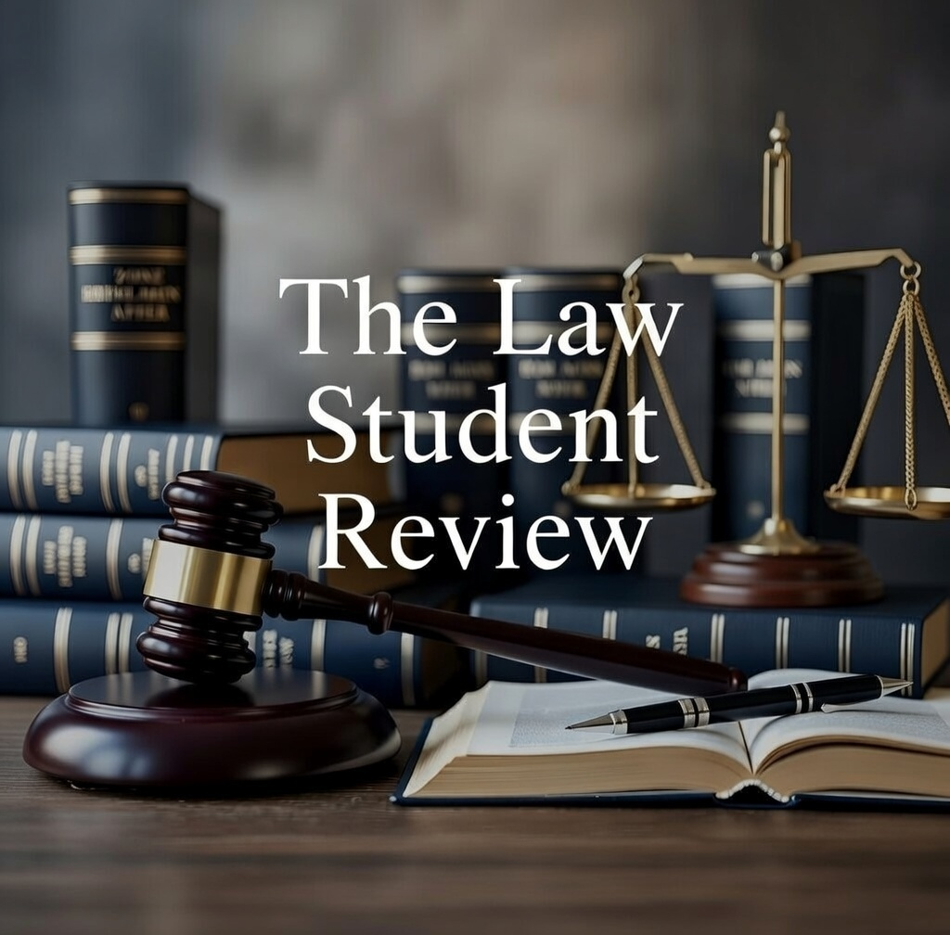

Roberts-Smith v Fairfax Media Publications Pty Limited (No 41) [2023] FCA 555 (‘Roberts-Smith’).
Roberts-Smith (n 1) [4].
Ibid [5].
National Security Information (Criminal and Civil Proceedings) Act 2004 (Cth) s 38B.
Defamation Act 2005 (NSW) s 25 (‘Defamation Act’).
Defamation Act (n 5) s 26.
Roberts-Smith (n 1) [76].
Evidence Act 1995 (Cth) s 140.
Briginshaw v Briginshaw (1938) 60 CLR 336 (‘Briginshaw’); Neat Holdings Pty Ltd v Karajan Holdings Pty Ltd (1992) 110 ALR 449 [449-450].
Roberts-Smith (n 1) [530].
Longman v The Queen (1989) 168 CLR 79 [107-108].
Roberts-Smith (n 1) [573].
Briginshaw (n 9) [362] (Dixon J).
Defamation Act (n 5) s 25.
Roberts-Smith (n 1) [227].
Roberts-Smith (n 1) [887].
Defamation Act (n 5) s 26.

