

O’Callaghan v Trustees of the Marist Brothers [2023] NSWSC 432

By Luciana Romanski

I FACTS
In or around 1963, O’Callaghan (‘the Plaintiff’) alleged that when he was a boarder at St Francis, being a school operated by the Trustees of the Marist Bros (‘the Defendant’), he was sexually abused by the school principal, Brother Calixtus. At the time, the Plaintiff was 12 years old.
On 15 September 2022, the Defendant filed a notice of motion seeking an order that the proceedings be permanently stayed as pursuant to section 67 of the Civil Procedure Act (‘CPA’). In addition, an alternative order was proposed under r 13.4 of the Uniform Civil Procedure Rules (‘UCPR’). This rule states the following:
- If in any proceedings it appears to the court that in relation to the proceedings generally or in relation to any claim for relief in the proceedings:
  - the proceedings are frivolous or vexatious, or
  - no reasonable cause of action is disclosed, or
  - the proceedings are an abuse of the process of the court,
the court may order that the proceedings be dismissed generally or in relation to that claim.
The reasons for the stay resulted from the Defendant being unable to meet the Plaintiff’s claim for the following;
- The alleged events occurred approximately 60 years ago.
- Brother Calixtus died in 2020.
- Prior to his death, Brother Calixtus suffered from cognitive difficulties.
- The Defendant has never had the opportunity to put the allegations to Brother Calixtus.
- The Defendant could not confirm in any records that the Plaintiff was a boarder at St Francis, despite extensive research. In addition, there were allegations that certain acts of abuse occurred in a motor vehicle, however, there are no records that establish if Brother Callixtus had access to or owned a motor vehicle.
- The claim’s procession would be “manifestly unfair” to the defendant.
The Plaintiff responded by stating that there had not been a “full and frank disclosure of all material”. Additionally, that the investigations carried out by the Defendant were “perfunctory and that they failed to distinguish between the admissibility and the weight of the evidence. Lastly, the Plaintiff noted that the facts of the case can be distinguished from the authorities relied upon by the Defendant as Brother Calixtus was alive when the allegations were made.

II JUDGE
The Judge in this matter was Associate Judge Elkaim (‘Elkaim AJ’).

III LEGAL ISSUES
The legal issue was whether the lack of evidence and inability to put allegation to the alleged abuser makes the proceeding manifestly unfair for the Defendant.

IV THE SUPREME COURT”S DECISION
His Honour noted that the distinguishing feature that differs from precedents relating to this matter was the Plaintiff’s submission on whether or not there had been an “open disclosure of everything at its disposal”, in which the Plaintiff did not believe there was. His Honour looked to Exhibit B, which contained a list of the privileged documents containing 15 out of the 19 persons who complained about the alleged abuse by Brother Calixtus. However, 15 of the claims for privilege were later withdrawn, leaving 54 claims at the date of the hearing of the motion. His Honour believed the Defendant’s failure to disclose all matters known to them concerning Brother Calixtus was “fatal to its claim for a permanent stay”.
Furthermore, Elkaim AJ looked to the email from the Plaintiff’s Brother which was received by the Defendant on 28 May 2019. At this time, Brother Calixtus was still alive, and no response was sought from him regarding the email. The Defendant submitted that the terms of the email did not generate requirements for communication with Brother Calixtus, an argument which His Honour found to be “extraordinary”. In their submission, the Defendants submitted that even if enquiries had been made of Brother Calixtus are unlikely to have been fruitful as in May 2019, he was suffering from a cognitive deficit.
Ultimately, His Honour made orders on two points. Firstly, on the commonality of facts from the cases he was referred to, and secondly, the spread of these cases across Australian jurisdictions, which emphasis the unexceptional nature of this type of case.

V ORDERS OF THE SUPREME COURT
His Honour decided that there were no exceptional circumstances in this matter. It was ordered that the notice of motion filed by the Defendant on 15 September 2022 be dismissed and that the Defendant pay the Plaintiff’s costs of the notice of motion filed on 15 September 2022.

VI IMPLICATIONS OF THE COURT’S DECISION
The Court highlighted that a passing of time is not to be treated alone as an unacceptably prejudicing a fair trial. Consequently, this precedent held a high threshold as full disclosure is required even if it was previously privileged and that the death of the alleged abuser does not automatically prevent a fair trial. Additionally, this matter proved that Institutional Defendants must promptly investigate claims, and that a failure to do so or withholding information can lead to the refusal of a stay application. On 23 May 2023, the Defendant responded to ABC Four Corners in a Media Release. The Defendant states that “The Marist Brothers have settled claims for decades from their own financial resources and will continue to do so”. As per the Court’s orders, an unsuccessful stay application requires the defendant to pay the Plaintiff’s costs.

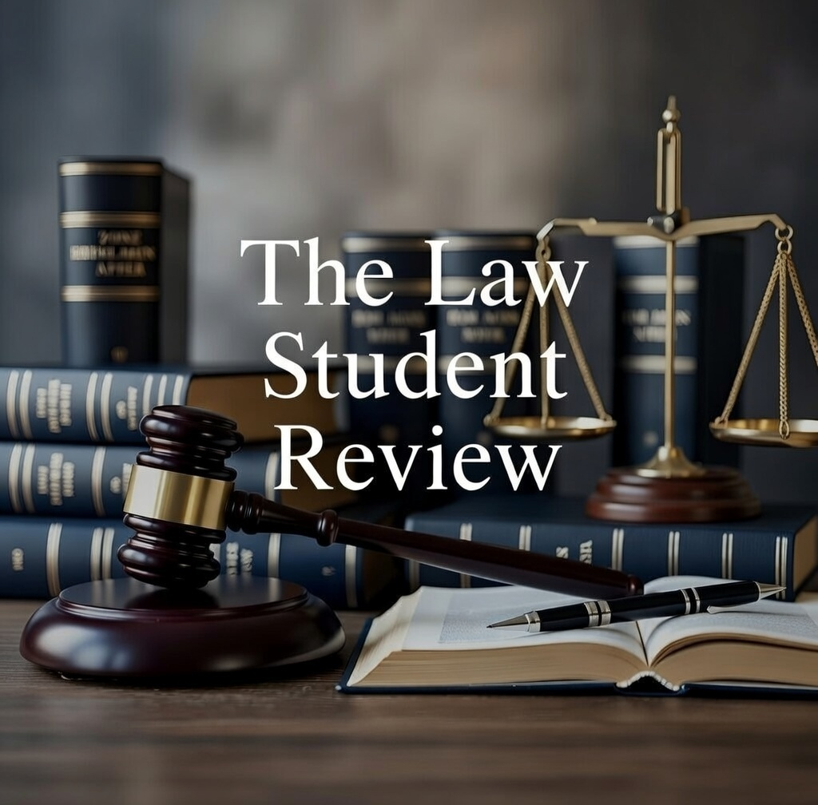

Civil Procedure Act No 28 2005 (NSW) (‘CPA’) s 67.
Uniform Civil Procedure Rules 2005 (NSW) (‘UCPR’) r 13.4.
O’Callaghan v Trustees (n 1) [5].
Ibid [6].
Ibid [18].
Ibid [26].
Ibid [27].
Marist Brothers Australia, ‘Response to ABC Four Corners’ (Media Release, 23 May 2023) 2.

