

Beyond the Boardroom
Shadow Directors and the Legal Construction of Corporate Control
By Tracey Tran
I INTRODUCTION
The formal allocation of corporate authority does not always reflect its practical exercise. Corporate governance instruments – including constitutions, board appointments and formal resolutions – vest decision-making authority in directors acting collectively. Yet corporate practice is often more diffuse. Influence may be exerted by dominant shareholders who direct strategy, financiers whose approval determines corporate survival, or advisers whose recommendations are routinely adopted despite the absence of formal office. The board remains the visible centre of governance, yet effective control may, in substance, lie elsewhere.
II LEGAL ARCHITECTURE OF SHADOW DIRECTORSHIP
Australian corporate law rejects formalism in favour of functional accountability, recognising that the capacity to direct corporate affairs may exist independently of formal appointment. Responsibility under the Corporations Act 2001 (Cth) therefore attaches not to title, but to the exercise of real power.
Three categories of directors are accordingly recognised:
- De jure directors: formally appointed officeholders whose authority derives from valid compliance with the Corporations Act 2001 (Cth) and the company’s constitution.
- De facto directors: individuals who, though lacking valid appointment, assume and perform the functions of the office with apparent authority.
- Shadow directors: persons who neither hold nor purport to hold office, yet exert sustained, determinative influence over the board.
Shadow directorship is concerned with the displacement of independent board judgement. Section 9 of the Corporations Act 2001 (Cth) provides that a person is taken to be a director where “the directors of the company or body are accustomed to act in accordance with the person’s instructions or wishes,” excluding advice given in the proper performance of professional functions or arising from a business relationship. The statutory inquiry is therefore evidentiary and behavioural: whether there exists a pattern of habitual compliance sufficient to demonstrate practical control.
A parallel formulation appears in the statutory definition of ‘officer’, which adopts materially similar language. The repetition of the ‘accustomed to act’ criterion across both provisions confirms that liability under the Act turns on substantive influence over corporate decision-making rather than formal designation.
The definition is, however, carefully confined. By expressly excluding professional advice, the Act preserves the capacity of lawyers, accountants and other advisers to provide robust guidance without incurring fiduciary or statutory liability. The doctrine thus draws a principled distinction between influence and control. Only where influence becomes sufficiently sustained to subordinate the board’s independent judgement – effectively transforming directors into instruments of another’s will – does statutory responsibility arise.
III JUDICIAL THRESHOLDS
The statutory language of ‘accustomed to act’ acquires content only through judicial discipline. Courts have been careful to preserve a meaningful boundary between commercial influence and corporate governance, recognising that shadow directorship is engaged not by power in the abstract, but by the systematic displacement of collective board autonomy.
Consider a company whose continued survival depends entirely upon a dominant supplier willing to extend credit. Where that supplier imposes strict financial conditions and operational oversight, does influence harden into control? The Supreme Court of New South Wales addressed precisely this question in Buzzle Operations Pty Ltd (in liq) v Apple Computer Australia Pty Ltd (2011). The alleged control arose in the context of acute commercial dependency.
Buzzle was formed in September 2000 through the merger of six independent Apple resellers, quickly becoming Apple’s largest Australian reseller and accounting for nearly 40 per cent of Apple Australia’s turnover. Its financial survival depended heavily on continued product supply and credit from Apple, to whom it ultimately owed approximately $24 million. Apple agreed to extend support, but subject to stringent commercial conditions, including tightening credit limits, revised payment arrangements, detailed financial reporting and close monitoring of trading performance. These requirements significantly shaped the company’s operational flexibility, reflecting the acute economic dependence of Buzzle upon its primary supplier. Despite these measures, the company collapsed within six months and entered liquidation.
In 2003, liquidator Andrew Wily commenced proceedings alleging that Apple had exercised such extensive control over Buzzle’s financial and operational decisions that it should be treated as a shadow director and therefore liable for insolvent trading and related breaches.
Justice Richard White of the Supreme Court rejected that contention. Applying section 9 of the Corporations Act 2001(Cth), he held that the statutory test requires more than significant commercial influence or leverage. What must be shown is that the directors were accustomed to act in accordance with the alleged shadow director’s instructions or wishes, as previously outlined – a pattern of conduct demonstrating habitual compliance. On the evidence, Apple’s involvement did not rise to that level. Although it imposed strict credit conditions and required detailed financial reporting, those measures were protective responses to commercial risk, not directives displacing the board’s authority. The directors remained free to accept or reject Apple’s terms; they continued to exercise independent judgement in managing the company’s affairs. It was found that there was no established practice of the board acting in submission to Apple’s instructions; Buzzle retained internal legal agency.
On appeal, the New South Wales Court of Appeal affirmed that reasoning – Justices Dennis Hodgson, Peter Young and Robert Whealy – endorsed White’s interpretation of section 9 and the stringent threshold for shadow directorship. The judgement clarified that shadow directorship is concerned with behavioural subordination, not economic dependency. A creditor may exert significant leverage, even to the point of influencing strategic outcomes, without assuming the legal responsibilities of a director. The statutory threshold was therefore not satisfied.
Buzzle ultimately represents a judicial insistence that corporate accountability attaches to executive power, not to commercial leverage alone, thereby preserving the distinction between governance authority and ordinary market power.
IV COMMERCIAL IMPLICATIONS AND BEST PRACTICE
The doctrine of shadow directorship does not prohibit commercial engagement; rather, it delineates the conditions under which influence hardens into legally significant control. As clarified in the case study of Buzzle, liability turns not on economic leverage, but on behavioural subservience. For advisers, financiers, investors and other influential stakeholders, the question is therefore: does involvement shape board decision-making, or does it supplant it?
The distinction is preserved where:
- Advisory input remains non-directive.
Courts distinguish between persuasive influence and instructions to which directors are accustomed to conforming. Recommendations, however robust, must leave space for deliberation. Liability emerges not from strong views, but from patterns of compliance that evidence surrendered judgement.

- Boards demonstrably exercise independent judgement.
Autonomy is reinforced through deliberative processes; recording dissent, documenting alternative strategic courses considered and evidencing the capacity to reject proposals. Such practices rebut any inference of habitual obedience and affirm that ultimate authority resides with the board.
- Decision-making authority is structurally transparent.

Clear role delineation, defined reporting lines and contemporaneous records of rationale safeguard against ambiguity about who is employing corporate power. Collaboration between in-house management and external advisers must comply within identifiable governance boundaries, such as where major decisions are formally resolved by the board and recorded contemporaneously. By employing transparent practices, it ensures that influence remains consultative rather than constitutive of command.
Recognising the boundary between influence allows commercial actors to engage robustly in corporate decision-making while remaining in the limits of the law. Where governance structures are respected and decisions remain demonstrably those of the board, liability does not arise. The doctrine therefore preserves commercial freedom without sacrificing accountability.
V CONCLUSION
Shadow directorship reflects corporate law’s refusal to be governed by appearances alone. It acknowledges that power may operate beyond formal roles and that accountability must follow where practical control is exercised. Far from undermining commercial practice, the doctrine sustains it by ensuring that governance remains anchored to responsibility, even when authority prefers the shadows.

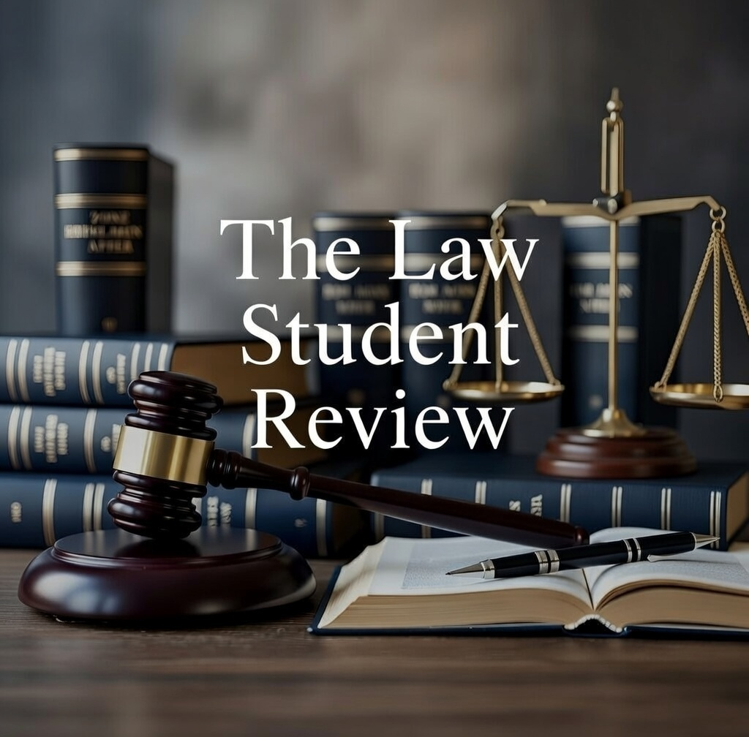

Corporations Act 2001 (Cth) s 9AC(1)(b)(ii) (‘Corporations Act’).
Ibid, s 9AD(1)(b)(iii).
Ibid.
Buzzle Operations Pty Ltd (in liq) v Apple Computer Australia Pty Ltd (2011) 81 NSWLR 47 (‘Buzzle’).
Sean Mitchell, ‘Explainer: The spectacular collapse of Apple’s Buzzle stores’, ChannelLife Australia (Webpage, 23 October 2025) <https://channellife.com.au/story/explainer-the-spectacular-collapse-of-apple-s-buzzle-stores>.
Ibid.
Ibid.
‘From reality TV to courtroom drama’, The Sydney Morning Herald (online, 28 March 2002) < https://www.smh.com.au/national/from-reality-tv-to-courtroom-drama-20020328-gdf5ie.html>.
Buzzle Operations Pty Ltd (in liq) v Apple Computer Australia Pty Ltd [2010] NSWSC 223 (White J).
Corporations Act (n 1) s 9.
Corporations Act (n 1) s 9.
Buzzle Operations Pty Ltd (in liq) v Apple Computer Australia Pty Ltd [2011] NSWCA 109 (Hodgson J, Young J, Whealy J).
Buzzle (n 4).
Australian Securities and Investments Commission v Godfrey [2017] FCA 1569 (Moshinsky J).
Office of the Australian Information Commissioner, ‘The Deliberative Processes Exemption – s 47C’, (Agency Resource) <https://www.oaic.gov.au/__data/assets/pdf_file/0025/238624/Agency-resource-The-deliberative-processes-exemption-47C.pdf>.
‘What is corporate governance? The 2025 guideline’, IMD (Blog Post, April 2025) < https://www.imd.org/blog/governance/what-is-corporate-governance/#:~:text=Accountability%20ensures%20that%20the%20board,responsible%20behavior%20throughout%20the%20organization.>.
‘Non-profit Fact Sheets – What is a Shadow Director?’ Better Boards (Web Page) < https://betterboards.net/non-profit-fact-sheets/shadow-directors/#:~:text=Are%20shadow%20directors%20illegal?,%2C%20creditors%2C%20and%20other%20stakeholders.>.

