 | ACCA Template:  Webinar Registration Page

Please submit the completed template to ACCA a minimum of 6 weeks before your webinar goes live to ensure it is well advertised and attended. This will offer the best opportunity to engage the highest number of leads for your further business promotion. Please note once registrations are open it cannot be amended.

Please also look at the ACCA list of current topics, trends and talking points to assist in keeping your event relevant and well received by the financial services community. ANNEX 1

Description | Example | Your event text
Event title | What does digital transformation mean for finance departments in 2026?
Event date | 18 February 2026
Event time | Live: 1 PM (UK)
Audience (specify countries, regions or global, target sector and size of organisation if applicable) | Please refer the attached excel sheet. working in corporate sector organisations
Event duration (usually 1 hour or 45 min. Plan 15-10 min for Q/A) | 1 hour including 15 min for Q/A
Teaser (around 50 words) – what organisations are presenting, when is it and what is the main objective of the session? | Finance leaders, did you know that businesses who have definitively integrated digitalisation as a tool of strategic transformation are 26% more profitable on average with a 9% higher turnover? These figures speak for themselves: it seems inevitable to escape this disruptive wave without digitalisation endangering the future of one’s business in a context of increased competitivity. The real question is: how can you fully leverage this opportunity?  This webinar with XXXX in association with ACCA aims to provide a concrete roadmap on digital transformation.
Details (around 150 words) – put the topic of the webinar into context, convince delegates why they should attend and include top takeaways that delegates will get from attending | Did you know that businesses who have definitively integrated digitalisation as a tool of strategic transformation are 26% more profitable on average with a 9% higher turnover?  These figures speak for themselves: it seems inevitable to escape this disruptive wave without endangering the future of one’s business in a context of increased competitivity.  This webinar will provide you with a concrete roadmap on:  - Why you shouldn't wait any longer to digitalisation  - What are the main tools available for CFOs and their team.  - How to choose the best solution, through main criteria such as level of automation, simplicity and functional coverage.  Join our webinar, in association with the ACCA to find out what digital transformation really mean for finance department in 2025 and how you can leverage this opportunity.
Speakers:  - Name  - Job Title  - Company  - Biography (around 40 words per speaker)  - Speaker’s email address  - Speaker’s photo in JPG format attached | Jane DOE, XXXX Consultant  Jane.DOE@XXXX.com  Our consultant, Jane has a large experience in IT with several years accompanying worldwide based clients in the implementation of the Accounts Payable Automation solution, XXXX. She is helping clients such as Mazars or Five guys to improve their internal processes and gain efficiency. Very alert to new technologies and finance trends, Emily is seen as a trusted advisor who helps all size companies to implement adapted strategies, take full advantage of the tech and reach their full potential.
Registration fields.  Could be updated to address your needs. Any questions for the audience are welcome. Please keep it simple to allow easy registration process. | - First name  - Last name  - Job title  - Company name  - Work email  - Work phone  - Country
For submission 10 days prior your webinar date:
- Slide Deck | File Format: Use PowerPoint (PPT, PPTX) or PDF. Avoid using Google Slides or Apple Keynote unless converted to PDF.
- Polls | Poll 1; Slide 5: How prepared is your finance department for digital transformation?  - Very prepared  - Somewhat prepared  - Not prepared at all
- Seed Questions  Please ensure you have some seed questions to start an interesting discussion during Q/A lead by ACCA Moderator. | 1. How has digital transformation reshaped the role of finance departments in recent years?  2. What are the key technologies driving digital transformation in finance?

ANNEX 4
Example of ACCA Webinar Report
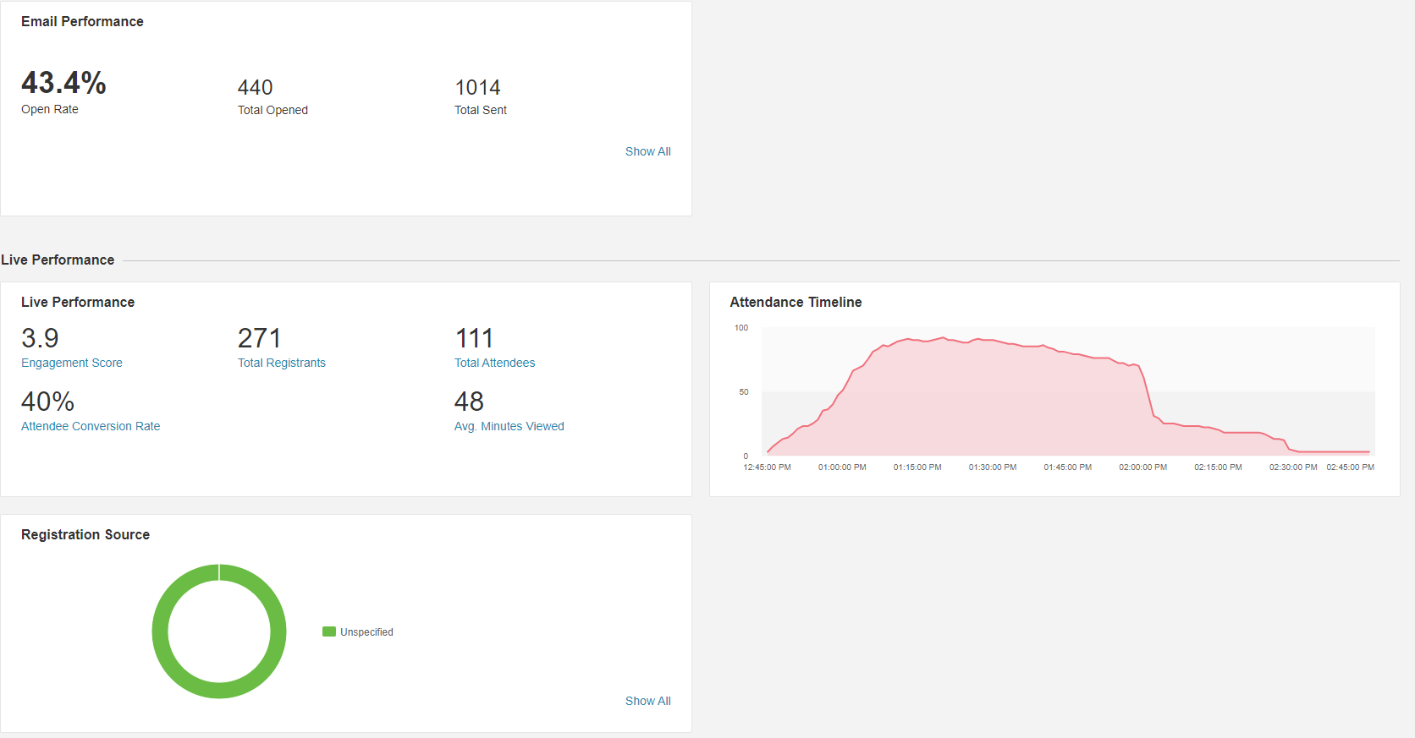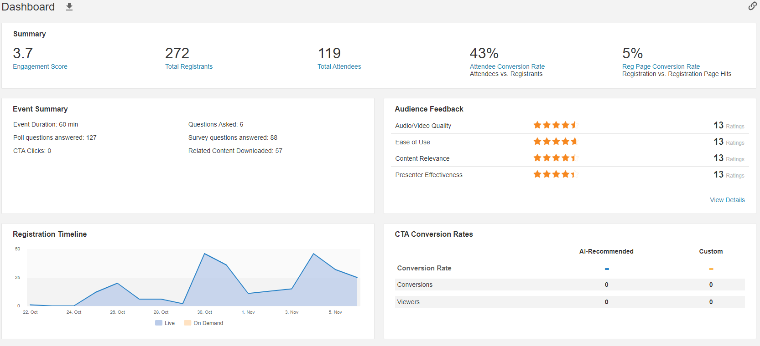
`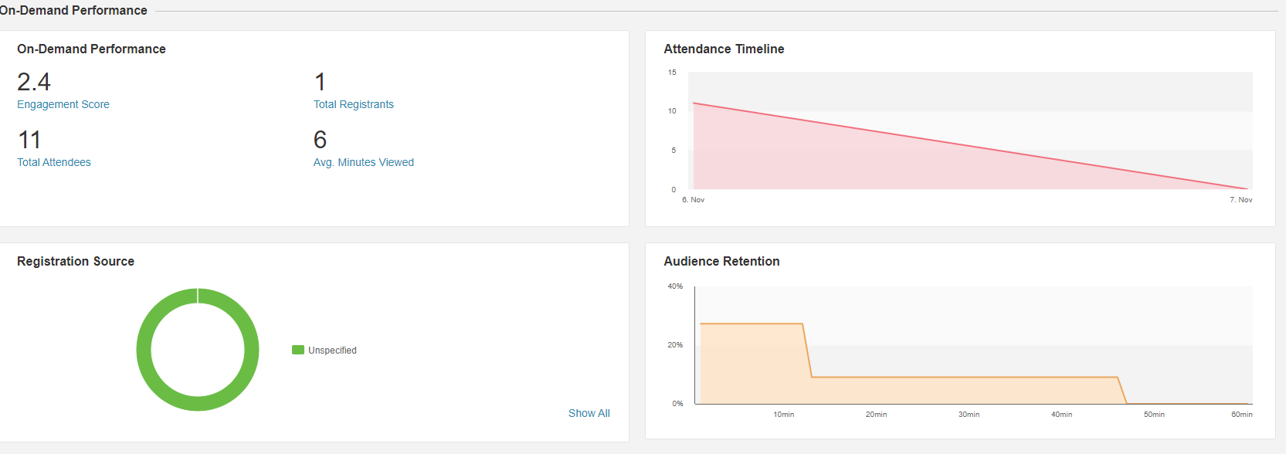
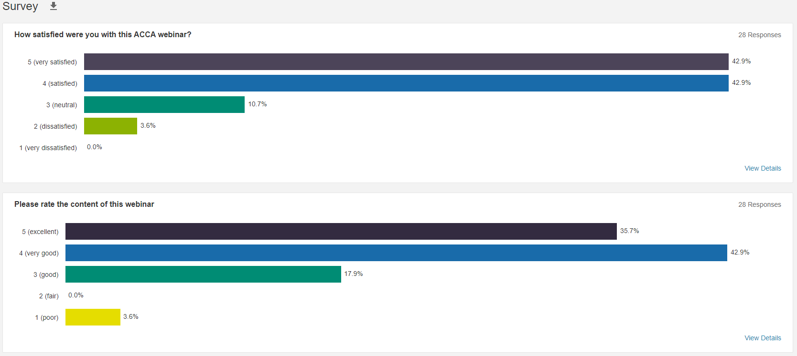
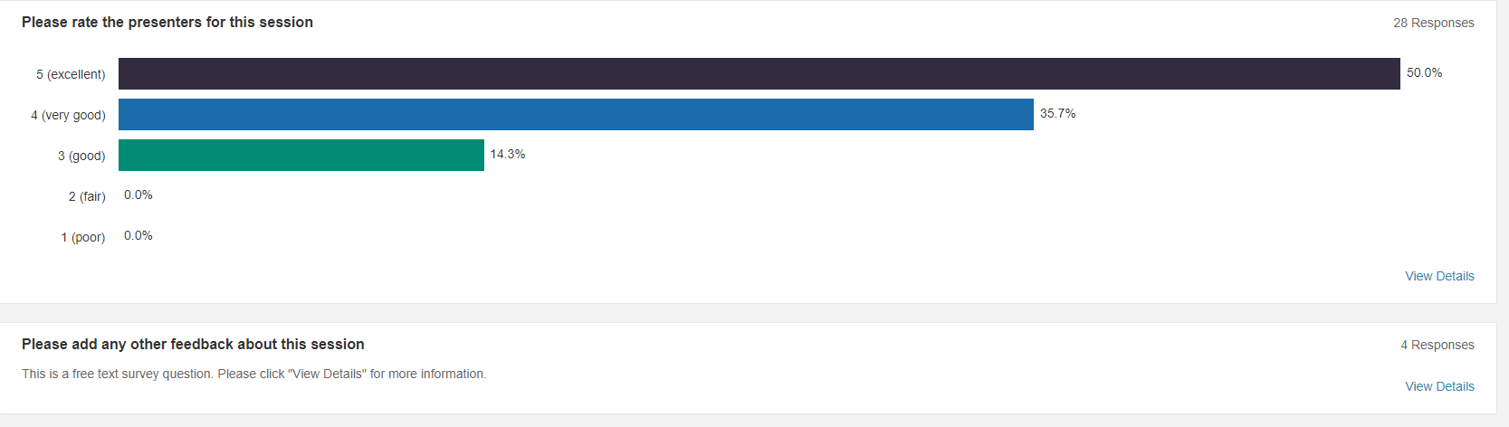
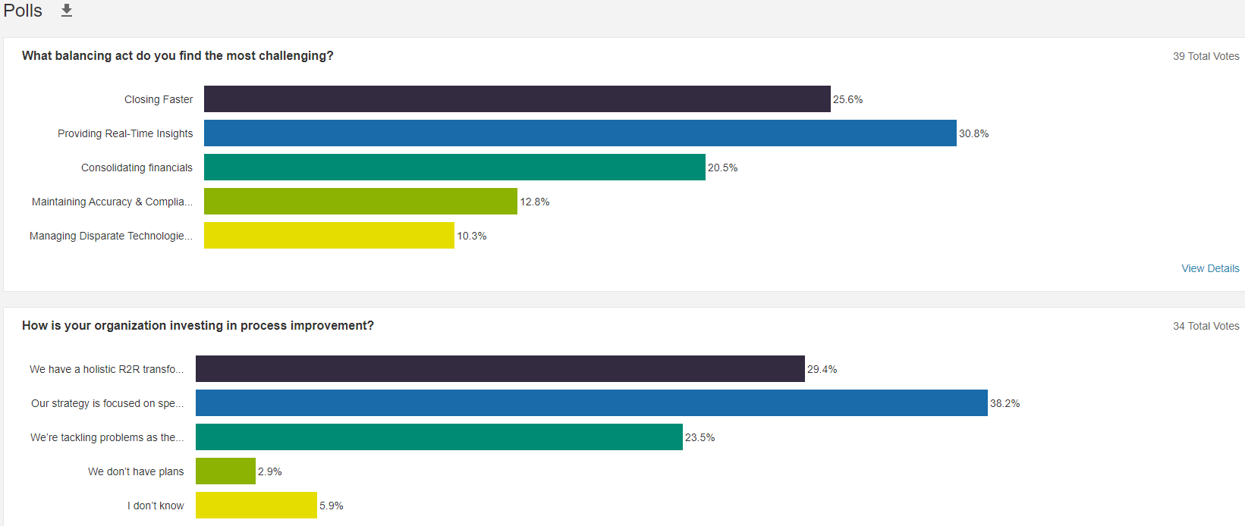
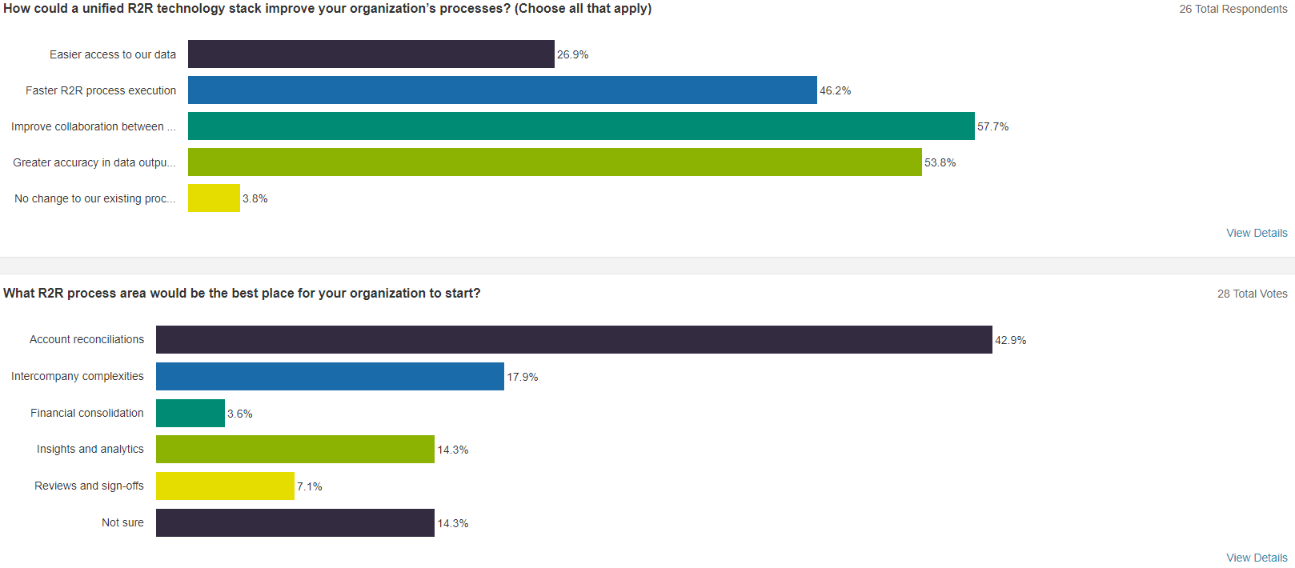

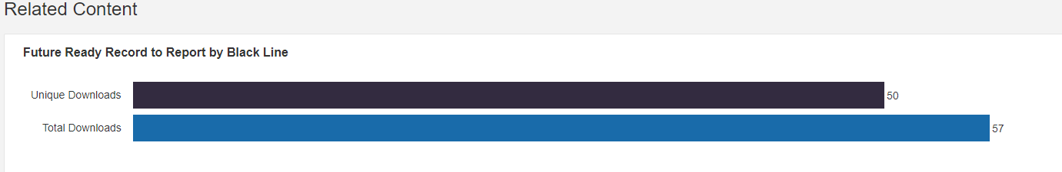
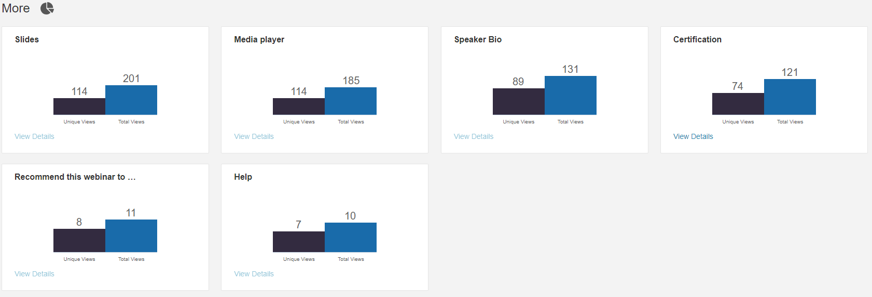
List of Registered Participants of the Webinar / Leads
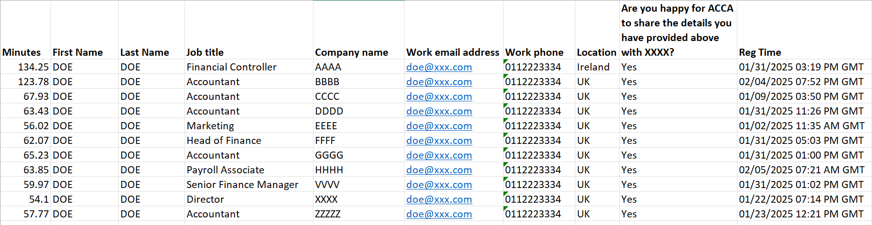

ANNEX 5
Benefits of a Dynamic Webinar Presentation
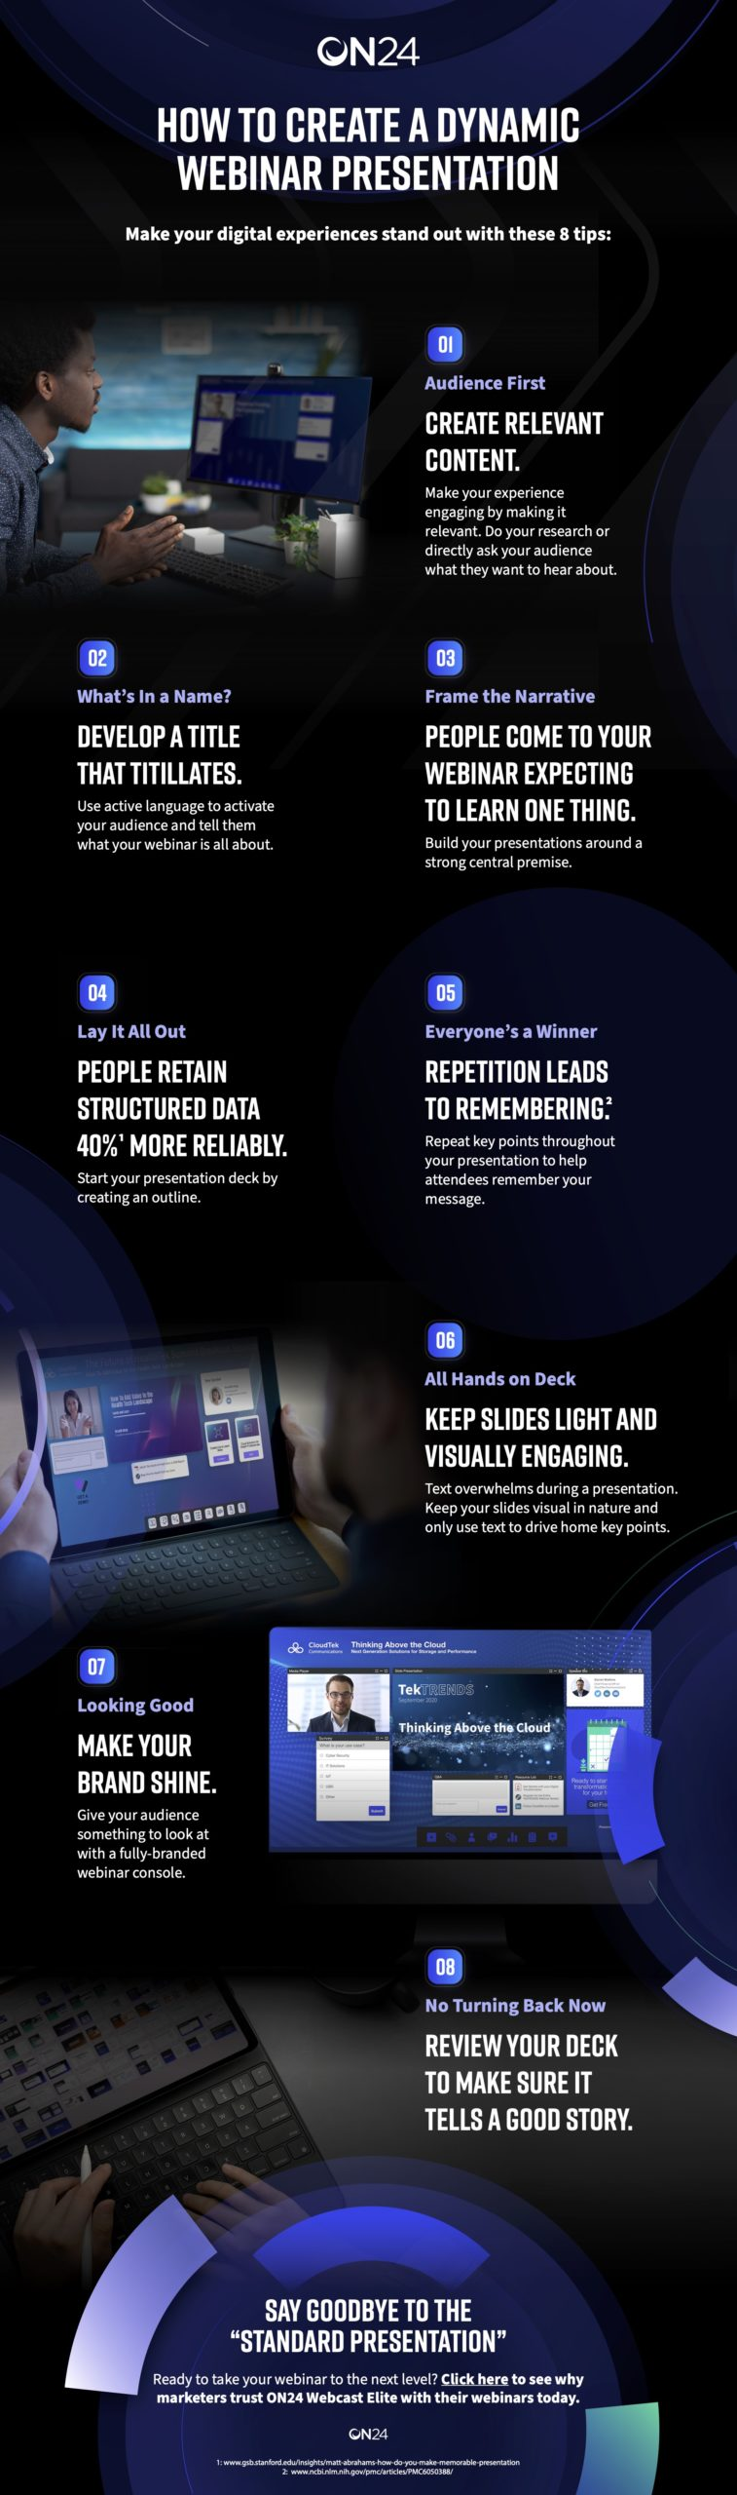 | Your webinar presentation needs to captivate your audience and keep them engaged throughout to maximize its potential value.  Dynamic presentations ensure that the information presented is interesting, visually appealing, and actively engaging. They improve engagement by using:  - Visual storytelling: animations, infographics and videos help to break up complex information into a digestible format.  - Interactive features: interactive content increases engagement rates by 52% and makes it easier for attendees to engage with your message.  - Well-designed presentation slides: simple design changes like deploying a visual hierarchy and using consistent branding can make your presentation easier to follow.  Increasing attendee engagement with a dynamic presentation can have a direct impact on return on investment (ROI). When attendees are more deeply engaged, they are more likely to stay until the end of your webinar and more likely to take follow-up actions.  By increasing engagement, you can increase lead conversion rates and overall sales, leading to a tangible impact on revenue.  Tips for Interactive Webinars  Here are some easily actionable tips on how to do a webinar presentation that encourages interaction:  - Polls & surveys can be deployed throughout the webinar to maintain interest and keep attendees actively participating. They can be used as icebreakers, to illustrate key points, or to test knowledge.  - Q&As are an important part of any interactive webinar, allowing attendees to clarify what they’ve learned. Allocating a time slot (about 10-15 min) for questions and answers will ensure no one feels rushed or dissatisfied.

