Skuodas Cluster Hybrid Project
Non-Technical Summary of the ESIA – Annex P
Prepared for

European Energy A/S
Date
04th August 2026
Reference
0819625
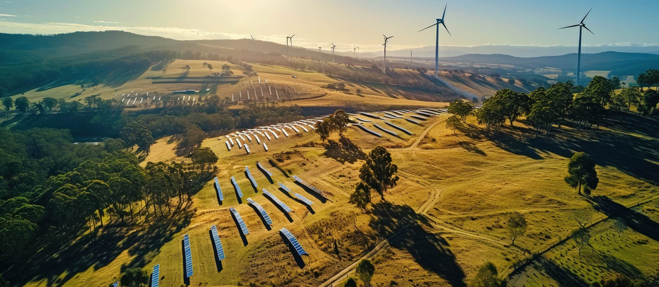
Document details
DOCUMENT TITLE | Skuodas Cluster Hybrid Project
DOCUMENT SUBTITLE | Non-Technical Summary of the ESIA – Annex P
PROJECT NUMBER | 0819625
DATE | 04th August 2026
VERSION | Final
AUTHOR | CORPI and ERM working group
CLIENT NAME | European Energy A/S

Document history
 |  |  |  | Approval to issue
Version | Revision | Author | Reviewed by | Name | Date | comments
Final | 00 | CORPI working group and ERM working group | Constanza Mateos, Julius Morkunas | Alessandro Sestagalli, Julius Morkunas | 10 July 2026
Final | 01 | CORPI working group and ERM working group | EBRD | Alessandro Sestagalli, Julius Morkunas | 4 August 2026 | EBRD comments addressed

Signature page

Skuodas Cluster Hybrid Project
Non-Technical Summary of the ESIA – Annex P
0819625

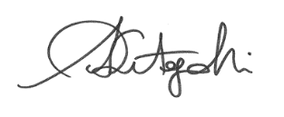
Alessandro Sestagalli  Partner |  | Julius Morkunas  CORPI
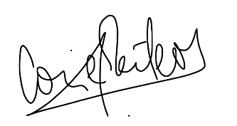
Constanza Mateos
Project Manager

© Copyright 2026 by The ERM International Group Limited and/or its affiliates (‘ERM’). All Rights Reserved.
No part of this work may be reproduced or transmitted in any form or by any means without prior written permission from ERM.

Contents
Key Skuodas Project facts 7
1. About this document 9
2. Who is developing the Project? 9
3. What is an ESIA and why is it needed? 10
4. What laws and standards apply to the Project? 10
4.1 National Environmental Impact assessment screening 10
4.2 National, EU requirements, and International conventions 11
4.3 International standards 13
5. Overview of the Project 14
5.1 Where is the Project? 14
5.2 What will the Project include? 14
5.3 How will it be constructed? 15
5.4 What happens during its operation? 17
5.5 Why is the Project needed? 18
5.6 What Project alternatives were considered? 18
6. What is the baseline state of the environment? 19
6.1 The Physical Environment 20
6.2 The Biological environment 21
6.3 The Socioeconomic Environment 24
7. Project impacts 26
7.1 How are Project impacts assessed? 26
7.2 What are the Project’s key impacts? 27
7.2.1 Impact summary tables 30
7.3 How are unplanned events assessed? 34
7.4 What are the Project’s key unplanned events? 34
7.5 Unplanned events summary table 35
7.6 What about interactions between the Project and other Projects in the area? 36
8. Mitigation measures 38
8.1 What are the main measures planned to address Project impacts? 38
9. Environmental and Social Management and monitoring Plan 40
9.1 Environmental and Social Monitoring 40
9.2 Implementation, Monitoring, and Auditing 41
10. Stakeholder Engagement Activities 41
10.1 Activities Undertaken to Date 42
10.2 Planned Activities 44
11. How to contact the Project: The community Feedback/Grievance Mechanism 44
12. Conclusion 46

List of Tables
Table 4-1 Lithuanian, Eu requirements and international conventions applicable to the Project 11
Table 5-1 Summary of Project alternatives 19
Table 7-1 project impacts on the physical environment 30
Table 7-2 Project impacts on the biological environment 31
Table 7-3 Project impacts on the socioeconomic environment 32
Table 7-4 Unplanned events assessment matrix 34
Table 10-1 Summary of Stakeholders concerns and Project responses 43
Table 11-1 Where and how can a grievance, question or feedback be raised? 45

List of Figures
Figure 5.1 Project layout 14
Figure 5.2 Project schematic 15
Figure 5.3 Construction activities 16
Figure 6.1 PHOTOGRAPH LOOKING OUT TOWARDS THE PROJECT AREA FROM ŽEMYTĖ VILLAGE (OBTAINED VIA GOOGLE EARTH) 21
Figure 6.2 Protected areas 22
Figure 6.3 Eastern Tree Frog (Left) and Great Crested Newt (Right) 23
Figure 6.4 SENOJI ĪPILTIES HILLFORT 25
Figure 7.2 Simulation of the future landscape with wind turbines 29
Figure 7.3 Consequence designations 34
Figure 7.4 Probability designations 34
Figure 6-1 THE PROJECT AREA IN RELATION TO NEIGHBOURING Projects 37

ACRONYMS AND ABBREVIATIONS
Acronyms | Description
BAT | Best Available Techniques
BESS | Battery Energy Storage System
CCTV | Closed-Circuit Television
CORPI | Coastal Research and Planning Institute
DC | Direct Current
EBRD | European Bank for Reconstruction and Development
EIA | Environmental Impact Assessment
EMF | Electromagnetic Fields
ESIA | Environmental and Social Impact Assessment
ESMMP | Environmental and Social Management and Monitoring Plan
ESMP | Environmental and Social Management Plan
ESRs | Environmental and Social Requirements
GBVH | Gender-Based Violence and Harassment
GHG | Greenhouse Gas
HV / MV / LV | High / Medium / Low Voltage
HVAC | Heating, Ventilation and Air Conditioning
IFC | International Finance Corporation
ILO | International Labour Organization
LCO | Lithium Cobalt Oxide
LFP | Lithium Iron Phosphate
NTS | Non-Technical Summary
OHS | Occupational Health and Safety
PV | Photovoltaic
UN | United Nations
WT | Wind Turbine

Key Skuodas Project facts
Project name | Skuodas Cluster Hybrid Project
Developer |   European Energy A/S
Location | The Project is located in north-western Lithuania, within Skuodas District Municipality, Klaipėda County. It will be developed across agricultural land around the villages of Plaušiniai, Palegija, Žemytė and Juodeikiai in Lenkimai Eldership. The Project area covers approximately 230–250 hectares, lies less than 3 km from the Latvian border, around 50 km from Klaipėda and approximately 15–20 km from the Baltic Sea coast.
Main components and capacity | The Project combines 24 wind turbines with a total capacity of approximately 173 MW, 16 fenced solar photovoltaic clusters with a total capacity of around 120 MW DC, a battery energy storage system of 100 MW / 200 MWh capacity comprising approximately 20–30 containerised battery units and associated electrical equipment, a new transformer substation, a medium-voltage underground cable network, optic fibre cables and an approximately 9 km high-voltage underground export cable to the Darbėnai substation.
Construction duration and programme | Construction is expected to last around two years. Construction will be phased, with some components starting operations while others are still under construction. Solar power generation is expected to start first, followed by wind power generation and then the battery energy storage system.
Workforce | The construction phase is expected to require an average workforce of around 155 workers, with short-term peaks of up to approximately 300 workers during specific activities. Workers are expected to be accommodated in existing hospitality facilities in the wider area. During operation, the Project will be largely managed through remote monitoring and control systems and is expected to create around five to six full-time equivalent roles.
Key potential impacts | During construction, most impacts are expected to be temporary and localised. Key impacts include dust, construction noise, temporary traffic disruption, soil disturbance, temporary disturbance to nearby households and land users, potential disturbance to fauna and birds, and temporary pressure on local roads and services. During operation, key impacts relate mainly to the visual presence of turbines and other infrastructure, shadow flicker, glint and glare, operational noise, long-term occupation of agricultural land, and collision risk for birds and bats. With the planned mitigation and management measures, most residual impacts are expected to be reduced to minor or negligible levels, although some residual effects related to bird collision risk and visual effects on heritage settings may remain moderate.
Key benefits | The Project will support Lithuania’s renewable energy transition, contribute to climate change mitigation and energy security, add renewable electricity generation and storage capacity to the grid, support the wider economy through electricity generation and export, and create temporary construction employment, local spending and business opportunities, together with limited long-term operational employment.
Stakeholder engagement and contact details | Stakeholders can request information, submit feedback, raise concerns or lodge grievances through the Project’s stakeholder engagement and grievance mechanism.  Contact details are the following:  Phone (EE Office): +370 6 010 2224  E-mail: skuodas@europeanenergy.com  By Letter: To the EE office in Ukmergės g. 219, LT·07152 Vilnius  Submission box online: skuodasrenew.lt  On site will be present designated grievance box available at Lenkimai community center ( Lenkimų sen. bendruomenės namai [S. Daukanto g. 59, Lenkimai] )

About this document
This document presents the key findings of the Environmental and Social Impact Assessment (ESIA) for the Skuodas Cluster Hybrid Project in Skuodas municipality, north-western Lithuania. The Project includes renewable power generation (including solar panels and wind turbines), a battery energy storage system (BESS) to store electricity, a new transformer substation, and an underground cabling network. The Project is being developed by European Energy A/S. The ESIA, as well as the present document, has been prepared on behalf of European Energy (EE) by the Coastal Research and Planning Institute (CORPI) and ERM Italia S.p.A (ERM).
This Non-Technical Summary (NTS) forms part of the broader disclosure package prepared for the Project. The full Environmental and Social Impact Assessment (ESIA) examines the existing environmental and socio-economic conditions within the Project’s area of influence, assesses the Project’s impacts, provides a comprehensive list of measures to mitigate identified impacts, and outlines monitoring commitments.
The ESIA incorporates information from numerous technical studies conducted during the ESIA phase to provide a detailed understanding of the socio-economic environment. It identifies critical areas for intervention, enabling actions that aim to ensure the Project delivers, to the maximum feasible extent, no changes to the initial socio-economic conditions.
The aim of the ESIA is to validate that the Project is in full compliance with the environmental and social standards commonly applied by major international financial institutions. In particular, European Bank for Reconstruction and Development (EBRD) Environmental and Social Policy (2024).
The Project has been subject to the Lithuanian national Environmental Impact Assessment (EIA) screening process, which concluded that a full national EIA was not required.
This NTS is intended to be used as an accessible summary of the ESIA and technical documents, more technical details are available in the full ESIA report and Annexes.
Full documents are available for consultation, the Stakeholder Engagement Plan (SEP) and the grievance mechanism explain how to get involved and reach out to relevant Project parties to provide feedback, share concerns or complaints at any point throughout the Project’s lifetime.

Who is developing the Project?
The Project is being developed by European Energy A/S (EE). EE is a company with European values at its heart, founded in Denmark in 2004. It has over 900 employees of 51 nationalities, across more than 30 offices. The company has Project development activities in 23 countries. EE generally manages its Projects from start to finish: from screening, development, construction, and through operation. EE has an already-established presence in Lithuania, with an office in Vilnius. EE has already successfully developed a number of battery energy storage, wind and solar Projects in Lithuania, some of which have already been operating for a number of years and some of which are under construction.

What is an ESIA and why is it needed?
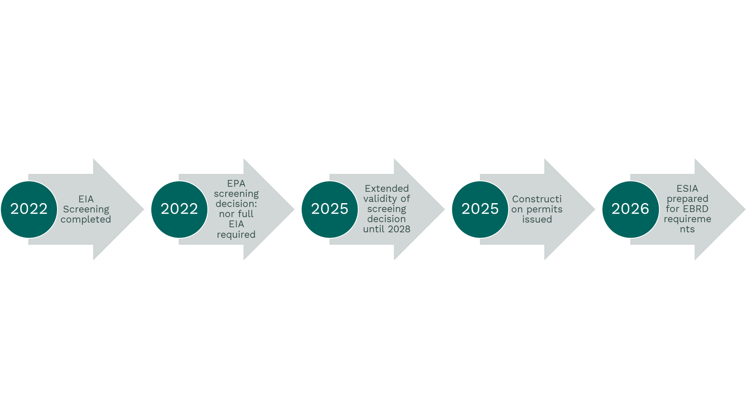
The Project has already gone through the national permitting process required under Lithuanian law, including the Environmental Impact Assessment (EIA) screening report. A screening for the wind turbines was carried out in 2022 and outcomes confirmed that a full ESIA was not required, this conclusion remain valid up to October 2028. The other main components of the Project, namely the solar panels (PVs) and the BESS are not subject for development of a screening report considering their spatial extension and energy. As a conclusion of the screening process a full national EIA was not required, and the Project obtained permit for construction. A separate Environmental and Social Impact Assessment (ESIA) was nevertheless undertaken for banking purposes, as part of the environmental and social due diligence required by international lenders.
The full ESIA allows to identify key areas of interventions were the Project may generate alterations of the original socio-economic conditions and define the implementation of mitigation measures to avoid, reduce, or manage adverse impacts and risks, and to enhance positive impacts where feasible. These measures will be integrated into the Project’s environmental and social management plans.
The ESIA preparation follows a Public Disclosure phase where the Project is presented to relevant stakeholders, this is a key step in which stakeholder feedback is gathered and answered and can lead to amendments to the ESIA.

What laws and standards apply to the Project?

National Environmental Impact assessment screening
The Project has undergone the national permitting procedure under Lithuanian legislation, including the environmental impact assessment (EIA) screening process, carried out in 2022. Required approvals for the development and construction of the Project have already been obtained from the national standpoint. The key national requirements with regards to the permitting procedure are specified in: Law on Environmental Impact Assessment of the Proposed Economic Activity of the Republic of Lithuania, No. I-1495 of 15 August 1996; Order No. D1-845 of the Minister of Environment of the Republic of Lithuania of 16 October 2017 “On the Approval of the Description of the Procedure for Screening of Proposed Economic Activities for Environmental Impact Assessment”
Lithuania’s national environmental impact assessment system requires an EIA screening whenever a development includes three or more wind turbines exceeding 50 m in height. The Project features 24 wind turbines and therefore met the requirements for screening.
The Project’s other components (namely battery energy storage system and solar power generation) are not automatically subject to EIA screening under Lithuanian legislation unless significant effects on Natura 2000 sites (Type of protected area) cannot be excluded.
The conclusions of the Lithuanian Environmental Protection Agency with regards to the Project in the EIA screening of 2022 are as follows:
- A full EIA is not required for the Project. This conclusion is valid until October 2028.
- The proposed wind turbine locations fall within areas already designated for infrastructure and wind energy development under the municipal planning framework.
- No significant adverse impacts on Natura 2000 sites are expected, and an EIA procedure is not required for the battery energy storage system and solar power generation components of the Project.
- No significant adverse effects on Latvia (3 km away) are expected, and therefore no transboundary EIA procedure was required.
- An international ESIA has been undertaken to ensure the Project meets requirements of major international financial institution such as EBRD.

National, EU requirements, and International conventions
The national regulatory framework in Lithuania is composed of a number of laws that govern biodiversity conservation, land‑use planning, construction, pollution prevention, noise, water use and a number of other topics relevant to the Project. Lithuania adheres to European Union (EU) directives which ensure that environmental impacts are assessed and addressed consistently across Europe. Lithuania is also party to international conventions setting out requirements promoting sustainable development on a global level. The requirements most applicable to the Project are indicated below. During the screening phase transboundary impacts were found unlikely to be significant despite proximity to Latvia’s border of 3 km.
Table 4-1 Lithuanian, Eu requirements and international conventions applicable to the Project
Topic | Reference
Key national requirements
Environmental protection | Law on Environmental Protection of the Republic of Lithuania, No. I-2223 of 21 January 1992
Protected areas | Law on Protected Areas of the Republic of Lithuania, No. I-301 of 9 November 1993; Resolution No. 276 of the Government of the Republic of Lithuania of 15 March 2004 “On the Approval of the General Regulations for Areas Important for the Protection of Habitats or Birds”; Habitats Directive 92/43/EEC; Birds Directive 2009/147/EC
Territorial planning | Law on Territorial Planning of the Republic of Lithuania, No. I-1120 of 12 December 1995
Special land use conditions | Law on Special Land Use Conditions of the Republic of Lithuania, No. XIII-2166 of 6 June 2019
Construction | Law on Construction of the Republic of Lithuania, No. I-1240 of 19 March 1996
Water protection | Law on Water of the Republic of Lithuania
Renewable energy | Law on Renewable Energy of the Republic of Lithuania, No. XI-1375 of 12 May 2011
Environmental requirements for solar power plants | Order No. D1-358 of the Minister of Environment of the Republic of Lithuania of 14 November 2022 “On the Approval of Environmental Requirements for Planning, Construction and Operation of Solar Power Plants”
Noise | Law on Noise Management of the Republic of Lithuania; Lithuanian Hygiene Standard HN 33:2026 “Noise Limit Values in Residential and Public Buildings and Their Environment”; STR 2.01.08:2003 “Management of Noise Emitted into the Environment by Equipment Used Outdoors”
Waste management | Law on Waste Management of the Republic of Lithuania; Waste Management Rules approved by Order No. 217 of the Minister of Environment of the Republic of Lithuania of 14 July 1999; Rules on Management of Electrical and Electronic Equipment and its Waste; Construction Waste Management Rules
Cultural heritage | Law on the Protection of Immovable Cultural Heritage of the Republic of Lithuania, No. I-733 of 22 December 1994; Heritage Management Regulation PTR 2.13.01:2022 “Management of Archaeological Cultural Heritage”
EU Directives
EIA | Directive 2011/92/EU as amended by Directive 2014/52/EU (EIA Directive)
Habitats | Habitats Directive (Directive 92/43/EEC)
Birds | Birds Directive (Directive 2009/147/EC)
International conventions
Climate Change | United Nations Framework Convention on Climate Change (UNFCCC)
Climate Change | Kyoto Protocol to the UNFCCC
Climate Change | Paris Agreement
Biodiversity and Ecosystems | Convention on Biological Diversity (CBD)
Biodiversity and Ecosystems | Bern Convention on the Conservation of European Wildlife and Natural Habitats
Biodiversity and Ecosystems | Convention on Wetlands of International Importance Especially as Waterfowl Habitat (Ramsar Convention)
Biodiversity and Ecosystems | Convention on the Conservation of Migratory Species of Wild Animals (CMS / Bonn Convention)
Public Participation | Convention on Access to Information, Public Participation in Decision-Making and Access to Justice in Environmental Matters (Aarhus Convention)
Waste and Hazardous | Basel Convention on the Control of Transboundary Movements of Hazardous Wastes and their Disposal
Waste and Hazardous | Rotterdam Convention on the Prior Informed Consent Procedure for Certain Hazardous Chemicals and Pesticides in International Trade
Waste and Hazardous | Stockholm Convention on Persistent Organic Pollutants
Waste and Hazardous | Minamata Convention on Mercury
Cultural Heritage | Convention Concerning the Protection of the World Cultural and Natural Heritage
Human Rights and Labour | Core UN human rights treaties and relevant ILO conventions ratified by Lithuania

International standards
The Project also follows international standards used by international financial institutions (IFIs). The current involved IFIs is the European Bank for Reconstruction and Development (EBRD), the Project’s focus has been on the application of the EBRD’s Environmental and Social Policy (2024) and its Environmental and Social Requirements (ESRs). The ESRs delineate aspects to consider and measures to assess, mitigate, monitor, and manage environmental and social risks and impacts throughout the project lifecycle.
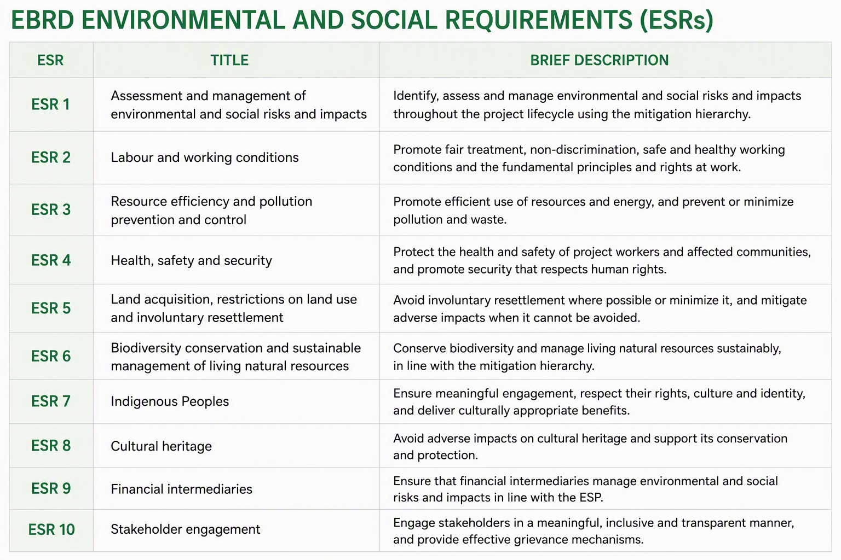
The ESIA also considers other internationally recognized frameworks, including the IFC Performance Standards, the Equator Principles IV, the World Bank Group Environmental, Health and Safety Guidelines and the UN Guiding Principles on Business and Human Rights. The IFC Performance Standards are another widely used set of international good-practice requirements for projects financed by banks and investors. They help ensure that projects understand and manage possible effects on people, workers, land, natural resources, cultural heritage and local communities. These standards help ensure that the Project meets high environmental and social performance expectations. Whenever international standards differ from EU or national legislation, the approach is to apply whichever are most stringent.

Overview of the Project

Where is the Project?
The Project is located in north‑western Lithuania, within Skuodas District Municipality in Klaipėda County, across agricultural land surrounding the villages of Plaušiniai, Palegija, Žemytė and Juodeikiai in Lenkimai Eldership. The development area covers approximately 230–250 hectares and lies less than 3 km from the Latvian border, around 50 km from Klaipėda and 15–20 km from the Baltic Sea coast. The landscape is characterised by flat farmland at 30–45 m above sea level, intersected by small rural roads, some of which are unpaved and drainage channels. Figure 5-1 shows the Project layout on a map of the broader area.
Figure 5.1 Project layout
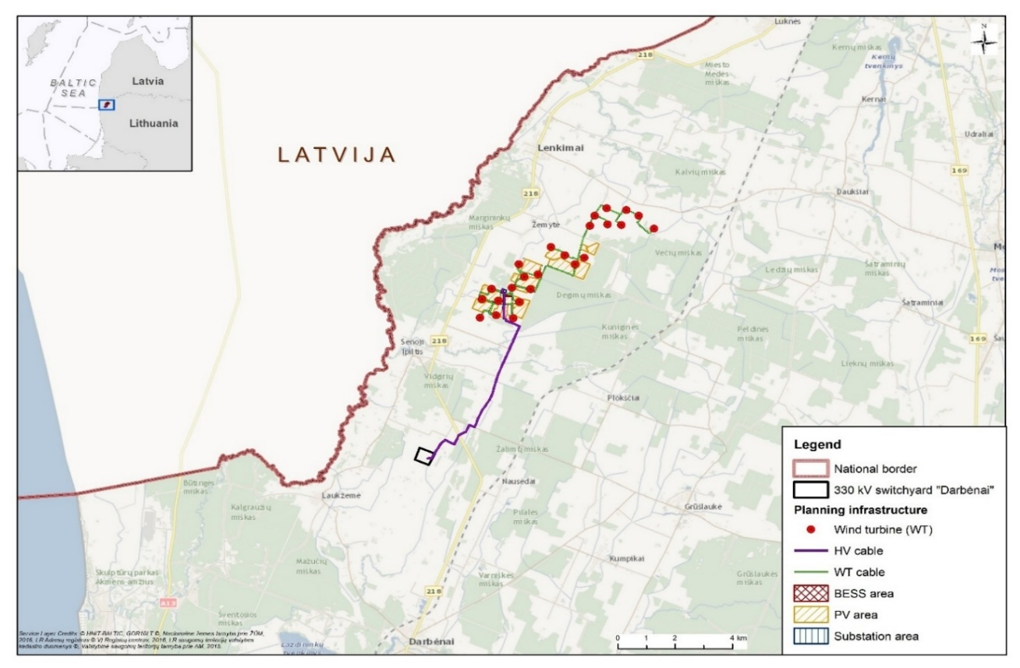
Note: Acronyms used are as follows: HV – High voltage; WT – Wind turbine; BESS – Battery Energy Storage System; PV – Photovoltaic (solar).

What will the Project include?
The Project consists of the following key components, illustrated in Figure 5.2:
- 24 wind turbines (WT) with a total capacity of about 173 MW.
- 16 solar Photovoltaic (PV) clusters (fenced) with a total capacity of around 120 MW (DC).
- A Battery Storage Energy System (BESS) of 100 MW / 200 MWh capacity.
The wind turbines and PV cluster components will generate power by transforming the energy from the wind and the sun into electricity. The BESS will store energy produced in 20-30 containers with battery cells and associated electrical equipment.
the BESS will store energy when the Project produces more electricity than that which is required by the grid, releasing it during periods of high energy demand, ensuring electricity availability at all times.
Other Project’s key components include:
- A medium voltage electrical network consisting of buried electrical cables and optic fibre cables. Electrical equipment will also be required at wind turbines and PV clusters to transform and step-up voltage of the electricity produced. This component will allow the transport of the electricity generated by the Project to its transformer substation and support a number of ancillary equipment and services (remote monitoring systems and CCTV).
- A transformer substation (referred to as the “Mančiai substation”).
- A high voltage buried cable of 9 km.
The above components will respectively collect and step-up the voltage of the electricity produced by the Project and transport it to a point at which it connects to the Lithuanian grid (Darbėnai substation). The grid connection point and electrical transmission infrastructure may require some upgrades, which are beyond the scope of the Project but will be necessary for the Project’s development.
Figure 5.2 Project schematic
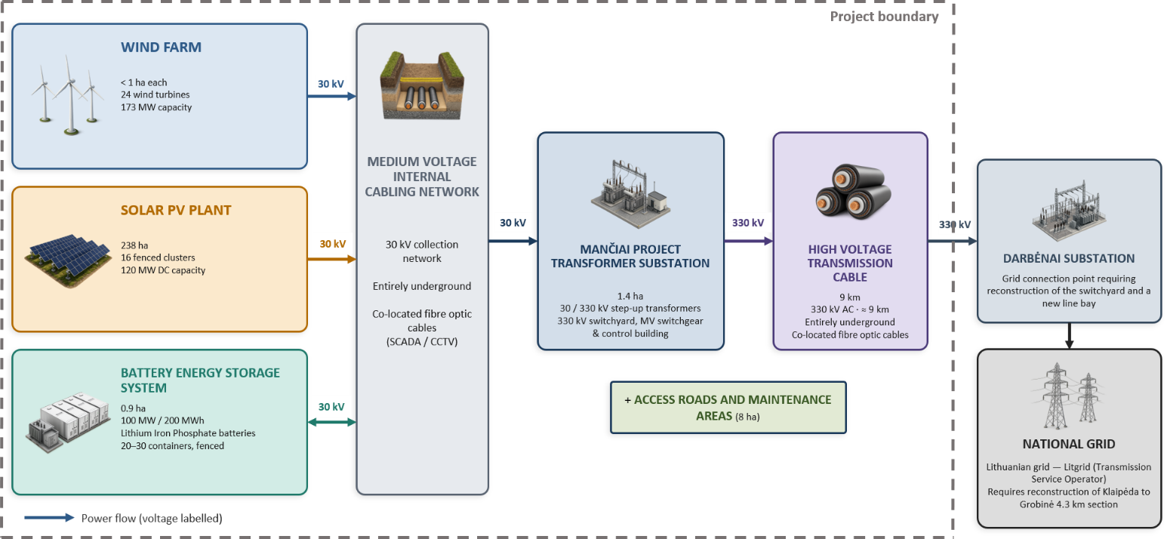

How will it be constructed?
The construction will last around 2 years and will require an average of 155 workers. There may be more or fewer workers during specific Project activities (up to 300).
Preparing the site: Before construction, a number of areas will be stripped of the topsoil layer. These areas include those where the transformer substation and battery energy storage system will be constructed, and areas around future wind turbines and access roads. New access roads will be made of gravel and kept to the minimum. Existing roads will be used whenever feasible.
Construction of components: A number of machines and trucks will be present on site, including loaders, excavators, but also cranes to install the wind turbines. Large trucks will be used to transport Project components and may require temporary modifications between Klaipeda port and the Project area to let the larger trucks pass through. Cables will be installed in trenches. Where there are roads, obstacles or utilities, a special tunneling technique will be used to avoid damaging any surface infrastructure. The battery energy storage system area will have an impermeable membrane installed to ensure that even if there is a leak in battery containers (a very rare, unplanned event), the effluents do not contaminate the soil.
After construction: After construction, the fertile topsoil layer which was removed will be redistributed across the site. Areas where the soil has been exposed will be seeded with perennial, low-growing grass. Any access road which is not necessary for the operation phase will be removed.
Construction of different components will occur step by step. Therefore, disturbance will be localized and restricted to specific areas at a given point in time. Specific assets will start operating while others are still in construction. Solar power generation first (autumn 2027), wind power generation second (spring 2028), and battery energy storage system last (summer 2028).
Figure 5.3 Construction activities
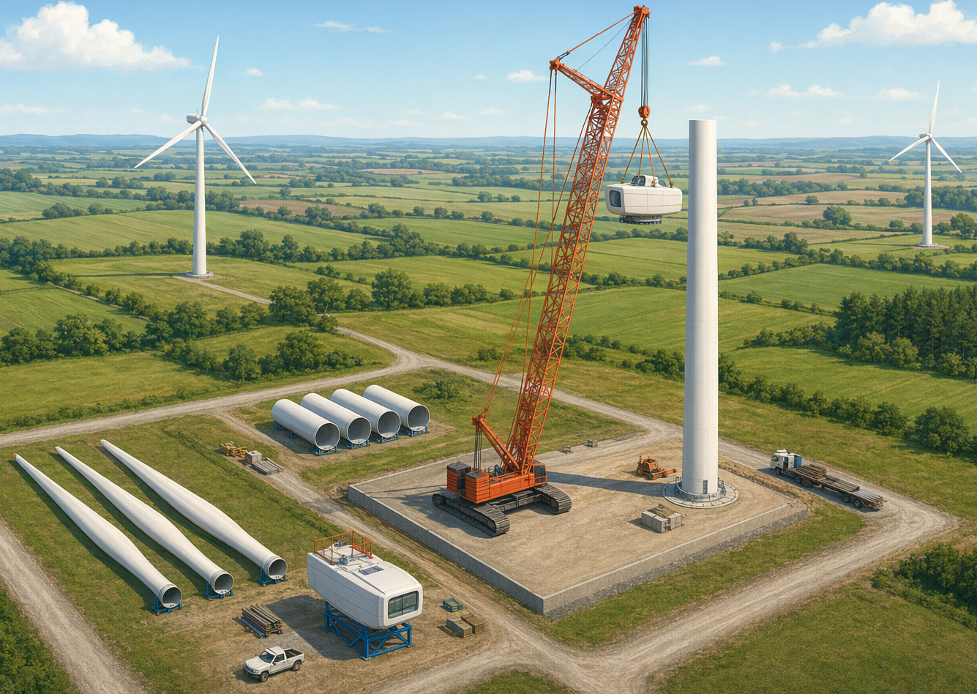
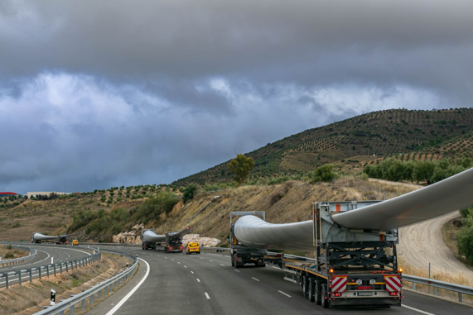
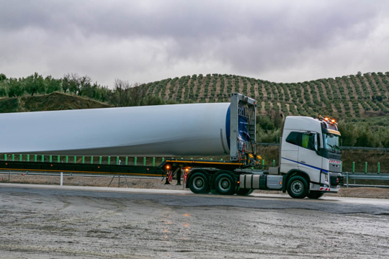
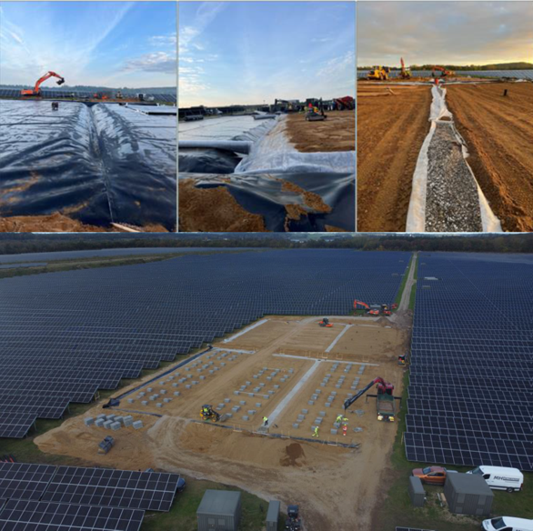

Note: Pictures are illustrative. Top – Wind turbine installation; Center – Battery Energy Storage System construction; Bottom – Wind turbine transportation.
During construction, workers will be hosted in local hospitality facilities in the broader area around the Project, at the discretion of EE’s construction contractors. Around 60% of the workforce may be recruited from outside the local area; however, workforce accommodation will be managed through a dedicated Workforce Accommodation and Services Management Plan, which will define accommodation arrangements, assess demands on local services and infrastructure, and establish engagement procedures with accommodation providers and local authorities. In addition, potential impacts on local communities arising from worker presence will be managed through the Community Health, Safety and Security Plan, Labour Management Plan and Stakeholder Engagement Plan, including measures addressing worker conduct, workforce-community interactions, grievance management, communicable disease prevention, gender-based violence and harassment risks, and ongoing communication with affected communities.

What happens during its operation?
Once each Project component is constructed and tested, it will be commissioned and progressively brought into operation. This means that some parts of the Project may already be generating, storing or transmitting electricity while other components are still under construction. When all components are commissioned, the Project will move into its full operational phase.
The Project will operate for around 30 years. It will not require many workers during operations as it is designed to be managed mostly through remote monitoring and control systems. On-site presence will be required for scheduled inspections, planned, and occasional corrective maintenance activities. In total, around five full-time employments will be created. Solar, transformer substation and battery energy storage system areas will be fenced so the land will not be accessible. Around certain wind turbines, there will be no fencing and agricultural activity can proceed.

Why is the Project needed?
Lithuania aims to improve its energy security, rely less on imported energy, and produce more electricity than it uses by 2030. In the longer term, the country aims to become a net energy exporter by 2050. Intermediate targets established for 2030 include achieving a 100% share of renewable electricity in total final electricity consumption and increasing the share of renewables in gross final energy consumption to 55%, compared to a 95% target by 2050. Expansion of domestic renewable energy generation constitutes a key pathway to achieving these objectives.
In this context, the Project would contribute approximately 5.4% of the onshore wind capacity (4.5 Gigawatts, GW) and 2.9% of the solar capacity (4.1 GW) required nationally by 2030, both of which are planned to be further expanded to 10 GW of wind and 9 GW of solar capacity by 2050.
The inclusion of BESS would further support grid stability by addressing intermittency, frequency regulation, and peak demand management.
An expansion of domestic renewable generation would also reduce Lithuania’s exposure to energy supply disruptions and price volatility associated with fossil fuel markets.
Locally, the Project is expected to bring some economic benefits. These may include regular payments to landowners through long-term land lease agreements, additional tax income for the municipality, and opportunities for local companies and workers to provide goods and services during construction and operation. The construction phase may also help workers gain skills and experience in renewable energy, electricity infrastructure and battery storage systems, which could support future job opportunities in similar projects. If the Project does not go ahead, these local economic and employment benefits would not take place.
Finally, the Project’s strategic location in proximity to Klaipėda port, the largest in the country, may also provide long-term opportunities to supply low GHG emission electricity to the port facilities and port operations, supporting also the emerging energy value chains such as production of hydrogen and its derivatives, e-fuels, etc..

What Project alternatives were considered?
The table below summarizes the key alternatives considered for the Project and why specific choices in terms of development, location, and design were made:
Table 5-1 Summary of Project alternatives
Alternatives | Comment | Selected base case
No Project alternative | A no Project alternative is one where the Project is not developed. It is considered unfavorable because it represents a missed opportunity to contribute to climate change mitigation, energy security, and industrial and economic development in the country. | Proceed with the development of the Project
Other locations | There are locations with better resources on a global level, but they do not benefit from the same policy support, and stable, reliable jurisdiction and economy as Lithuania. The electrical transmission infrastructure is ready to accommodate the Project, and the site has some of the best wind resources in the country. It is designated in spatial planning as an area to be developed for wind energy. | Project site, in Klaipeda County
Other battery technologies | There are higher performing battery technologies which can store more energy, but they have a greater risk of catching fire and contain Cobalt, a toxic heavy metal. It has been decided to select the safest solution. | Lithium Iron phosphate batteries
Other wind turbine models | The selected model is the tallest, which will generate the most clean energy for the land available. The height difference with other models will not make a noteworthy difference to landscape impacts and the noise emissions of all models were similar. | Vestas V172
Solar technologies | The selected technologies follow the sun as it moves across the sky throughout the day, and generate electrical energy from the backside of PV modules to capture energy from light reflected off the ground. This generates the most clean energy for the land available. | Bifacial modules  Single-axis trackers
Overhead lines | Instead of having underground cables, an alternative would be to have cables above the ground, as overhead lines. This would create more visual and ecological impact, be more at risk of damage, and occupy more land surface. Burying the cables is therefore preferred. | Buried cables

Why this location was selected
The Project location was selected to be compatible with the surrounding environment, biodiversity features and nearby communities. The main characteristics supporting the choice of this location include:
- The area has a relatively low population density compared with many central or southern European locations with similar wind resources. Skuodas District is also less densely populated than many inland or peri-urban alternatives in Lithuania. This means fewer people are likely to be affected, reducing the potential need for additional mitigation measures.
- The Project does not directly overlap with nationally or internationally protected areas.
- No cultural heritage assets are located within the Project site.

What is the baseline state of the environment?
This chapter summarises the existing environmental and social conditions in the Project area and its surroundings. Understanding baseline conditions is essential for assessing how the Project may interact with the environment, local communities, and cultural heritage. The baseline reflects a predominantly rural landscape in north‑western Lithuania, characterized by agricultural land, dispersed settlements, and a network of small rivers and drainage channels. The Project area lies within Skuodas District Municipality, close to the Latvian border and approximately 15–20 km from the Baltic Sea coast.

The Physical Environment
- Climate, climate change and greenhouse gases
Western Lithuania experiences a milder climate with lower temperature variability than the east. The climate of the Project area is influenced by its location in a “highland” area and its proximity to the coast, which makes it a relatively wet and windy area, featuring snow during the colder months of the year. Lithuania has set ambitious targets with regards to mitigating and adapting to climate change. In the future, a changing climate will imply wetter, warmer conditions which more frequent and intense extreme weather events.
- Air quality
The air quality within the Project study area is considered good, and air pollutant concentrations in the Klaipeda region are well below applicable standards. There are no nearby industrial air pollution sources, and the windy, wet conditions favour settlement and dispersion of air pollution.
Noise Monitoring: A team went on site to record noise levels in the area. The data collected was used to better understand the existing noise levels at homesteads and help predict how Project noise will combine with existing noise. This allows to understand the overall noise levels during Project activities.

- Noise
The Project area is not particularly noisy: It is a rather quiet rural area, where the main noise sources are vehicle passage on local roads, agricultural activity and natural sounds such as wind rustling through vegetation.
- Water resources
The Project area is within the Venta River Basin and is characterized by a network of small rivers, streams and artificial drainage systems and ditches supporting the agricultural activity. Main rivers at the Project site include the Pagraistupys, Plaušmirkis and Pievupis rivers. The Kiaupškė, Įpiltis and Kulšė rivers will be crossed by the high voltage cable route. The groundwater in the Project area is generally close to the surface, and there is a well around 700 m from the Project area.
- Geology and soils
The land sits on soils and sediments left behind by the last Ice Age, which deposited a mix of loam (a blend of clay, silt and sand) and in a few places finer clays, clayey sands or sandy silts. The soils are mineral rich and considered good for agriculture. They do not show any sign of contamination. Overall, the soils and geology are not rare, unusual or specially protected.
- Landscape
The Project Area is agricultural and sparsely populated. The terrain is flat or undulating, with fields, patches of woodland, dispersed farms, and local roads, drainage systems and scattered vegetation belts. It has open views, with wind turbines already present in some locations.

Figure 6.1 PHOTOGRAPH LOOKING OUT TOWARDS THE PROJECT AREA FROM ŽEMYTĖ VILLAGE (OBTAINED VIA GOOGLE EARTH)

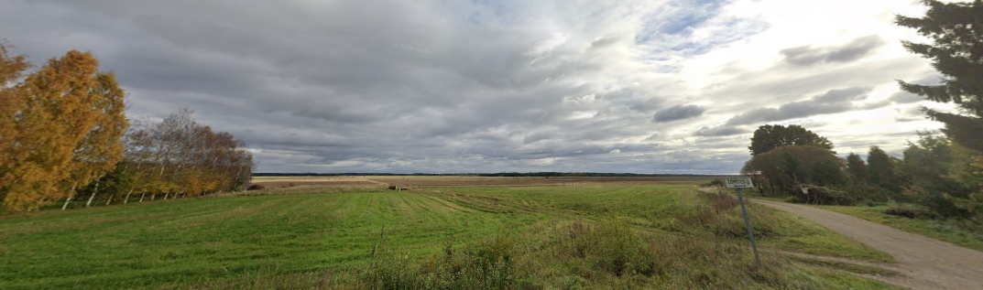

The Biological environment
- Protected areas
No protected areas lie within the Project boundary, nor is any proposed infrastructure situated within protected areas or Natura 2000 assessment zones. The nearest protected area is the Margininkai Botanical–Zoological Reserve, (1.0–1.7 km), which protects pine forest, riverbank vegetation and fauna. Closely linked to it is the Šventoji River Valley Natura 2000 site (1.5–1.8 km away), designated for high￼value grassland, meadow, bog and forest. Additional Natura 2000 sites and reserves are located between 2.6 km to 5.3 km from the Project area, protecting grasslands, alluvial meadows, alkaline fens, wetland habitats and their species. Salantai Regional Park and Erla Geomorphological Reserve lie 7 km away and safeguard valley landscapes, geomorphological features, etc.
Figure 6.2 Protected areas
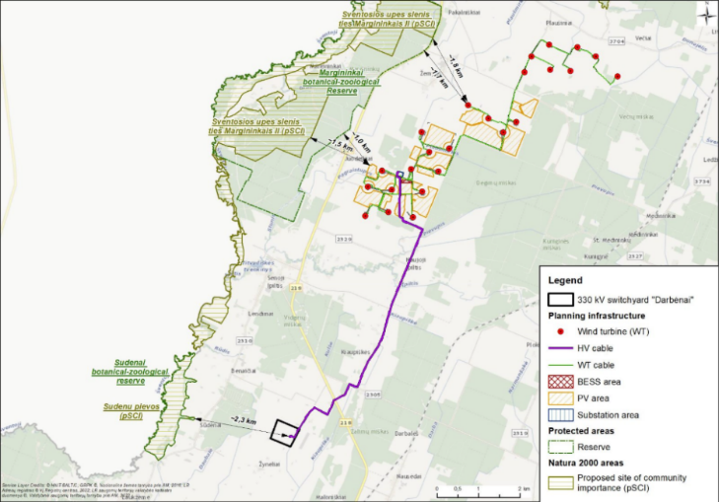
- Habitats
There are no protected habitats at national or EU level within the Project area, which consists mainly of intensively farmed landscape. The nearest high-value habitat is Molinia meadows (EU code 6410), located 35 m from the Project. Additional species-rich grasslands, alluvial meadows and wetland habitats are found 1–3 km away in Natura 2000 sites along the Šventoji River valley.
- Species
A variety of wildlife groups inhabit the Project area. Desk research and surveys found: 23 recorded invertebrate species of which 2 protected species: Marsh Fritillary (Euphydryas aurinia) and Swallowtail (Papilio machaon) (nationally and/or at EU level). One fish species in the local drainage channels. One reptile and six amphibian species of which two are protected (the Eastern tree frog Hyla arborea and Great Crested Newt Triturus cristatus). Seventynine bird species were recorded in the Project area, including cranes, storks, geese, and raptors and protected species under EU and national law.
The following list of protected species are those indicated in the Lithuanian Red Book:
- Black Stork Ciconia nigra Breeding
- White-tailed Eagle Haliaeetus albicilla resident
- Lesser Spotted Eagle (Clanga pomarina)- breeding
- Common Kestrel Falco tinnunculus breeding
- Montagu’s Harrier Circus pygargus resident
- Red Kite Milvus milvus- breeding
- Eurasian Goshawk Accipiter gentilis- resident/breeding
- Eurasian Curlew (Numenius arquata)- migrant
European Golden Plover Pluvialis apricaria- migrant
- Ruff Calidris pugnax- migrant
- Eurasian Hoopoe (Upupa epops) breeding
- Grey Partridge Perdix perdix - breeding
- European Turtle Dove Streptopelia turtur - breeding
- Stock Dove Columba oenas -breeding

Bird species of European concern (IUCN STATUS VU/NT) are the following:
- Eurasian Curlew Numenius arquata – NT - migrant
- Ruff Calidris pugnax – NT - migrant
- Northern Lapwing Vanellus vanellus – VU - breeding
- Common Snipe Gallinago gallinago – VU- breeding
- Rook Corvus frugilegus – VU - residant
- European Turtle Dove Streptopelia turtur – VU -breeding

Over 200 nests were found within 2 km of the Project. Nineteen species of mammals were also found (deer species, European Beaver, European Badger, Red Fox and the Eurasian Otter (protected). Alien invasive species (plants and one mammal) are present in the wider municipality. Non of invasive plants species are found in protected areas.

Figure 6.3 Eastern Tree Frog (Left) and Great Crested Newt (Right)
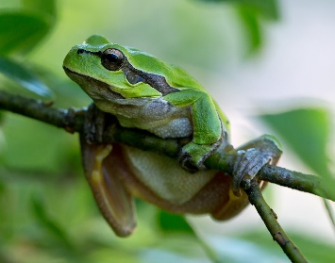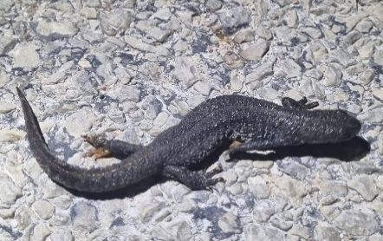

Biodiversity Surveys: On-site surveys were conducted to characterize local species and assess the presence of protected species, habitats, and invasive species. Additional surveys for birds and bats are currently ongoing and will conclude in autumn 2026. This extended monitoring ensures full coverage of seasonal biodiversity variations, such as migratory patterns. However, these ongoing studies will not alter the primary conclusions or require additional mitigation measures, as the key periods of species activity and reproduction have already been comprehensively evaluated.
- Ecosystem services and bio-corridors
Nature provides a number of services for residents including crop production, collection of wild fruits, mushrooms and medicinal plants. The local drainage network and vegetation provide key biological corridors within which species can shelter, forage and breed, and through which they can move. They are key to maintaining habitat connectivity and sustaining biodiversity.

The Socioeconomic Environment
Social & archaeological surveys: A team went on site in May 2026 to collect municipal data, carry out household surveys and interviews. An archaeological survey found 3 areas with elevated archaeological potential which may require investigation prior to construction.

- Demographics
The Project area is sparsely populated and has an ageing, declining population (median age of 50). Out-migration is caused by limited employment opportunity and creates shortages in labour/services. Vulnerable groups include elderly residents, women-headed households, persons with disabilities, and low-income households.
- Land use and ownership
Land is mainly agricultural and privately owned. Surveyed landholders reported private or co￼ownership and confirmed that they had signed voluntary land￼use agreements with the Project developer. Most of the agreements for the land plots required by the Project were voluntarily signed, agreements for the remaining plots are in progress). Mixed farming, crop production, livestock keeping and land leasing form the core livelihood activities. Seasonal activities (planting, spraying, harvest) are important periods for agricultural operations.
- Economy and employment
Economic activities include crop and livestock farming, beekeeping, growing vegetables at home, repairs, seasonal labour, pensions, and participating in local commerce. The rural economy is not very diversified and may be sensitive to demographic changes. Public sector employment offers stability to only a small fraction of residents. Lenkimai Eldership has an accommodation capacity of around 350 beds, spread across family-run homesteads and private lodgings.
- Education
Education is provided through district‑level institutions, with several schools serving the wider area. Attendance is stable, though absenteeism persists among socially vulnerable students. Transportation from remote villages is a key challenge in access to education. Agricultural skills are strong locally, while vocational training opportunities are limited.
- Health & Wellbeing, infrastructure and services
Quality of life is affected by constraints in infrastructure, water supply issues, and poor road conditions. Non-communicable diseases dominate the local health profile (circulatory disease is the major death cause amongst the elderly, respiratory illness is more common in the young). Due to its rural situation, the area has limited health services (part-time/visiting staff, only basic ambulatory support). Specialist or emergency care (as well as police/firefighting) depends on larger regional centres 30 km away). Road transport is the only practical means of mobility.
- Human rights
Survey findings show no discrimination based on ethnicity, religion, gender, or disability. However, rural structural issues can restrict access to services and impact how different groups can exercise their rights. The population is ethnically homogeneous, and some individuals speak a local dialect. There are no indigenous people according to IFC and EBRD criteria.
- Cultural Heritage
No registered immovable cultural heritage is within the Project area. The wider 10 km around the Project features 130 registered sites (hillforts, cemeteries, sacral objects, etc.). The nearest registered assets lie 1.1 km to 1.7 km from planned infrastructure, and include the Naujoji Įpiltis Hill, and the Old Įpiltis Hillfort (a mythological and sacral landscape feature and Iron Age hillfort).
Figure 6.4 SENOJI ĪPILTIES HILLFORT
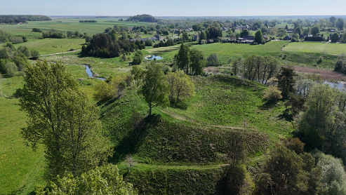

Project impacts

How are Project impacts assessed?
Project impacts on receptors of the physical, biological, and socioeconomic environment are evaluated in a step-by-step process divided into:
- What changes in the environment will occur because of the Project? (Impact prediction and identification)
- How significant is the change? (Impact Evaluation)
- How can the change be addressed and avoided, reduced, or compensated for? (Impact Mitigation)
- How significant is the change if we apply mitigation measures? (Residual Impacts)
The assessment is carried out as a continuous and iterative process, supported by stakeholder engagement, studying using a modelling approach and studies using data collected in dedicated field surveys. A more detailed overview of the methodology is presented in the figure below.
Impacts are classified (in order of severity) from Negligible (not significant impact), minor, moderate, Major (significant and very visible impact). This helps flag any impacts which are of little concern and will not be noticeable, or on the contrary, those which may be long lasting, cover a large area, breach legal limits or standards. This is evaluated for the construction and operation of the Project. Impacts related to the dismiss of the Project (in at least 30 years time) are not assessed as they will occur at a far-away point in time, and are expected to be similar to those of the construction phase.

What are the Project’s key impacts?
During construction - Most impacts are temporary and localized. Main impacts include:
Impacts to the Physical Environment
- Dust generation from construction machinery and soil movement, as well as emissions of air pollutants and greenhouse gases (MINOR residual impacts).
- Soil disturbance, compaction and erosion, due to passage of heavy vehicles and exposure of loose soil. The soil can reach watercourses and ditches and create water quality issues (NEGLIGIBLE residual impacts).
- Noise from the many vehicles and machinery moving in and out of the Project area (MINOR residual impacts).
- Visual impacts, due to cranes occupying the field of view during wind turbine installation MINOR residual impacts).
Impacts to the Biological Environment
Protected habitats lie outside the Project footprint, and no direct habitat loss of EU-protected types is anticipated.
- Disturbance due to habitat fragmentation / alteration of ecological connectivity from construction activities that require excavation and heartworks (MINOR residual impacts).
- Temporary displacement of individuals due to disturbance (noise, vibration, light), habitat fragmentation, risk of introduction and spread of alien and invasive species, risks of mortality to fauna (MINOR residual impacts).
Impacts to the Socioeconomic Environment
- Disturbance due to degradation of the physical environment (dust and noise affecting households closest to construction works). (MINOR residual impacts).
- Project traffic from Klaipeda port to the Project site causing congestion on local roads. (MINOR residual impacts).
- Restriction of agricultural land access (addressed by land lease agreements). (MINOR residual impacts).
- Potential positive (but limited) contribution of the Project to the local economy through purchased goods/services and employment. (MINOR residual impacts).
Impacts to Cultural Heritage
- No impacts are expected to any cultural heritage artifacts, in case of any findings they will be promptly notified to relevant authorities and managed to minimize impacts (MINOR residual impacts).
During operation - Impacts will remain localized, but will generally be long-lasting, for the entire operational lifetime of the Project (around 30 years). Main impacts include:
Impacts to the Physical Environment
- Visual presence of turbines, shadow flickering (passage of turbine blades in front of the sun causing a flickering effect in households) or glint & glare (reflection of sunlight on solar panels or turbines creating a bothersome flash of light). (MINOR residual impacts)
- Noise from electrical equipment and wind turbines: Project noise was modeled considering all Project components, and may exceed applicable limits only during the evening/nighttime but can be mitigated where needed. Mitigation measures will be implemented to ensure compliance with regulatory and international limits (MINOR residual impacts)
Impacts to the Biological Environment
- Collision risk, namely to birds and bats, some of which benefit from a protection status under EU or national law (MINOR residual impacts).
- Permanent habitat modification (MINOR residual impacts).
Impacts to the Socioeconomic Environment
- Permanent occupation of land and loss of access for existing users and land-use restrictions (MINOR residual impacts).
- Limited impacts. Possible disturbance in connection to impacts on the landscape, shadow flicker, glint and glare, and noise (MINOR residual impacts)..
Impacts to Cultural Heritage
- In the Project footprint there is no record of cultural heritage artifacts, minor impacts are expected due to visual intruision of the newly built wind turbines from two nearby cultural heritage settings (MINOR residual impacts)..

Positive Project Impacts - The Project will generate benefits on the environment and local community during all phases (construction and operation):
- Climate mitigation and low-carbon transition.
- Employment opportunities.
- Local economic spending and procurement benefits.
- Supplier/contractor/service-provider opportunities.

The following figure shows an example of the visual landscape before and after installation of the wind turbines.
Figure 7.2 Simulation of the future landscape with wind turbines
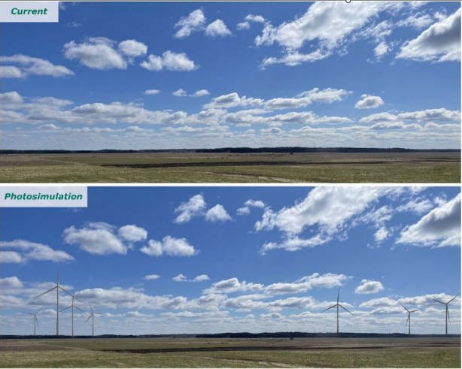

Impact summary tables
Table 7-1 project impacts on the physical environment
Receptor | Phase | Impact source(s) | Impact | Significance | Residual significance (after mitigation measures)
Greenhouse Gases & Climate Change | Construction and operation | GHG emissions from operation of equipment and machinery, electricity consumption, land disturbance and material use | Contribution to climate change, hindrance of national climate commitments and reputational damage | Negligible | Negligible
Greenhouse Gases & Climate Change | Operation | Supply of a low-GHG-emission electricity supply to the local grid | Positive contribution to climate mitigation objectives and the transition to a low-carbon economy | Positive | Positive
Air Quality | Construction | Vehicle/machinery traffic on unpaved roads, clearing and earthworks, movement and stockpiling of loose material (soil and aggregate) | Dust raising (resuspension of dry soil) and potential nuisance, human health and ecological impacts | Minor | Minor
Air Quality | Construction | Thermal combustion of fuel within equipment, vehicles and machinery engines | Emission of atmospheric pollutants harmful to human health | Negligible | Negligible
Air Quality | Operation |  | Emission of atmospheric pollutants harmful to human health | Negligible | Negligible
Noise | Construction | Excavation and earthworks; construction of equipment and roads; | Short-term increase in noise disturbance | Minor | Negligible
Noise | Construction | Transportation and traffic | Short-term increase in noise disturbance | Negligible | Negligible
Noise | Operation | Cumulative contribution of all noise sources: Battery Energy Storage System (HVAC systems and transformers); occasional vehicle movements for routine/corrective maintenance; PV transformers and inverters; transformer substation and wind turbine operation | Increase in noise disturbance | Moderate | Minor
Electromagnetic Fields (EMF) | Operation | EMF emissions from the turbines | Potential electromagnetic field emissions interfering with the surrounding environment | Negligible | Negligible
Electromagnetic Fields (EMF) | Operation | EMF emissions from the 30 kV electrical network, the 30/330 kV step-up Mančiai substation and the 330 kV cable | Potential electromagnetic field emissions interfering with the surrounding environment | Negligible | Negligible
Surface Waters | Construction | Excavation and earthworks for site preparation and construction (runoff, increased turbidity, contaminants) | Potential deterioration of surface water quality | Minor | Negligible
Surface Waters | Construction | Chemical / fuel spills | Potential deterioration of surface water quality from fuels, lubricant oils and chemicals | Minor | Negligible
Surface Waters | Operation | Spills from fuels, lubricant oils and chemicals (maintenance vehicles) | Potential deterioration of surface water quality | Negligible | Negligible
Soils | Construction | All construction works involving excavation, vegetation removal, movement/storage of loose soil and passage of heavy vehicles | Physical disturbance, including degradation of structure (compaction/vegetation removal) and soil loss (erosion) | Minor | Negligible
Soils | Construction | Occupation of land (access roads, working areas, hardstand/laydown areas, storage) | Unavailability of fertile agricultural soil | Minor | Negligible
Soils | Operation | Long-term occupation of land by the Project’s operational assets (turbines, PV arrays, Battery Energy Storage System, substation, access roads) | Unavailability of fertile agricultural soil | Minor | Negligible
Landscape & Visual Amenity | Construction | Site preparation works; construction and installation of Project components; use of cranes, heavy machinery and construction traffic | Physical changes to elements that constitute the landscape and temporary visual impact | Minor | Negligible
Landscape & Visual Amenity | Construction | Temporary construction lighting | Lighting impact | Minor | Minor
Landscape & Visual Amenity | Operation | Permanent land intake from Project infrastructures (turbines foundations, PV arrays, Battery Energy Storage System, substation, access roads) | Physical changes to elements that constitute the landscape and visual impact on local receptors | Minor | Minor
Landscape & Visual Amenity | Operation | Physical presence and operation of Project infrastructures | Lighting impact | Minor | Minor
Landscape & Visual Amenity | Operation | Operation of Solar PV arrays | Potential glint and glare effects | Negligible | Negligible
Landscape & Visual Amenity | Operation | Operation of turbines | Shadow flicker effects | Moderate | Minor

Table 7-2 Project impacts on the biological environment
Receptor | Phase | Impact source(s) | Impact | Significance | Residual significance (after mitigation)
Terrestrial Habitats & Flora | Construction | Site preparation works; excavation and earthworks (turbines, PVs, Battery Energy Storage System, onshore substation, 30 kV cabling network, 330 kV cable) | Habitat loss and degradation | Negligible | Negligible
Terrestrial Habitats & Flora | Construction |  | Habitat fragmentation | Negligible | Negligible
Terrestrial Habitats & Flora | Construction |  | Increased risk of colonization by invasive or opportunistic species | Minor | Negligible
Terrestrial Habitats & Flora | Operation | Physical presence of turbines, access roads, Battery Energy Storage System, substation and cabling network | Permanent habitat modification | Negligible | Negligible
Terrestrial Habitats & Flora | Operation |  | Habitat fragmentation / alteration of ecological connectivity | Minor | Minor
Terrestrial Fauna  (fauna / birds & bats) | Construction | Excavation and earthworks; construction of equipment and buildings; access road construction/upgrade; transportation and traffic | Habitat loss and degradation | Negligible | Negligible
Terrestrial Fauna  (fauna / birds & bats) | Construction |  | Temporary displacement of individuals due to disturbance (noise, vibration, light) | Minor (fauna) / Moderate (birds) | Negligible (fauna) / Minor (birds)
Terrestrial Fauna  (fauna / birds & bats) | Construction |  | Barrier effect and habitat fragmentation | Minor (fauna) / Moderate (birds) | Negligible (fauna) / Minor (birds)
Terrestrial Fauna  (fauna / birds & bats) | Construction |  | Introduction or spread of invasive species | Minor (fauna) / Moderate (birds) | Negligible (fauna) / Minor (birds)
Terrestrial Fauna  (fauna / birds & bats) | Construction |  | Mortality risk to individuals | Minor (fauna) / Moderate (birds) | Negligible (fauna) / Minor (birds)
Terrestrial Fauna  (fauna / birds & bats) | Operation | Physical presence and operation of turbines | Collision mortality risk for birds and bats | Moderate (bats) / Major (birds) | Minor (bats) / Minor (birds)
Terrestrial Fauna  (fauna / birds & bats) | Operation | Physical presence of PV arrays, PV fencing, permanent access roads and other ground-level infrastructure | Permanent habitat modification | Minor (fauna) / Moderate (birds) | Negligible (fauna) / Minor (birds)
Terrestrial Fauna  (fauna / birds & bats) | Operation | Operation and maintenance activities (routine inspections, maintenance traffic, vegetation management) | Mortality risk to individuals | Negligible | Negligible
Terrestrial Fauna  (fauna / birds & bats) | Operation | Physical presence and operation of turbines; PV arrays, fencing, access roads and ground-level infrastructure | Disturbance on fauna generated by lighting systems | Negligible | Negligible

Table 7-3 Project impacts on the socioeconomic environment
Receptor | Phase | Impact source(s) | Impact | Significance | Residual significance (after mitigation)
Land Use, Tenure, Property Value & Livelihoods | Construction | Land acquisition | Temporary loss of land access | Minor | Minor
Land Use, Tenure, Property Value & Livelihoods | Construction | Construction and installation activities (site preparation, generating assets, grid connection) | Temporary loss of land access | Moderate | Minor
Land Use, Tenure, Property Value & Livelihoods | Construction |  | Soil disturbance and disruption to agricultural activities | Moderate | Minor
Land Use, Tenure, Property Value & Livelihoods | Operation | Physical presence of Project infrastructure (PV, turbines, permanent access roads, Battery Energy Storage System and substation) | Permanent occupation of land and loss of access for existing users | Minor (turbines, roads, Battery Energy Storage System, substation) / Moderate (PV) | Minor
Land Use, Tenure, Property Value & Livelihoods | Operation | Physical presence of Project infrastructure (cabling infrastructure) | Long-term land use restrictions within infrastructure corridors and protection zones | Minor | Minor
Social Cohesion | Construction | Workforce (physical presence, employment, accommodation) | Changes in community dynamics due to presence of non-local workforce | Minor | Negligible
Employment | Construction | Workforce (physical presence, employment) | Direct employment creation for the project workforce | Positive | Positive
Employment | Construction | Procurement and use of materials, fuel, water, power and services; Project transport activities | Increased income and business opportunities for suppliers, contractors and local service providers | Positive | Positive
Employment | Operation | Workforce (presence, employment, periodic site attendance) | Creation of limited long-term employment opportunities for the operational workforce | Positive | Positive
Economy | Construction | Workforce (physical presence, employment, accommodation) | Increased local spending and income for businesses serving the construction workforce | Positive | Positive
Economy | Construction | Procurement and use of materials, fuel, water, power and services; Project transport activities | Increased revenue and business opportunities for suppliers, contractors and service providers | Positive | Positive
Economy | Construction | Waste and wastewater management | Business opportunities for local waste services | Positive | Positive
Economy | Operation | Workforce (presence, employment, periodic site attendance) | Increased local spending and income for businesses serving the operational workforce | Positive | Positive
Economy | Operation | Power generation and export to the grid | Contribution to the wider economy through electricity generation and export to the grid | Positive | Positive
Economy | Operation | Waste and wastewater management | Business opportunities for local waste services | Positive | Positive
Mobility (Traffic & Pedestrians) | Construction | Procurement and use of materials, fuel, water, power and services; Project transport activities (component delivery and worker transport) | Increased traffic volumes, temporary congestion and delays, and road safety risks for road users and pedestrians associated with construction traffic and abnormal load deliveries | Moderate | Minor
Mobility (Traffic & Pedestrians) | Construction | Site preparation works (vegetation clearing, topsoil stripping, grading, access roads, drainage, fences, foundations, hardstands, CCTV) | Temporary disruption to local movement patterns, including access restrictions, diversions and interaction between construction activities and road users/pedestrians | Moderate | Minor
Community Health & Safety | Construction | Workforce (physical presence, employment, accommodation) | Increased risk to community health, safety and wellbeing, including inappropriate behaviour, gender-based violence and harassment (GBVH) | Minor (general) / Moderate (women & girls) | Negligible (general) / Minor (women & girls)
Community Health & Safety | Construction | Procurement and use of materials, fuel, water, power and services; Project transport activities | Increased risk to community health and safety due to construction traffic, transport of workers/materials, and interaction between Project vehicles and local road users/pedestrians | Moderate | Minor
Community Health & Safety | Construction | Site preparation works (vegetation clearing, topsoil stripping, grading, access roads, drainage, fences, foundations, hardstands, CCTV) | Increased risk to community health and safety due to temporary access restrictions, open work areas and movement of plant and machinery | Moderate | Minor
Community Health & Safety | Construction | Construction and installation of Project components (turbines, Solar PVs, Battery Energy Storage System, transformer substation, cabling) | Increased risk to community health and safety due to exposure of nearby residents, land users or third parties to construction hazards | Moderate | Minor
Community Health & Safety | Operation | Physical presence of Project infrastructure (turbines, access roads, PV, Battery Energy Storage System and substation) | Potential risk to community health and safety due to unauthorised access to Project infrastructure and exposure to operational hazards | Minor (general) / Moderate (elevated-sensitivity receptors) | Negligible (general) / Minor (elevated-sensitivity receptors)
Occupational H&S & Working Conditions | Construction | Workforce (physical presence, employment, accommodation) | Adverse impacts on the labour rights of direct workers, potentially affecting their physical and psychological well-being | Moderate | Minor
Occupational H&S & Working Conditions | Operation | Workforce (physical presence, employment, accommodation) | Adverse impacts on the labour rights of direct workers, potentially affecting their physical and psychological well-being | Minor | Negligible
Public & Private Infrastructure & Services | Construction | Workforce (physical presence, employment, accommodation) | Increased pressure on local public services and infrastructure (accommodation, water supply, waste management, local services) | Minor | Negligible
Public & Private Infrastructure & Services | Construction | Procurement and use of materials, fuel, water, power and services; Project transport activities | Increased pressure on and deterioration of local road infrastructure and transport networks due to heavy vehicle traffic | Moderate | Minor
Public & Private Infrastructure & Services | Construction | Site preparation works (vegetation clearing, topsoil stripping, grading, access roads, drainage, fences, foundations, hardstands, CCTV) | Temporary disruption or damage to local access routes, drainage systems and plot-level infrastructure | Moderate | Minor
Public & Private Infrastructure & Services | Construction | Construction and installation of generating assets (turbines, Solar PV, Battery Energy Storage System, transformer substation, cables) | Disruption or damage to existing utilities and local infrastructure (underground services, drainage networks, local access infrastructure) | Moderate | Minor
Public & Private Infrastructure & Services | Construction | Waste and wastewater management | Increased pressure on local waste management and wastewater services | Minor | Negligible
Public & Private Infrastructure & Services | Operation | Power generation and export to the grid | Increased pressure on existing electricity transmission infrastructure | Minor | Negligible
Cultural Heritage | Construction | Groundworks / ground-disturbance works at areas of Elevated Archaeological Potential | Direct removal of archaeological material during groundworks | Minor | Minor
Cultural Heritage | Operation | Physical presence of turbines / Project infrastructure within the landscape setting | Visual intrusion on the setting of registered heritage sites | Moderate | Minor

How are unplanned events assessed?
Unplanned events are those events which are not expected to occur as part of the Project’s routine activities. They can occur unexpectedly or accidentally throughout the Project’s lifetime. As opposed to the Project’s routine impacts, these are assessed considering their consequences, but also the probability that these will actually occur during the Project’s lifetime. These are assessed on a risk scale ranging from negligible to major according to the matrix shown below:
Figure 7.3 Consequence designations
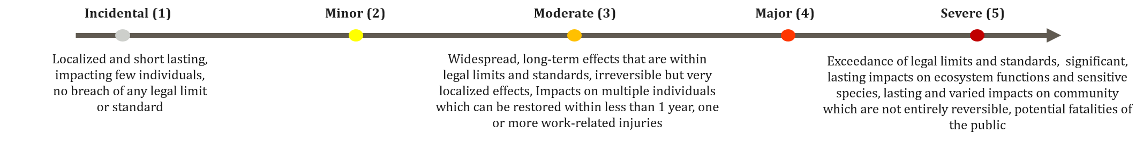

Figure 7.4 Probability designations

Table 7-4 Unplanned events assessment matrix
Level of risk |  | Likelihood of Occurrence
 |  | Remote | Very unlikely | Unlikely | Likely | Expected
Consequence | Incidental | Negligible | Negligible | Negligible | Negligible | Negligible
Consequence | Minor | Negligible | Minor | Minor | Minor | Moderate
Consequence | Moderate | Minor | Minor | Moderate | Moderate | Major
Consequence | Major | Moderate | Moderate | Major | Major | Major
Consequence | Severe | Major | Major | Major | Major | Major

What are the Project’s key unplanned events?
The Project’s key unplanned events are detailed in the table below. These events represent low‑probability but potentially high‑consequence situations, and therefore require careful planning, prevention, and emergency preparedness.

Unplanned events summary table
Unplanned event | Description of the risk | Which receptor(s) are affected? | Pre-mitigation  risk | Residual risk  (after mitigation measures)
Construction & Operation
Leaks or spills of fuels, oils, transformer oil, battery electrolyte, or refrigerants | During construction and operation, accidental leaks of fuel or hydraulic oil (from vehicles and machinery), transformer oil or battery electrolyte could contaminate soil or water. Transformers contain large quantities of mineral oil requiring strict containment systems, bunding and oil-water separators. Refrigerants used in cooling systems have very high global warming potential, meaning accidental releases contribute significantly to greenhouse gas emissions. With proper containment, inspection and emergency response, residual impacts remain minor. | Physical and biological environment; Project workforce and local community | Minor | Minor
Fire or explosions | Fire and explosion risks arise from malfunctioning machinery, transformer failure or battery thermal runaway. Large-scale fires can generate toxic smoke, damage crops or habitats, and place pressure on emergency services. In worse cases, injury or loss of life of people in proximity to the fire can occur.  Uncontrolled battery fires may require temporary evacuation or restrictions on outdoor activity. Firefighting water can contaminate soil or surface water if not contained. However, the Project already has containment measures in place, and firefighting water will be directed to a dedicated tank during emergencies. Preventive measures such as firefighting equipment, training, fire prevention plans, and emergency response procedures can reduce the likelihood of such an event, but the consequences can still be severe. Residual impacts are moderate. | Physical and biological environment; Project workforce and local community | Major | Moderate
Traffic and transport accidents | The construction activities will increase heavy-vehicle movements in the Project area and along the component transport route, elevating the risk of collisions with road users including other vehicles, pedestrians and cyclists on narrow rural roads, as well as local fauna. Such accidents can cause damage to assets, injury or loss of life, and add pressure on local healthcare in the event of multiple casualties. The risk exists also in the operation phase during maintenance activities, but is much lower given the limited vehicle activity in this phase. | Fauna; local residents around the Project site; residents along the component transport route | Moderate | Minor
Structural or mechanical failure of wind turbines (blade throw, tower collapse) | Rotor-blade failure (blade throw) or tower collapse; possible at any time once turbine towers are erected, including during construction and pre-commissioning. Mechanical failures such as blade throw (wind turbine blade comes off the tower and is launched away) or tower collapse are rare but can pose safety risks to workers or nearby residents, and can result in damage to property, injury or loss of life. | Local residents and Project workforce | Moderate | Minor
Operation
Operational system failure | Failure of key operational systems (e.g. remote control, automatic shutdown), including failure of collision-risk mitigation could interrupt power generation or increase the risk of collisions for birds and bats. | Fauna; local economic activity dependent on grid power supply | Minor | Minor
Wind turbine shutdown due to atmospheric conditions (icing) and ice throw | Ice forming on turbine blades and thrown by blade rotation during extreme cold events; the associated turbine shutdown interrupts generation.  During extreme cold events, ice can accumulate on turbine blades and be thrown during rotation, posing risks to people (injury or loss of life) or damage to property. Icing can also trigger turbine shutdowns, temporarily reducing power generation, disrupting local economic activity dependent on the grid supply. | Local residents and Project workforce; local economic activity dependent on grid power supply | Minor | Minor
Construction
Damage to utility networks or buried archaeology | Excavation and trenching during construction may accidentally damage underground utilities or disturb unrecorded archaeological remains. | Buried archaeology / cultural-heritage resources; buried utility networks | Moderate | Minor

It is to be noticed that after implementation of preventive and mitigation measures the possibility of occurrence to an unplanned event is minimized to the most feasible extent but the possibility of an unplanned event remains. Therefore, in case of the occurrence of an accidental event some impacts remain moderate.

What about interactions between the Project and other Projects in the area?
The Project’s impacts can combine with the impacts of other nearby Projects and create impacts which are greater than those of the Project alone. The ESIA has looked at existing or planned Projects which will coincide with the Project’s lifetime, which are within a 10 km radius. Nearby Projects identified include windfarms and solar power plants. All cumulative impacts from these different activities in combination with that of the Project are expected to remain minor.
Here is a map showing the projects considered and their location compared to the Skuodas Hybrid Project:
- approximately 3.0 km north of the project site, UAB ‘RITVIDA’ operates the Bonus 95 kW wind farm in Lenkimai, comprising used Danish wind turbines;
- approximately 3.7 km south-west of the project site, two wind farms owned by UAB “Renerga” are in operation: the Benaičiai wind farm comprises six Vestas V100 2.75–3 MW wind turbines, with a capacity of 16 MW; and the ‘Benaičiai–1’ wind farm, with a capacity of 34 MW, comprising seventeen Enercon E82 2 MW wind turbines.
- Planned construction of three wind turbines in Kretinga District Municipality, Darbėnai Parish, Grūšlaukė, at approximately 6.7 km south of the Project site. The Environmental Protection Agency issued its conclusion on the EIA screening (letter No. (30.2)-A4E-3983 dated 14 May 2020): UAB “Gera galia”, UAB “Žydras dangus”, UAB “Pajūrio energetika” – for the construction of three wind turbines in Kretinga District Municipality, Darbėnai Parish, Grūšlaukė is not subject to an environmental impact assessment.
- A solar power park is planned adjacent to the existing UAB “Renerga” wind farm; in a letter dated 4 August 2021 (No. (30.2)-A4E-9052), the Environmental Protection Agency issued its conclusion on the EIA screening: An environmental impact assessment is not required for the planned economic activity of UAB “Renerga” – the construction of a solar power plant with an installed capacity of up to 62 MW on an area of approximately 86 ha in Kretinga District Municipality, Darbėnai Parish, Žynelių village, Sūdėnų village, Pelėkių village and Benaičių village – an environmental impact assessment is not required.
Figure 6-1 THE PROJECT AREA IN RELATION TO NEIGHBOURING Projects
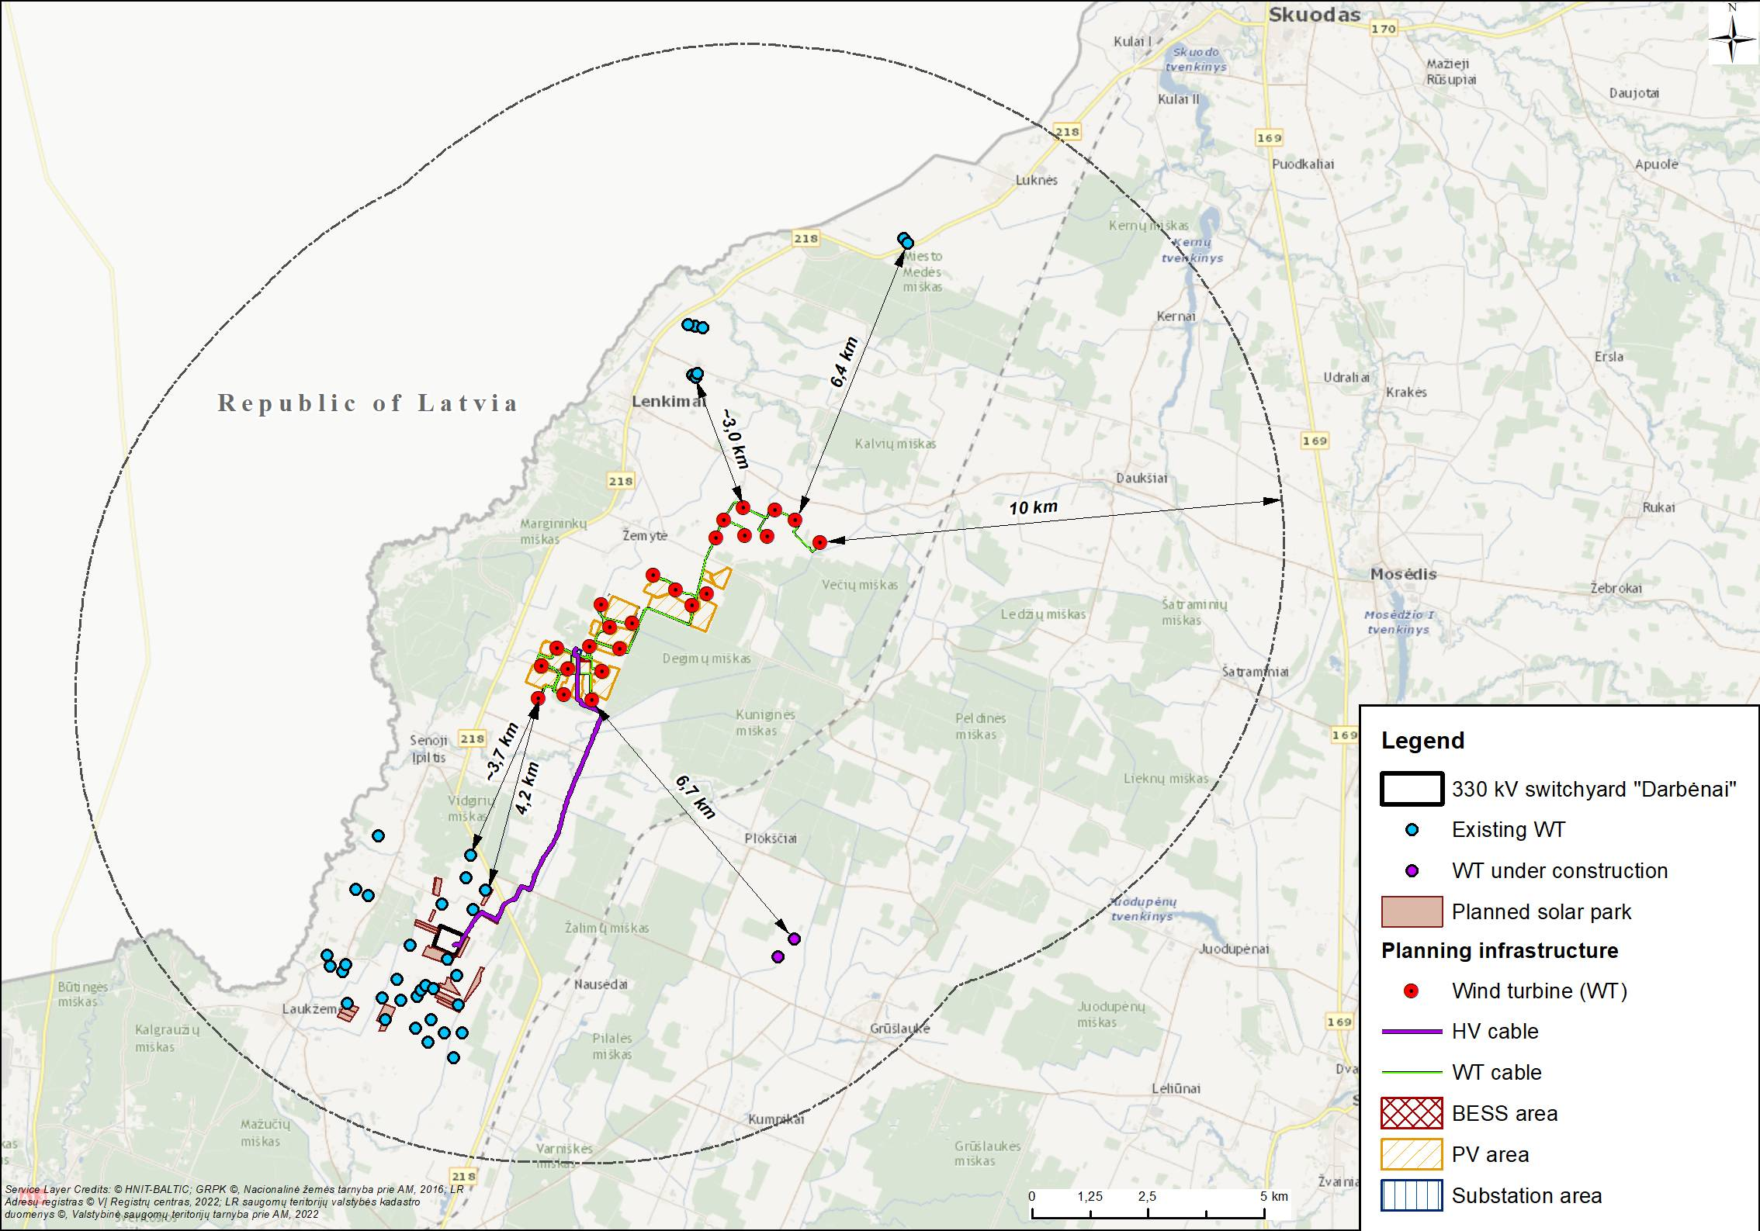

Mitigation measures
During the ESIA phase where significant impacts where identified the Project include targeted actions to reduce the impact (mitigation measures). The following table include all mitigation measures proposed. It has to be noted that they are not definitive at this stage and are subject to change.

What are the main measures planned to address Project impacts?
The following table summarizes the key measures applied to address key impacts on different receptors, in the different phases of the Project. This is not an exhaustive list and pulls out only a selection of the full list of measures detailed in the ESIA:
Topic or Receptor | Construction | Operation
Greenhouse gases and climate change | - Source materials and components locally where feasible and optimise transport routes and truck loading to reduce transport emissions.  - Train vehicle operators in fuel-efficient driving and monitor fuel use. | - Minimise the Project’s own electricity use (efficient LED lighting, automatic switching) to maximize export of clean energy to the grid.  - Maintain a full inventory of refrigerants and carry out regular leak checks on cooling and electrical equipment.
Air quality | - Implement a Dust Management Plan, spray water on loose soil to stop dust raising, wash vehicle wheels, limit vehicle speeds and cover stockpiles.  - Reseed exposed soil promptly with native grasses and protect exposed surfaces (turf, erosion-control mats) | Impact is negligible – no additional measure is required
Noise | - Switch off machinery and equipment when not in use.  - Route heavy vehicles on roads away from sensitive receptors, locate stationary equipment as far from them as practicable, and select machinery according to Best Available Techniques (BAT).  - Restrict the noisiest activities to appropriate daytime hours. | - Optimise maintenance activities to minimise added noise.  - Keep all equipment and machinery well maintained for efficient, low-noise operation.  - Grievance mechanism in place for any noise-related complaints and potential restrictions/changes to wind turbine operation or additional noise protection barriers (e.g. vegetation or acoustic glazing).
Electromagnetic fields | Not applicable – no impacts expected | Impact is negligible – no additional measure is required
Surface waters | - Apply good-practice erosion and sediment control. A site drainage plan and a Project water-management strategy will also be in place to protect the drainage network and remove debris after the works.  - Maintain equipment to prevent leaks and establish emergency spill-response procedures with spill kits on site. Refuel only in paved, controlled locations. | - Maintain equipment and refuel only in paved, controlled areas.  - Keep emergency spill-response procedures and spill kits available for maintenance activities.
Geology and groundwater | Not applicable – no impacts expected | Not applicable – no impacts expected
Soils | - Strip and stockpile topsoil separately from subsoil; manage stockpiles (limited size/duration, protective covers, location away from drainage) and reinstate/reseed exposed ground as soon as possible.  - Schedule major earthworks for drier months if compatible with targeted timeline, control water ingress and erosion, aerate/till compacted areas and clearly limit working areas with markings/fencing to prevent unlimited driving on unpaved surfaces and compaction. | - Keep landowners of long-term occupied land informed with lease/compensation agreements in place, and restitute land as soon as feasible.
Landscape and visual amenity | - Confine works to approved areas, keep a tidy site, and remove temporary stockpiles, materials and fencing as soon as practicable.  - Reinstate disturbed land (topsoil redistribution and revegetation) and locate laydown/storage areas away from the nearest homes.  - Limit lighting to safety and security needs and prepare a landscape and visual management plan. | - Maintain screening vegetation/ground cover around infrastructure and use suitable colours, finishes and low-reflectivity materials.  - Direct operational lighting downward and avoid light spill toward homes.  - For shadow flicker, maintain a grievance mechanism and apply targeted curtailment (e.g. turbine shutdown at specific times) where receptors are affected.
Biodiversity (Protected areas, habitats, species, etc.) | - Strictly limit and clearly delineate vegetation clearance and construction zones to protect ditches and drainage margins. Avoid interventions in proximity to Molinia meadows as much as possible; implement a Biodiversity Management Plan.  - Prevent the spread of invasive species by inspecting/cleaning vehicles and equipment and implementing an invasive-species management plan.  - Reduce fauna disturbance and mortality: Enforce vehicle speed limits and a traffic management plan and install escape ramps in curbs/excavation areas for small mammals, amphibians and reptiles. | For birds  - Deploy camera-based anti-collision systems on all turbines to continuously monitor bird activity and trigger automated turbine shutdowns upon detecting high-risk species (birds of prey and storks).  - Temporarily stop specific turbines during ploughing, harvesting, mowing, and hay collection activities when these activities are in 500 m radius.  - Paint blades with contrasting patterns (e.g., one black blade and two white blades, striped patterns, UV-reflective paints); apply colour gradients on tower base.  For Bats:  - Stop turbine operation from sunset to sunrise when wind speed at rotor height is below 6 m/s and temperature is higher than 10° C. Or install automated systems capable of detecting bat activity and stopping turbines during critical events can be as alternative to bat curtailment (above).  - Combine monitoring results with operational restrictions and habitat measures
Social receptors (Land use, Economy, Mobility, health & safety, infrastructure, etc.) | - Implement a Land Access Management Plan (advance notice, records, agreed access)  - Implement a Traffic Management Plan (defined routes, delivery scheduling, abnormal-load management  - Road-condition surveys pre and post construction and remediation of any damage.  - Apply a Worker Code of Conduct (GBVH prevention), Labour Management and Construction OHS Plans, local employment/procurement measures and secured, demarcated work areas; maintain a Stakeholder Engagement Plan and grievance mechanism. | - Implement a Land Access Management Plan during operation to manage long-term land access restrictions, land use changes, stakeholder engagement and monitoring of land and livelihood related impacts.  - Maintain an up-to-date register of affected landowners, tenant farmers and other land users with interests in Project-affected land, including records of agreements, obligations and ongoing engagement activities.  - Minimise the operational footprint of permanent infrastructure where feasible.  - Protect public safety around infrastructure through perimeter fencing, controlled access, hazard signage, safe access-road management and emergency-response arrangements.
Cultural heritage | - Implement a Cultural Heritage Management Plan and Chance Finds Procedure, with contractor guidance on avoiding and reporting damage.  - Carry out pre-construction archaeological surveys at areas of elevated archaeological potential. | - Undertake a vegetation and access maintenance programme for the registered heritage sites (scoped by a heritage specialist with the relevant authority) to offset visual/setting effects.
Unplanned Events | - Develop an inventory of refrigerants in all site equipment and ensure implementation of regular leak checks in accordance with applicable requirements.  - Prepare an Emergency Response Plan to cover accidental and emergency situations, and engage with local stakeholders on how to respond to unplanned events.  - Ensure products are properly stored on site  - Implement on-site prevention measures such as (i) Equip the site with proper equipment (such as fire extinguishers, proper communication equipment) and regularly inspect and maintain them; regular maintenance of the water tank for fire prevention and the water pump system (ii) Prepare a Fire prevention and Fighting Plan; (iii) Conduct firefighting training to the emergency support team, contractors and workers on site.

Environmental and Social Management and monitoring Plan
No impacts were identified that could not be minimised to acceptable levels through the application of the proposed mitigation measures detailed in the impact assessment. Mitigation measures identified in the ESIA will be set out in an Environmental and Social Management and Monitoring Plan (ESMMP). The ESMMP will describe the measures to be implemented, helping ensure that the Project is carried out in line with the requirements and measures identified through the ESIA. The ESMMP is to be considered a dynamic document that may be continuously revised as part of an on-going environmental management and improvement process.
The objectives of the ESMMP are:
- To provide the mechanism to ensure compliance with Lithuanian legislation, EU directives, international conventions and standards, and good international industry practice;
- To ensure that all the mitigation measures and all the commitments made by EE identified in the ESIA report are taken into account during the Project construction and operation phases;
- To provide a framework for mitigating impacts that may be unforeseen or unidentified;
- To establish a number of monitoring plans so that the Project can track environmental and social conditions throughout construction and operation, verify the effectiveness of mitigation measures, and identify whether additional measures or corrective actions are needed.

Environmental and Social Monitoring
Monitoring focuses on environmental and social components that may be affected by the Project or that require regulatory oversight.
Twice per year efficiency trails and two scavengers activity trails. Environmental monitoring will cover noise, biodiversity, protected areas, water management, waste handling and other physical parameters. Noise monitoring verifies compliance with the Lithuanian hygiene standard HN 33:2026 and includes daytime measurements during construction and 24￼hour campaigns during operation, with meteorological data to ensure valid readings. Biodiversity monitoring is extensive and includes birds, bats, terrestrial fauna, flora and vegetation. Bird and bat monitoring follows national permitting requirements and international biodiversity conventions, with 12 month pre-construction surveys. Monitoring will occur continuously during the construction phase. Carcass searches will be conducted every 5 days from March through October for the first 3 years after construction. Additionally, searcher efficiency trials and scavenger removal trials will be conducted twice a year. Followed by repeated monitoring cycles every five years. More detailed information on monitoring and management is available in the Biodiversity Monitoring and Management Plan. Terrestrial fauna surveys focus on species presence, abundance, habitat use, and seasonal activity, while flora monitoring assesses structural and floristic characteristics, rare and invasive species, and the success of any revegetation or transplanting works. Monitoring locations are aligned with the ongoing ante￼operam surveys to ensure comparable datasets.
Annual monitoring results will be delivered to the Lithuanian authorities and the project developer. Lithuanian environmental protection agency will monitor compliance with the treasholds. Monitoring reports will be publicly available.
Social monitoring focuses on community wellbeing, safety, and access. It includes tracking traffic conditions and road safety along transport routes, verifying that construction activities do not restrict access to agricultural land or public services, and monitoring community health and safety concerns. The Project’s Grievance Mechanism is also monitored to ensure that concerns raised by residents are recorded, addressed and resolved transparently and promptly.
All monitoring results will be compiled into technical reports that describe objectives, methods, monitoring locations, timing, measured parameters, results, and any required corrective actions. Reporting occurs at the end of each monitoring campaign during construction and annually during operation.

Implementation, Monitoring, and Auditing
Contractors are responsible for applying mitigation measures, adhering to environmental and social requirements, maintaining records, and reporting performance. Their Environmental and Social Management Plans must align with the Project’s Environmental and Social Management System (ESMS) and topic‑specific management plans. EE will oversee ESMP contractor implementation, ensure contractors comply with legal and lender requirements, manage documentation, and apply corrective actions when non‑compliance occurs.
The ESMMP is supported by a suite of topic‑specific management plans, including the Environmental Management Plan, Air Quality and Dust Management Plan, Water, Stormwater and Drainage Management Plan, Biodiversity Management Plan, Waste Management Plan, Traffic Management Plan, Occupational Health and Safety Plan, Emergency Preparedness and Response Plan, Cultural Heritage Chance‑Find Procedure and the Stakeholder Engagement Plan. These plans define mitigation actions, performance criteria, monitoring indicators, reporting obligations and corrective action procedures.
Compliance is verified through internal and external audits, inspections and systematic review of monitoring results. Audits assess the implementation of mitigation measures, contractor performance, non‑conformities and opportunities for improvement. The ESMMP uses an adaptive management approach, meaning that mitigation measures are updated when monitoring results indicate emerging risks, unexpected impacts or changing project conditions. This ensures continuous improvement and long‑term protection of environmental and social values throughout the Project’s operation.

Stakeholder Engagement Activities
Stakeholder engagement for the Project is a continuous process that ensures people who may be affected by the Project are informed, listened to, and able to provide input while Project planning is still ongoing. As stated in the Project’s Stakeholder Engagement Plan (SEP), engagement aims to provide “effective, timely, and meaningful engagement with stakeholders throughout the assessment process”. In detail, The Project engages with stakeholders with the following objectives:
- Identifying all stakeholders who may be affected;
- Providing clear, transparent information to reduce uncertainty;
- Building constructive relationships and avoiding conflict;
- Documenting concerns and responding to them;
- Managing expectations realistically; and
- Meeting Lithuanian legal requirements and international standards such as EBRD and IFC.
These objectives ensure that engagement is meaningful and supports both community wellbeing and responsible project development.

Activities Undertaken to Date
To date, the Project has carried out early engagement activities to support both the ESIA and the national permitting process. During ESIA preparation, the team conducted:
- Site visits in April and May 2026, covering settlements, land plots, and access routes.
- Meetings with the Eldership representatives and landowners to discuss land use, agricultural activities, and local priorities.
- Technical coordination with authorities, including municipal departments, environmental institutions, and infrastructure operators, to clarify permitting requirements and data needs.
These discussions highlighted key community concerns such as land use, agricultural continuity, transport routes, and construction-related disturbance. Formal ESIA community consultations will take place during the public disclosure meetings planned for August 2026.
In parallel, all legally required public hearings under the Lithuanian EIA process have already been completed. Between August 2025 and May 2026, nine (9) public meetings were held with communities and authorities in Skuodas, Kretinga, and Klaipėda Municipalities. These hearings covered all major project components and provided early opportunities for stakeholders to ask questions and share feedback.
Key outcomes from the hearings:
- Communities were informed about the technical design, locations, and expected impacts of each component.
- Municipal architects, Eldership leaders, and landowners provided comments on siting, access, and land use.
- Participants raised questions about noise, visual impact, transport routes, safety, and agricultural disruption.
- Feedback was documented and incorporated into Project design refinements where feasible.
The hearings fulfilled all legal requirements for public participation under Lithuanian EIA law.
Moreover, vulnerable groups were identified, including elderly residents, persons with disabilities and low-income households. The Project commits to targeted engagement where needed, including small-group meetings or household visits where appropriate, as well as accessible information and grievance channels (more information are available in Annex S – SEP).
The following table summaries the key concern raised from stakeholders during the consultation with given responses.
Table 10-1 Summary of Stakeholders concerns and Project responses
Key concern raised during consultation | How the Project responded / proposes to respond
Transport access and connectivity, including limited public transport and access to services/employment. | Transport and infrastructure are identified in the SEPas a priority and commits to stakeholder communication on traffic disruptions, construction logistics and major activities during construction. Engagement with authorities and affected communities is planned, including updates on construction schedule and traffic-related disturbances where relevant (more information are available in Annex S – SEP)
Employment opportunities, including lack of local jobs and reliance on seasonal/agricultural work. | The Project recognises local economic opportunities as a stakeholder interest and includes communication tools to communicate recruitment opportunities where applicable and commits to a continued engagement on Project opportunities (more information are available in Annex S – SEP).
Health access, particularly limited local healthcare services and the need to travel to larger towns. | Health access is part of the broader social sensitivity context in the area. . Direct Healthcare service improvement are not considered a necessity in relation to the Project and are not part of the Project’s commitments, active consultation is in place together with a Grievance Mechanism for Project-related concerns to address any health access and preassure potential concerns (more information are available in Annex S – SEP).
Land use and agricultural disruption, including land access | Land use and access are identified as key stakeholder concerns. The Project has undertaken direct notification of affected landowners and neighbouring land users and will continue targeted engagement with affected landowners, land users and neighbouring residents, including one-to-one meetings where appropriate. The Project will provide information on land access arrangements, construction planning and expected disturbances, and land-related comments or grievances will be managed through the Project Grievance Mechanism and follow-up engagement where needed (more information is available in Annex S – SEP).
Noise, visual impact, and safety | Stakeholders raised questions on turbine siting and proximity to land plots, dust, and general Project safety. The Project will address these topics through ESIA disclosure process as well as ongoing reporting with stakeholders, active communication on traffic disfruptions and major construction activities to stakeholders and local authorities, and continued dissemination of the Grievance Mechanism to allow concerns to be recorded, tracked and responded to (more information are available in Annex S – SEP).

Planned Activities
Further engagement will occur during the ESIA disclosure, and construction and operation phases. The ESIA disclosure is planned for the beginning of August 2026 and will be conducted following focus group meetings. During this disclosure period, stakeholders will be able to review the ESIA findings, ask questions, and provide feedback on proposed mitigation measures.
This will be followed by consultations with directly affected landowners, engagement with vulnerable groups, and regular communication with municipalities. Engagement will increase during the construction phase, when temporary disturbances may occur.
These planned activities aim to maintain open dialogue, support informed participation, and ensure that community perspectives continue to be considered as Project planning and implementation progress.

How to contact the Project: The community Feedback/Grievance Mechanism
Currently, the Project is engaging with the community via phone and face-to-face conversations through European Energy’s Social Lead who manages and maintains those relationships and is the main point of contact for the community. A dedicated Community Liaison Officer (CLO) will be appointed to support day-to-day engagement with local communities. The Social Lead, will oversee social performance and ensure the quality of engagement, while the Health Safety and Environmental Manager will monitor grievances that may have health, safety, or environmental implications.
The Project has a Grievance Mechanism in place which is a structured process for receiving, reporting, investigating, and responding to all types of community feedback raised in connection with the activities of the Project, in any of its phases. Grievances may take the form of specific complaints for damages/injury, concerns about Project activities, or perceived incidents or impacts, as well as questions, suggestions or other feedback that stakeholders wish to raise to the Project. Special procedures will be in place for sensitive issues, including gender-based violence and harassment.
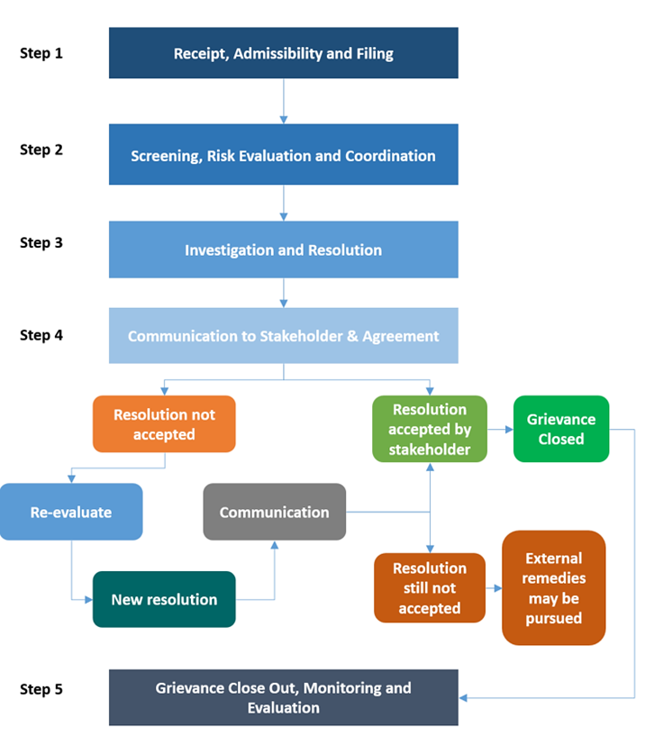
Contact made through this channel can be:
- Named or anonymous;
- From any individual or group; and
- On any topic relating to the activities and plans of European Energy or related to a third party, such as one of its Project Contractors.
Any doubts or questions regarding this ESIA can be sent to European Energy via the following communication channels:
Table 11-1 Where and how can a grievance, question or feedback be raised?
Means | Details
By telephone | To EE office: +370 6 010 2224
By email | skuodas@europeanenergy.com
Online via the submission box | skuodasrenew.lt
In person at the physical box | located in Lenkimai community center ( Lenkimų sen. bendruomenės namai [S. Daukanto g. 59, Lenkimai] )
By letter | To an individual or;  To the EE office in Ukmergės g. 219, LT·07152 Vilnius
In person | Face to Face to Project representatives
By e-mail | To the Project’s email address skuodas@europeanenergy.com

Conclusion
The Project’s environmental, social, biodiversity, and cultural heritage impacts are predominantly minor and manageable with proposed mitigation measures. Cumulative impacts are limited, and risks from unplanned events are controlled through robust safety systems and emergency procedures. With full implementation of the ESMMP, the Project can proceed in a manner consistent with Lithuanian legislation, IFC Performance Standards, EBRD requirements and good international industry practice. The Project contributes to renewable energy development while protecting environmental and social resources.
No significant residual impacts on flora and fauna are anticipated. The creation of grasslands in PV areas will benefit invertebrates, amphibians, and small mammals. Mitigation measures will limit impacts on birds and bats to a minor level, with ongoing monitoring conducted to ensure compliance with threshold limits

ERM has over 140 offices across the following countries and territories worldwide
Argentina  Australia  Belgium  Brazil  Brunei  Canada  Chile  China  Colombia  France  Germany  Guyana  Hong Kong  India  Indonesia  Ireland  Italy  Japan  Kenya  Malaysia | Mexico  Mozambique  Netherlands  Panama  Peru  Poland  Portugal  Romania  Singapore  South Africa  South Korea  Spain  Switzerland  Taiwan  Thailand  United Arab Emirates  United Kingdom  United States  Vietnam |  | ERM Italia S.p.A.  Via San Gregorio, 38  20124 Milan - Italy  T: +39 02 674401  www.erm.com

