
Passive Oversight is Not Enough
Corporate Governance Failure, Directors' Duties, and the Limits of Board Reliance in ASIC v Star Entertainment Group

By Bahira Ameer

I INTRODUCTION
On 5 March 2026, Justice Lee of the Federal Court of Australia handed down the liability judgment in Australian Securities and Investments Commission v Bekier [2026] FCA 196, concluding civil penalty proceedings that ASIC had commenced in December 2022 against eleven current and former directors and officers of The Star Entertainment Group Limited (Star). The 500-page judgment is widely regarded as the most significant corporate governance decision in Australian legal history, and the first time ASIC had pursued an entire board for an alleged breach of section 180 of the Corporations Act 2001 (Cth) in relation to non-financial risk management. This article sets out the background to the litigation, the key facts, the legal issues, the arguments advanced by each party, the findings of the Court, and the implications of the decision for directors and officers in Australia.

II BACKGROUND AND FACTS
Star is an ASX-listed company operating major casino properties across Australia, most notably The Star Sydney. As a holder of a casino licence under the Casino Control Act 1992 (NSW), Star was subject to stringent obligations regarding the identification and management of money laundering risk. Between approximately 2016 and 2020, serious concerns emerged across two areas of operation.
The first concerned Star's dealings with Suncity, a major VIP junket operator. Evidence before the Court established that Suncity had been permitted to operate a private cash cage within Star's Sydney casino, allowing large sums of cash to move through the facility in a manner that raised serious anti-money laundering concerns and which attracted regulatory scrutiny. The second concerned Star's facilitation of transactions through China UnionPay cards at a foreign exchange bureau located within the casino, in circumstances where the transactions appeared designed to circumvent the prohibition on the use of credit cards for gambling.
These risks were not unknown to Star's management. Internal compliance reporting, risk committee materials, and external media scrutiny had generated significant information touching on both issues. The critical question before the Court was what Star's senior executives and directors knew, when they knew it, and whether their responses met the standard required by section 180(1) of the Corporations Act 2001 (Cth).

III LEGAL ISSUES
The central legal issue was whether the defendants had each breached section 180(1) of the Corporations Act 2001 (Cth), which requires a director or officer to exercise their powers and discharge their duties with the degree of care and diligence that a reasonable person would exercise in the corporation's circumstances. The duty is objective and prospective, and its application is calibrated to the specific role, the information available, and the nature and complexity of the corporation involved.
ASIC alleged that senior executives failed to respond appropriately to known and emerging risk indicators relating to both the Suncity and UnionPay issues, and failed to ensure the Board was adequately and accurately informed of those risks. ASIC further alleged that non-executive directors failed to recognise deficiencies in the information provided to them and failed to make sufficient inquiry when that information was incomplete.
A secondary legal issue concerned the business judgment rule under section 180(2) of the Corporations Act 2001 (Cth), which provides a safe harbour from the section 180(1) duty where a director makes a business judgment in good faith, for a proper purpose, without material personal interest, on an informed basis, and in the rational belief that the judgment is in the best interests of the corporation.

IV ARGUMENTS FOR PARTIES

ASIC’S CASE
ASIC contended that the former CEO and Managing Director, Matthias Bekier, and the former Chief Legal and Risk Officer and Company Secretary, Paula Martin, each failed to respond to the Suncity and UnionPay risks with the care and diligence a reasonable person in their respective positions would have exercised. ASIC argued both had access to information establishing the severity of the risks, failed to implement or enforce adequate compliance controls, and failed to escalate the issues with appropriate urgency. In relation to the non-executive directors, ASIC argued the Board should have proactively sought better information, identified the gaps in management reporting, and demanded remedial action.

THE DEFENDANTS’ CASE
The executive defendants argued their conduct met the standard of a reasonable person in their positions, having regard to the scale and complexity of the organisation and the information available at the relevant times. The non-executive directors argued they were entitled to rely on management to surface material risks to the Board and that, absent specific information identifying the full extent of the risks, their conduct could not be said to fall below the statutory standard. The business judgment rule was also invoked in respect of certain executive decisions regarding the management of the Suncity relationship.

V DECISION
Justice Lee found that Matthias Bekier and Paula Martin each contravened section 180(1) of the Corporations Act 2001 (Cth). Both had failed to respond to the Suncity and UnionPay risks with the vigilance and action a reasonable person in their respective positions would have exercised. The findings turned on their failure to act on known risk indicators, their failure to implement or require adequate compliance safeguards, and their failure to ensure the Board was properly and adequately informed of material risks facing the company.
The case against the seven former non-executive directors was dismissed. While Justice Lee was critical of Star's board information practices, the Court was not satisfied that ASIC had proved the non-executive directors' conduct fell below the statutory standard, having regard to their roles and the information actually available to them. Critically, the Court found that management had failed to apprise the Board sufficiently of material information it possessed, even when warning signals were apparent.
The business judgment rule defence did not succeed. Justice Lee confirmed the rule protects positive commercial decisions made on an informed basis but provides no shelter where directors or officers have simply neglected to engage with the systems and safeguards through which risk is managed. Prior to judgment, ASIC had reached separate settlements with the former Chief Financial Officer and former Chief Casino Officer, each agreeing to financial penalties and periods of disqualification from managing corporations.

VI REGULATORY AND LICENSING CONTEXT
The ASIC litigation did not occur in isolation. Prior to the commencement of proceedings, Star had been the subject of two major independent public inquiries in New South Wales and Queensland — most notably the Bell Inquiry in New South Wales — which concluded that Star was unsuitable to hold a casino licence in each jurisdiction. Star's casino licences were suspended, and the company was placed under the supervision of independent managers appointed by the regulator. These regulatory findings, while not directly before the Federal Court in the section 180 proceedings, form essential context for understanding the scale of the governance failure that the ASIC litigation addressed. The human cost — to employees, patrons, and communities dependent on the operation of those casinos — is the real-world dimension of what the Court was evaluating as a question of corporate law.

VII IMPLICATIONS

EXECUTIVE ACCOUNTABILITY FOR NON-FINANCIAL RISK.
The judgment establishes clearly that section 180(1) imposes real obligations on senior executives in relation to regulatory and compliance risk, not only financial performance. Mr Bekier and Ms Martin were held personally liable not for commercial decisions that failed but for failing to manage known and escalating non-financial risks with the seriousness those risks demanded. This is a direct signal to chief executives and general counsel across regulated industries that passive management of compliance risk can itself constitute a breach of the statutory duty of care.

THE BOARD ACCOUNTABILITY PROBLEM
Although the non-executive directors were not found to have breached their duties, the judgment contains pointed criticism of Star's board information practices. Justice Lee was critical of management for failing to synthesise and prioritise material risk information within board packs running to hundreds of pages, and critical of the Board for not exercising greater control over the volume and quality of materials it received. The practical message is that non-executive directors may rely on management but that reliance is not unlimited. Where inadequacy in management reporting is visible, directors are expected to seek better information. The management failure reduced the directors' liability in this case but it did not excuse the executives.

ARTIFICIAL INTELLIGENCE AND GOVERNANCE
Justice Lee acknowledged that the use of AI tools by directors to navigate dense board materials is a contemporary reality and nothing inherently objectionable, but cautioned that technology can assist comprehension without displacing judgment. For boards already using or considering AI-assisted board paper summarisation tools, the judgment signals that such use is permissible but should be formally governed, and cannot be a substitute for substantive engagement with material risk information.

THE LIMITS OF BUSINESS JUDGEMENT AND RULE
The judgment clarifies that the business judgment rule does not operate as a general defence to governance failure. Where the complaint is not that a director made a wrong commercial call but that they failed to establish and engage with the systems through which risk is managed, the rule provides no protection. This is a clarification of real practical importance given a tendency in some quarters to treat the rule as broad protection against regulatory second-guessing of board conduct.

VIII CONCLUSION
ASIC v Bekier does not change the law. Justice Lee was explicit that no novel legal principle was applied and that the section 180(1) duty of care and diligence is well settled. What the judgment does is apply established principles to a detailed factual record of governance failure, producing the most comprehensive judicial guidance yet available on what it means in practice to exercise care and diligence as a director or officer of a complex, regulated Australian corporation.
Executives who receive warning signals about serious regulatory risk and fail to act on them with appropriate urgency cannot rely on organisational complexity as an excuse. Non-executive directors who receive inadequate information from management are not automatically liable, but they are expected to recognise inadequacy and to demand better. Passive oversight, in either role, is not enough.

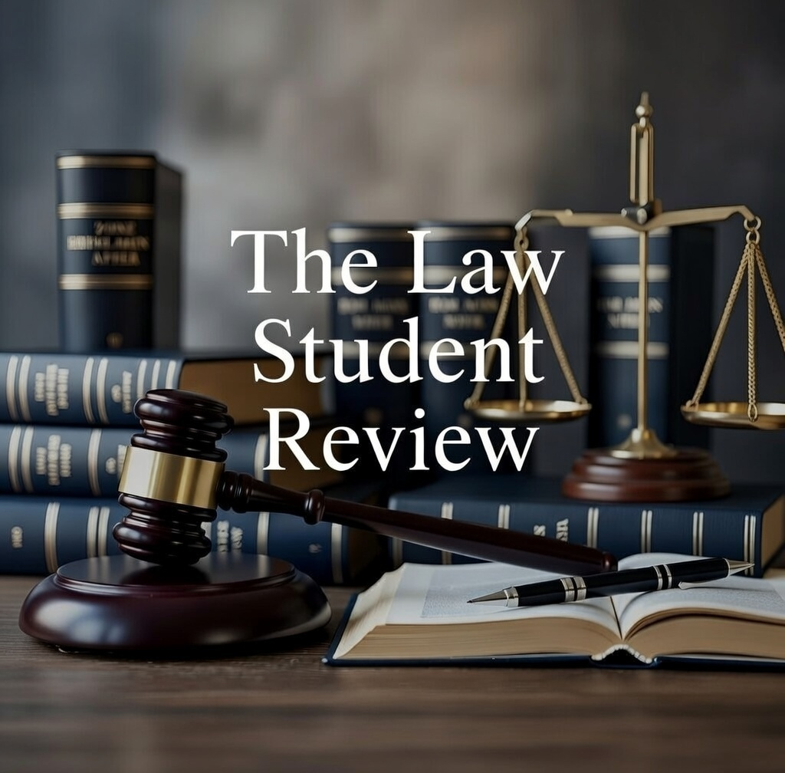

Australian Securities and Investments Commission v Bekier (Liability Judgment) [2026] FCA 196 (Lee J), delivered 5 March 2026 ("ASIC v Bekier"); Australian Securities and Investments Commission, Media Release 22-351MR, "ASIC launches proceedings against 11 current and former Star Entertainment directors and officers" (13 December 2022).
Australian Institute of Company Directors, "Star Entertainment Group Judgment: Implications for Directors" (5 March 2026).
Corporations Act 2001 (Cth) s 180(1); Casino Control Act 1992 (NSW) s 5 (licence conditions).
ASIC v Bekier (n 1); Bell Report (Adam Bell SC, Report of the Inquiry under Section 143 of the Casino Control Act 1992, 2021) ch 3.
ASIC v Bekier (n 1); Norton Rose Fulbright, "Raise the Risk: The Federal Court's Message to Executives and Boards in ASIC v Bekier" (7 March 2026).
Corporations Act 2001 (Cth) s 180(1); ASIC v Bekier (n 1).
Corporations Act 2001 (Cth) s 180(1). The duty is objective and prospective: Hopgood Ganim, "High Stakes Governance: Federal Court Clarifies Directors' Duties in the Star Decision" (11 March 2026).
ASIC v Bekier (n 1); Australian Securities and Investments Commission, Media Release 26-040MR, "Federal Court finds two Star Entertainment senior executives breached duties" (5 March 2026).
ASIC v Bekier (n 1); Hopgood Ganim (n 7).
Corporations Act 2001 (Cth) s 180(2).
ASIC v Bekier (n 1); Australian Securities and Investments Commission Media Release 26-040MR (n 8).
ASIC v Bekier (n 1). The Court was not satisfied that ASIC had proved the non-executive directors' conduct fell below the statutory standard having regard to their roles and the information available to them.
ASIC v Bekier (n 1). The Court found management had failed to apprise the Board sufficiently of material information it possessed, even when warning signals were apparent.
ASIC v Bekier (n 1); A&O Shearman, "ASIC v Bekier: A Landmark Australian Decision on Director and Officer Accountability" (April 2026). The Court confirmed the business judgment rule "offers no shelter where directors simply neglected to deal with proper safeguards".
Prior to judgment ASIC settled with the former CFO (penalty $60,000 and nine-month disqualification) and the former Chief Casino Officer (penalty $180,000 and eighteen-month disqualification): Norton Rose Fulbright (n 5).
Bell Report (n 4); Independent Liquor and Gaming Authority, Inquiry under Section 143 of the Casino Control Act 1992 (Crawford Inquiry, 2022); Casino Control Act 1992 (NSW) s 143.
Clayton Utz, "What Directors and Officers Need to Know about ASIC's Court Result against Star's Former Board and Executives" (16 March 2026); Dentons, "Key Takeaways for Directors and Officers from the Star Judgment" (19 March 2026).
ASIC v Bekier (n 1); Clayton Utz (n 17). His Honour was critical of management for failing to synthesise information and of boards for not controlling the volume of board pack materials.
ASIC v Bekier (n 1); A&O Shearman (n 14). His Honour stated the use of AI to navigate board materials is "a contemporary reality" and "nothing inherently objectionable" but cautioned that "the use of technology may assist comprehension, but it cannot displace judgment".
Corporations Act 2001 (Cth) s 180(2); ASIC v Bekier (n 1); Corrs Chambers Westgarth, "Information, Oversight and Modern Duty of Care: Governance Lessons from ASIC v Star Directors" (10 March 2026).
ASIC v Bekier (n 1). His Honour confirmed no novel legal principle was applied: the duty under s 180(1) is well settled, and the case turned entirely on its facts.
Wotton Kearney, "ASIC's Case against the Directors of Star Entertainment: Directors' Duties through a Modern Lens" (18 March 2026); Corrs Chambers Westgarth (n 20).

