
By Tara Bush

Attacking Australia’s Ugly Underbelly
The Combatting Antisemitism, Hate and Extremism Bill 2026
The rule of law prevents arbitrary power from being exercised and advocates for equality, transparency and accountability before the law. Preachers, like all others, are subject to the rule of law. Preachers have the ability to become highly influential within their communities. In conjunction with the rise of the internet, the preacher’s powers have led to an increase in promotion of violent radicalisation and extremist racism proliferated through the means of media. In 2025, the Federal Court of Australia determined whether a series of lectures published online were conducted to offend, insult, humiliate and intimidate Jewish people in Australia, whether prohibition on the free exercise of religion could be permitted due to the acts constituting discrimination on the basis of race and whether it was in the public interest to restrict the freedom of expression. In Haddad’s lectures, he opined that ‘Jews should and will be killed’, blaming Jews for the discord among Muslims alongside a myriad of racist imputations. The result was that the videos had to be removed from the internet and following the Bondi attacks the Preacher’s centre will be shut down. Not only did videos preaching radical Islam by the terrorist of the recent Bondi attacks, Naveed Akram, surface, it has also been found that he was a ‘follower’ of the infamous Sydney preacher Haddad. The amendments to the Criminal Code Act 1995 that are introduced by the Bill will strengthen punishments for spiritual preachers if they commit an offence involving threatening force or violence against groups, against members of groups or close associates, or threatening damage to or destruction of real property.
Another constituent of Australia’s extremist movements are the neo-Nazi’s, operating in chapters across the country, disguising the grooming of vulnerable youth as ‘homeschooling’, and leading protests against immigrants, Islam, the LGBTQIA+ community and Jewish people. The Bill seeks to make it an offence to direct the activities of a prohibited hate group, recruit, be a member of, be involved in the training of members, provide support and funding for prohibited hate groups. Hate groups will be prohibited by the Governor-General where the Australian Federal Police Minister reasonably believes that the organisation has committed, planned, assisted, or promoted hate crimes, and that banning the organisation is reasonably necessary to prevent serious harm, such as violence, death, major property damage or risks to public safety. The Bill has already made shockwaves through Australia’s neo-Nazi groups as the National Socialist Network and White Australia Party announced that they would disband imminently to avoid members being arrested and charged once the Bill comes into effect.
The amendments seek to refuse or cancel visas, place persons in detention and remove or deport individuals from Australia if they are found to have been, or are, members of, or support the purposes of, a terrorist organisation, state sponsor of terrorism or a prohibited hate group, or have engaged in conduct amounting to a hate crime, whether or not they have been convicted. If the person has made a publicly endorsing statement that promotes racial, ethnic or national superiority or hatred in the past, they too will trigger the new provision which does not require the Minister to determine whether a person’s membership of, or association with, an organisation is continuing, and no procedural fairness is required. Despite the legislature prioritising the safety of the Australian community in its amendments, it is undoubtable that significant legal questions will be raised in the future as to whether this jeopardises Australia’s non-refoulment obligations, a right to a fair trial, and equality before the law.
Strengthening these laws, such as imposing tougher penalties, is a double-edged sword. It may prevent reoffending, such as the higher rates of acquiescence and conformity with probation when the immediate response to noncompliance is jail. Considering the internet proliferates hate and facilitates violent extremism, the powerful tool to temporarily suspend extremist preaching and activities is advantageous to the extent that it can control these online entities and hate groups. On the other hand, an overwhelming amount of literature postulates that punishment has minimal effect in reducing recidivism, particularly as jail alienates people from ordinary life and mentalities, allowing them to deepen their allegiance to other criminals, and psychological and drug-induced disturbances of the mind impair the ability to think about future consequences of unlawful actions.
In sum, the growing influence of preachers and hate groups has been amplified by the internet and targeting of vulnerable youth. The vilification of Jewish people from both radical Islam and the far-right has resulted in the call for tougher penalties to be imposed. Rhetoric and harmful action that explicitly calls for violence and serious harm will be the primary focus of the Bill. However, while tougher penalties may assist in dismantling extremist activity and groups, they risk limited impact on long-term reoffending and may exacerbate group ties and radicalisation, as imprisonment can deepen criminal affiliation.

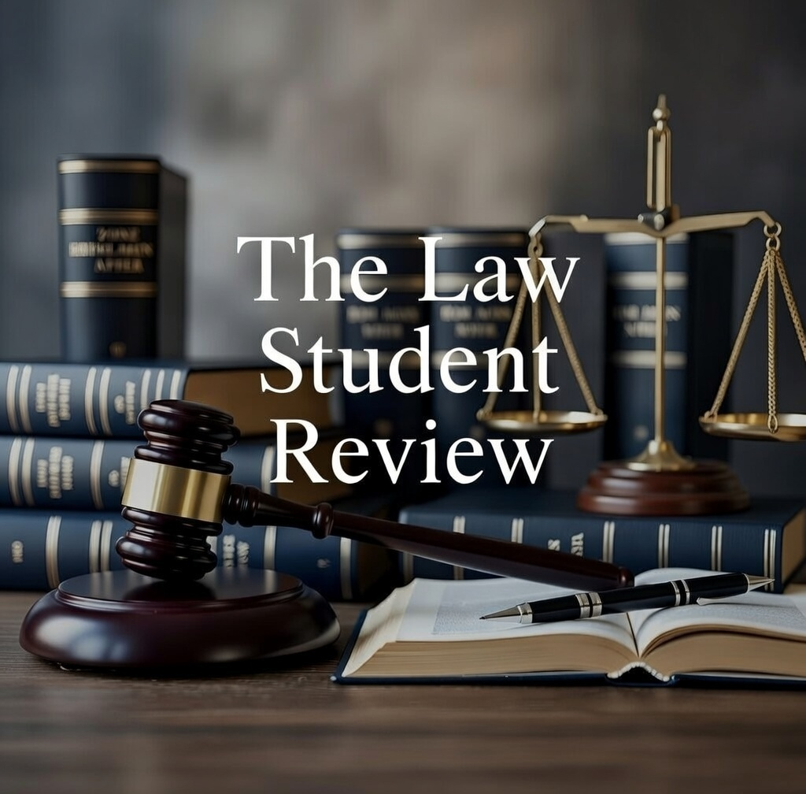

James Triggs, ‘Authority, Democracy and the Rule of Law (2008) 30 Australian Bar Review 221.
Michael Kirby, ‘The Rule of Law Beyond the Law of Rules’ (2010) 33 Australian Bar Review 195.
Angela Gendron ‘The Call to Jihad: Charismatic Preachers and the Internet’ (2017) 40(1) Studies in Conflict and Terrorism 44, 44.
Wertheim v Haddad [2025] FCA 720.
Wertheim v Haddad, ‘Statement of Claim’ (Federal Court of Australia, 1503/2024, 25 October 2024), [29].
Emily Baker, ‘Prayer hall linked to notorious preacher Wisam Haddad to close permanently’, Australian Broadcasting Corporation (Web Page, 14 January 2026) < https://www.abc.net.au/news/2026-01-14/bankstown-prayer-hall-linked-to-wisam-haddad-to-close/106228186>.
Olivia Caisley, ‘Bondi Beach Shooting Gunman Naveed Akram was Follower of Pro-Islamic State Preacher Wisam Haddad’, Australian Broadcasting Corporation (Web Page, Tuesday 16 December 2025) < https://www.abc.net.au/news/2025-12-16/video-shows-bondi-beach-shooting-gunman-preaching-islam-to-teens/106145626>.
Criminal Code Act 1995 (Cth) 82.BA; 82.BB; 82.BD
Callum Jones et al, ‘’You Can’t Trust the Mainstream Media’: Exploring Shifts in Racist, Homophobic, Transphobic, Sexist, Antisemitic and Islamophobic Sentiment within Australian Far-right Alternative News Media’ (2024) Media International Australia 1.
Combatting Antisemitism, Hate and Extremism Bill 2026 (Cth) 114B.
Ibid 114A.4.
Emily Baker, ‘Neo-Nazi National Socialist Network Says It Will Disband Due to Proposed Hate Speech Laws’ Australian Broadcasting Corporation (Webpage, Tuesday 13 January 2026) < https://www.abc.net.au/news/2026-01-13/neo-nazi-group-national-socialist-network-to-disband/106225638>.
Bill (n 10) Part 2 Amendment of the Migration Regulations 1994, Part 157; 5001(c) of Schedule 5.
Ibid Schedule 2 Amendment of the Migration Act 1958 (1C).
Ibid 114A.4(5).
Explanatory Memorandum p 4
National Research Council, ‘The Crime Prevention Effects of Incarceration’ in Jeremy Travis, Bruce Western, and Steve Redburn (eds), The Growth of Incarceration in the United States: Exploring Causes and Consequences (The National Academies Press, 2014).
Ines von Behr et al, Radicalisation in the Digital Era: The use of the Internet in 15 cases of terrorism and extremism (Rand Corporation, 2013) 1, 17.
David Roodman, ‘The Impacts of Incarceration on Crime’ (2017) Open Philanthropy Project 5, 10.
Ben Knight, ‘Do Harsher Punishments Deter Crime?’ University of New South Wales (Web Page, 16 July 2020) < https://www.unsw.edu.au/newsroom/news/2020/07/do-harsher-punishments-deter-crime>.

