

Easy Read – Incident Management
What is an incident and how is it managed?

 | This document tells you what an incident is and how Compassion SA manages them.
 | There are two types:  - A general incident  - A reportable incident.
 | A general incident is:  - When a person causes you harm or could have caused you harm  - when you hurt someone else  - when you feel that someone is going to hurt you.
 | A reportable incident is when one of the following happens:  - a death  - a serious injury  - abuse  - neglect  - sexual misconduct  - unregulated use of restrictive practices.
 | If you are involved in an incident you must tell our General Manager, your support worker or a trusted person immediately.
 | Our General Manager will meet with you to record what was said and done during the incident.
 | Our General Manager will ask you:  - what happened  - the names of people who saw the incident  - when you told someone about the incident (date and time)  - details of the person you told  - how the incident affected you  - what could be done to stop the incident happening again.
 | Your safety is important to us.  After an incident we will provide support or assistance to help you recover from the incident.
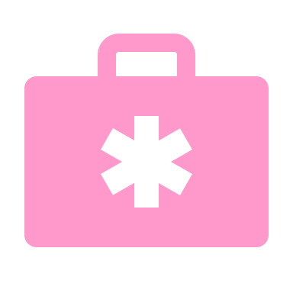 | After an incident, Compassion Sa will:  - do all we can to make sure you are safe  - provide you with advice and support  - arrange for counselling or medical support (if required).
 | We will support you by:  - fixing the incident quickly  - helping you look after your health and wellbeing (where we can).
 | We will regularly keep you up to date with how we are managing the incident.
 | The General Manager will contact you to:  - talk about what happened  - tell you what actions we will take to fix the incident  - explain to you what actions have already been taken.
We will ask for your:
- feedback and thoughts on how we are fixing the problem
- ideas about any changes that could help you in the future.

 | Our General Manager investigates the incident to work out what happened and stop it happening again.
We then complete a review of the incident to improve our service by:
- learning what happened
- making changes to stop it happening again.

 | Some changes we might make could be to:  - change our practices  - change our policies  - retrain our staff.
 | Reportable incidents
 | A reportable incident is when you, or another participant, is very badly hurt or mistreated.
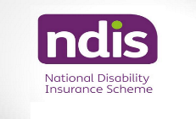 | If a reportable incident happens Compassion SA must tell the NDIS Commission.
We must complete an NDIS Reportable Incident Form. Either the:
- Immediate Notification Form
- 5-Day Notification Form.
 | Compassion SA then must send the form to the NDIS Commission using the NDIS portal.
 | The NDIS Commission reviews the incident.  They will tell us if we need to take any further action.
 | We will update you on the NDIS Commission’s findings including any actions we must take.
 | We keep everything you tell us private.
If you are unhappy with the way we handled your incident, you can tell the NDIS Commission:
- Call: 1800 03 55 44 (free call from a landline)
- Go to their website: www.discommission.gov.au

