BENEFITS
SAC305 LEAD FREE SOLDER PASTE NO CLEAN SMT PRINTING & DISPENSING PROCESS
EXCELLENT LOW VOIDING

SOLDERIX SAC 305 is especially designed to reduce the dimension and amount of voids. This is especially beneficial when soldering bottom terminated components and for applications where excellent thermal management is crucial. A reduction of voids contributes to a better heat dissipation, more reliable electrical connection and a better intermetallic solder joint strength.
This solder paste is furthermore well balanced in terms of wettability, reliability, good compatibility with most conformal coating in the market and transparent clear residues. Besides the type 4 solder paste formulations are made from 100% recycled metals and paste in jar packaging can be stored at room temperature, which contributes to an overall reduction in CO2 emissions.

PERFORMANCE | - Low voiding to offer great heat dissipation  - Very good wetting on all surface finishes, including OSP  - Transparent colorless residue, even after multiple reflow cycles
COST | - Long stencil lifetime reduces equipment downtime and paste waste  - Increase lifetime and reliability of your product, hence reduces risk of premature failures.
HSE | - Lead Free  - No halogen  - Free of CMR containing substances

FEATURES

STANDARD OPTIONS
SPECIFICATIONS | SOLDERIX  SAC – 305, 88.0 - T4 | SOLDERIX  SAC – 305, 88.5 - T4 | SOLDERIX  SAC – 305, 88.5 - T5
Alloy | Sn96,5Ag3Cu0,5 | Sn96,5Ag3Cu0,5 | Sn96,5Ag3Cu0,5
Melting point (°C/°F) | 217 / 422 | 217 / 422 | 217 / 422
Metal content (%) | 88 | 88.5 | 88.5
Post reflow residues | Approximately 5% by w/w | Approximately 5% by w/w | Approximately 5% by w/w
Halogen content | No Halogen | No Halogen | No Halogen
Powder size | 20 – 38 microns / Type 4 | 20 – 38 microns / Type 4 | 15-25 microns / Type 5
Spiral pump* Viscosity (Pa.s 25°C) | Typical 135 | Typical 135 | Typical 155
*The equipment used to test spiral pump viscosity is Malcom at a 10 rpm rotation speed.

SPECIFICATIONS | SOLDERIX  SAC – 305, 88.0 - T6
Alloy | Sn96,5Ag3Cu0,5
Melting point (°C/°F) | 217 / 422
Metal content (%) | 88
Post reflow residues | Approximately 5% by w/w
Halogen content | No Halogen
Powder size | 5-15 microns / Type 6
Spiral pump* Viscosity (Pa.s 25°C) | **Range 125-185
*The equipment used to test spiral pump viscosity is Malcom at a 10 rpm rotation speed.
**Slight adjustments in viscosity possible after finalizing full industrialization test procedure.

DISPENSING OPTIONS
SPECIFICATIONS | SOLDERIX  SAC – 305, 85.0 - T5
Alloy | Sn96,5Ag3Cu0,5
Melting point (°C/°F) | 217 / 422
Metal content (%) | 85
Post reflow residues | Approximately 5% by w/w
Halogen content | No Halogen
Powder size | 15-25 microns / Type 5
Spiral pump* Viscosity (Pa.s 25°C) | Typical 65
*The equipment used to test spiral pump viscosity is Malcom at a 10 rpm rotation speed.

ADDITIONAL OPTIONS ON REQUEST
SPECIFICATIONS | SOLDERIX  SAC – 305, 88.0 - T3 | SOLDERIX  SAC – 305, 89.0 - T4 | SOLDERIX  SAC – 305, 88.0 - T5
Alloy | Sn96,5Ag3Cu0,5 | Sn96,5Ag3Cu0,5 | Sn96,5Ag3Cu0,5
Melting point (°C/°F) | 217 / 422 | 217 / 422 | 217 / 422
Metal content (%) | 88 | 89.0 | 88.0
Post reflow residues | Approximately 5% by w/w | Approximately 5% by w/w | Approximately 5% by w/w
Halogen content | No Halogen | No Halogen | No Halogen
Powder size | 25 – 45 microns / Type 3 | 20 – 38 microns / Type 4 | 15-25 microns / Type 5
Spiral pump* Viscosity (Pa.s 25°C) | Typical 135 | Typical 170 | Typical 155
*The equipment used to test spiral pump viscosity is Malcom at a 10 rpm rotation speed.

CHARACTERISTICS

CHARACTERISTICS | VALUES | METHOD
Flux Classification | ROL0 | ANSI/J-STD-004
Flux Classification | 113 | ISO 9454
Solder balling test | Pass | ANSI/J-STD-005
Copper mirror | Pass | ANSI/J-STD-004
Copper corrosion | Pass | ANSI/J-STD-004
SIR (IPC) | Pass | ANSI/J-STD-004
SIR (Bellcore) | Pass | Bellcore
Electromigration (IPC / Bellcore) | Pass | ANSI/J-STD-004 / Bellcore
Bono Corrosion test (85°C / 85% HR – 15 days) | Pass Corrosion Factor <8% | Internal procedure
SAC - 305 achieves very low level of voiding, especially for power components (QFN, DPAK, etc.).

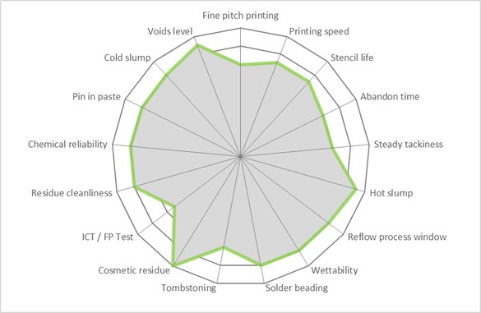
RADAR CHART: SAC – 305 - T4
2

PROCESS RECOMMENDATION
The best process will depend on factors such as operating conditions, equipment, board or component design. Our team is ready to advise you.

SOLDER PASTE PREPARATION
- Put the paste at room temperature for at least 4 hours prior to use.
- Before printing, it is essential to properly mix the solder paste, either manually with a spatula or by doing several preliminary prints on the stencil.
- Automatic solder paste mixing is neither required nor advised.

PRINTING GUIDELINE
Apply the solder paste to the stencil to form a roll of 1 to 2 cm in diameter all along the squeegee or around 100g per 10 cm of squeegee length. This way, the solder paste will roll easily under the squeegees to offer excellent printing quality.

PARAMETER | REMARK
Printing speed | Minimum 20 to maximum 150 mm/s (1 to 6 inch/s)  Maximum depends on printer capabilities
Minimum pitch | 0.4 mm for Type 4 powder
Pressure | Guideline value for a 250 mm squeegee is 7 Kg at 100 mm/s  Actual value depends on equipment, printing speed and squeegee length
Stencil life in continuous printing process | >12 hours
Abandon time between prints | >2 hours
Steady tackiness | >12 hours

REFLOW GUIDELINE
Although this paste performs very well under air, a nitrogen atmosphere will even more improve the wettability whereas achieving even a larger reflow process window.
Linear preheating ramp rate is recommended, however high-density boards may require a soak zone during preheating to stabilize the temperature over the circuit board before peak reflow.
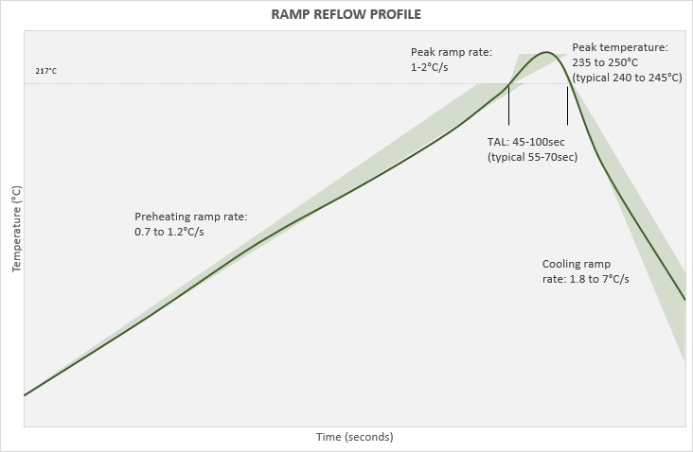
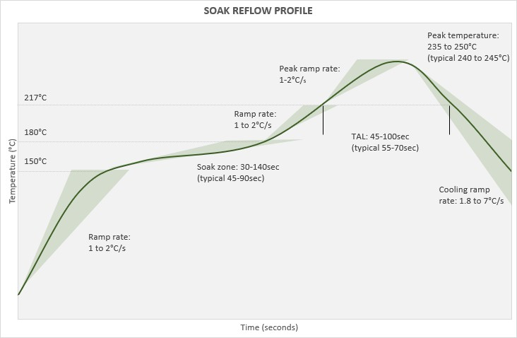

REFLOW STEPS | REMARKS
Preheating ramp rate with linear preheating | 0.7 to 1.2°C/s ( according to the circuit board size and density
Preheating steps in case of preheating soak zone | - From 20 to 150°C ramp rate 1 to 2°C/s  - Soak zone between 150 to 180°C (302 to 356°F): 60-140s reflow (typical soak 45-90s)  - From 170°C (380°F) to liquidus 1 to 2°C/s
Peak ramp rate | 1 to 2 °C/s
Peak temperature | 235 to 250°C (455 to 582°F) / 240 to 245°C (464 to 473°F) is optimum  The paste can withstand a temperature higher than 250°C (482°F), but it is not recommended to preserve component integrity.
Time above liquidus | 45 to 100s - 55 to 70s typical
Cooling ramp rate | 1.8 to 7°C/s  Studies has demonstrated 1.8 to 2.2 °C/s allows a more homogeneous joint structure and reduced surface crack formation.

CLEANING POST SOLDERING
This product is a no-clean solder paste, so cleaning is not required to meet IPC standards. The chemistry is specially designed so that any remaining flux residue is chemically inert and will not impact your assembled board or packaging under normal conditions. However, when cleaning is desired or required (e.g. high reliability assembly or to improved conformal coating adhesion), the flux residue can be easily removed with SOLDERIX own formulated flux cleaners.

PACKAGING, STORAGE & SHELF LIFE

ARTICLES / STORAGE CONDITIONS | ROOM TEMPERATURE (<30°C) | 0°C TO 10°C
solder paste in jar for type 4 | shelf life 6 months | shelf life 12 months
solder paste in jar for type 3, 5 & 6 | confirmation test ongoing | shelf life 12 months
- Room temperature storage is currently under evaluation for other packaging and powder sizes.
- For an optimal preservation, store cartridges in a vertical position, tip downwards.

AVAILABLE PACKAGING

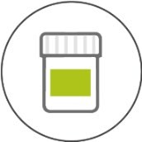

JAR
250g & 500g
PRODUCT ARTICLE CODIFICATION
Below example as a reference

Alloy reference

SOLDERIX 3 0 5 - 8 8 . 0 T 4

Brand name
Metal content & powder size

