By Maria Chakkours
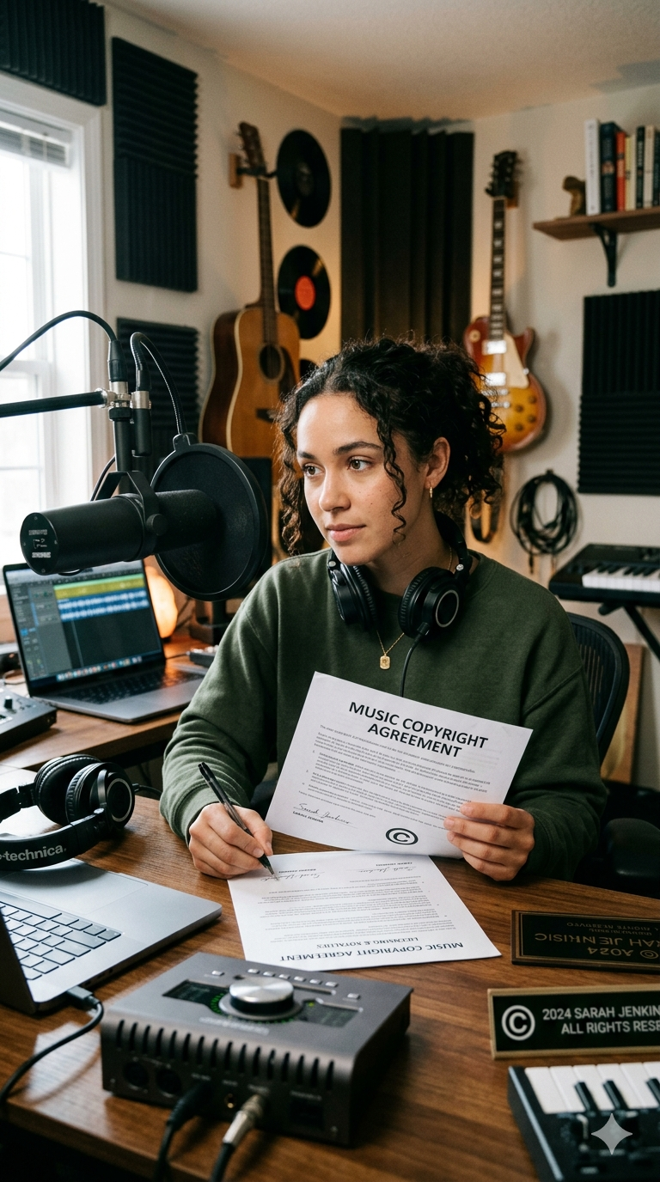

Copyright, Authorship, and Artificial Intelligence
Emerging Legal Issues in the Australian Music Industry
Law Student Review

ABSTRACT
Australian copyright law, as codified in the Copyright Act 1968 (Cth), proceeds on the foundational premise that intellectual works are the product of human authorship. That premise is under sustained pressure from the proliferation of generative artificial intelligence ("AI") in the music industry. This article examines the doctrinal architecture of copyright protection in Australia as it applies to musical works and sound recordings, analysing the frameworks governing authorship, ownership, and licensing, whilst critically evaluating the legal lacunae that arises when AI is introduced as a creative agent.
I FOUNDATIONS OF COPYRIGHT LAW WITHIN AUSTRALIA
Copyright protection in Australia is exclusively governed by the Copyright Act 1968 (Cth) (“the Act”), which establishes a binary classification of subject matter relevant to the music industry regarding “musical works” on one hand, and “sound recordings” on the other. It refers to the underlying composition: melody and harmony, whilst the latter protects the particular recorded fixation of a performance. These categories attract distinct statutory rights regimes, rights for artists, ownership structures, and considerable practical consequences for artists, producers, and labels.
For copyright to subsist in either category, two prerequisites must be met. First, the work must be original, a product of one’s own independent intellectual effort. The High Court’s analysis in IceTV Pty Ltd v Nine Network Australia Pty Ltd confirmed that the concept of originality demands evidence on the authors “independent intellectual effort”and “sufficient effort of a literary nature”. The concept of this is more qualitative rather than quantitative.
Second, the work must be reduced to “material form”. Encoded in the Act’s definition of “writing”, it is a requirement that art is constructed broadly to include notation, digital files, and audio recordings.
II AUTHORSHIP AND OWNERSHIP

A) Default Rules
Under the Act, the author of a musical work or composition is the person who created it. This ownership automatically vests in that author upon the work’s creation and fixation; registration is not required. In the music industry however, this default position is modified frequently by agreement. The composer and lyricist of a song typically co-own the musical work in proportions negotiated between them, whilst the producer who records the track may separately own the copyright in the resulting sound recording.

B) Employment and Commission Exceptions
Where a work is created by an employee in the course of their employment, the Act reverses the default: copyright vests in the employer. This exception applies where a songwriter is engaged under a staff writing agreement with a publisher, or where a session musician records in an employed capacity. With respect to commissioned works, this position is more nuanced. Unlike some comparable jurisdictions, the Act does not provide a general commissioner's exception for musical works, such that ownership typically remains with the creator absent an express contractual assignment.

C) Split Ownership in Practice
Particularly within the realm of the contemporary music industry, ownership is susceptible to a multi-layered and often fragmented relationship. A commercially released track may involve a co-written composition (split ownership of the musical work), a producer's recorded arrangement (ownership of the sound recording), and a record label holding an exclusive licence or outright assignment of both. Publishing agreements most commonly assign the musical ownership to a publisher in exchange for royalty entitlements, whilst recording agreements vest the sound recording copyright in the label. Understanding these proprietary interests is essential to the legal analysis of licensing, infringement, and the emerging questions posed by AI-generated music.
III LICENSING AND ROYALTY FRAMEWORKS
Copyright in a musical work confers upon the owner the exclusive right to reproduce, perform, communicate and adapt the work. Infringement constitutes if any of such rights are exercised by a third party without authorisation. In practice, these rights are monetised through the process of licensing by which the copyright owner grants permission in exchange for remuneration. This may be on either an exclusive or non-exclusive basis.
With respect to the music industry, three principal categories of licensing arise. Mechanical licenses permit musicians or labels to reproduce and distribute a copyrighted song in audio-only formats, such as streaming, vinyl, CDs, and digital downloads. Public performance licenses are legal permissions required to play copyrighted music in public, such as in businesses, restaurants, gyms, or at events. In Australia, most of these rights are covered by a "blanket licence" from OneMusic Australia, which represents the Australasian Performing Right Association (APRA) and the and Australasian Mechanical Copyright Owners Society (AMCOS), ensuring creators are paid. Synchronisation (“sync”) licenses encompass the musical contracts that allow copyrighted music to be paired with visual media such as films, TV shows, advertisements, or video games. To avoid copyright infringement, it is required from the copyright owners (songwriters and publishers for composition, labels and artists for sound recording) before public release.
APRA AMCOS are copyright management organisations (also known as copyright collectives) that jointly represent over 100,000 songwriters, composers, and music publishers across Australia and New Zealand. Operating as a unified body, they administer and enforce music copyright by licensing the use of musical works and ensuring creators are fairly remunerated for the use of their music. This includes issuing licences to businesses, broadcasters, digital platforms, and event organisers, collecting royalties when music is performed, communicated, or reproduced, and distributing those royalties back to their members, thereby supporting the sustainability of the music industry and protecting the economic rights of creators.
IV DIGITAL MUSIC INDUSTRY CONTEXT
Within the architecture of the music industry, the transition to digital distribution, as opposed to physical sales and ownership-based models (such as CDs and vinyl), has substantially restructured the economics and legal frameworks that protect artists and labels. Streaming platforms, particularly Spotify, Apple Music, and Amazon Music, now constitute the primary mode of music consumption globally. These platforms operate on the basis of licences obtained directly from record labels and publishing rights organisations, rather than from individual artists, which has significant implications for the distribution of royalty income and the bargaining power of independent artists.
For independent artists without label affiliation, digital distributors such as DistroKid serve as intermediaries between the artist and the streaming ecosystem. Distributors deliver content to platforms on the artist's behalf, collect and remit streaming royalties, and provide administrative tools for rights management. Independent artists have little to no power to negotiate the terms platforms impose on them, and because recommendation algorithms are largely a black box, platforms hold even more control over who gets visibility. This has real legal implications: in practice, an artist's ability to benefit from their copyright is only as strong as the platform permits.
V ARTIFICIAL INTELLIGENCE AND COPYRIGHT LAW

A) The Authorship Problem
The central doctrinal issue posed by AI-generated music is authorship. The Act defines an “author” as the person who created the work, and Australian courts have interpreted this as requiring human creative input. In Telstra Corporation Ltd v Phone Directories Company Pty Ltd, Gordon J held that copyright cannot subsist in a work produced without human intellectual effort, requiring 'sufficient effort of a literary nature'. Applied to AI, this means that where a musical work is created autonomously without sufficient human input, copyright will not subsist under current Australian law.

B) Ownership of AI-Generated Works
The question of authorship leads directly to a question of ownership. Without an author, there is simply no one in whom copyright can vest. A user who prompts an AI model to generate music, may not, on current doctrine, acquire copyright in the resulting output. Unless there is meaningful human creative input somewhere in the process, the law has nothing to latch onto. The Attorney General’s “Copyright and AI - Transparency discussion paper” acknowledged this doctrinal gap, designed to gather expert stakeholder input on AI transparency issues as part of a broader, ongoing copyright reform process. The Report fed into what has since become a more concrete reform agenda around licensing and enforcement.

C) Training Data and Infringement
The key issue is whether the training of AI models on copyrighted musical works constitutes infringement. Where a model is trained on a dataset that incorporates sound recordings or musical works without licence, the reproduction involved in that training process may engage the exclusive reproduction right of the copyright owner. While this issue has produced significant litigation in comparable common law jurisdictions, no Australian court has yet resolved the question definitively. The absence of a broad "fair use" defence in Australia means that a statutory exception would likely be required to legitimate training-data reproduction without a licence.

D) Vocal Impersonation and Deepfakes
A further and rapidly emerging concern is the use of AI tools to synthesise the vocal characteristics of existing recording artists without authorisation. Such "vocal deepfakes" and “cloning” raise issues of copyright infringement (where the training data incorporates protected sound recordings), passing off (where the resulting work is presented as the work of the impersonated artist), and potentially, misappropriation of the performer's attributes. This raises not only licensing concerns, but also significant issues relating to the protection of performers’ personal identity and privacy.
VI INDUSTRY AND REGULATORY RESPONSES
Beyond impersonation controls, Spotify's September 2025 announcements reflected a broader industry effort to develop governance frameworks responsive to generative AI. The platform announced a new music spam filter designed to identify and suppress AI-generated content deployed for fraudulent royalty farming. This development illustrates a form of platform selfregulation that, while protective of economic interests, operates outside any formal legislative framework.
Spotify also announced support for a new industry standard for AI disclosures in music credits, developed through DDEX (Digital Data Exchange), the international body responsible for developing standards for the music supply chain. Under this standard, artists and rights holders will be able to indicate the role of AI in a track's creation, such as AI-generated vocals, instrumentation, or production. This allows for an unprecedented level of transparency in music metadata.

VII CONCLUSION
The rapid integration of artificial intelligence into the music industry exposes a fundamental tension at the heart of Australian copyright law: a legal framework built upon human authorship is now being asked to regulate increasingly non-human modes of creation. Ultimately, the issues raised by AI-generated music cannot be resolved through doctrinal adjustment or law reform alone. They require a more fundamental reconsideration of the relationship between creativity, technology, and legal protection. Australian copyright law must evolve to address the realities of machine-assisted and machine-generated creation. Failing this, the law risks both underprotecting human creators, to the detriment of innovation, fairness, and the long-term sustainability of the music industry.

LAW STUDENT REVIEW
Disclaimer: The views expressed herein are solely those of the author and do not necessarily reflect other authors or the Law Student Review

Copyright Act 1968 (Cth) s 10(1) (definition of "musical work"); s 10(1) (definition of "sound recording").
Copyright Act 1968 (Cth) ss 32, 89.
IceTV Pty Ltd v Nine Network Australia Pty Ltd (2009) 239 CLR 458, 471–472 (French CJ, Crennan and Kiefel JJ).
Copyright Act 1968 (Cth) s 22(1).
Copyright Act 1968 (Cth) s 10(1) (definition of "author").
Copyright Act 1968 (Cth) s 35(6) (works made under a contract of employment).
Copyright Act 1968 (Cth) ss 97, 100.
Copyright Act 1968 (Cth) Div 3 Pt IV (sound recordings).
Copyright Act 1968 (Cth) s 31(1)(a)(i)–(vi) (musical works); s 85 (sound recordings).
Copyright Act 1968 (Cth) s 36 (infringement of copyright in works).
Copyright Act 1968 (Cth) s 47 (licence as a defence to infringement).
APRA AMCOS, About APRA AMCOS (Web Page) <https://www.apraamcos.com.au>.
See DistroKid, 'How It Works' (Web Page) <https://distrokid.com/how>.
Spotify, Spotify for Artists Terms and Conditions of Use (Web Page) <https://www.spotify.com/au/legal/spotify-for-artiststerms-and-conditions/>.
Copyright Act 1968 (Cth) s 10(1) (definition of "author").
Telstra Corporation Ltd v Phone Directories Company Pty Ltd (2010) 194 FCR 142, 160 (Gordon J).
Copyright Act 1968 (Cth) s 35(1) (ownership vests in the author).
Australian Law Reform Commission, ‘Arguments against Fair Use in Australia’ in Copyright and the Digital Economy (Discussion Paper No 79, 2013) <https://www.alrc.gov.au/publication/copyright-and-the-digital-economy-dp-79/4-the-case-forfair-use-in-australia/arguments-against-fair-use-in-australia/>.
TokenRing AI, ‘Spotify Takes on the “Slop Problem”: A New Era of AI Governance in Music’ (17 October 2025) <https:// markets.financialcontent.com/stocks/article/tokenring-2025-10-17-spotify-takes-on-the-slop-problem-a-new-era-of-aigovernance-in-music>.

