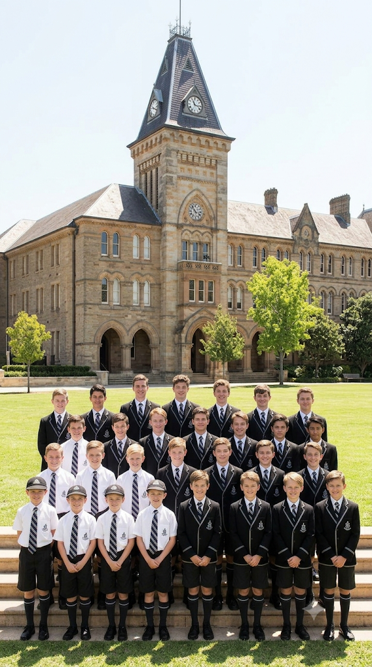

Student A v Council of Newington College [2025] NSWSC 534
A case summary
Law Student Review
By Kepueli Hanisi

I INTRODUCTION
In 1881, Newington College officially opened within Sydney’s innerwest of Stanmore. Since its foundation, it has operated as an all-boys school within both their primary and secondary levels of education. Newington is governed by the Newington College Council Act 1922, pursuant to its foundational deed of trust in 1873. The Deed gives the school council named, ‘Council of Newington College’ jurisdiction over the management of the school. After consultations with members of the school community the Council announced in November of 2023, that it intended to transition the College into coeducational learning. On the Stanmore campus, this process would commence with the junior schools in 2026 and the senior school to follow in 2028. This decision generated widespread controversy among some parents, alumni and students at the time. So much so that it brought forth a legal dispute in May of 2025, by one of the pupils at the school referred to as “Student A”, in an attempt to prevent mixed-sex education. The anonymisation order for “Student A” was made to protect the plaintiff’s privacy, so the student was not critiscied for his personal feelings on the matter of the intergration. The litigation before the court and Parker J was concerned only with the Council’s power to merge, and not with the merits of that decision.

II FACTS
The Newington College Council Act requires the College to act in accordance with the objects set out in the 1873 Trust Deed. With the relevant provision in the document stating that one of the objects of the institution is “to provide an efficient course of education for youth”. The principal contention made on behalf of “Student A” in these proceedings, focused on the word “youth” in the Trust Deed. The claim was that at the time that the deed was being made, the word was meant to only refer to boys and young men, and not young women and girls. Additionally, it was argued that the Council did not have the authority to undergo the transition it was planning to perform, or expend College resources for that purpose. The Council of Newington College argued that the word “youth” was not restricted to boys, the founding documents did not legally require single-sex education and that the Council did not have the authority necessary to change their enrolment policy.

III LEGAL ISSUES
The main legal issues in Student A v Council of Newington College [2025] NSWSC 534 included whether the interpretation of the founding trust deed legally required the College to remain an only-boys school, what the word “youth” meant at the time, the scope of the College Council’s authority to introduce coeducation, whether the purpose of the trust was broad enough to include boys and girls, and whether the Couuncil was within their jurisdiction to allocate school resources and funds into implementing the integration.

IV OUTCOME
Justice Parker presided over the case and engaged with these legal issues. To follow are his comments and ultimate decisions on the matter.

The judge thought the gender-neutral language concerning enrolments, for example referring to students as pupils, was particularly significant. He asserted that if a male-only enrolment policy was to have been mandated, that it was precisely where one would expect to see the use of male-only language. The attempt by counsel for Student A to suppose that the gender-neutral language of the deed meant all boys or young men was unconvincing. The Supreme Court found the reasoning particularly circular, beginning with the assumptions that the parties to the Deed had that limitation in mind, and then read the limitation into the gender-neutral language of the Deed as a consequence. In Justice Parker’s opinion, the meaning of the term “youth” as observed in the third clause of the Deed was unambiguous. Additionally, it was determined that there was nothing to qualify its ordinary gender-neutral meaning and that it must be presumed that the gender-neutral interpretation, was the meaning which the parties to the Deed intended to express at the time.
In observing the Newington College Council Act, which governs the College Council’s operations, it was determined that there were no regulations that were adopted which would prevent the school from becoming coeduational. It was in s 13 of the Act where the Council was given the power to make that change unless it would conflict with the “general objects for which the college was founded”.
All parties proceeded on the basis that these “general objects” were to be observed with the object stated in cl 3 of the Trust Deed, namely, “the provision of an efficient course of education for youth”.
The court ruled in favour of Newington College. Student A appealed on the basis that the original court was wrong in their interpretation, however, the New South Wales Court of Appeals upheld the decision of the Supreme Court and dismissed the case.

V IMPLICATIONS
Had the plaintiff succeeded, further questions may have arisen as to whether the male-only limitation applied to other property held by the Council for the purposes of the College. However, with the claim failing it may very well set a strong precedent that is not limited to only enrolment throughout Newington College, but also other unrelated subjects of discussion within the Council’s jurisdiction.
With Cranbrook School facing similar public backlash among its own current student population, parent, faculty and alumni community in 2022; this case builds on a very general precedent not just limited to Newington, but perhaps sparking further coeducational discussions among other elite traditionally all-boys private schools. Such as The King’s School in North Parramatta, Scots College in Bellevue Hill and Knox Grammar School in Wahroonga to name a few.
The implications of this case is perhaps an indication of the much more progressive and inclusive times that we are in now. Schools like Newington feature some of the most highly networked and affluent families in the country. This level of exclusivity more often than not promotes a culture of elitism that tends to exclude different types of people, which can be seen in the public scrutiny that both Cranbrook and Newington faced in merely announcing their intentions to integrate. This case certainly challenges a deep-rooted issue inside a niche part of our society within the private education system and upperclass of Australia.

LAW STUDENT REVIEW
Disclaimer: The views expressed herein are solely those of the author and do not necessarily reflect other authors or the Law Student Review

Student A v Council of Newington College [2025] NSWSC 534 [1].
Ibid [5].
Ibid [7].
Ibid [10].
Ibid [8].
Ibid [11].
Ibid [12].
Ibid.
Ibid [130].
Ibid [131].
Ibid [132].
Ibid [90].
Ibid [15].

