HYPERSYNC – SUPPLEMENTAL TERMS OF USE
(Issued by TartanHQ Solutions Private Limited)
Effective Date: [●]
- These Supplemental Terms of Use (herein after referred to as “HyperSync Terms”) govern the access to and use of the HyperSync product and related services (hereinafter referred to as “HyperSync”) made available by TartanHQ Solutions Private Limited (hereinafter referred to as “Tartan”, “we”, “us”, or “our”), a private limited company, having its corporate office at 6th floor, Spring House, Unitech Trade Centre, Sushant Lok Phase I, Sector 43, Gurugram-122022, Haryana.
These HyperSync Terms are in addition to, and shall be read together with, Tartan’s Terms of Use available on its website (herein after referred to as “Terms of Use”), updated time to time. In the event of any inconsistency, these HyperSync Terms shall prevail solely with respect to the HyperSync.

HyperSync service enables real-time, consent-driven synchronization of data across human resource information system, customer relationship management, and enterprise resource planning systems through unified APIs, facilitating automated workflows, integrations, onboarding, and accurate cross-platform data exchange. By accessing or using HyperSync, the user agrees to be bound by both the Terms of Use and these HyperSync Terms.

Following main parties are involved in the process of Hypersync:

- Tartan’s Client/Customer – a party involved in providing corporate employee benefits, group insurance, etc. that instructs Tartan to obtain information from its corporate client. The client base of Tartan shall include, without limitation, banks, financial institutions, enterprises, and other similar entities.
- Corporate/ Authorised Representative – the data fiduciary (typically an employer, organization, or institution) that intends to procure for its employees or workforce benefits (such as insurance, financial products, or HR services) from Tartan’s Client. Such person represents and warrants that it has the requisite legal authority and responsibility to collect, use, and share personal data of its personnel, and to provide such data to Tartan through Tartan’s Client for specified processing purposes. It acts on behalf of its employees or associated personnel and shall ensure that all necessary consents, notices, and applicable compliance requirements are duly fulfilled prior to such data sharing.
- Tartan - data processor, that processes the personnel’s information basis documented instructions from Tartan’s Client. Tartan acts solely as a structured intermediary layer between the Data Principal, Customer, and Data Fiduciary for the purpose of standardising and presenting data in a usable format.

- NATURE, PROCESS AND SCOPE OF HYPERSYNC SERVICES

  - HyperSync is a proprietary technology platform of Tartan that enables structured integration, synchronization, validation, verification, and exchange of data between enterprise systems, including but not limited to HRMS platforms, payroll systems, financial systems, enterprise databases, and related infrastructure.

  - HyperSync operates strictly as a technology intermediary that facilitates automated data exchange based on system integrations authorised by the Customer.

  - Tartan does not generate, modify, create, or independently validate source data originating from third-party systems. Tartan does not guarantee the completeness, accuracy, or authenticity of such third-party data.

  - HyperSync services may include APIs, dashboards, reporting layers, workflow tools, and integration infrastructure as contractually agreed.

  - Tartan may access authorised systems, APIs, portals or data sources through integrations and authenticated by the credentials lawfully provided by the Corporate, for the purpose of collecting and synchronising data.

  - Corporate shall act as an intermediary between the End User and Tartan’s Client and shall be responsible for ensuring that all data relating to the Data Principal is duly collected and provided to Tartan in accordance with the applicable consent and terms.

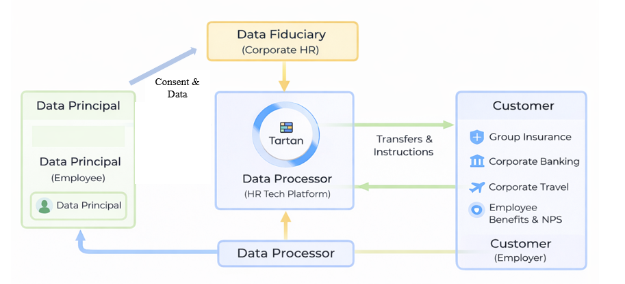

- ELIGIBILITY AND AUTHORISATION

  - HyperSync may only be accessed by entities that have executed a valid commercial agreement with Tartan or Tartan’s Clients, as the case may be.

  - The Corporate/ Authorised Representative represents and warrants that:
- it has full corporate authority to enter into the agreement;
- it has lawful rights to transmit and process data through HyperSync;
- it complies with all applicable data protection and privacy laws.

- DATA AND CONSENTS

  - The Authorised Representative shall be solely responsible for obtaining all legally required consents, authorisations, notices, and approvals from end users, employees, contractors, or data subjects whose data is processed through HyperSync and thereafter provided to Customer via Tartan and provide such evidence to Tartan’s Clients.

  - Tartan’s Clients shall procure that Authorised Representative expressly represents and warrants that:
- all data shared with Tartan has been lawfully collected;
- adequate notice has been provided to data subjects;
- required consents under applicable law have been validly obtained.

  - Tartan shall be entitled to rely entirely on such representations and shall have no obligation to independently verify the legality of data collection or consent and shall be indemnified and held harmless against any claims, penalties, regulatory actions, or liabilities arising from failure to obtain valid consent or lawful basis for processing.

  - The data collected shall be utilised exclusively for the purposes of HyperSync and shall not be used for any other purpose without obtaining explicit consent. HyperSync provides “Real-time, consent-driven data sync across human resource information system, customer relationship management, and enterprise resource planning via unified APIs, enabling automated workflows, integrations, onboarding, and accurate cross-platform data exchange.”

  - Tartan shall process Data solely for the purpose of enabling secure data exchange, orchestration, validation and redirection to the Customer’s authorised onboarding or workflow journeys and for no independent or commercial purpose and redirecting the Employee to the Bank’s digital onboarding journey, and for no other purpose whatsoever.

  - Tartan shall not use, disclose, analyse, monetise, or process such Data for independent business purposes, profiling, analytics, or marketing.

  - Tartan shall process Data strictly in accordance with such lawful basis and documented instructions and shall not process Data beyond the scope of HyperSync.

  - Tartan shall process only the minimum Personal Data necessary to enable secure link generation and redirection to the Customer’s onboarding journey.

  - Tartan shall not collect, store, or process KYC documentation, financial credentials, banking passwords, authentication secrets, or any sensitive financial access information.

- DATA RETENTION AND DELETION

Tartan shall retain data processed through HyperSync only for the duration necessary to fulfil the specific purpose of the authorised redirection, integration, and synchronisation process, or for such longer period as may be required under applicable law or contractual obligations. Upon completion of the redirection journey and subject to applicable legal or regulatory retention requirements, Tartan shall delete or anonymise such data within a reasonable and documented timeframe, and shall not retain such data indefinitely.

- INFORMATION SECURITY AND BREACH NOTIFICATION

  - Tartan shall implement and maintain reasonable and appropriate technical and organisational security measures including encryption, access controls, audit logging, and incident response mechanisms designed to protect Personal Data against unauthorised access, disclosure, alteration, loss, or destruction, considering the nature, scope, and sensitivity of Personal Data processed through HyperSync.

  - In the event of any actual, suspected, or confirmed Data Breach affecting Data processed under these Terms, Tartan shall notify the Customer and/or Corporate/ Authorised Representative (including the relevant Tartan Client, where applicable) without undue delay and, in any event, promptly upon becoming aware of such breach. Such notification shall include reasonable details regarding (i) the nature and circumstances of the Data Breach, (ii) the categories and approximate volume of Data of Data Subjects affected, (iii) the likely consequences and impact, and (iv) the remedial actions taken or proposed to mitigate the breach and prevent recurrence.

  - Tartan shall further provide reasonable cooperation, information, and assistance as may be required to enable the Customer to comply with its obligations under applicable law in connection with such Data Breach.

- DISCLAIMERS

  - HyperSync is provided on an “as-is” and “as-available” basis.

  - In the case of data that is being authorised to be transmitted over Tartan’s software, Corporate represents and warrants that it is duly authorised to share the data in compliance with applicable law. The obligation to verify such authority and obtain necessary consents rests solely with the Authorised Representative to Tartan’s Client. Tartan may rely on this representation and shall bear no liability for any lack of valid authorisation.

  - Tartan disclaims all express or implied warranties, including fitness for a particular purpose and non-infringement.

  - Tartan does not warrant that:
- HyperSync will meet specific business objectives;
- third-party integrations will remain continuously available;
- outputs will be error-free where source data is inaccurate.

