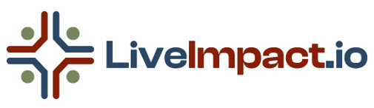

PRESS KIT
(Latest Update: August 2025)

Latest Press Release
FOR IMMEDIATE RELEASE

Turning the World of Impact Investing on Its Head
New civic tech platform makes impact investing available to everyone,
no portfolio required
HOLLAND, MI – August 19, 2025, The term “impact investor” has long been reserved for the wealthy: individuals allocating large sums toward social or environmental causes, expecting a blend of measurable impact and financial return.
But LiveImpact.io, a new civic tech platform currently in development, is turning that model upside down.
At LiveImpact.io, anyone who contributes, even just $10, is considered an Impact Investor. That contribution grants lifetime access to a platform designed to log and track real-world actions for good, display collective momentum on a public dashboard, and operate free of ads, algorithms, or data mining.
“We don’t need more apps that track us,” says LiveImpact.io founder Rick Zwetsch. “We need platforms that back us. That’s why we’re building LiveImpact.io ten bucks at a time.”
The team behind LiveImpact.io says the goal isn’t to build another content platform. It’s to build civic infrastructure a people-powered system that offers visibility, accountability, and shared progress across causes and communities.
The platform’s funding model reflects that ethos. There are no subscriptions, premium tiers, or venture capital backers. Just a one-time $10 investment and the option to pay it forward by funding access for others.
“The return we’re offering isn’t financial,” Zwetsch explains. “It’s a Return on Integrity a public, transparent record of action that reminds people they’re not alone, and that what they do matters.”
Why It Matters
LiveImpact.io is launching amid growing public disillusionment with traditional social platforms, which often monetize outrage, suppress civic content, and manipulate visibility with opaque algorithms. By contrast, LiveImpact.io is purpose-built for trust, transparency, and real-world outcomes.
And the platform’s redefinition of “impact investing” is a strategic shift: away from extractive, high-capital systems toward inclusive, collaborative infrastructure.
“It’s not charity,” says Zwetsch. “It’s investment in the systems we wish already existed.”
LiveImpact.io is currently raising funds via GoFundMe, where early investors are contributing in increments as small as $10.
About LiveImpact.io
LiveImpact.io is a civic-tech platform where real-world action counts not just clicks. The platform lets users pledge and track tangible actions across causes they care about, shows progress on a public dashboard, and is designed to be entirely free from ads, subscriptions, or algorithmic manipulation. The platform is built for trust, visibility, and collective impact.

Media Contact
Rick Zwetsch
Founder, LiveImpact.io
Email: rick@liveimpact.io
Website: www.LiveImpact.io
###

One-Page Fact Sheet
Platform Snapshot
- Name: LiveImpact.io
- Launch Status: Pre-launch - currently in fundraising, platform MVP framework design and cause-nomination phase
- Founded: 2025
- Location: Holland, MI
- Tagline: You act. We count. The world sees.™
What We Do
LiveImpact.io is a people-powered civic tech platform that lets anyone pledge and track real-world actions for causes they care about, with progress displayed on a public dashboard. No ads, no algorithms, no data mining. Just visible, collective impact.
Why It Matters
Impact investing has been reserved for the wealthy for too long. We’re redefining it to include everyday people, everyday actions, and everyday causes from local food security, environmental stewardship issues to planting a pollinator garden to starting a compost bin.
Key Differentiators
- Anyone can join for a one-time $10 lifetime membership
- No portfolios required - actions matter as much as donations
- Causes nominated and upvoted by users, not gatekeepers
- Visible collective impact through a public dashboard
Funding Model
$10 one-time lifetime membership, with an optional “pay it forward” to cover membership for others.

Founder Bio & Headshot
Short Bio (137 words)
Rick Zwetsch is the founder of LiveImpact.io, a civic-tech platform making impact investing accessible to everyone, no portfolio required. For the last 16+ years, he has served as a nonprofit consultant, partnering with hundreds of mission-driven organizations to develop strategies, guide planning, and foster sustainable growth. Rick’s work has spanned sectors from environmental advocacy to community development, giving him a broad perspective on how change happens. He believes the tools for social change should be in everyone’s hands and that small actions, multiplied, can transform communities. LiveImpact.io reflects that belief by empowering people to pledge and track real-world actions, connect with causes they care about, and see their collective impact in real time. Based in Holland, Michigan, Rick brings a blend of entrepreneurial vision, strategic thinking, and a deep commitment to civic good to everything he builds.
Long Bio (230 words)
Rick Zwetsch is the founder of LiveImpact.io, a civic-tech platform designed to make impact investing accessible to everyone, no portfolio required. For more than 16 years, Rick has worked as a nonprofit consultant, partnering with hundreds of mission-driven organizations to shape strategy, guide planning, and foster sustainable growth. His consulting career has spanned sectors from environmental advocacy to disability rights, public media, and community development, giving him a broad and nuanced perspective on how change happens.
The idea for LiveImpact.io emerged from a simple but stubborn frustration: too many people feel disconnected from the impact of their actions, and too many tools for social change are designed for those with significant financial resources. Rick envisioned a platform where everyday people could pledge tangible actions from planting a pollinator garden to advocating for policy change and see their contributions join thousands of others on a public, transparent dashboard.
His vision for LiveImpact.io is bold yet simple: build civic infrastructure that runs on trust, transparency, and collective participation. Free from ads, algorithms, and outside influence, the platform invites anyone to invest in the systems we wish already existed. Rick believes that small actions, multiplied, can shift communities and that making those actions visible can inspire even greater change.
Based in Holland, Michigan, Rick brings entrepreneurial vision, strategic thinking, and a lifelong commitment to civic good to every aspect of LiveImpact.io.

Headshots
 | 

Visual Assets
Logo files

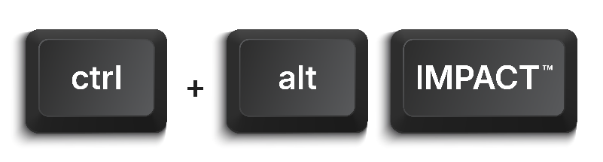
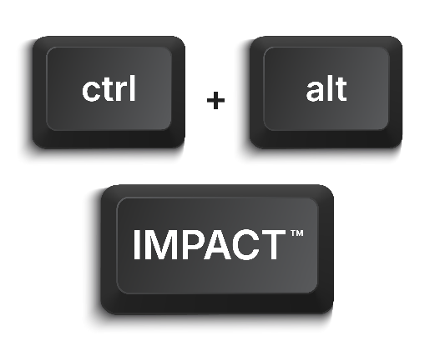

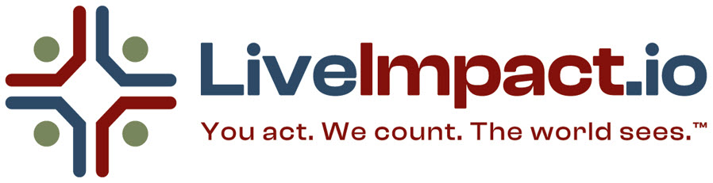

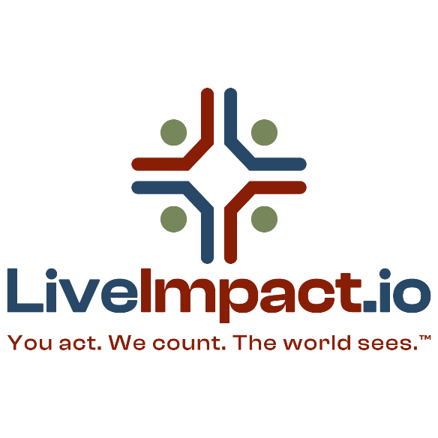

How It Works

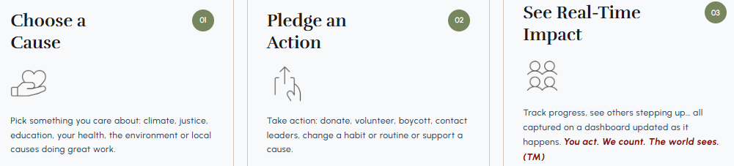
1. Pick a Cause
From environmental justice to local food security, or everyday actions like starting a compost bin, planting a pollinator-friendly garden, or removing microplastics from your local shoreline - the choice is yours.
2. Pledge an Action
Donate, volunteer, advocate, boycott or take a personal step like setting up your compost bin this weekend, adding native plants for pollinators this spring, or organizing a shoreline cleanup with friends.
3. See Your Impact
Every action completed adds to a public record of real-world change.

Key Messages & Talking Points
- Core Message: LiveImpact.io makes impact investing available to everyone - no portfolios, no gatekeepers, just real-world action and visible results.
- Soundbite: “We don’t need more apps that track us. We need platforms that back us.”
- Why We’re Different: People-powered, ad-free, algorithm-free, no politics, no social media, lifetime membership model, built for trust and transparency.
- Vision: A new civic infrastructure where what you do matters as much as what you give.

FAQ for Journalists
Q: Who is behind LiveImpact.io?
A: LiveImpact.io is led by founder Rick Zwetsch, a serial entrepreneur and veteran nonprofit consultant with over 20 years of experience across the social impact sector. With no internal team or technical cofounder, Rick is leveraging advanced AI tools as an integrated creative, strategic, and operational partner in every stage of development. As the platform moves toward launch, future collaborators and technical partners will join to help scale within a system that is already strategically mapped and operationally sound.
Q: How is LiveImpact.io different from traditional impact investing?
A: We’re shifting the definition from capital-focused to action-focused. No portfolios, just real-world impact from anyone who cares enough to act.
Q: Why a $10 lifetime membership?
A: It’s accessible, sustainable, and keeps the platform free from advertising, outside control, or algorithmic manipulation.
Q: What happens after launch?
A: Users pick a cause, pledge an action, mark it completed, and see it contribute to collective impact in real time.
Q: When will you launch?
A: Development will begin once we meet our fundraising goal. Target timeline: within 90 days of funding completion.
Q: How can people get involved now?
A: Join as a lifetime member, nominate causes, or pay it forward for others.

Media Contact & Links
Rick Zwetsch, Founder, LiveImpact.io
Email: rick@liveimpact.io
Website: www.LiveImpact.io
GoFundMe: www.gofundme.com/liveimpact
Substack: https://liveimpactio.substack.com/
LinkedIn: https://www.linkedin.com/in/rickzwetsch/

