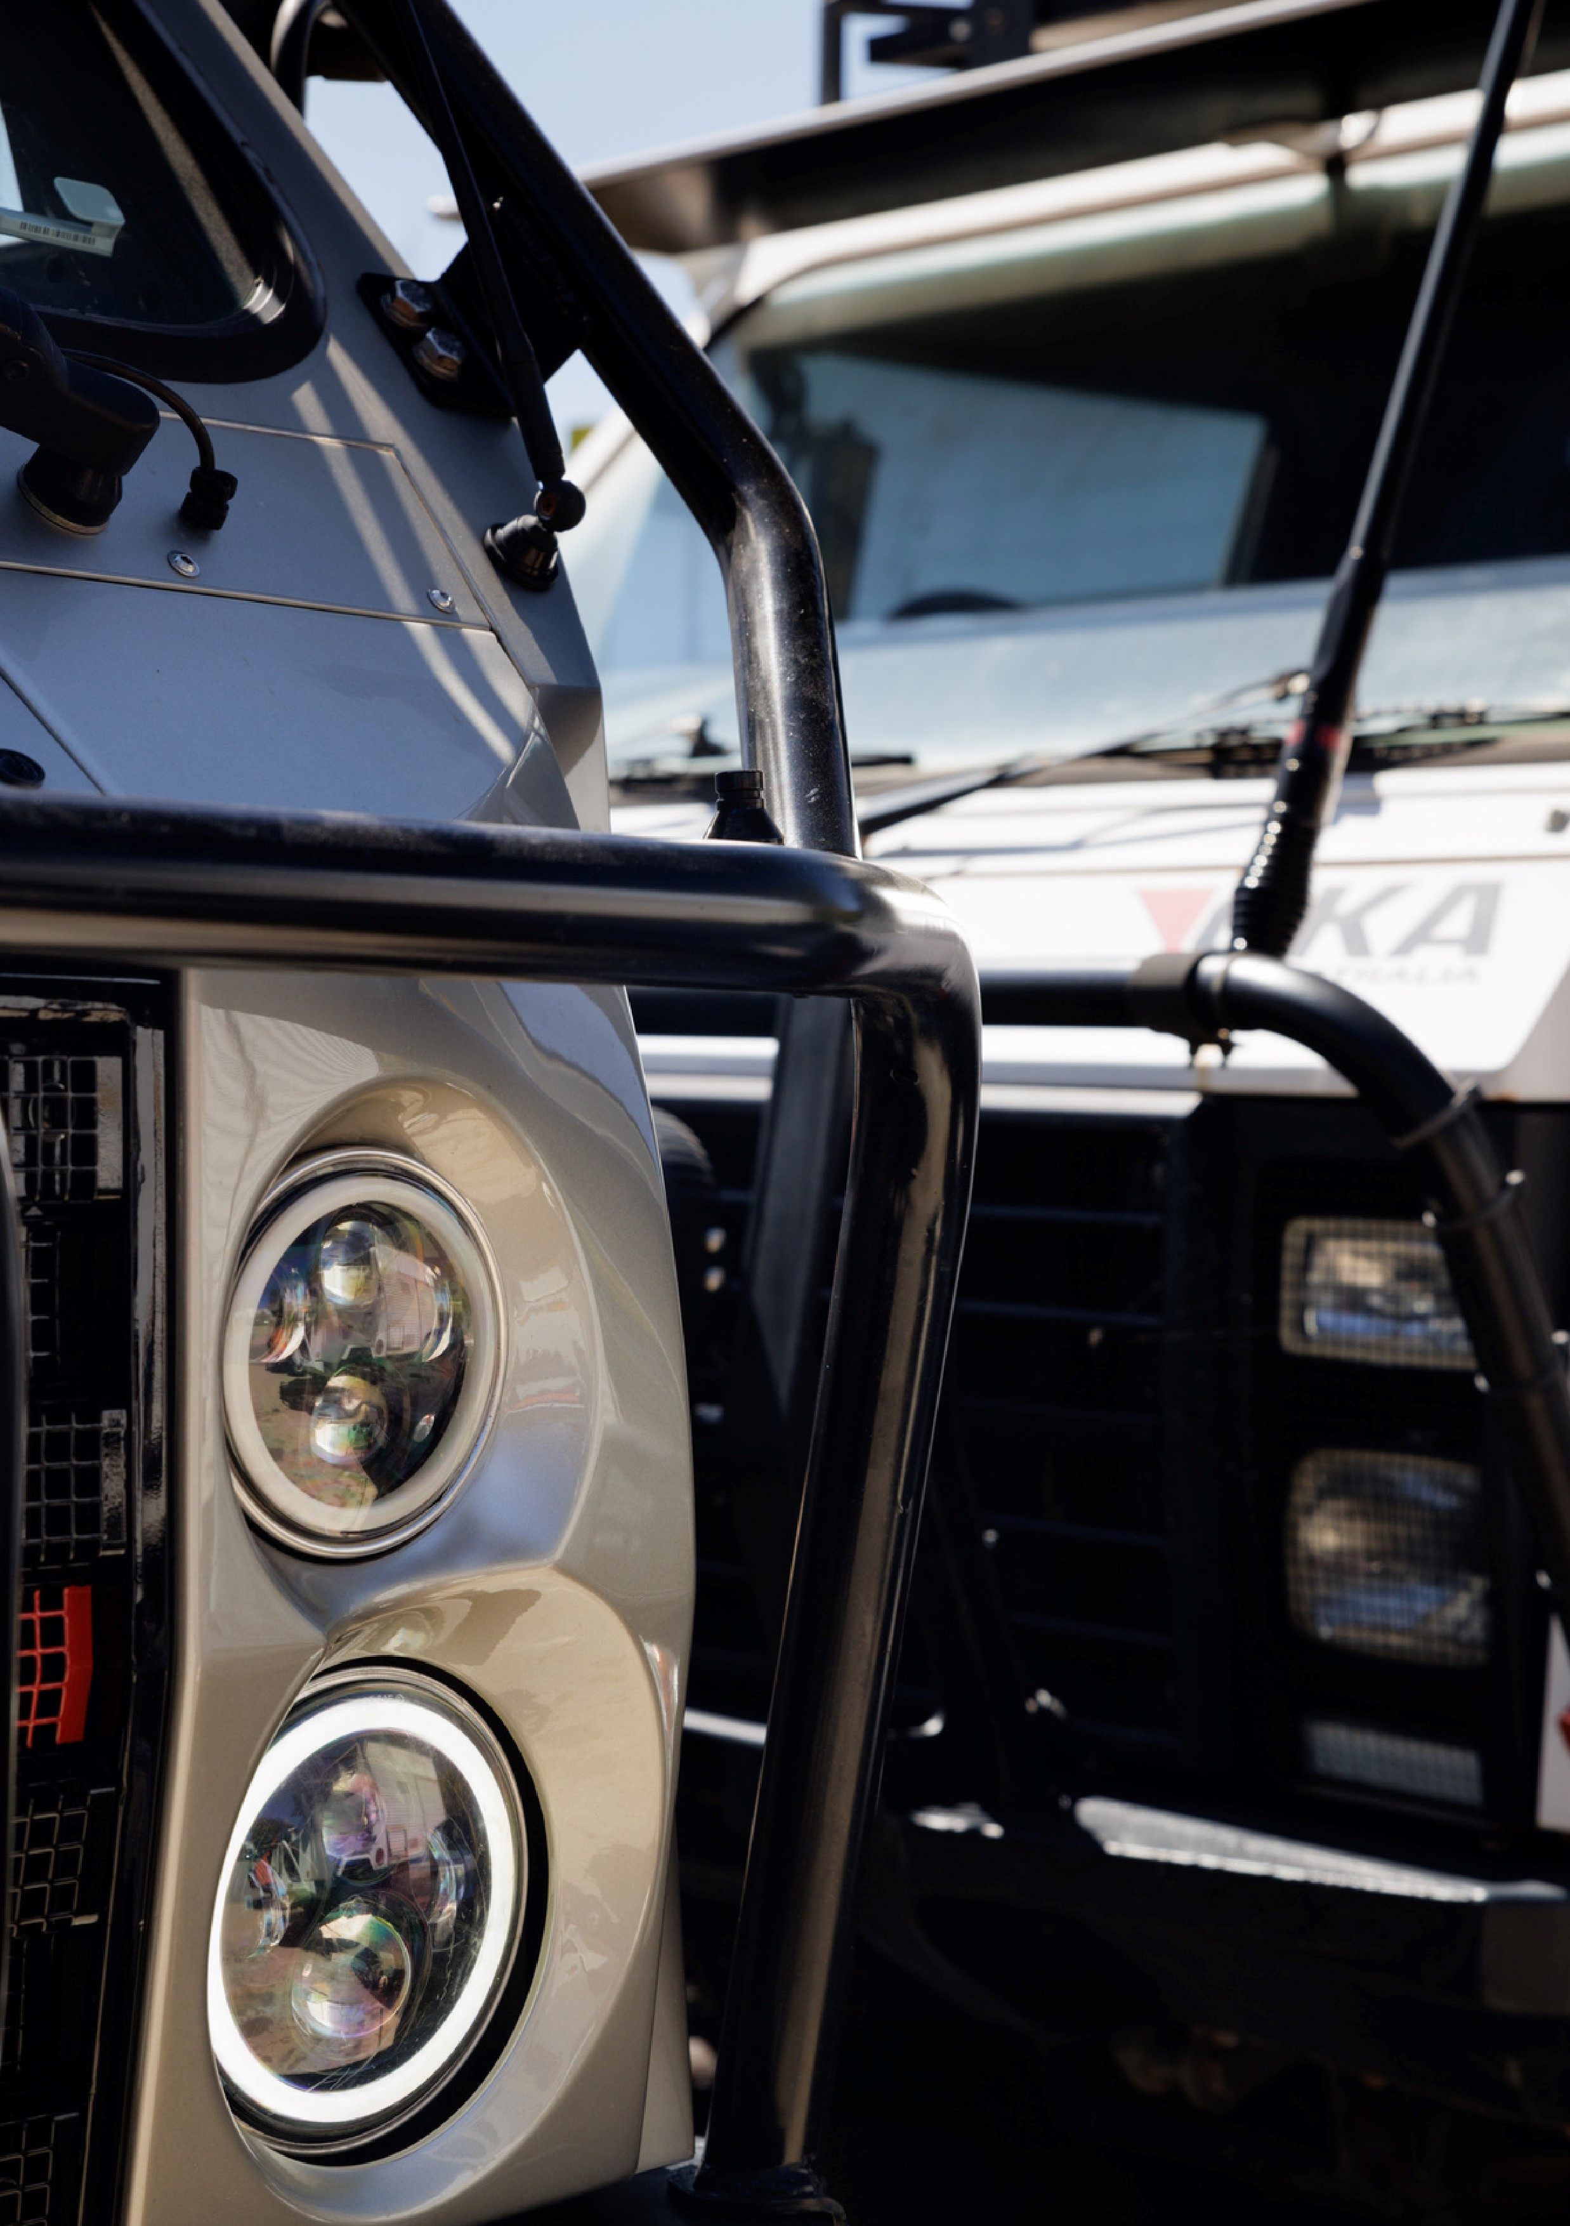
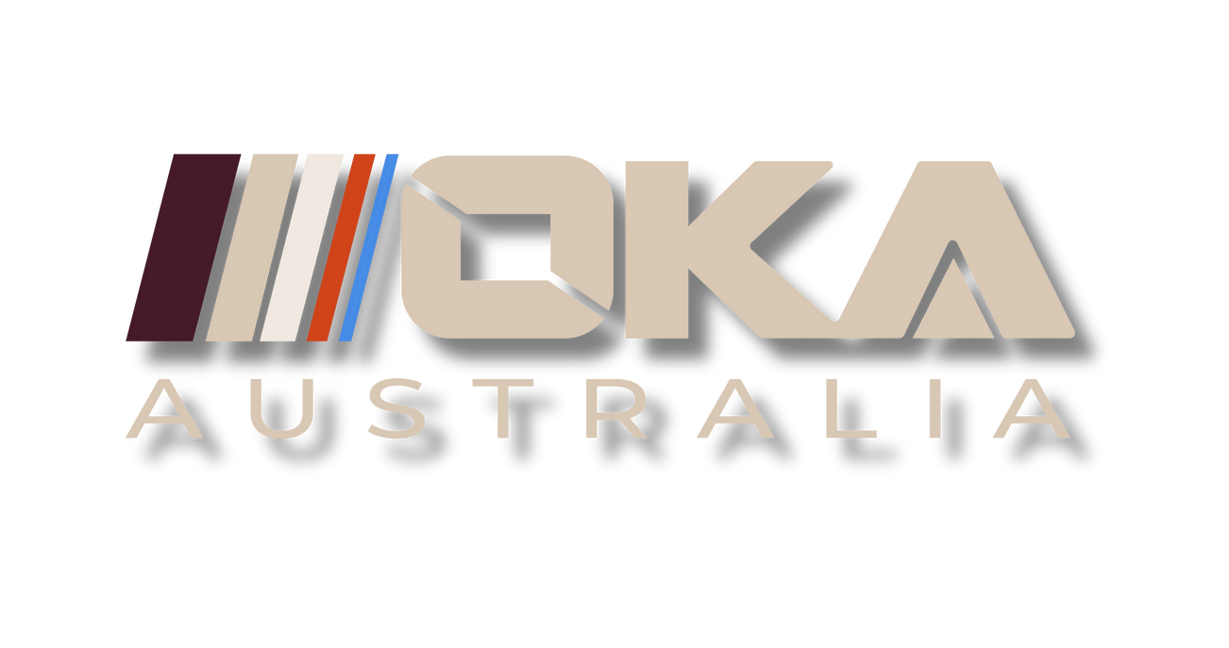
01
INVESTOR NEWSLETTER
EDITION 01
OCTOBER 2025
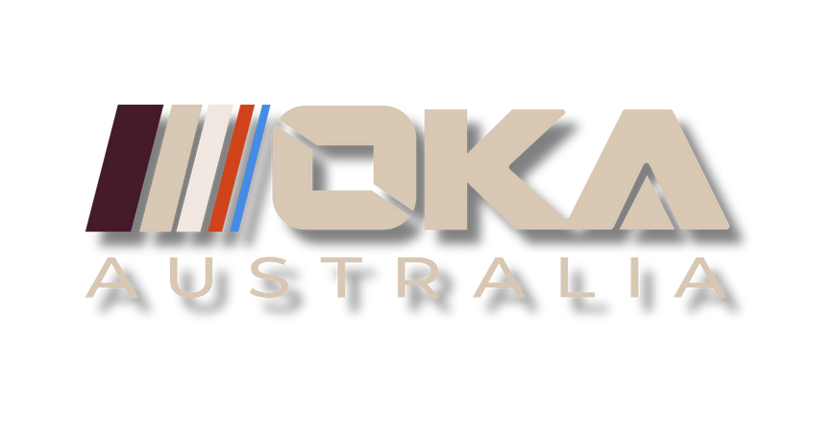
Investor Newsletter
Edition 01
October 2025

OKA Completes OzTerrain Acquisition
OKA is pleased to announce the successful acquisition of the assets of OzTerrain Pty Ltd, bringing OKA’s intellectual property, engineering capability, and team fully under the OKA Australia banner and control.
Given the strong momentum, market response, and commercial traction achieved, OKA and OzTerrain’s owner, Dean Robinson, mutually agreed to accelerate the acquisition timeline. The transaction was completed on 30 September 2025, seven months ahead of the original April 2026 milestone.
The structure of the agreement includes a deferred payment and share arrangement extending through 2027. This approach allows OKA to prioritise incoming capital from fundraising activities toward executing its scale-up plans.
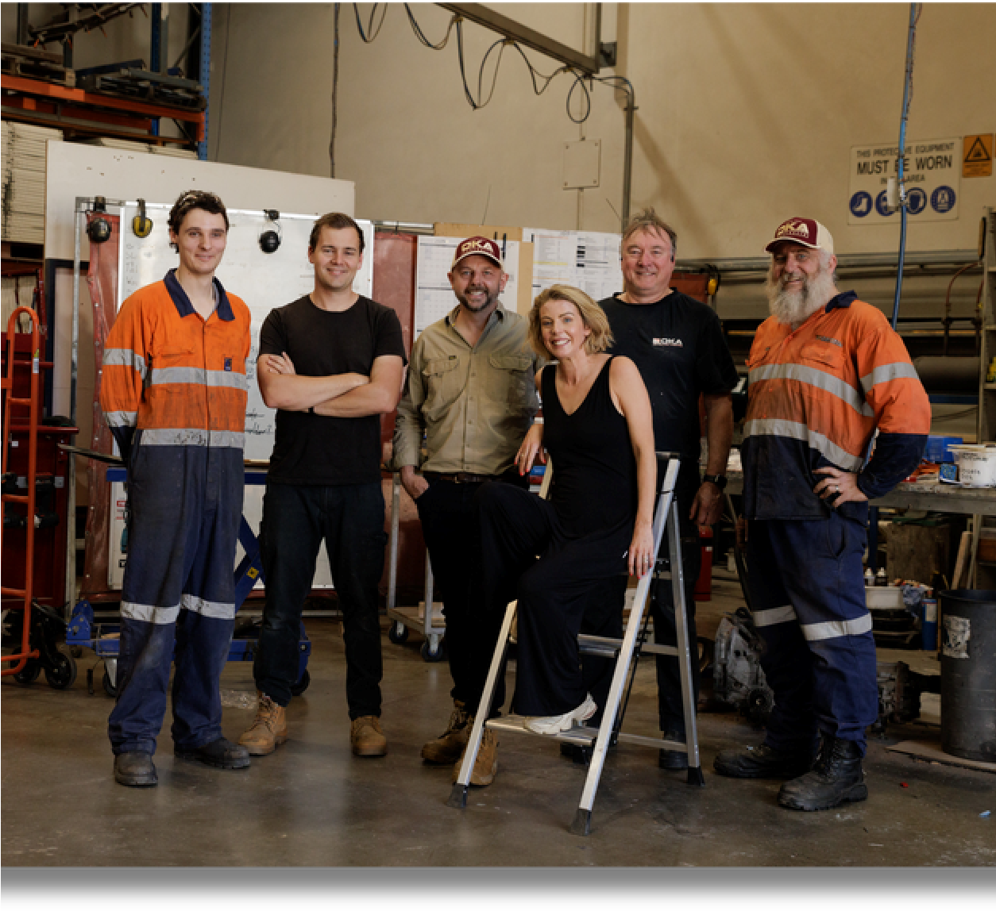
With the acquisition now complete, OKA has entered full operational mode with a focus on sustainably scaling Gen-5 production, implementing supply chain improvements and expanding industry partnerships. We thank Dean Robinson for his continued support and alignment with our mission to scale this iconic Australian vehicle, and we wish him well as he prepares for retirement over the coming years.
01

Investor Newsletter
Edition 01
October 2025

STRATEGIC MOU WITH VARLEY GROUP
PARTNERSHIP:
OKA has signed a Memorandum of Understanding with Varley Group, one of Australia’s most established engineering and manufacturing firms with over 140 years of sovereign engineering expertise.

WHAT THIS MEANS FOR OKA
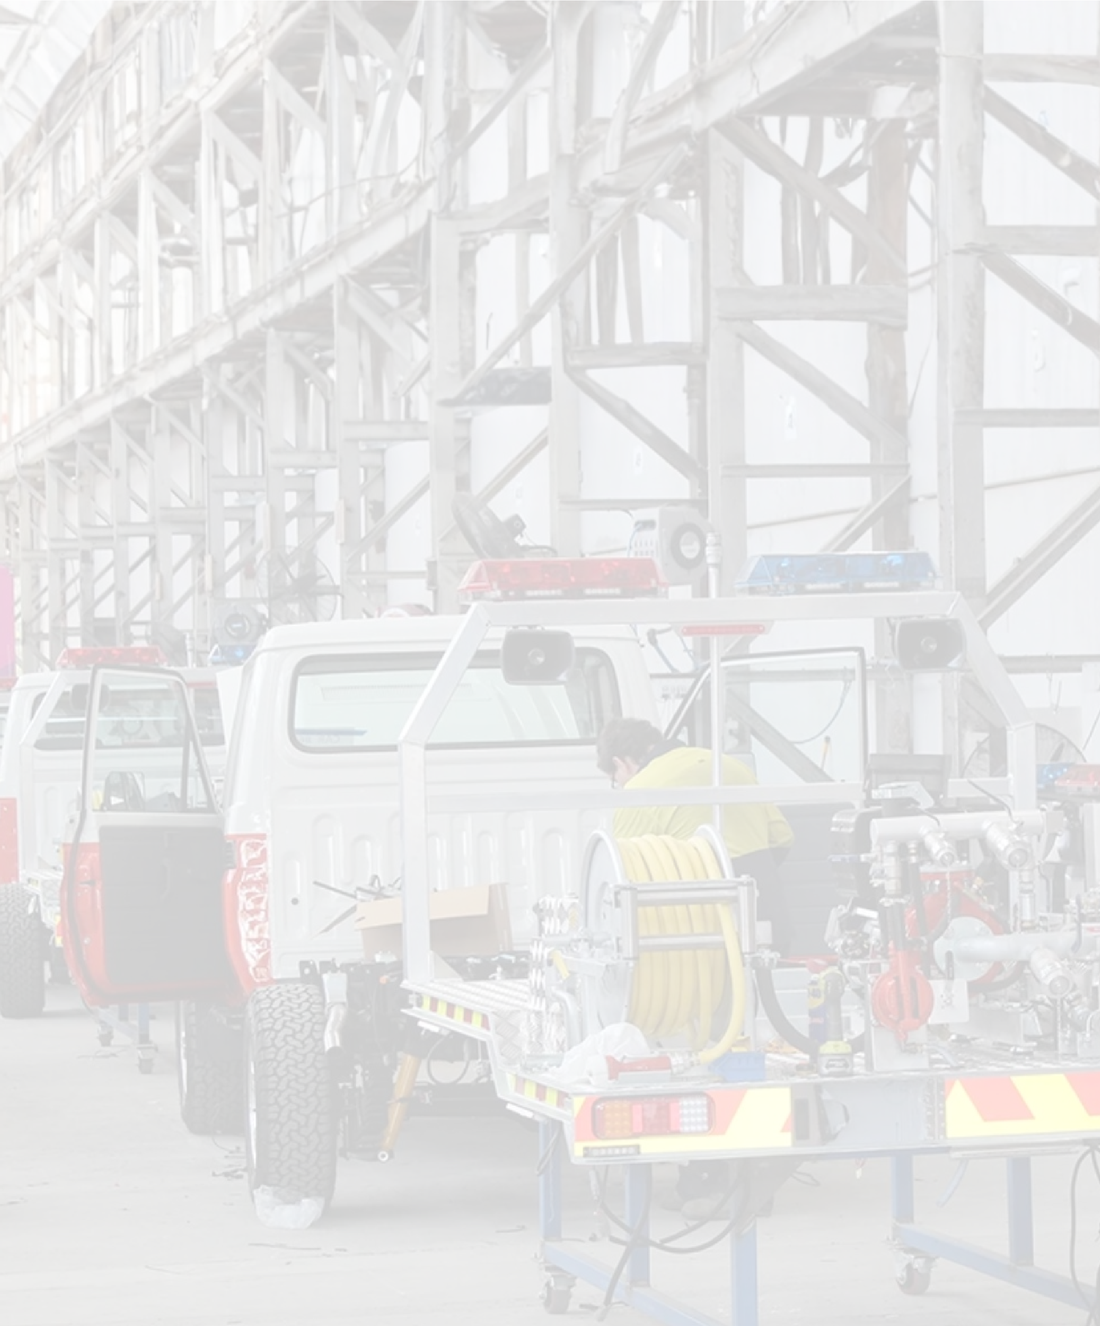


“OKA Australia has built a strong reputation for rugged and reliable all-terrain vehicles, and together we can combine their innovative platform with Varley’s manufacturing expertise.”

Jeff Phillips
Managing Director, Varley Group

OKA can scale efficiently, reduce lead times, and maintain quality by leveraging Varley’s established infrastructure, technical capability, and fleet management systems.
Enables the Gen-5 cab-chassis platform to be paired with a range of superstructures and delivered as a complete operational asset for emergency, defence, humanitarian, industrial, or recreational use.
This partnership moves OKA from small-scale production to a national manufacturing model, leveraging Varley’s multiple
accredited production facilities and 1,200 personnel across
Australia and the US
02
Investor Newsletter
Edition 01
October 2025

Growing OKA Team & Resources
Following the OzTerrain acquisition, OKA opened a new Fremantle office on 13 October and is now scaling operations. We are seeing strong inbound interest and are focused on reducing delivery timelines from 18 months to under 6 months while improving cost efficiency.
This month we welcomed:

PAUL VINEY - FRACTIONAL CFO

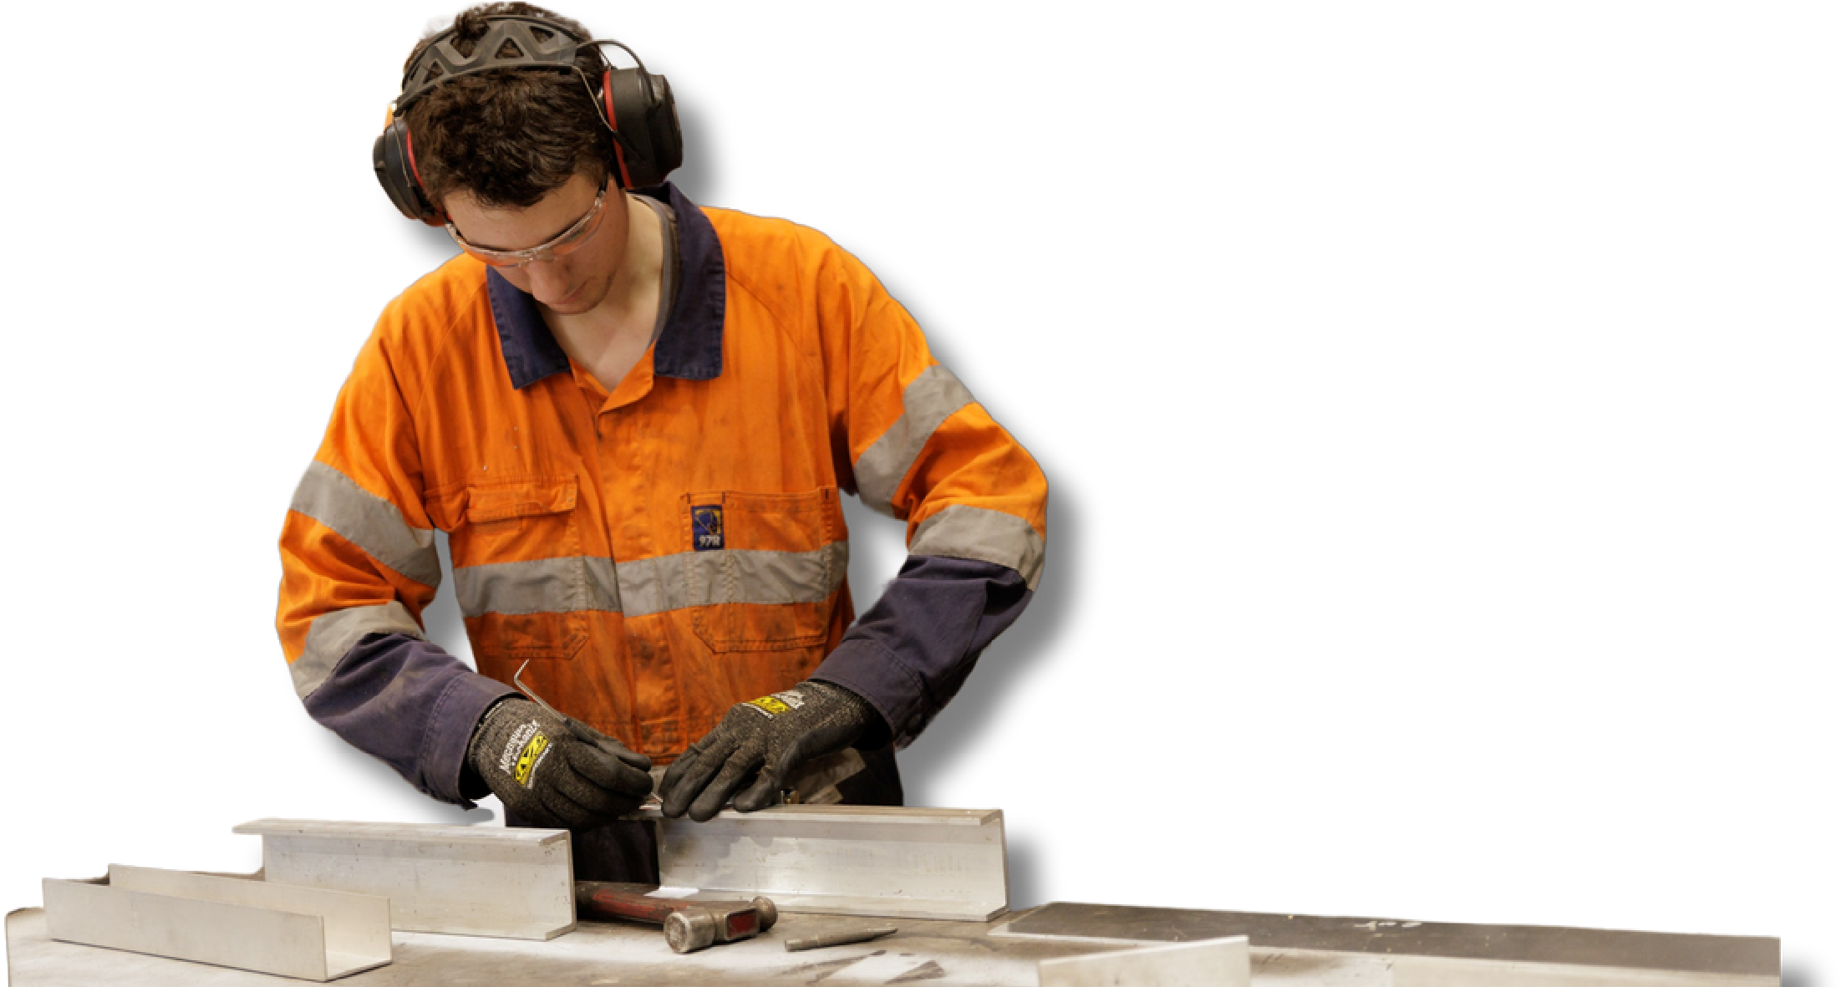

Paul is the former Group CFO of Elphinstone with deep expertise in finance, manufacturing, and capital markets. He led the A$5.3 billion creation of MyState Limited (ASX:MYS) in 2008 and managed an ASX IPO for a venture capital company with 26 tech businesses. As CFO of Tasmanian Perpetual (ASX:TPX) and Elphinstone Group, he's delivered major M&A transactions across mining equipment, biotech, logistics, and financial services.
KALEB MILSOM - TECHNICAL MANAGER
Kaleb joins OKA as Technical
Manager, supporting systems development, engineering integration, and scale up support.
Kaleb was an integral part of the
OzTerrain Gen 5 development program and has been directly involved in OKA vehicle builds over the past 24 months,
providing valuable continuity and technical insight as we move into full-scale production.

OKA TRADE MISSION: UAE ENGAGEMENT
AND STRATEGIC TIMING
In early October Executive Directors Oliver Barnes and Zoe Barnes completed a trade mission to the United Arab Emirates to reconnect with longstanding regional contacts and engage with key government entities and enterprises.
This trip aligned with the commencement of the Australia–UAE
Comprehensive Economic Partnership Agreement (CEPA) on 1 October 2025 which establishes a more efficient two way trade framework with tariff and logistics advantages that strengthen OKA’s export strategy. This creates a favourable cost base for Australian manufactured products entering the UAE and onward into wider global markets.
The UAE holds clear strategic relevance for OKA as a major logistics and manufacturing hub linking Asia, Europe and Sub Saharan Africa. Its geographic position provides an efficient gateway for the export of OKA vehicles into emerging markets where demand for durable off road transport is strong.
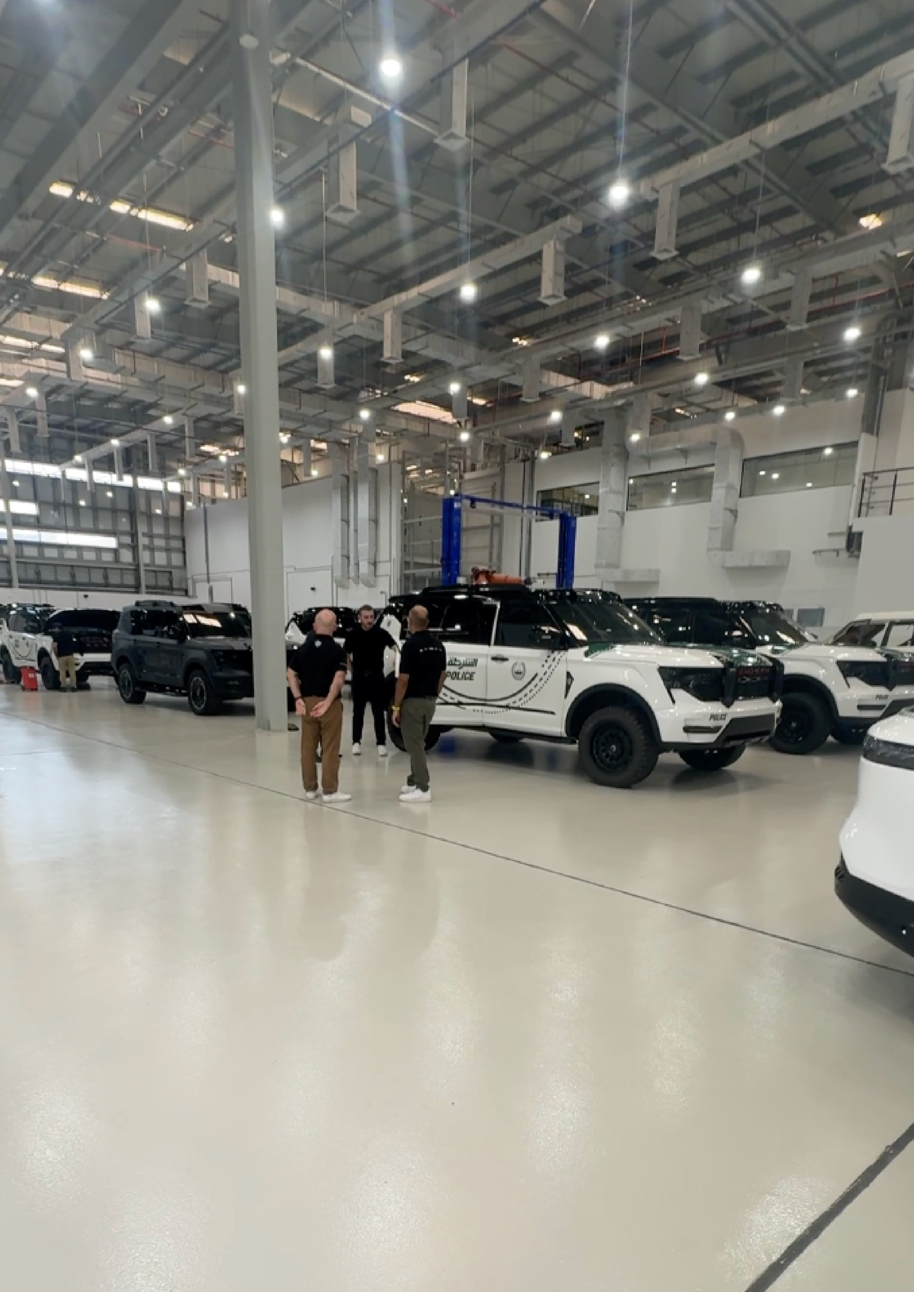


Abu Dhabi has launched a major automotive initiative under its Automotive Investment Programme to position the emirate as a global manufacturing and export hub. The state-owned enterprises we met are expanding port infrastructure, building logistics corridors, and developing dedicated automotive zones to anchor this strategy and attract partners capable of supplying differentiated platforms for regional and global deployment.
It was clear from our discussions in the region that the capability gap OKA addresses in Australia is mirrored across the UAE and globally. The government and state-owned entities we met expressed strong interest in OKA’s proprietary chassis and modular design as a way to close gaps within their existing fleet offerings.
We were encouraged by the enthusiastic reception and support from the region for our plans and look forward to exploring the opportunities presented over the coming months.

LOOKING FORWARD: KEY AREAS OF FOCUS
With the OzTerrain acquisition now complete and the foundational groundwork laid, our focus over the coming months will be:
Finalising manufacturing arrangements under the Varley MOU.

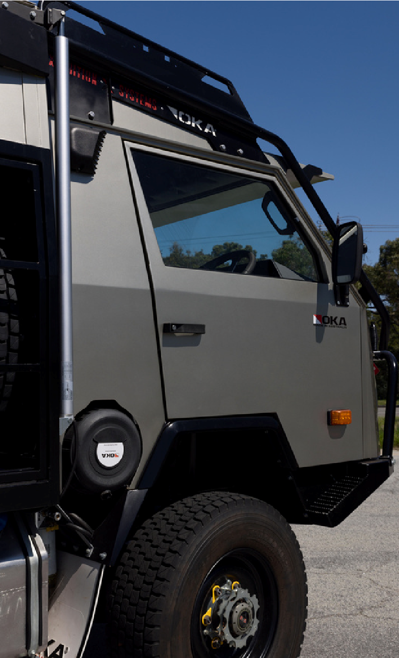
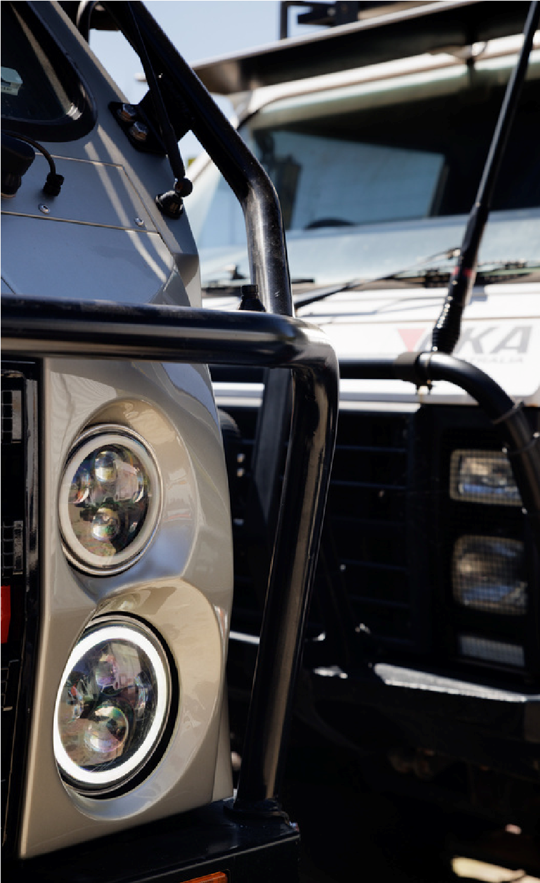
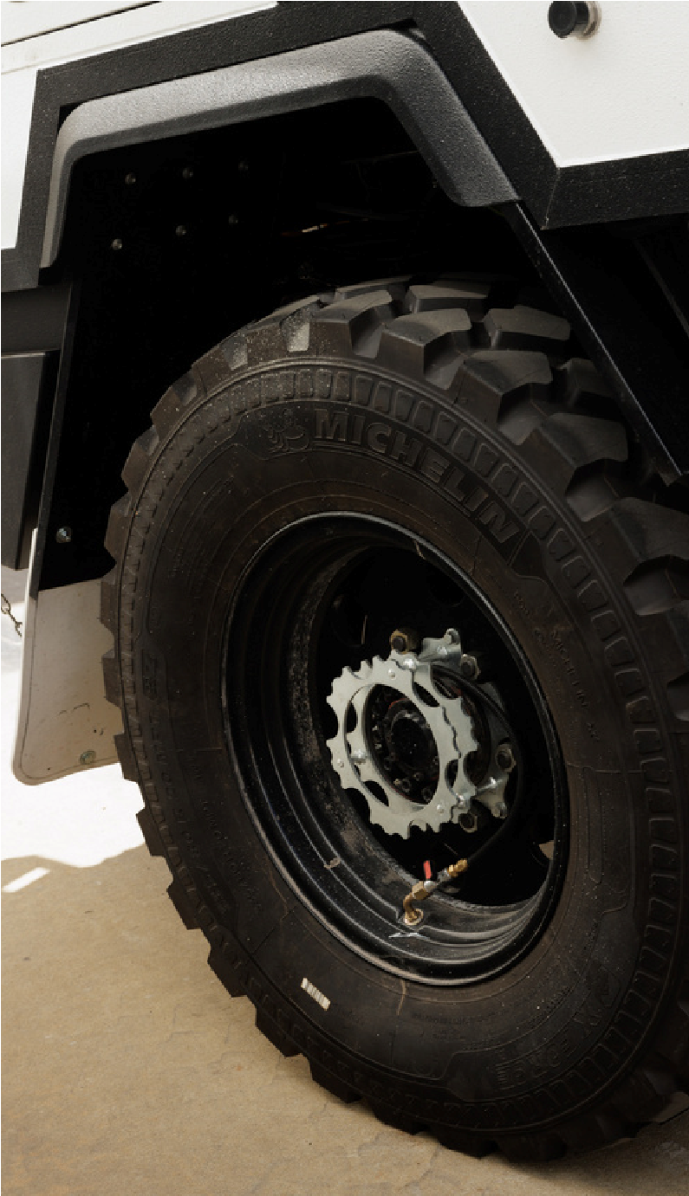

Commencing production of OKA Australia's first Gen-5 vehicles. Establishing export and sales pathways to support international demand.
Investor Newsletter
Edition 01
October 2025
Securing additional capital and strategic partnerships to accelerate our scale-up. As always, we welcome and thank our shareholders for introductions to potential investors and partners from their networks.

