Draft: For Review Only

NEWS ALERT

GATC Health and UCI to Showcase Breakthrough Opioid Use Disorder Drug Candidate at Society for Neuroscience’s 2025 Conference
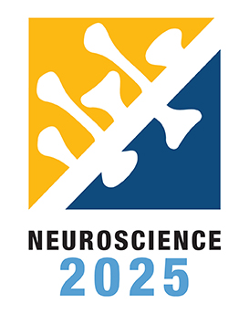
San Diego, CA—November 18, 2025—GATC Health is pleased to announce its co-sponsorship with the University of California, Irvine (UCI) for a poster presentation at the Neuroscience 2025 conference, taking place November 15–19 at the San Diego Convention Center. The event, organized by the Society for Neuroscience, brings together leading researchers and innovators to share the latest developments in brain science and therapeutics, with more than 30,000 attendees expected from around the world this year.
At Neuroscience 2025, UCI researchers Drs. Valeria Lallai and Christie Fowler will present a poster detailing groundbreaking findings from joint research in UCI's laboratories, evaluating GATC Health’s novel drug candidate for opioid use disorder (OUD). The research utilizes GATC’s proprietary AI platform, which rapidly identifies and evaluates new compounds with the potential to impact the root causes of addiction. The OUD candidate has already shown significant promise in preclinical studies, demonstrating effectiveness at reducing fentanyl self-administration and minimizing opioid relapse behaviors.
“The collaboration between GATC Health and UCI is a milestone for the future of neuroscience and addiction medicine,” said Ian Jenkins, Chief Science Officer of GATC Health. “By combining world-class laboratory science with our validated AI-driven platform, we’re demonstrating that machine learning can accurately predict and accelerate effective therapies for opioid use disorder. Presenting this work at Neuroscience 2025 highlights the strength of scientific partnership and the real-world impact of AI in advancing safer, faster treatments for those who need them most.”
GATC Health scientists Dr. Waldemar Lernhardt, Sam Kho, and Ian Jenkins will attend the event to engage with colleagues across the neuroscience community and discuss the platform’s role in accelerating addiction therapeutics.
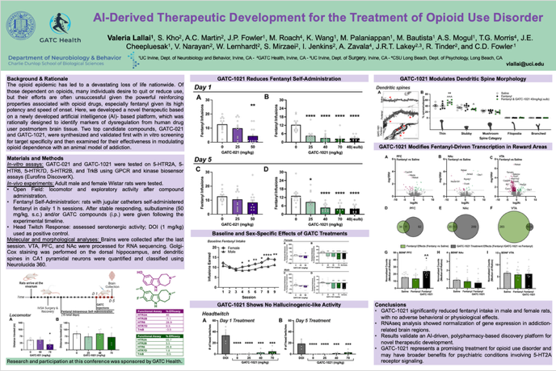
GATC Health’s AI platform continues to be validated through independent academic partnerships, including recent verification by UCI of true positive rates of 86% and true negative rates of 91% in predicting early-stage drug candidate outcomes. These scientific advancements support GATC’s broader mission to address unmet needs in addiction medicine, a field urgently requiring new solutions.
GATC Health invites attendees of Neuroscience 2025—both in-person and virtually—to visit the poster session, participate in discussion, and connect with the presenting and attending teams to learn more about the future of AI-powered drug discovery for opioid use disorder.
About GATC Health
GATC Health is a tech-bio company revolutionizing drug discovery and development by simulating complex human biology to predict how drugs will perform in the body, achieving 91% specificity and 86% sensitivity. Trusted by the world’s largest insurance marketplace, biopharma, researchers, and investment partners, GATC Health’s risk prediction product, the Derisq™ AI report, accurately assesses and predicts drug candidate safety, efficacy, and non-obvious side effects prior to the commitment of development capital. GATC Health’s AI platform is also generative, creating intellectual property, extending pipelines, and optimizing assets. By uniting advanced AI, multiomics, and predictive modeling, GATC Health accelerates breakthroughs and reduces costly late-stage failures to bring safer, more effective therapies to patients worldwide. For more information, visit www.gatchealth.com.

