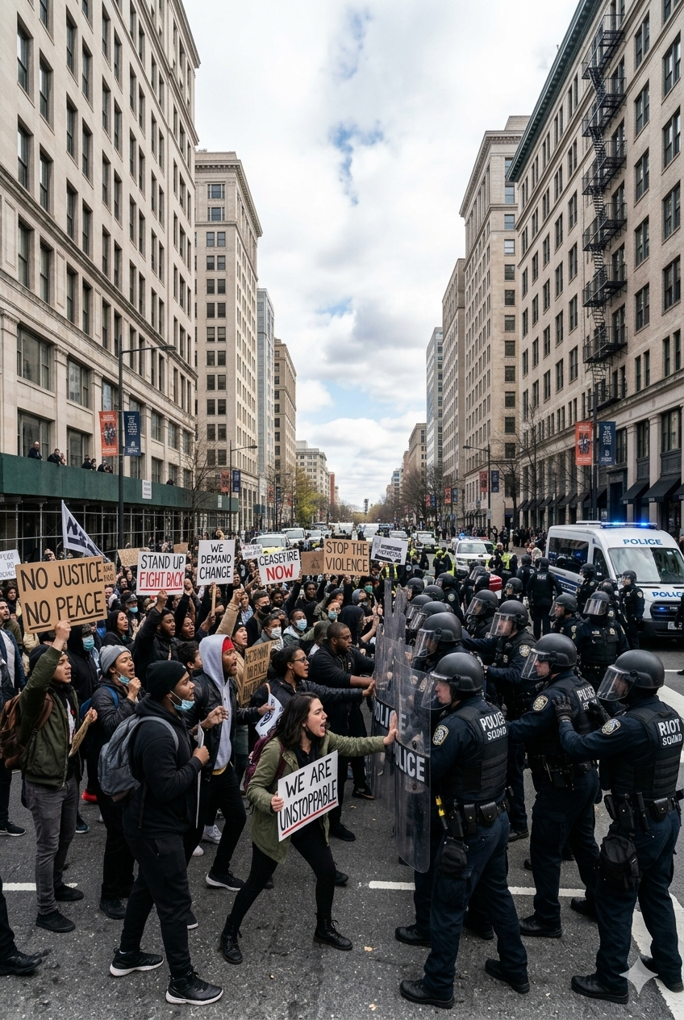
By Vasili Lazanas
Commissioner of Police (NSW Police Force) v Joshua Lees [2025] NSWSC 8

Commissioner of Police (NSW Police Force) v Joshua Lees [2025] NSWSC 858
A Case Summary

I BACKGROUND INFORMATION
On the 26th of July 2025 in accordance with section 23 of the Summary Offences Act 1988 (NSW), Joshua Lees, lodged a form 1 notice of intention to hold a public assembly on behalf of the Palestine Action Group. The organisers of the ‘March For Humanity’ disclosed their intention to march across the Sydney harbour bridge with an estimate of 10,000 protestors. Despite the legality of the form 1, the proposed ‘March For Humanity’ was subject to an enormous amount of public scrutiny and backlash, particularly regarding public safety concerns and the significance of closing the bridge for a protest. Concerns and criticism from members of the executive and legislature inevitably led to the judicial proceeding outlined in section II.
II FACTS OF THE CASE
On the 1st of August 2025 the NSW Supreme Court heard an application from the plaintiff, NSW police commissioner Karen Webb, which sought to prohibit the ‘March For Humanity’ which was organised by the defendant, Joshua Lees, and was scheduled to occur on the 3rd of August 2025. The plaintiff filed the application seeking an order under section 25 of the Summary Offences Act 1988 (NSW) which is the ‘Prohibition by a court of a public assembly’ In order to support the application's objective, the plaintiff called upon certain members from the executive and legislature to present affidavits regarding the dangers of the march in order to compel the judge to approve the application. If this were to be successful then the ‘March For Humanity’ would no longer be an authorised public assembly. The main arguments presented in the affidavits concerned public safety, disruption to traffic, inadequate preparation time, the capacity of the assembly meeting point and terrorism risks.
On the contrary, the defendant was optimistic and firm on his stance that the march would be conducted in a safe and orderly manner. The defendant and his team presented evidence of the Palestine action groups successful and lawful protest history in order to support their defence. Since the group's foundation in October 2023, the defendant has been involved in over 85 successful protests which had minimal incidents. Furthermore, the group have always had an active and positive relationship with police when organising events or resolving minor incidents, In addition to this, the defendant outlined how they had arranged 100 high-visibility vest marshals to sustain order and safety during the march. Finally, the defendant stated how even if the supreme court issues a prohibition order, a multitude of protestors would still gather on the date and proceed with the public assembly. To support the claim that prohibition won’t deter attendance, the defendant made reference to Bassi v Commissioner of Police [2020] NSWCA where 20,000 people turned up to a protest despite the fact that it had not been authorised yet.
III LEGAL ISSUES
The key legal issue that the case revolved around concerned the terminology under section 25 of the Summary Offences Act 1988 (NSW) which is the ‘Prohibition by a Court of a public assembly’. A court order under section 25 does not actually prohibit or make a public assembly illegal due to the implied right to freedom of political communication under the Australia constitution. The court clarified that an unauthorised public assembly is not unlawful, although it does come with the consequence of making the immunity and special privileges given to protestors by section 24 invalid. The main legal issue became a matter of whether the court would take away protestors immunity or not.
IV THE DECISION
On the 2nd of August 2025, Justice Rigg refused to approve the plaintiff’s application for a prohibition order and dismissed the summons. Justice Rigg stated, “Had there been evidence suggesting that public safety will be enhanced by a prohibition order that would also have been an important factor in my consideration; but there is no such evidence.” Following this decision there was no appeal from the plaintiff and the march for humanity proceeded the next day as planned.
V REASONS FOR THE DECISION
There were three main reasons for the decision, the first leading reason was the foresight that the protest on the 3rd was inevitably going to occur and the bridge will be closed regardless of the decision. Uncertainty comes with risks, hence why it is more effective to authorise the assembly which would mitigate risks, sustain an organised structure, and give authorities a better chance of preparing. Additionally, authorisation will sustain the special privileges given to protestors under section 24 of the Summary Offences Act 1988 (NSW) which prevents police from arresting protestors who block vehicle and pedestrian traffic whilst also reducing arrest rates. The court also affirmed that the police force has extensive powers under the Law Enforcement (Powers and Responsibilities) Act 2002 (NSW) which enables them to sufficiently handle incidents from both authorised and unauthorised protests. Finally the court took into consideration that prohibiting the assembly could significantly increase the number of protestors. With this foresight in consideration, the plaintiff was unable to provide evidence that indicated how prohibition would reduce risks to public safety.
The second vital reason for the decision was the court's acknowledgement of the Palestine Action Groups cooperative, prosocial, and lawful history. The defendants presented a large amount of evidence relating to the success and professionalism of organisers and marshals in past assemblies which Justice Rigg deemed to be important. In her decision, Justice Rigg expressed confidence that the Palestine Action Group “will continue to work constructively with police to achieve as safe and smooth an event as possible.”
The final key reason for the decision was the consideration of public interests. There was a heavy emphasis placed on the social importance of proceeding with the march promptly as the timing corresponded with recent escalations in the Gaza humanitarian crisis. Justice Rigg agreed with the defendant’s case which stated that the new momentum was an imperative time for humanitarian advocacy. Finally, the court also made reference to the importance of freedom of expression and how that is what the public desires and needs at this crucial moment of time.
VI IMPLICATIONS OF THE DECISION
The court's decision displayed how the Australian constitution's separation of powers doctrine upholds the rule of law and enforces international human rights documents domestically. The case also gave an insight into the importance of balancing interests of many different parties including the plaintiff, defendant, and society as a whole. Finally, the case has created an opportunity for future discussion concerning the relevance of prohibition orders on public assemblies.

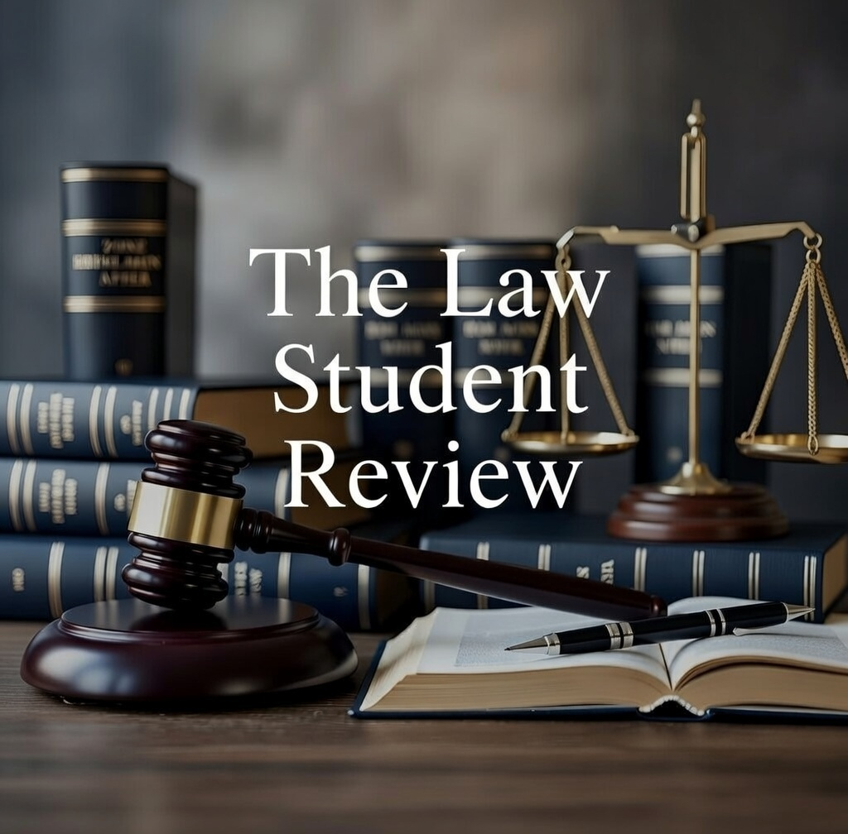

Joshua Lees, ‘Statutory Declaration’ (20 August 2025).
Commissioner of Police (NSW Police Force) v Joshua Lees [2025] NSWSC 858.
Ibid.
Ibid [2].
Ibid [19].
Ibid [21].
Ibid [64].
Ibid [6].
Ibid [70].
Ibid [71].

