BENEFITS
SAC0307 LEAD FREE SOLDER PASTE NO CLEAN SMT PRINTING PROCESS
HIGH VOLUME PRODUCTION & ROBUST ASSEMBLY

SOLDERIX SAC - 0307 is especially designed to cater high volume electronics with an overall balanced solder paste performance to guarantee a stable assembly process. It`s a No Clean solder paste combining the metallurgical properties of a low silver alloy with the high performance chemistry range. Besides cost benefits, a low silver alloy provides also a better drop-shock resistance.
This solder paste has excellent visual solder joint cosmetics with transparent residues, even after multiple reflow cycles. It has a high first pass yield testability in ICT and very good wetting on different board finishes, including OSP.
SOLDERIX SAC - 0307 is the ideal paste in paste in terms of cost/performance ratio for consumer, brown & white goods electronics manufacturing. The chemistry of SAC - 0307 is also available in other alloys.

PERFORMANCE | - Robust assembly for a stable process  - Very good wetting on all surface finishes, including OSP  - Transparent colorless residue, even after multiple reflow cycles
COST | - Good first pass yield testability in ICT
HSE | - No CMR containing substances  - Lead Free & No Halogen

FEATURES
STANDARD OPTIONS
SPECIFICATIONS | SOLDERIX SAC - 0307-T3 | SOLDERIX SAC – 0307-T4
Alloy | Sn99Ag0.3Cu0.7 | Sn99Ag0.3Cu0.7
Melting point (°C/°F) | 217 / 422 | 217 / 422
Metal content (%) | 88 +/-0,5 | 88 +/-0,5
Post reflow residues | Approximately 5% by w/w | Approximately 5% by w/w
Halogen content | No Halogen | No Halogen
Powder size | 25-45 microns / Type 3 | 20 – 38 microns / Type 4
Spiral pump* Viscosity (Pa.s 25°C) | Typical 135 | Typical 135
*The equipment used to test spiral pump viscosity is Malcom at a 10 rpm rotation speed.

CHARACTERISTICS

CHARACTERISTICS | VALUES
Flux Classification | ROL0 | ANSI/J-STD-004
Flux Classification | 113 | ISO 9454
Solder balling test | Pass | ANSI/J-STD-005
Copper mirror | Pass | ANSI/J-STD-004
Copper corrosion | Pass | ANSI/J-STD-004
SIR (IPC) | Pass | ANSI/J-STD-004
SIR (Bellcore) | Pass | Bellcore
Electromigration (IPC / Bellcore) | Pass | ANSI/J-STD-004 / Bellcore

PROCESS RECOMMENDATION
The best process will depend on factors such as operating conditions, equipment, board or component design. Our team is ready to advise you.

SOLDER PASTE PREPARATION
- Put the paste at room temperature for at least 4 hours prior to use.
- Before printing, it is essential to properly mix the solder paste, either manually with a spatula or by doing several preliminary prints on the stencil.
- Automatic solder paste mixing is neither required nor advised.

PRINTING GUIDELINE
Apply the solder paste to the stencil to form a roll of 1 to 2 cm in diameter all along the squeegee or around 100g per 10 cm of squeegee length. This way, the solder paste will roll easily under the squeegees to offer excellent printing quality.

PARAMETER | REMARK
Printing speed | Minimum 20 to maximum 150 mm/s (1 to 6 inch/s)  Maximum depends on printer capabilities
Minimum pitch | 0.4 mm for Type 3 powder
Pressure | Guideline value for a 250 mm squeegee is 5 Kg for T3 and 6kg for T4 at 100 mm/s Actual value depends on equipment, printing speed and squeegee length  Squeegee length Printing Speed PressureT3 Pressure T4 250mm 50 mm/s 3 kg 4 kg  100 mm/s 5 kg 6 kg  150 mm/s 7 kg 8 kg
Stencil life in continuous printing process | >12 hours
Abandon time between prints | >4 hours
Steady tackiness | >16 hours

REFLOW GUIDELINE
Although this paste performs very well under air, a nitrogen atmosphere will even more improve the wettability whereas achieving even a larger reflow process window.
Linear preheating ramp rate is recommended, however high-density boards may require a soak zone during preheating to stabilize the temperature over the circuit board before peak reflow.
Although low silver alloys usually show a quite similar reflow graph like SAC305, it is recommended to choose a slightly higher peak temperature between 240 °C to 255°C (464°F to491°F).
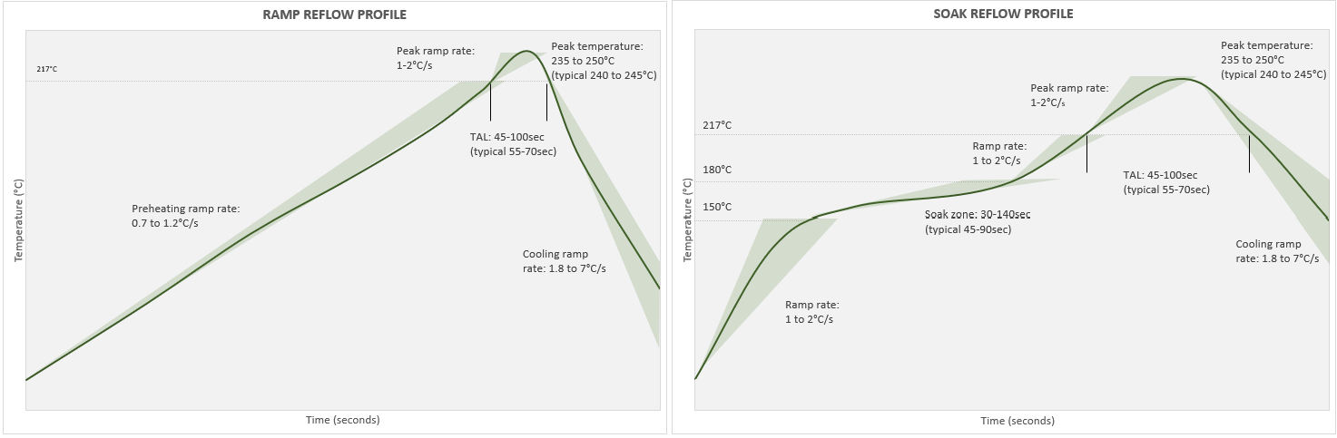

REFLOW STEPS | REMARKS
Preheating ramp rate with linear preheating | 0.7 to 1.2°C/s ( according to the circuit board size and density
Preheating steps in case of preheating soak zone | - From 20 to 150°C ramp rate 1 to 2°C/s  - Soak zone between 150 to 180°C (302 to 356°F): 60-140s reflow (typical soak 45-90s)  - From 170°C (380°F) to liquidus 1 to 2°C/s
Peak ramp rate | 1 to 2 °C/s
Peak temperature | 235 to 250°C (455 to 582°F) / 240 to 245°C (464 to 473°F) is optimum  The paste can withstand a temperature higher than 250°C (482°F), but it is not recommended to preserve component integrity.
Time above liquidus | 45 to 100s - 55 to 70s typical
Cooling ramp rate | 1.8 to 7°C/s  Studies has demonstrated 1.8 to 2.2 °C/s allows a more homogeneous joint structure and reduced surface crack formation.

CLEANING POST SOLDERING
This product is a no-clean solder paste, so cleaning is not required to meet IPC standards. The chemistry is specially designed so that any remaining flux residue is chemically inert and will not impact your assembled board or packaging under normal conditions.
However, when cleaning is desired or required (e.g. high reliability assembly or to improved conformal coating adhesion), the flux residue can be easily removed with flux cleaners.

PACKAGING, STORAGE & SHELF LIFE
- To ensure the best product performance, the recommended storage temperature range is from 0°C to 10°C.
- For an optimal preservation, store cartridges in a vertical position, tip downwards.
- Shelf-life is 12 months for jar packaging & 9 months
AVAILABLE PACKAGING
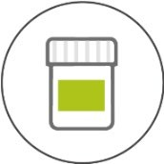

JAR 500g

